Supplementary Material

Supplementary Figures and Tables

Supplementary Tables

Supplementary Table 1. Analysis of variance (ANOVA).
Variable | Fertilizer | Genotype | Fertilizer x Genotype
Yield 2018/2019 | * | *** | ***
Yield 2019/2020 | ns | ns | ns
Selenium 2018/2019 | *** | ns | **
Selenium 2019/2020 | ns | ns | ns
Selenium recovery | ns | * | ns
Selenium in soil | ns | ns | ns
Amino acids | *** | *** | ***
Nitrogen | *** | *** | ***
Protein | *** | *** | ***
SOD | ns | *** | ns
CAT | ns | * | ns
APX | ns | ns | ns
MDA | ns | ns | **
H₂O₂ | ** | *** | ns

* Significance 0.05; ** Significance 0.01; *** Significance 0.001; ns = no significance by F test.

Supplementary Table 2. Selenium in soil, Se in grain (2019/2020 season), N content, and S content in grains.
Genotype | Fertilizer | Selenium in soil (mg dm⁻³) | Selenium in grain - 2019/2020 (mg kg⁻¹) | N (g kg⁻¹)
M5917 | C_MAP | 0.558 ± 0.28 | 0.445 ± 0.01 | 66.38 ± 0.70
TMG7061 |  | 0.924 ± 0.10 | 0.473 ± 0.08 | 46.11 ± 0.37
N5909 |  | 0.782 ± 0.24 | 0.624 ± 0.06 | 46.90 ± 0.34
58I60 LANÇA |  | 0.623 ± 0.11 | 0.563 ± 0.09 | 56.14 ± 0.74
M5917 | C-MAP + Se | 0.950 ± 0.30 | 0.614 ± 0.06 | 49.23 ± 0.53
TMG7061 |  | 0.705 ± 0.18 | 0.602 ± 0.06 | 45.88 ± 0.54
N5909 |  | 0.724 ± 0.33 | 0.598 ± 0.07 | 46.83 ± 0.31
58I60 LANÇA |  | 0.488 ± 0.16 | 0.699 ± 0.04 | 48.70 ± 0.21
M5917 | E-MAP | 0.911 ± 0.23 | 0.488 ± 0.09 | 49.61 ± 0.47
TMG7061 |  | 0.765 ± 0.17 | 0.361 ± 0.04 | 47.08 ± 0.09
N5909 |  | 0.614 ± 0.12 | 0.634 ± 0.13 | 46.97 ± 0.53
58I60 LANÇA |  | 0.656 ± 0.07 | 0.469 ± 0.07 | 49.54 ± 0.59
M5917 | E-MAP + Se | 0.694 ± 0.19 | 0.634 ± 0.01 | 49.95 ± 0.47
TMG7061 |  | 0.740 ± 0.23 | 0.556 ± 0.10 | 47.45 ± 0.49
N5909 |  | 0.976 ± 0.27 | 0.556 ± 0.06 | 47.15 ± 0.39
58I60 LANÇA |  | 0.703 ± 0.13 | 0.477 ± 0.04 | 49.40 ± 0.24

Supplementary Figures

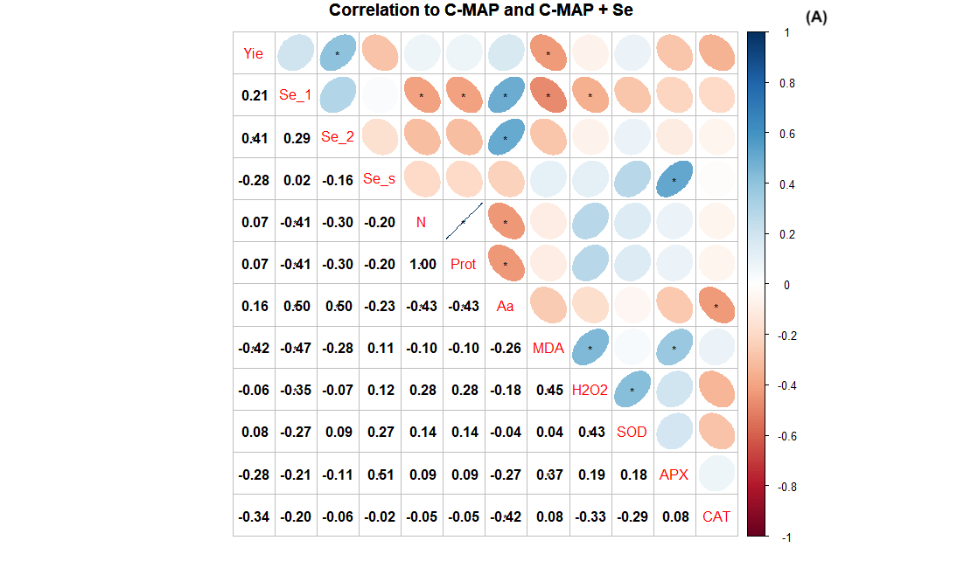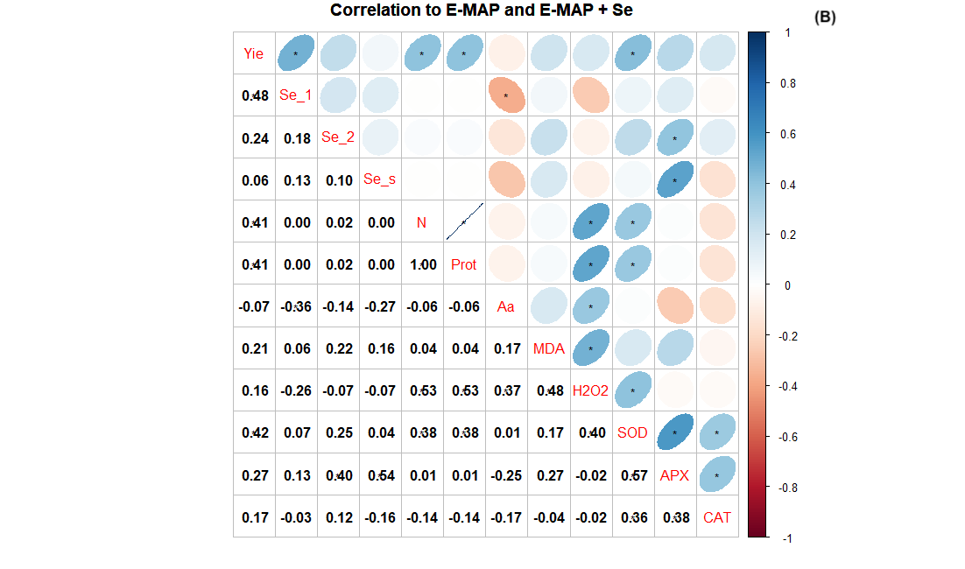

Supplementary Figure 1. Pearson’s linear correlation matrix to C-MAP and C-MAP + Se (A) and to E-MAP and E-MAP + Se (A). * significant relationship of soil and plant attributes at p < 0.05; blue ellipse with right sloping top: positive relationship; red ellipse with left sloping top: negative correlation. Se content in the grain 2018/2019 (Se_1), Se content in the grain 2019/2020 (Se_2), Se in soil (Se_s), yield (Yie) protein in grains (Prot), amino acids in grains (aa), lipid peroxidation (MDA), hydrogen peroxide (H₂O₂), catalase (CAT), superoxide dismutase (SOD), ascorbate peroxidase (APX).

