### *S2. Supplementary material 2. Site Specific Scenarios*

##### General linear models (GLM’s) and relative importance

Significant variables also varied depending on the thermal profile of all sites. Above average SST sites were mainly coastal areas distributed above Punta Baja, while below average SST sites were islands distributed along Baja California’s coastline; only one site displayed an average SST profile (ST), with only urchin catch and SST as significant variables in the GLM (Table III).

S2.1. Site specific GLM’s significant variables, coefficients (± errors). Only significant variables coefficients and intercepts are shown.

|  |  |  |  |
| --- | --- | --- | --- |
| Variable /Model | Above average  (GLMab) | Below average (GLMbe) | Average (GLMµ) |
| *Site code* | ICS, Pop, SM, PBan, Eren, Col, VT | ITS, ISM, PBaj, ISJ, AS, Can | ST |
| *Intercept* |  |  |  |
| *Kelp biomass* | 0.386 (±0.082) | 0.126 (±0.056) |  |
| *Urchin catch* | 0.721 (±0.051) | 0.874 (±0.045) | 0.231 (±0.044) |
| *Sheephead catch* |  |  |  |
| *Kelp seabass catch* |  |  |  |
| *Spiny lobster catch* |  | 0.228 (±0.046) |  |
| *SST* | 0.241 (±0.058) | -0.117 (±0.054) | 0.135 (±0.046) |
| *CgE* | 0.172 (±0.060) |  |  |
| *Upwelling index* |  | 0.276 (±0.053) |  |
| *MEI* |  |  |  |
| *NPGO* |  |  |  |

Significant variables in above average sites explain 65.42% of the observed variability. Red sea urchin catch was the most important variable, followed by SST, kelp biomass and CgE. Red sea urchin catch anomaly was the most important variable in below average sites, followed by lobster catch anomaly and upwelling index. Significant variables explain 71.21% of the observed variability. Red sea urchin catch anomaly was the most important variable in the average site, followed by SST; these variables explain 78.68% of the observed variability (Fig. 10).

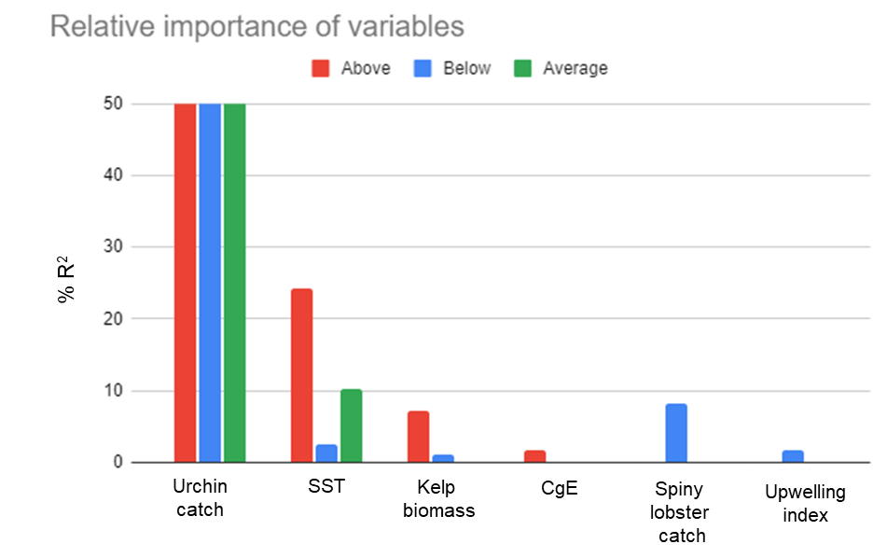

S2.2. Share of R2 (as percentage) of significant variables for above GLMab, below GLMbe, and average GLMµ models. Metrics are normalized to sum 100%. Urchin catch % of R2 is >50% in all scenarios.

With these results, we modeled *rsu* using above, below and average site important variables. All three models displayed good fits, with model GLMµ performance being higher (R2 =0.78; S2.3).

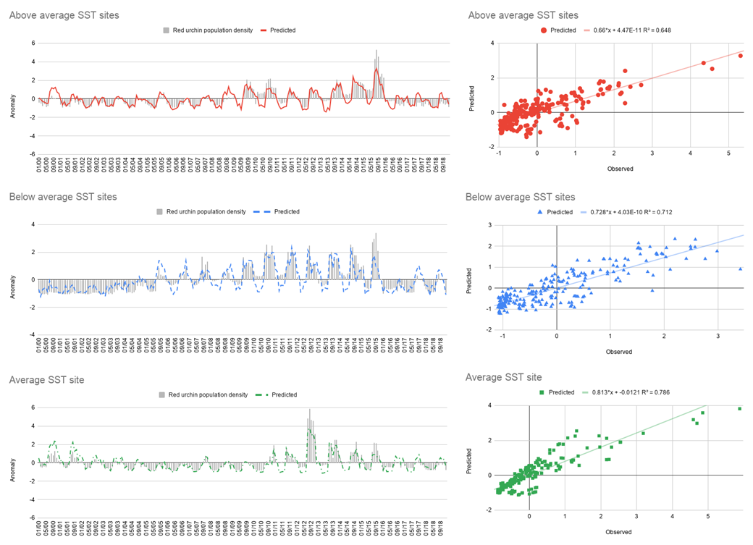

S2.3. Comparison between observed *rsu* values (bars), and predicted values from full time series for above (solid line), below (long dash) and average SST conditions (dash-dot) models.