### *S1. Supplementary material 1. Time lag of significant variables.*

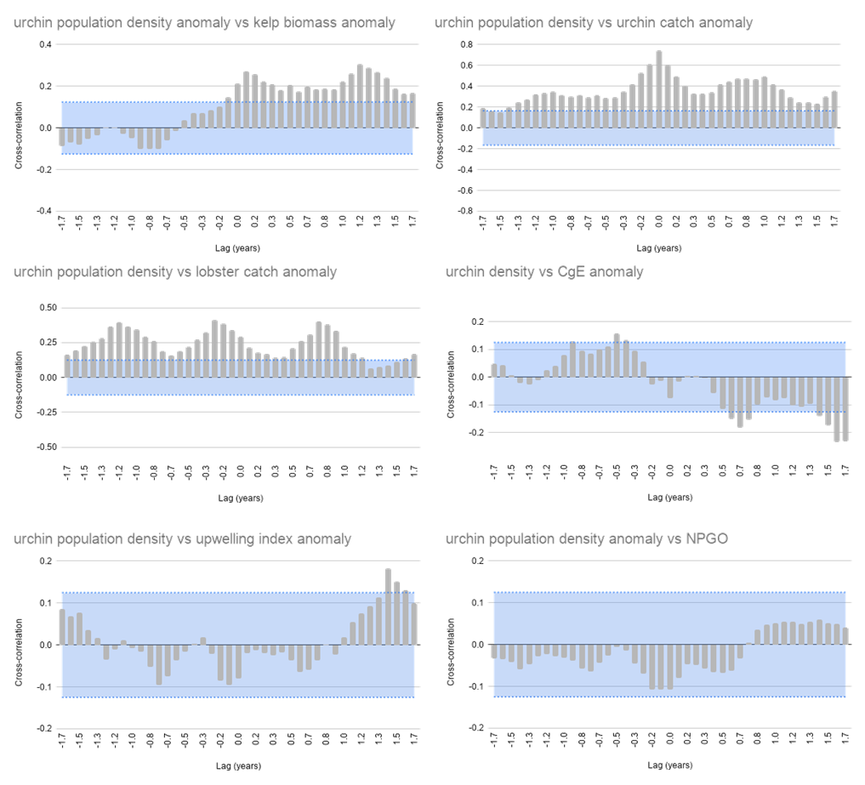

S1. 1. Cross-correlation functions for significant variables for model GLM00-18 (Full time series).

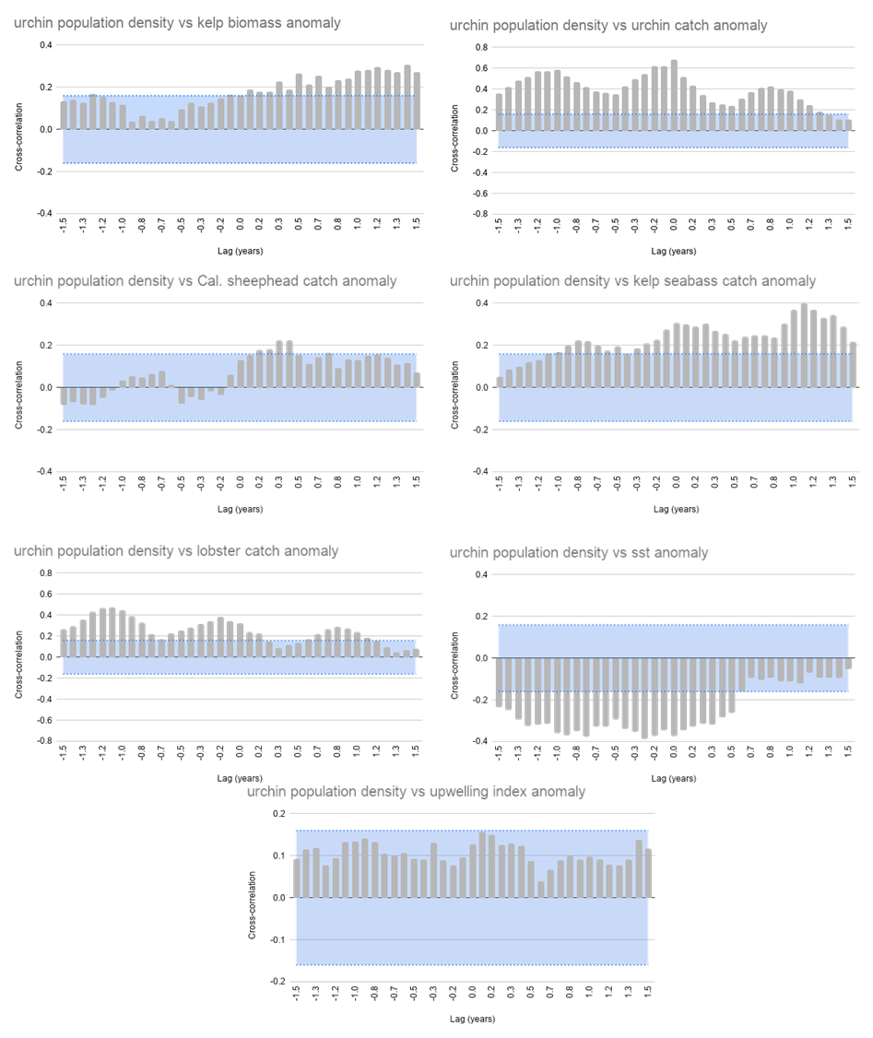

S1. 2. Cross-correlation functions for significant variables for model GLM00-11 (Pre – heatwave).

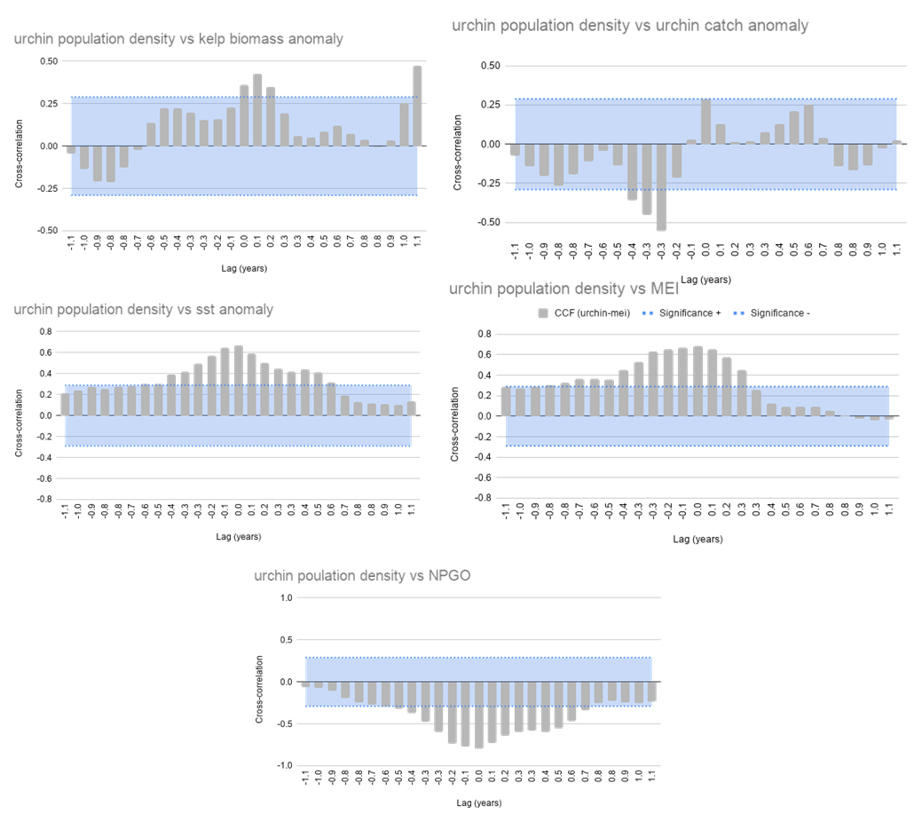

S1. 3. Cross-correlation functions for significant variables for model GLM12-15 (Heatwave).

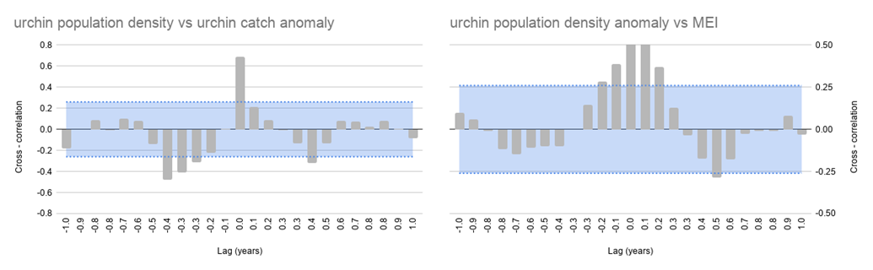

S1. 4. Cross-correlation functions for significant variables for model GLM16-18 (Post – heatwave).