Supplementary Material

Suppl. Figure 1. Receiver operating characteristic curves (ROC) to assess the prognostic value of baseline RDW (as a continuous variable) for the combined endpoint of death/HF rehospitalization at 12 months A) in the SGLT-2i (dapagliflozin) group and B) the control group.

No significant difference was observed between the aforementioned AUCs (p=0.349).

Suppl. Figure 2. Hemoglobin longitudinal changes in the dapagliflozin and control group.

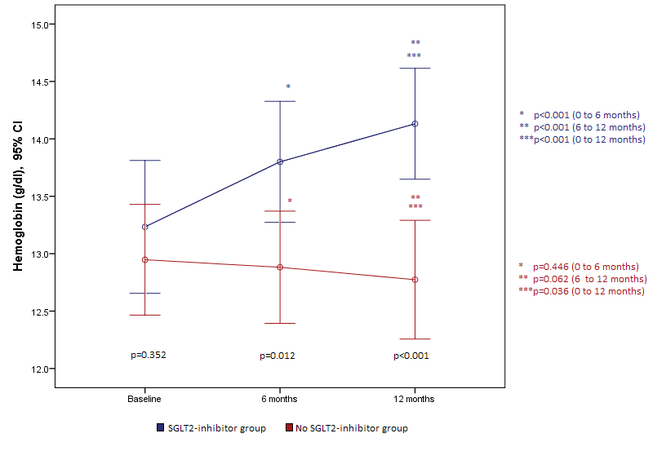

Suppl. Figure 3. Hematocrit longitudinal changes in the dapagliflozin and control group.
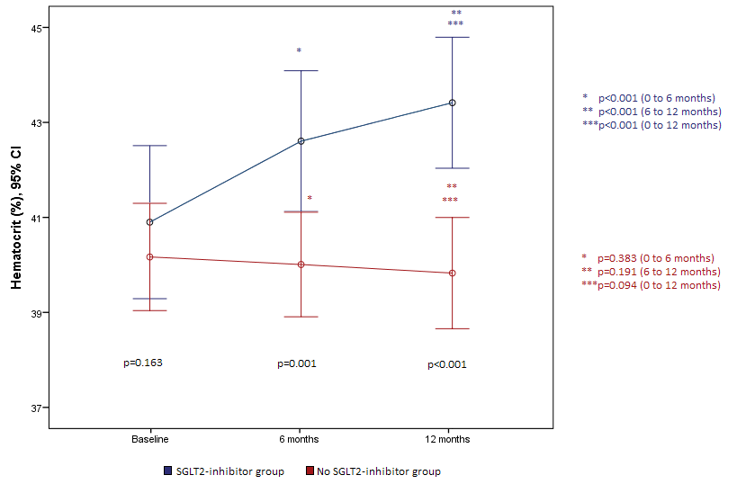

Suppl. Table 1. Percentages of 1-year death or rehospitalization in the two groups (Dapagliflozin vs control group)

 | Death or Rehospitalization |  |  |  |  | P Pearson's x² test
 | No |  |  | Yes
 | N | % | N |  | %
Dapagliflozin group | 51 | 91,1 | 5 |  | 8,9 | 0,223
Control group | 45 | 83,3 | 9 |  | 16,7

Suppl. Table 2. Univariate mixed linear regression results with ferritin as dependent variable.
Independent variables | β+ | SE++ | P
CRP | 0.37 | 0.34 | 0.275
WBC | 0.004 | 0.002 | 0.047
Fe | 1.23 | 0.17 | <0.001
STFR | -2.40 | 0.56 | <0.001
+regression coefficient; ++Standard Error

Suppl. Table 3. Correlation between RDW and hematocrit (Ht)/ hemoglobin (Hb) changes (from baseline to 12 months) in the SGLT-2i group (dapagliflozin)

Variable | Spearman’s rho | P-value
RDW-Ht | 0.30 | 0.033
RDW-Hb | 0.24 | 0.094

In the dapagliflozin group it was found that greater increase in hematocrit was significantly associated with greater increase in RDW values, rho=0.30; p=0.033. Also, in the aforementioned group, it was found that greater increase in hemoglobin tended to be associated with greater increase in RDW values, rho=0.24; p=0.094. RDW was not changed significantly in the control group, thus no further correlation analysis was conducted in this group.

