**Appendix**

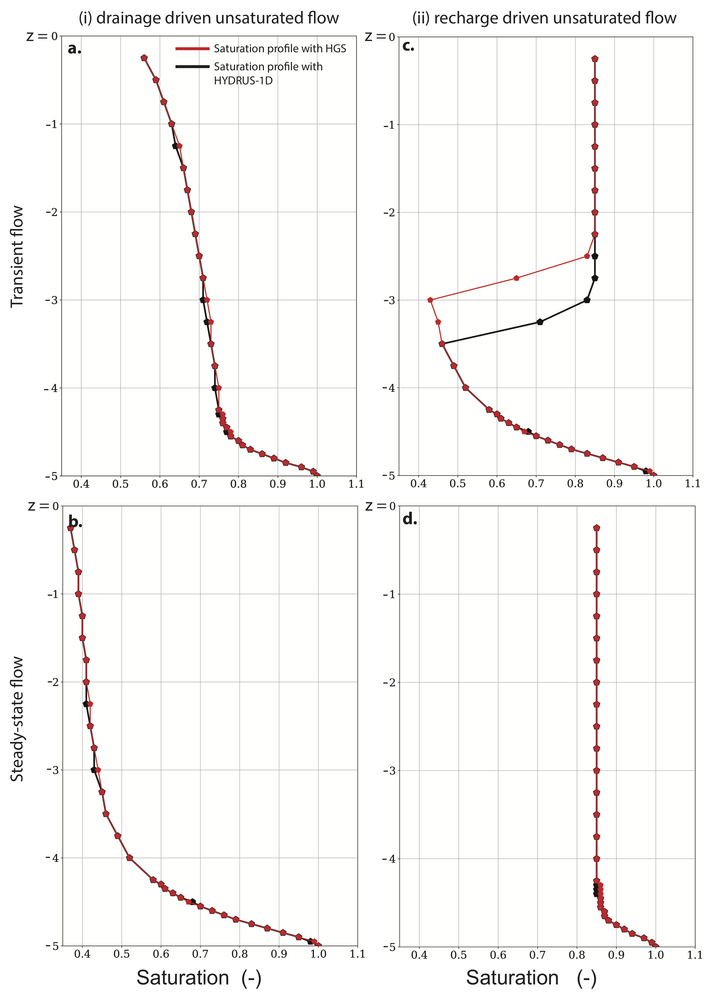

**Figure A1:** Saturations of a synthetic one-dimensional soil column model under (i) drainage driven flow and (ii) recharge driven flow. Differences between the model simulations can be attributed to different model solvers used by HGS and HYDRUS-1D to solve 1-dimensional simulations.

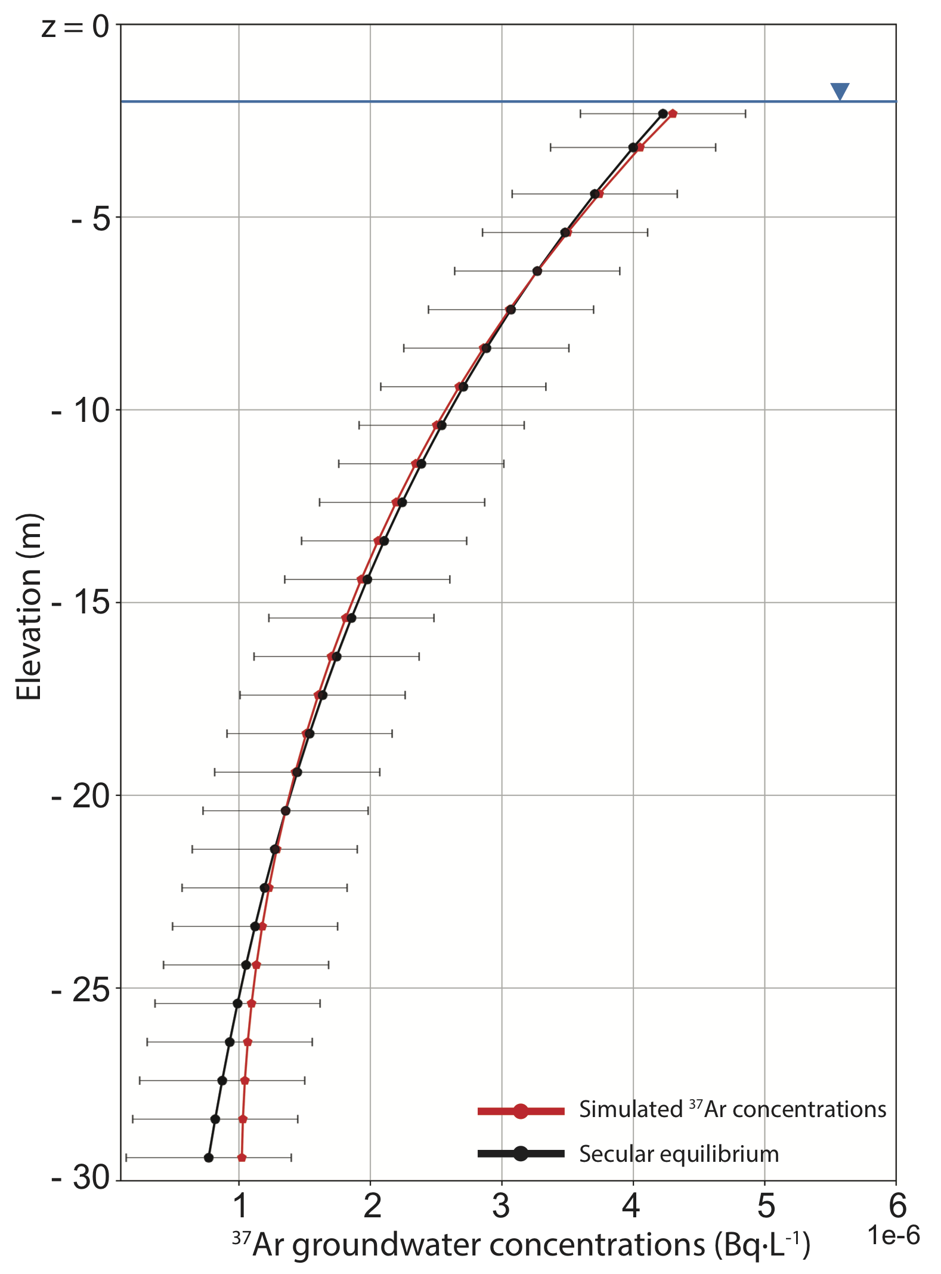

**Figure A2:** Reproduction of the 37Ar secular equilibrium profile fitted from measured groundwater concentrations in a sand and gravel alluvial aquifer (Schilling et al., 2017a). Horizontal bars represent 2σ standard deviations.