Supplementary Material
Supplementary methods
The presence of metabolic syndrome was defined by the coexistence of three or more of the following criteria: elevated waist circumference, elevated triglycerides, reduced high-density lipoprotein cholesterol (HDL-C), elevated blood pressure, and elevated fasting glucose (1, 2). In this study, the range of waist circumference was 20-140 cm, whereas plasma triglycerides were in the range of 4-1000 mg/dl, HDL-C of 3-120 mg/dl, systolic blood pressure of 60-300 mmHg, diastolic pressure of 30-150 mmHg, and fasting glucose of 2-450 mg/dl. The protocols for physical measurements and blood collection have been described elsewhere (3, 4).
Reference
1. Grundy SM, Cleeman JI, Daniels SR, Donato KA, Eckel RH, Franklin BA, et al. Diagnosis and management of the metabolic syndrome: an American Heart Association/National Heart, Lung, and Blood Institute scientific statement. Circulation. 2005;112(17):2735-52.
2. Alberti K, Eckel RH, Grundy SM, Zimmet PZ, Cleeman JI, Donato KA, et al. Harmonizing the metabolic syndrome: A joint interim statement of the international diabetes federation task force on epidemiology and prevention; National heart, lung, and blood institute; American heart association; World heart federation; International atherosclerosis society; And international association for the study of obesity. Circulation. 2009;120(16):1640-5.
3. Zhao Y, Hu Y, Smith JP, Strauss J, Yang G. Cohort profile: the China health and retirement longitudinal study (CHARLS). International journal of epidemiology. 2014;43(1):61-8.
4. Chen X, Crimmins E, Hu P, Kim JK, Meng Q, Strauss J, et al. Venous blood-based biomarkers in the China health and retirement longitudinal study: rationale, design, and results from the 2015 wave. American journal of epidemiology. 2019;188(11):1871-7.

Supplementary Figure 1. Multivariate-adjusted spline curves for associations of sleep duration with incident stroke.
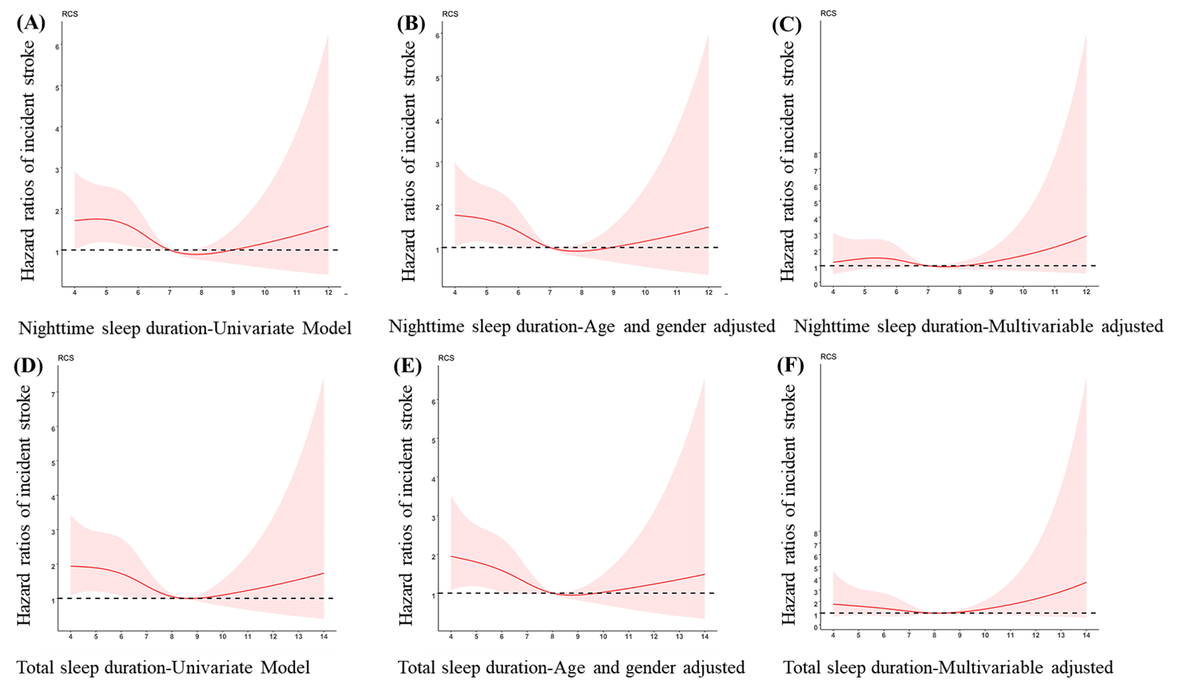
The curves demonstrate that participants with short nighttime sleep duration (A-C) and total sleep duration (D-F) had a higher incidence of stroke. (A-C) Nighttime sleep duration, the reference group was 7 hours/night for sleep duration. (D-F) Total sleep duration, the reference group was 8 hours/day for sleep duration. Multivariable adjusted for age, gender, educational level, marital status, area of residence, behaviors including smoking, drinking, and physical activity, body mass index, self-report diagnosis of stroke, hypertension, hyperlipidemia, diabetes or high blood sugar, waist circumference, systolic and diastolic blood pressure, HDL, triglycerides, fasting plasma glucose and HbA1c.

Supplementary Figure 2. Multivariate-adjusted association of sleep duration with incident stroke risk, stratified by baseline characteristics and metabolic syndrome.
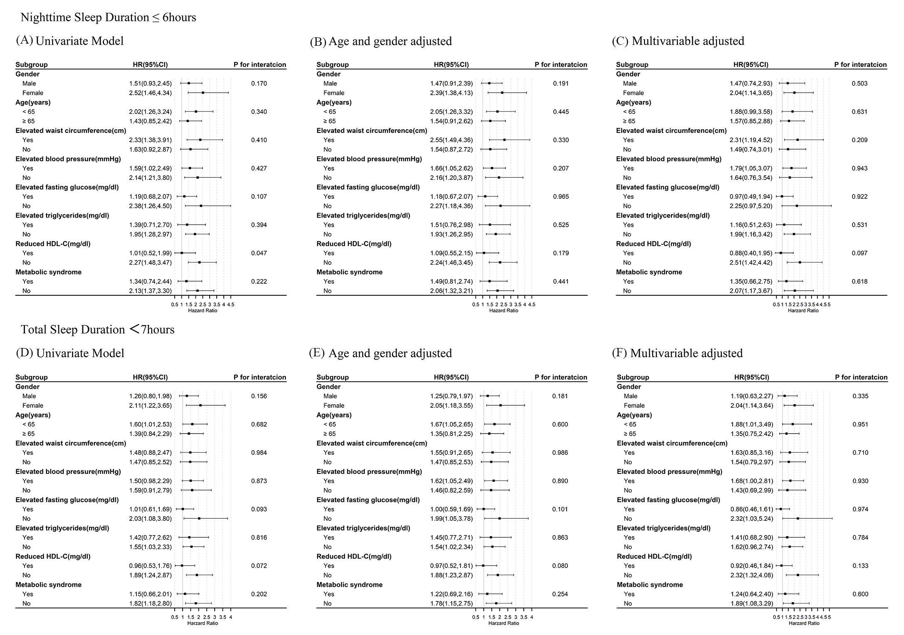
All hazard ratios were calculated with night sleep duration >6 hours/night (A-C) and (D-F) total sleep duration ≥7 hours/day as the reference groups. Multivariable model adjusted for age, gender, educational level, marital status, area of residence, and behaviors including smoking, drinking, and physical activity.
Abbreviations: HR = hazard ratio, CI = confidence interval.
Supplementary Table 1. Joint associations of nighttime sleep duration and daytime napping with incident stroke.
Variable |  | Incident stroke, Adjusted HR(95% CI)
Nighttime sleep duration, hours | Daytime napping, min | cases(N) | Univariate Model | Age and gender adjusted | Multivariable adjusted† | Multivariable adjusted‡
N≤6 | D=0 | 42(1579) | 1.82(1.06,3.12) | 1.71(0.99,2.95) | 1.83(0.95,3.52) | 1.83(0.95,3.52)
6＜N≤8 | D=0 | 19(1291) | 1.00 | 1.00 | 1.00 | 1.00
N＞8 | D=0 | 5(278) | 1.23(0.46,3.29) | 1.21(0.45,3.25) | 1.85(0.66,5.21) | 1.85(0.66,5.20)
N≤6 | 0＜D≤60 | 25(1174) | 1.45(0.80,2.63) | 1.26(0.69,2.31) | 1.29(0.62,2.70) | 1.29(0.62,2.69)
6＜N≤8 | 0＜D≤60 | 20(1188) | 1.14(0.61,2.14) | 1.08(0.57,2.02) | 0.94(0.42,2.10) | 0.93(0.41,2.08)
N＞8 | 0＜D≤60 | 3(181) | 1.13(0.33,3.81) | 1.04(0.31,3.52) | 0.86(0.19,3.84) | 0.85(0.19,3.79)
N≤6 | D＞60 | 10(453) | 1.50(0.70,3.23) | 1.17(0.53,2.58) | 1.31(0.50,3.45) | 1.30(0.49,3.42)
6＜N≤8 | D＞60 | 10(586) | 1.16(0.54,2.492) | 1.02(0.47,2.21) | 0.82(0.29,2.31) | 0.82(0.29,2.30)
N＞8 | D＞60 | 2(147) | 0.93(0.22,3.98) | 0.80(0.19,3.45) | 1.05(0.24,4.68) | 1.04(0.23,4.64)
Abbreviations: HR = hazard ratio; CI = confidence interval. Bold values indicate the positive results of the study.
† adjusted for age, gender, educational level, marital status, area of residence, and behaviors including smoking, drinking, and physical activity;
‡ adjusted for age, gender, educational level, marital status, area of residence, behaviors including smoking, drinking, and physical activity, along with additional adjustment for self-reported diagnosis of stroke, dyslipidemia, hypertension, diabetes or high blood sugar, BMI, waist circumference, triglycerides, HDL-C, systolic and diastolic blood pressure, fasting plasma glucose and HbA1c levels.
Supplementary Table 2: Sensitivity analysis: nighttime sleep duration and incident stroke risk, stratified by objectively assessed Mets (N = 4426).
 | Univariate Model |  |  | Age and gender adjusted |  |  | Multivariable adjusted† |  |  | Multivariable adjusted‡
Subgroup | HR (95%CI) | P value | P for interaction | HR (95%CI) | P value | P for interaction | HR (95%CI) | P value | P for interaction | HR (95%CI) | P value | P for interaction
Elevated waist circumference(cm)
Yes | 2.36(1.40,3.96) | 0.001 | 0.258 | 2.50(1.48,4.23) | 0.001 | 0.173 | 2.27(1.18,4.34) | 0.014 | 0.454 | 2.31(1.20,4.42) | 0.012 | 0.801
No | 1.51(0.86,2.67) | 0.154 |  | 1.43(0.81,2.53) | 0.219 |  | 1.46(0.73,2.93) | 0.288 |  | 1.47(0.73,2.96) | 0.276
Elevated blood pressure(mmHg)
Yes | 1.61(1.00,2.62) | 0.052 | 0.327 | 1.72(1.05,2.79) | 0.030 | 0.334 | 1.78(1.01,3.16) | 0.048 | 0.903 | 1.70(0.96,3.02) | 0.07 | 0.685
No | 2.42(1.27,4.60) | 0.007 |  | 2.19(1.15,4.18) | 0.017 |  | 1.77(0.77,4.07) | 0.177 |  | 1.78(0.78,4.09) | 0.173
Elevated fasting glucose(mg/dl)
Yes | 1.21(0.62,2.35) | 0.585 | 0.228 | 1.17(0.60,2.30) | 0.643 | 0.188 | 0.99(0.42,2.35) | 0.984 | 0.068 | 1.05(0.44,2.51) | 0.906 | 0.068
No | 2.03(1.21,3.39) | 0.007 |  | 2.02(1.20,3.39) | 0.008 |  | 1.87(1.00,3.51) | 0.050 |  | 1.85(0.99,3.47) | 0.054
Elevated triglycerides(mg/dl)
Yes | 1.35(0.67,2.71) | 0.400 | 0.495 | 1.35(0.67,2.73) | 0.402 | 0.524 | 0.98(0.41,2.31) | 0.957 | 0.274 | 0.97(0.41,2.31) | 0.951 | 0.294
No | 1.82(1.10,3.01) | 0.020 |  | 1.78(1.08,2.95) | 0.025 |  | 1.84(0.98,3.46) | 0.057 |  | 1.82(0.97,3.41) | 0.064
Reduced HDL-C(mg/dl)
Yes | 0.96(0.48,1.95) | 0.916 | 0.055 | 0.97(0.48,1.97) | 0.933 | 0.071 | 0.76(0.33,1.74) | 0.509 | 0.054 | 0.77(0.33,1.78) | 0.541 | 0.057
No | 2.26(1.36,3.78) | 0.002 |  | 2.21(1.32,3.70) | 0.003 |  | 2.50(1.28,4.91) | 0.008 |  | 2.46(1.25,4.84) | 0.009
Metabolic syndrome
Yes | 1.45(0.76,2.77) | 0.261 | 0.501 | 1.52(0.79,2.92) | 0.207 | 0.532 | 1.33(0.60,2.96) | 0.479 | 0.195 | 1.33(0.60,2.96) | 0.479 | 0.351
No | 1.90(1.22,2.95) | 0.005 |  | 1.83(1.18,2.86) | 0.008 |  | 1.71(0.99,2.96) | 0.054 |  | 1.71(0.99,2.96) | 0.054
Abbreviations: HR = hazard ratio; CI = confidence interval. Bold values indicate the positive results of the study.
† adjusted for age, gender, educational level, marital status, area of residence, and behaviors including smoking, drinking, and physical activity;
‡ adjusted for age, gender, educational level, marital status, area of residence, behaviors including smoking, drinking, and physical activity, along with additional adjustment for self-reported diagnosis of stroke, dyslipidemia, hypertension, diabetes or high blood sugar, BMI, waist circumference, triglycerides, HDL-C, systolic and diastolic blood pressure, fasting plasma glucose and HbA1c levels.
Supplementary Table 3: Sensitivity analysis: total sleep duration and incident stroke risk, stratified by objectively assessed Mets (N = 4426).
 | Univariate Model |  |  | Age and gender adjusted |  |  | Multivariable adjusted† |  |  | Multivariable adjusted‡
Subgroup | HR (95%CI) | P value | P for interaction | HR (95%CI) | P value | P for interaction | HR (95%CI) | P value | P for interaction | HR (95%CI) | P value | P for interaction
Elevated waist circumference(cm)
Yes | 1.46(0.87,2.44) | 0.151 | 0.956 | 1.60(0.95,2.68) | 0.078 | 0.790 | 1.74(0.92,3.31) | 0.088 | 0.929 | 1.76(0.93,3.35) | 0.084 | 0.909
No | 1.43(0.83,2.45) | 0.223 |  | 1.40(0.82,2.41) | 0.223 |  | 1.52(0.79,2.93) | 0.214 |  | 1.53(0.79,2.96) | 0.2035
Elevated blood pressure(mmHg)
Yes | 1.35(0.85,2.15) | 0.203 | 0.699 | 1.46(0.92,2.33) | 0.112 | 0.738 | 1.62(0.93,2.83) | 0.090 | 0.960 | 1.55(0.89,2.71) | 0.1243 | 0.997
No | 1.58(0.84,2.99) | 0.160 |  | 1.51(0.80,2.86) | 0.203 |  | 1.53(0.70,3.38) | 0.290 |  | 1.55(0.70,3.42) | 0.2778
Elevated fasting glucose(mg/dl)
Yes | 1.17(0.63,2.16) | 0.623 | 0.312 | 1.19(0.64,2.20) | 0.589 | 0.271 | 1.27(0.60,2.71) | 0.532 | 0.514 | 1.35(0.63,2.90) | 0.4373 | 0.523
No | 1.76(1.07,2.89) | 0.027 |  | 1.82(1.11,3.00) | 0.019 |  | 1.71(0.93,3.14) | 0.083 |  | 1.70(0.92,3.11) | 0.0883
Elevated triglycerides(mg/dl)
Yes | 1.33(0.70,2.51) | 0.387 | 0.661 | 1.36(0.72,2.59) | 0.344 | 0.652 | 1.28(0.61,2.71) | 0.511 | 0.619 | 1.26(0.60,2.67) | 0.5414 | 0.617
No | 1.58(0.97,2.58) | 0.064 |  | 1.63(1.00,2.66) | 0.050 |  | 1.70(0.92,3.13) | 0.090 |  | 1.67(0.91,3.08) | 0.0991
Reduced HDL-C(mg/dl)
Yes | 0.87(0.46,1.64) | 0.665 | 0.031 | 0.90(0.48,1.71) | 0.754 | 0.031 | 0.82(0.40,1.69) | 0.599 | 0.024 | 0.83(0.41,1.71) | 0.6206 | 0.023
No | 2.13(1.28,3.54) | 0.004 |  | 2.18(1.31,3.63) | 0.003 |  | 2.93(1.47,5.84) | 0.002 |  | 2.89(1.45,5.77) | 0.0026
Metabolic syndrome
Yes | 1.21(0.66,2.21) | 0.544 | 0.557 | 1.32(0.72,2.43) | 0.375 | 0.560 | 1.38(0.66,2.88) | 0.393 | 0.383 | 1.38(0.66,2.88) | 0.3927 | 0.383
No | 1.51(0.98,2.32) | 0.062 |  | 1.51(0.98,2.32) | 0.063 |  | 1.53(0.90,2.60) | 0.116 |  | 1.53(0.90,2.60) | 0.1156
Abbreviations: HR = hazard ratio; CI = confidence interval. Bold values indicate the positive results of the study.
† adjusted for age, gender, educational level, marital status, area of residence, and behaviors including smoking, drinking, and physical activity;
‡ adjusted for age, gender, educational level, marital status, area of residence, behaviors including smoking, drinking, and physical activity, along with additional adjustment for self-reported diagnosis of stroke, dyslipidemia, hypertension, diabetes or high blood sugar, BMI, waist circumference, triglycerides, HDL-C, systolic and diastolic blood pressure, fasting plasma glucose and HbA1c levels.

