Supplementary Material

Supplementary Figures
Supplementary Figure 1. Expression levels of NBPF1 in specific cancer subtypes.
Supplementary Figure 2. (A) Correlation between NBPF1 expression levels and DNA methylation. (B) Correlation between NBPF1 methylation and OS, PFS, DSS, and DFI in ACC patients.
Supplementary Figure 3. Expression levels of NBPF1 in specific cancer immune subtypes.
Supplementary Figure 4. Correlation between NBPF1 expression and (A) immune cell infiltration via TISDB, (B) stromal score, ESTIMATE score, and immune score.
Supplementary Figure 5. Correlation analysis between NBPF1 expression and the abundance of tumor-infiltrating lymphocytes in human cancers via (A) MCP-counter, (B) CIBERSORT-ABS, (C) quanTIseq, (D) TIP algorithms.
Supplementary Figure 6. Correlation analysis between NBPF1 expression and the abundance of tumor-infiltrating lymphocytes in human cancers via (A) xCell, (B) EPIC, (C) TIMER algorithms.
Supplementary Figure 7.
Supplementary Figure 8. Differences in tumor-associated immune cell infiltration between high NBPF1 expression and low NBPF1 expression groups in ACC patients with early-stage tumors.
Supplementary Figure 9. Correlation between NBPF1 expression and immunomodulators.
Supplementary Figure 10. Correlation between NBPF1 expression and immune checkpoints.
Supplementary Figure 11.
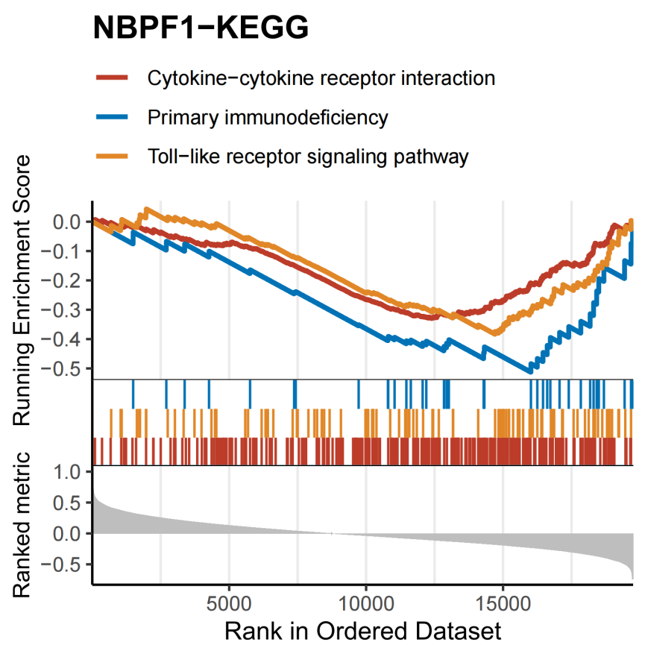
Supplementary Figure 12. GSEA enrichment NBPF1-related signaling pathway in the GEO dataset.
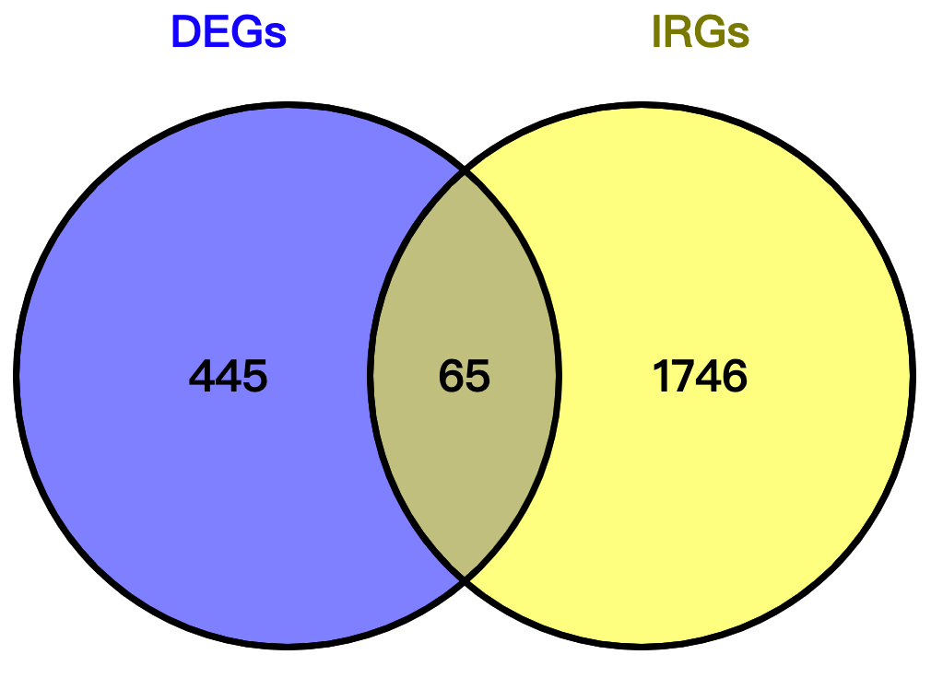
Supplementary Figure 13. Venn diagram for identification of the intersection of the 65 differentially expressed IDEGs.
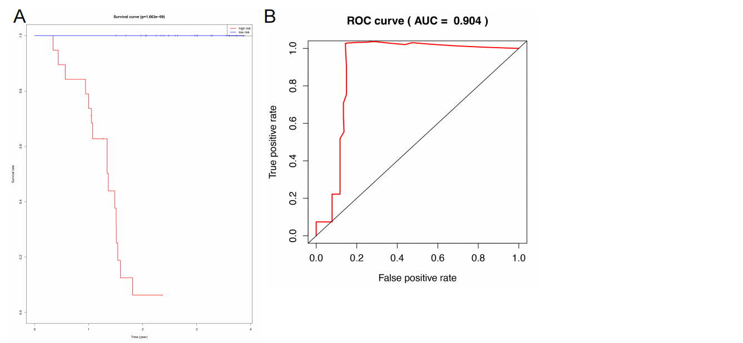

Supplementary Figure 14. Kaplan–Meier curve and ROC curve showing the predictive efficiency of the risk scores for the prognosis of ACC patients in the testing cohort.
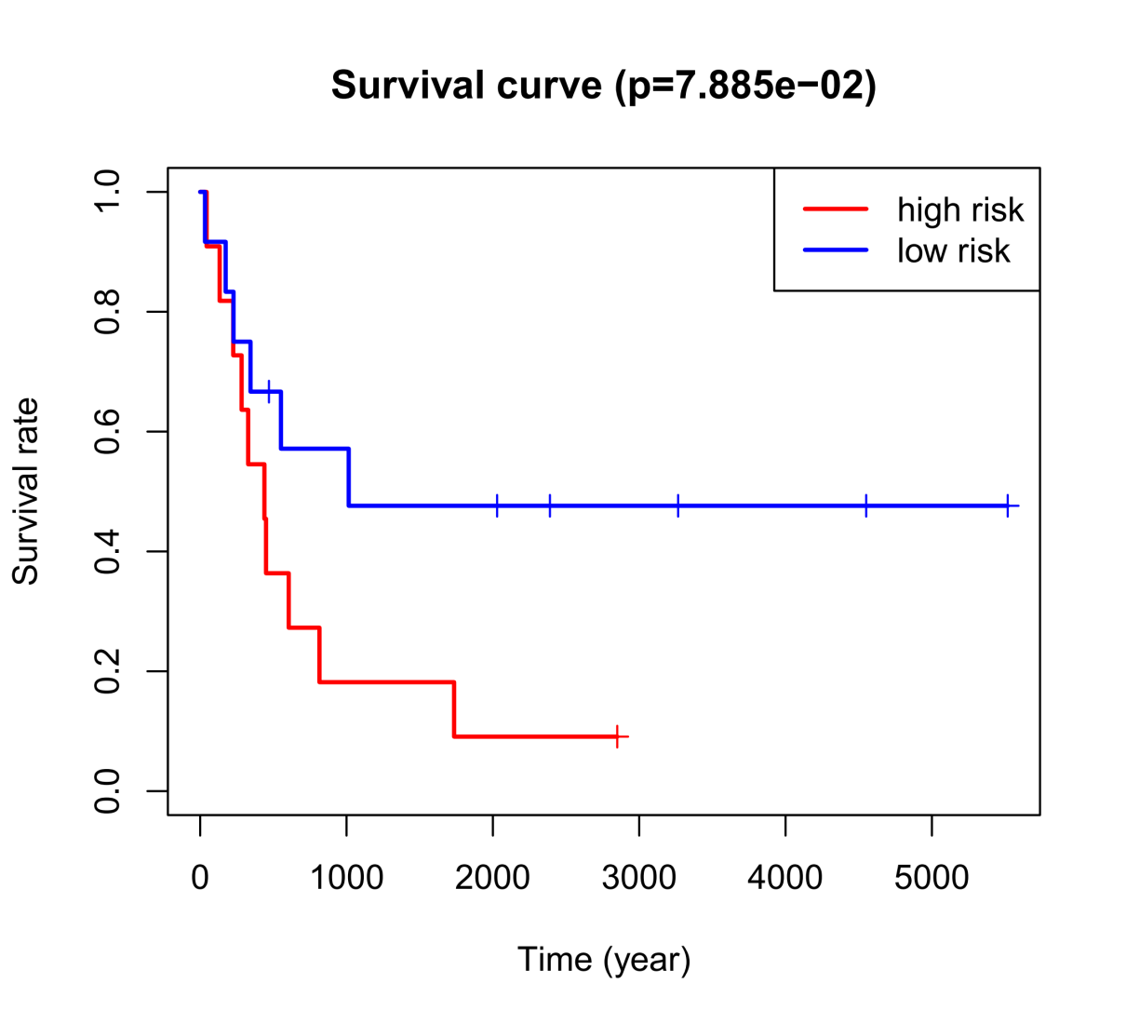
Supplementary Figure 15. Kaplan–Meier survival analysis of OS between high- and low- risk groups in external validation datasets.

Supplementary Tables
Supplementary Table 1. Demographic characteristics of the tumor cohort used in this study

Tumor  (n) | Noncancerous samples  (n) | Gender  (n) |  | Stage  （n） |  |  |  | T  (n) |  |  |  | N  (n) |  |  |  | M  (n)
 |  | Male | Female | Stage I | Stage II | Stage III | Stage IV | T1 | T2 | T3 | T4 | N0 | N1 | N2 | N3 | M0 | M1
BLCA  (408) | 19 | 305 | 109 | 4 | 130 | 142 | 136 | 5 | 119 | 196 | 60 | 239 | 46 | 77 | 8 | 202 | 11
BRCA  (1093) | 112 | / | / | 181 | 619 | 242 | 18 | 277 | 629 | 139 | 35 | 514 | 358 | 116 | 76 | 902 | 20
CESC  (304) | 3 | / | / | / | / | / | / | 140 | 72 | 21 | 10 | 134 | 61 | / | / | 116 | 11
CHOL  (36) | 9 | 16 | 20 | 19 | 9 | 1 | 7 | 19 | 12 | 5 | / | 26 | 5 | / | / | 28 | 5
COAD  (457) | 41 | / | / | 111 | 238 | 184 | 90 | 20 | 111 | 436 | 74 | / | / | / | / | / | /
DLBC  (48) | 0 | 22 | 26 | / | / | / | / | / | / | / | / | / | / | / | / | / | /
ESCA  (184) | 11 | 139 | 23 | 16 | 69 | 49 | 8 | 27 | 37 | 77 | 4 | 66 | 63 | 9 | 6 | 121 | 8
GBM  (153) | 5 | 289 | 239 | / | / | / | / | / | / | / | / | / | / | / | / | / | /
HNSC  (520) | 44 | 368 | 134 | / | / | / | / | 33 | 144 | 131 | 179 | 239 | 80 | 154 | 7 | 472 | 5
KICH  (66) | 25 | 39 | 26 | 20 | 25 | 14 | 6 | 20 | 25 | 18 | 2 | 39 | 3 | 2 | / | 34 | 2
KIRC  (533) | 72 | 186 | 353 | 272 | 59 | 123 | 82 | 278 | 71 | 179 | 11 | 241 | 16 | / | / | 428 | 78
KIRP  (290) | 32 | 212 | 77 | 172 | 22 | 51 | 15 | 193 | 33 | 59 | 2 | 49 | 24 | 4 | / | 95 | 9
LAML  (173) | 0 | 83 | 68 | / | / | / | / | / | / | / | / | / | / | / | / | / | /
LGG  (516) | 0 | 289 | 239 | / | / | / | / | / | / | / | / | / | / | / | / | / | /
LIHC  (371) | 50 | 253 | 121 | 173 | 87 | 85 | 5 | 183 | 95 | 80 | 13 | 254 | 4 | / | / | 268 | 4
LUAD  (515) | 59 | 286 | 249 | 294 | 123 | 84 | 26 | 175 | 289 | 49 | 19 | 348 | 95 | 74 | 2 | 361 | 25
LUSC  (501) | 51 | 371 | 131 | 245 | 162 | 84 | 7 | 114 | 294 | 71 | 23 | 320 | 131 | 40 | 5 | 412 | 7
MESO  (87) | 0 | 71 | 15 | 10 | 16 | 44 | 16 | 14 | 26 | 31 | 13 | 43 | 10 | 26 | 3 | 56 | 3
OV  (303) | 0 | / | / | / | / | / | / | / | / | / | / | / | / | / | / | / | /
PAAD  (178) | 4 | 98 | 80 | 21 | 146 | 3 | 5 | 7 | 24 | 142 | 3 | 50 | 123 | / | / | 79 | 5
PCPG  (179) | 3 | 81 | 102 | / | / | / | / | / | / | / | / | / | / | / | / | / | /
PRAD  (497) | 52 | / | / | / | / | / | / | 0 | 189 | 292 | 11 | 347 | 79 | / | / | 455 | 3
READ  (166) | 10 | 91 | 75 | 30 | 51 | 51 | 24 | 9 | 28 | 113 | 14 | 84 | 45 | 33 | / | 126 | 23
SARC  (259) | 0 | 119 | 144 | / | / | / | / | / | / | / | / | / | / | / | / | / | /
SKCM  (103) | 0 | 292 | 179 | 77 | 140 | 171 | 24 | 41 | 79 | 91 | 153 | 235 | 74 | 49 | 56 | 418 | 25
STAD  (415) | 35 | 241 | 134 | 53 | 111 | 150 | 38 | 19 | 80 | 168 | 100 | 111 | 97 | 75 | 74 | 330 | 25
TGCT  (150) | 0 | / | / | 106 | 12 | 14 | / | 80 | 52 | 6 | / | 51 | 11 | 2 | / | 4 | 51
THCA  (501) | 59 | 139 | 371 | 286 | 52 | 113 | 57 | 143 | 167 | 175 | 23 | 229 | 231 | / | / | 286 | 9
THYM  (120) | 0 | 62 | 57 | / | / | / | / | / | / | / | / | / | / | / | / | / | /
UCEC  (545) | 35 | / | / | / | / | / | / | / | / | / | / | / | / | / | / | / | /
UCS  (57) | 0 | / | / | / | / | / | / | / | / | / | / | / | / | / | / | / | /
UVM  (80) | 0 | 45 | 35 | / | 39 | 36 | 4 | 14 | 32 | 34 | 51 | / | / | / | / | 4 | 52

Supplementary Table 2. TCGA ACC patient characteristics.
Clinical characteristics |  | Total (79)
Age | <55 | 50
 | ≥55 | 29
Gender | Female | 31
 | Male | 48
Pathologic stage | Stage I | 9
 | Stage II | 37
 | Stage III | 16
 | Stage IV | 15
T | T1 | 9
 | T2 | 42
 | T3 | 8
 | T4 | 18
N | N0 | 68
 | N1 | 9
 | N2 | /
 | N3 | /
M | M0 | 62
 | M1 | 15
Mitotane therapy | No | 26
 | Yes | 49
Mitotic response rate | Mitotic rate>5/50 HPF absent | 29
 | Mitotic rate>5/50 HPF present | 41
Adrennal hormone history | Androgen | 6
 | Androgen/cortisol | 10
 | Cortisol | 8
 | Estrogen | 2
 | Mineralocorticoids | 2
Therapy outcome | Complete remission/response | 46
 | Partial remission/response | 1
 | Progressive disease | 18
 | Stable disease | 2
Residual tumor | R0 | 53
 | R1 | 5
 | R2 | 9
 | RX | 6
Supplementary Table 3.
Description | SetSize | EnrichmentScore | NES | pvalue | p.adjust | qvalues | Rank | Leading_edge
KEGG_CYTOKINE_CYTOKINE_RECEPTOR_INTERACTION | 250 | -0.33165178 | -1.662226821 | 0.001449275 | 0.031372549 | 0.024408848 | 5538 | tags=51%, list=28%, signal=37%
KEGG_LYSOSOME | 116 | -0.371821733 | -1.664202176 | 0.00155521 | 0.031372549 | 0.024408848 | 2969 | tags=29%, list=15%, signal=25%
KEGG_TOLL_LIKE_RECEPTOR_SIGNALING_PATHWAY | 97 | -0.37886444 | -1.660429169 | 0.001560062 | 0.031372549 | 0.024408848 | 5042 | tags=41%, list=26%, signal=31%
KEGG_HEMATOPOIETIC_CELL_LINEAGE | 83 | -0.413625802 | -1.762677661 | 0.0015625 | 0.031372549 | 0.024408848 | 6268 | tags=52%, list=32%, signal=36%
KEGG_OXIDATIVE_PHOSPHORYLATION | 117 | -0.407793259 | -1.825484034 | 0.001567398 | 0.031372549 | 0.024408848 | 2700 | tags=32%, list=14%, signal=28%
KEGG_GRAFT_VERSUS_HOST_DISEASE | 35 | -0.60011503 | -2.149917638 | 0.001628664 | 0.031372549 | 0.024408848 | 6137 | tags=69%, list=31%, signal=47%
KEGG_ALLOGRAFT_REJECTION | 33 | -0.617172228 | -2.167696792 | 0.001636661 | 0.031372549 | 0.024408848 | 6137 | tags=70%, list=31%, signal=48%
KEGG_AUTOIMMUNE_THYROID_DISEASE | 46 | -0.488507028 | -1.857794371 | 0.001652893 | 0.031372549 | 0.024408848 | 5756 | tags=70%, list=29%, signal=49%
KEGG_INTESTINAL_IMMUNE_NETWORK_FOR_IGA_PRODUCTION | 44 | -0.494678528 | -1.854323893 | 0.001672241 | 0.031372549 | 0.024408848 | 6137 | tags=55%, list=31%, signal=38%
KEGG_STEROID_BIOSYNTHESIS | 16 | 0.766246577 | 2.282919458 | 0.002352941 | 0.031372549 | 0.024408848 | 1936 | tags=69%, list=10%, signal=62%
KEGG_TERPENOID_BACKBONE_BIOSYNTHESIS | 15 | 0.730322721 | 2.124168161 | 0.002364066 | 0.031372549 | 0.024408848 | 3783 | tags=73%, list=19%, signal=59%
KEGG_PROPANOATE_METABOLISM | 31 | 0.620448729 | 2.287829681 | 0.002427184 | 0.031372549 | 0.024408848 | 3165 | tags=58%, list=16%, signal=49%
KEGG_VALINE_LEUCINE_AND_ISOLEUCINE_DEGRADATION | 43 | 0.56646885 | 2.206224619 | 0.00245098 | 0.031372549 | 0.024408848 | 3317 | tags=53%, list=17%, signal=45%
KEGG_PYRUVATE_METABOLISM | 40 | 0.5921999 | 2.269450574 | 0.0025 | 0.031372549 | 0.024408848 | 3110 | tags=50%, list=16%, signal=42%
KEGG_PEROXISOME | 77 | 0.418263799 | 1.860883177 | 0.002557545 | 0.031372549 | 0.024408848 | 3725 | tags=43%, list=19%, signal=35%
KEGG_PRIMARY_IMMUNODEFICIENCY | 35 | -0.493380357 | -1.767539689 | 0.003257329 | 0.037459283 | 0.029144523 | 3734 | tags=43%, list=19%, signal=35%
KEGG_CIRCADIAN_RHYTHM_MAMMAL | 11 | 0.759723385 | 2.062227909 | 0.004705882 | 0.046543002 | 0.036211946 | 517 | tags=36%, list=3%, signal=35%
KEGG_TYPE_I_DIABETES_MELLITUS | 39 | -0.495390167 | -1.824874013 | 0.004893964 | 0.046543002 | 0.036211946 | 6137 | tags=64%, list=31%, signal=44%
KEGG_FATTY_ACID_METABOLISM | 40 | 0.466939003 | 1.789421087 | 0.005 | 0.046543002 | 0.036211946 | 2904 | tags=40%, list=15%, signal=34%
KEGG_ASTHMA | 26 | -0.537536868 | -1.792135266 | 0.005059022 | 0.046543002 | 0.036211946 | 8027 | tags=69%, list=41%, signal=41%

