Supplementary Material

# Supplementary Figures

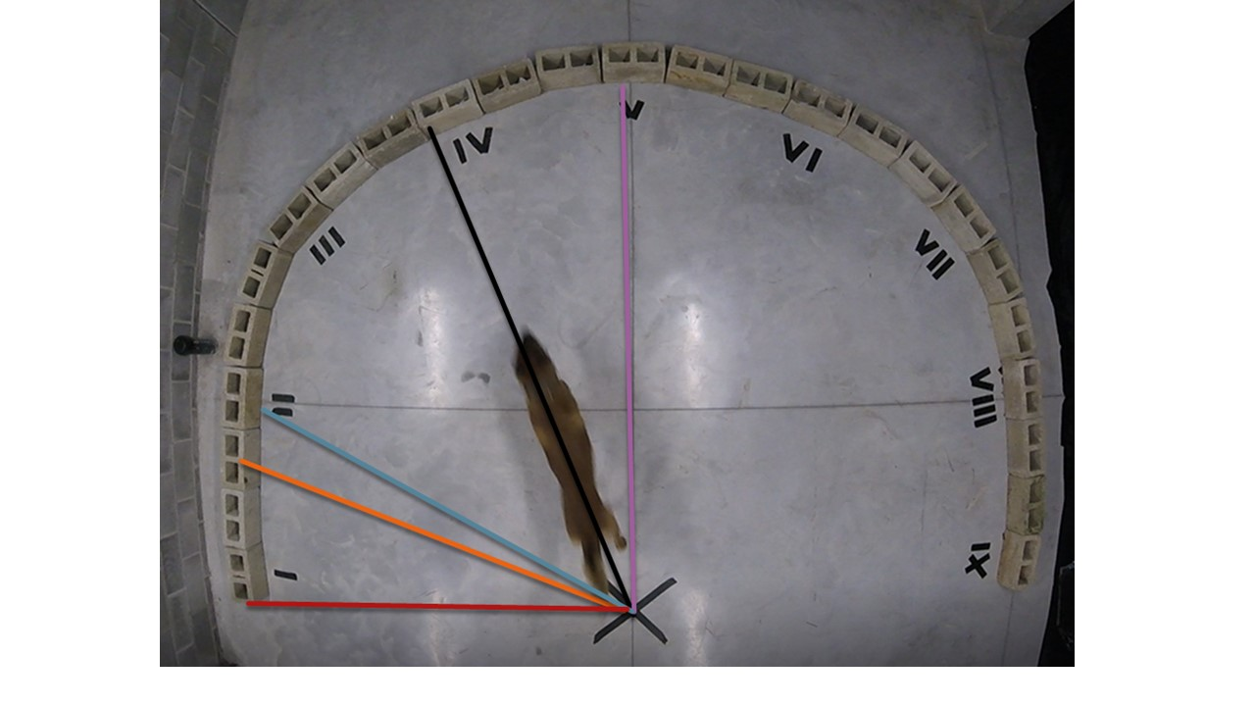

Supplementary Figure 1 Illustration of the starting angles of dogs in the arena during the quantitative MAP. The position of the target odour of this trial is II. The black line is the initial direction of this dog when this trial began. The position of the target odour of the previous trial was V. The orange line is the dog’s initial direction at the previous trial. The Zero angle is measured between the black line and the red line. The Target angle is the angle between the black line and the blue line. The Previous angle is between the black line and the orange line. The Previous Target angle is between the black line and the purple line.

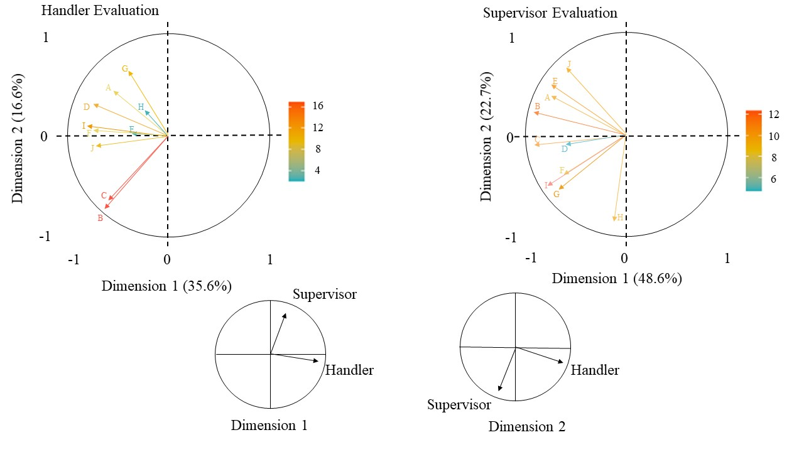

**Supplementary Figure 2 Coinertia analyses of the two evaluation from dogs’ handlers and supervisors**. The two above cycle are the correlation plot generated by the PCA analyses of dog handler’s evaluation (right circle) and supervisor evaluation (left). Each criteria of evaluation are represented by the Letters in these two cercles (A: Rapidity; B: Strategy; C: Strategy