Immunomodulatory role of Surfactant Protein-D in a Transgenic Adenocarcinoma of Mouse Prostate (TRAMP) model
Kasturi Ganguly¹, Uday Kishore^{2,3}, Siddhanath M Metkari⁴, Taruna Madan^{1*}

Supplementary Figures

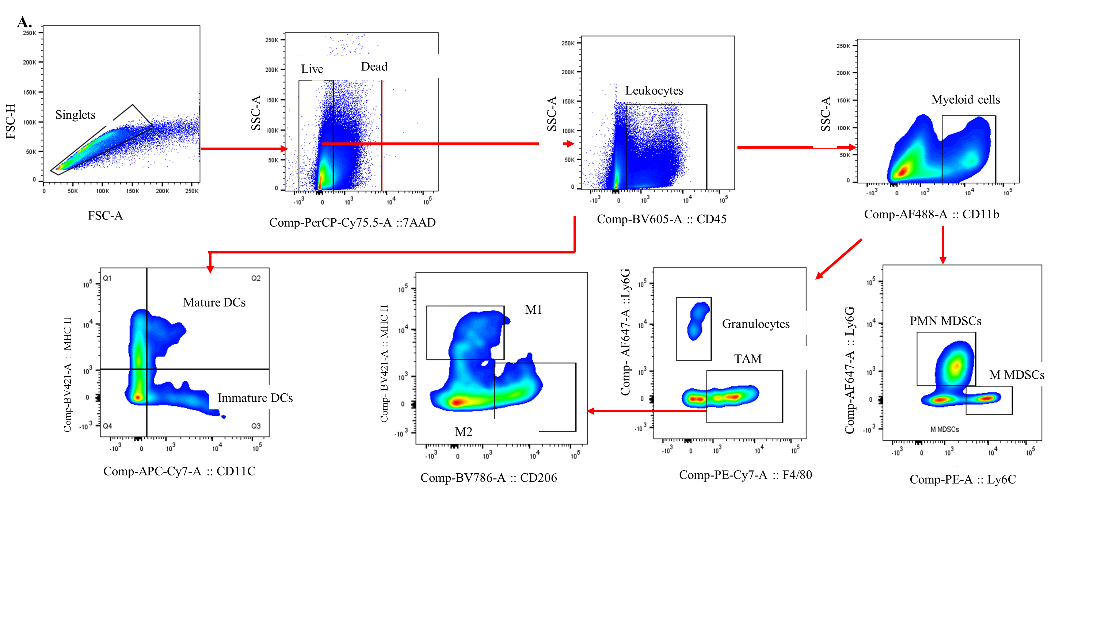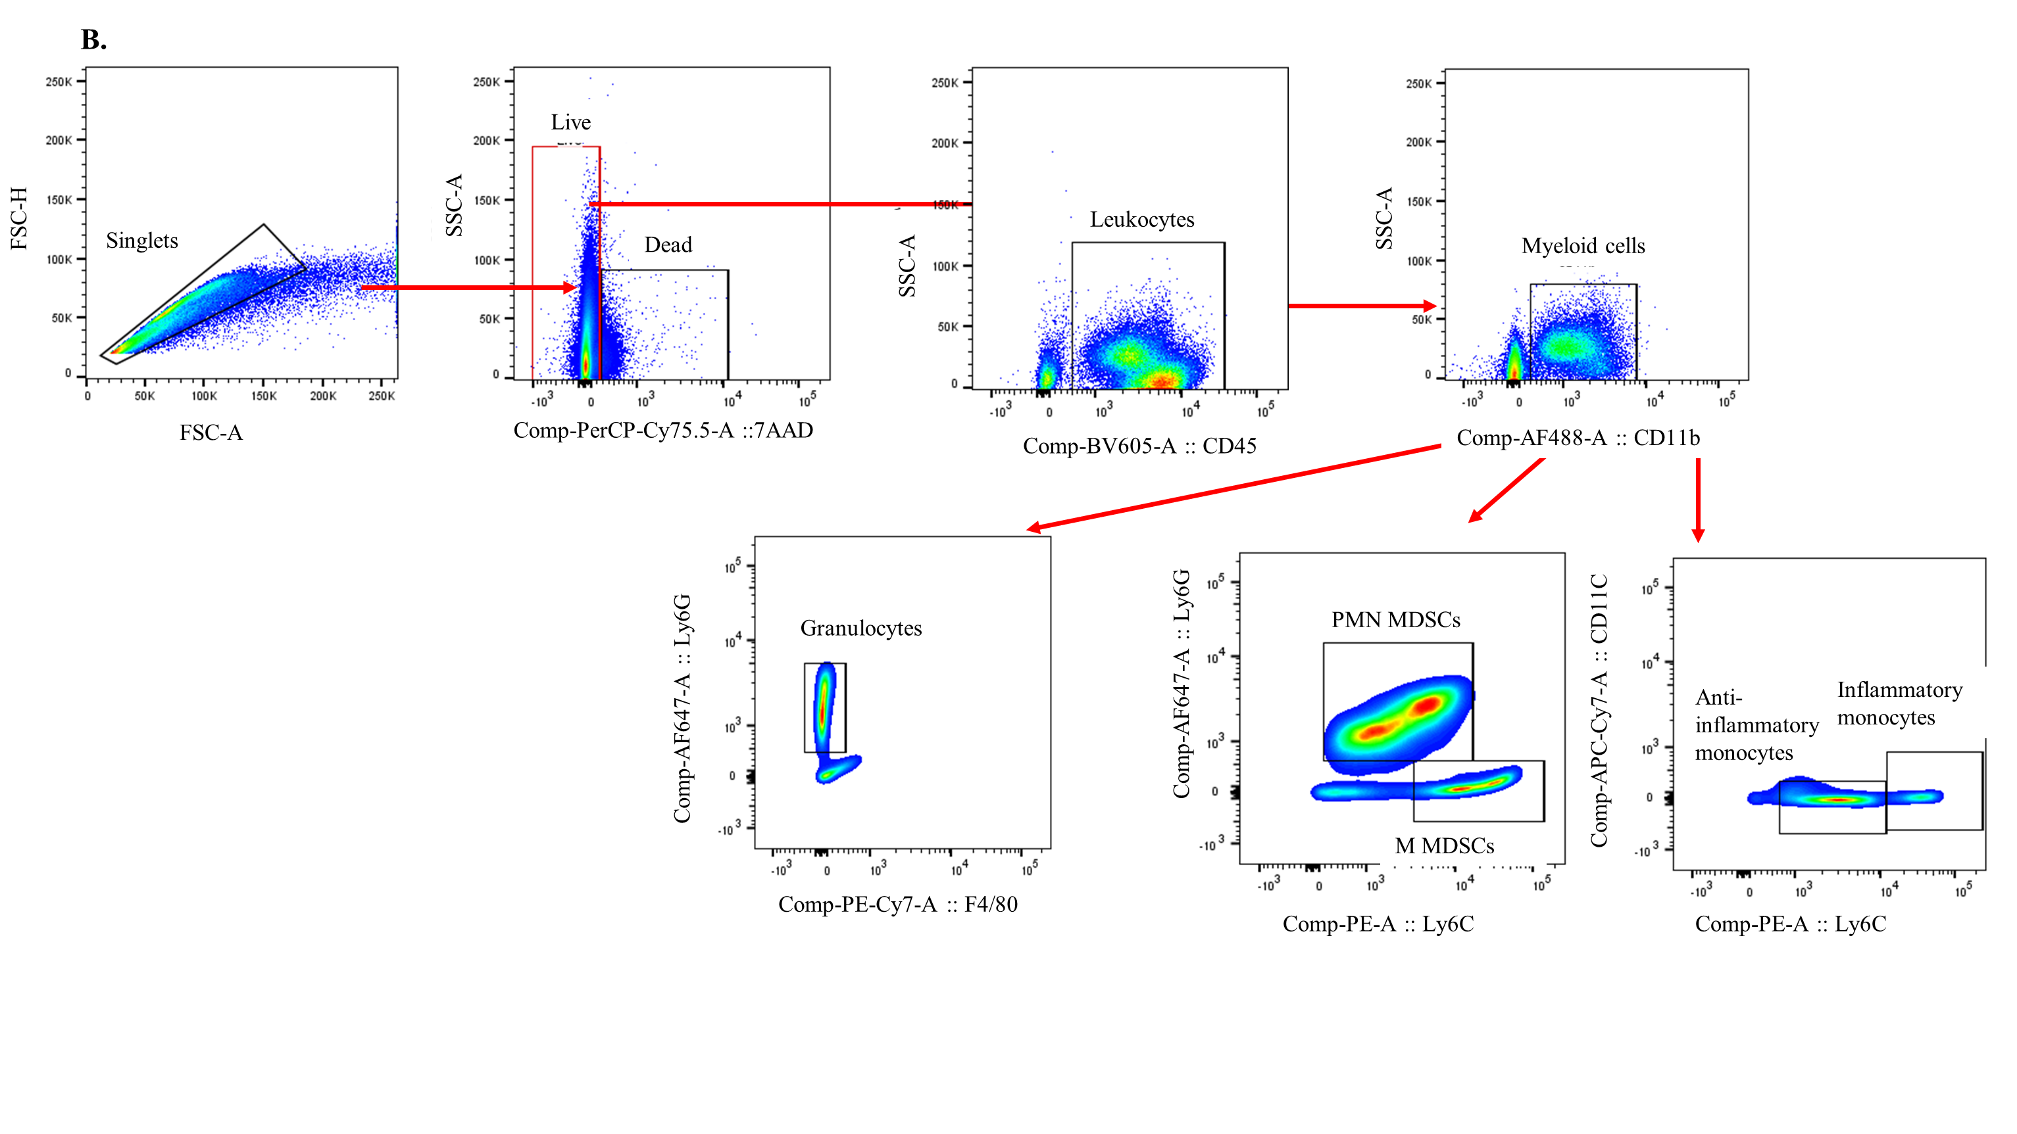

Figure S1: Flow cytometric gating strategy for (A) tumour-residing and (B) circulatory immune cells. For all the flow cytometric analyses, initial gating was performed on singlets, live cells, and CD45+ cells, followed by antigens of interest. FSC-A = Forward Scatter-Area, FSC-H = Forward Scatter-Height, SSC-A = Side Scatter-Area.

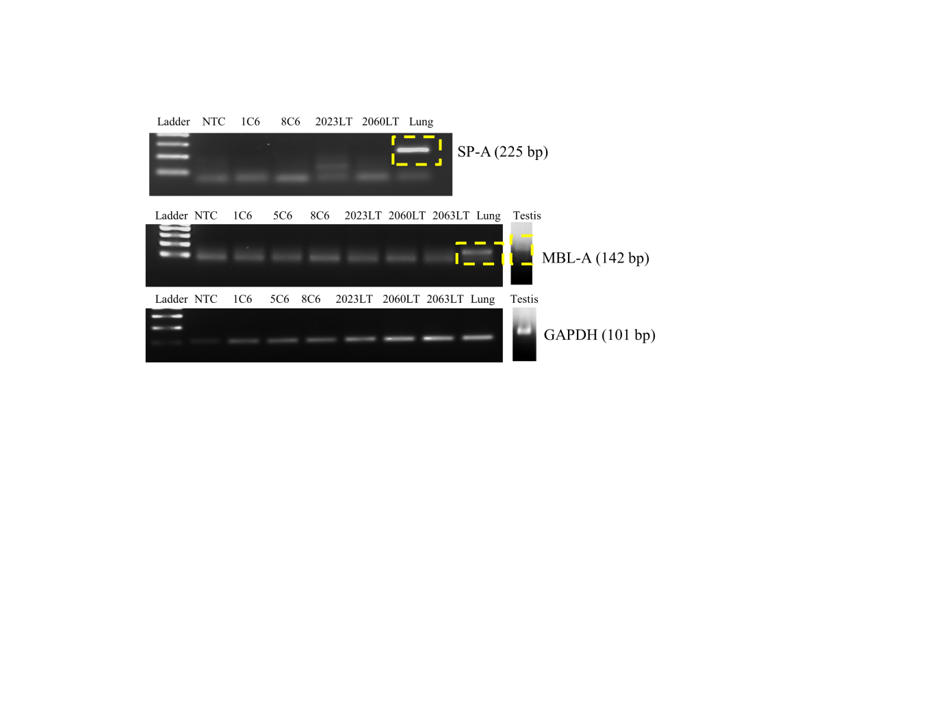
Figure S2: Visualization of RT-qPCR amplified transcripts of SP-A and MBL on 2% agarose gel. The positive controls i.e cDNA of murine lung tissue showed PCR amplified SP-A transcript at 225 base pairs and cDNA of murine testis and lung showed PCR amplified MBL-A transcript at 142 base pairs. Whereas, the control and TRAMP prostate tissue cDNAs didn’t show any specific PCR amplified SP-A or MBL-A transcript products under the same amplification conditions. GAPDH was used as an endogenous control gene for the RT-qPCR. C6: 6M Control mice; LT: Late TRAMP; 1C6: 6M Control mice no. 1; 5C6: 6M Control mice no. 5; 8C6: 6M Control mice no. 8; 2023LT: Late TRAMP mice no. 2023; 2060 LT: Late TRAMP mice no. 2060; 2063 LT: Late TRAMP mice no. 2063.
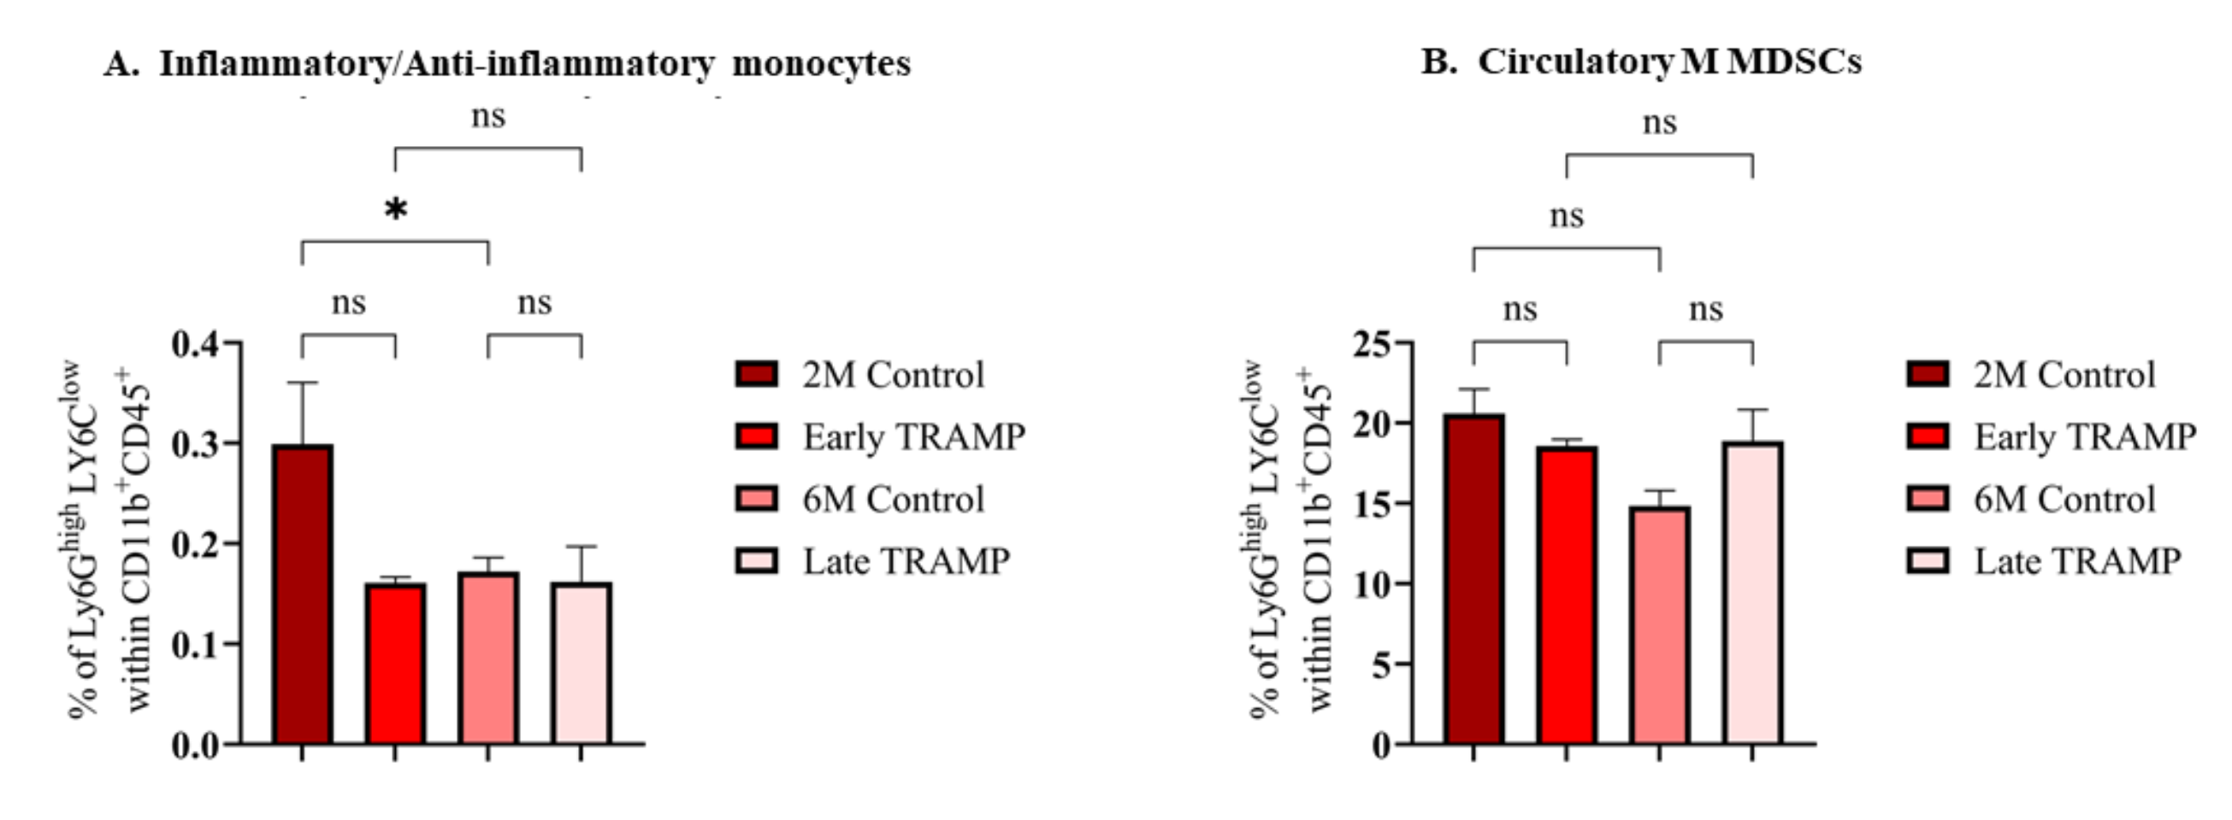

Figure S3: Flow cytometric analysis of the (A) ratio of inflammatory/anti-inflammatory monocytes and (B) Monocytic MDSCs (M-MDSCs) in circulation of the control and TRAMP mice. Data are represented as mean ± SEM. Statistical significance was determined using one-way ANOVA followed by Tukey's multiple comparisons test, ns: Non-significant.

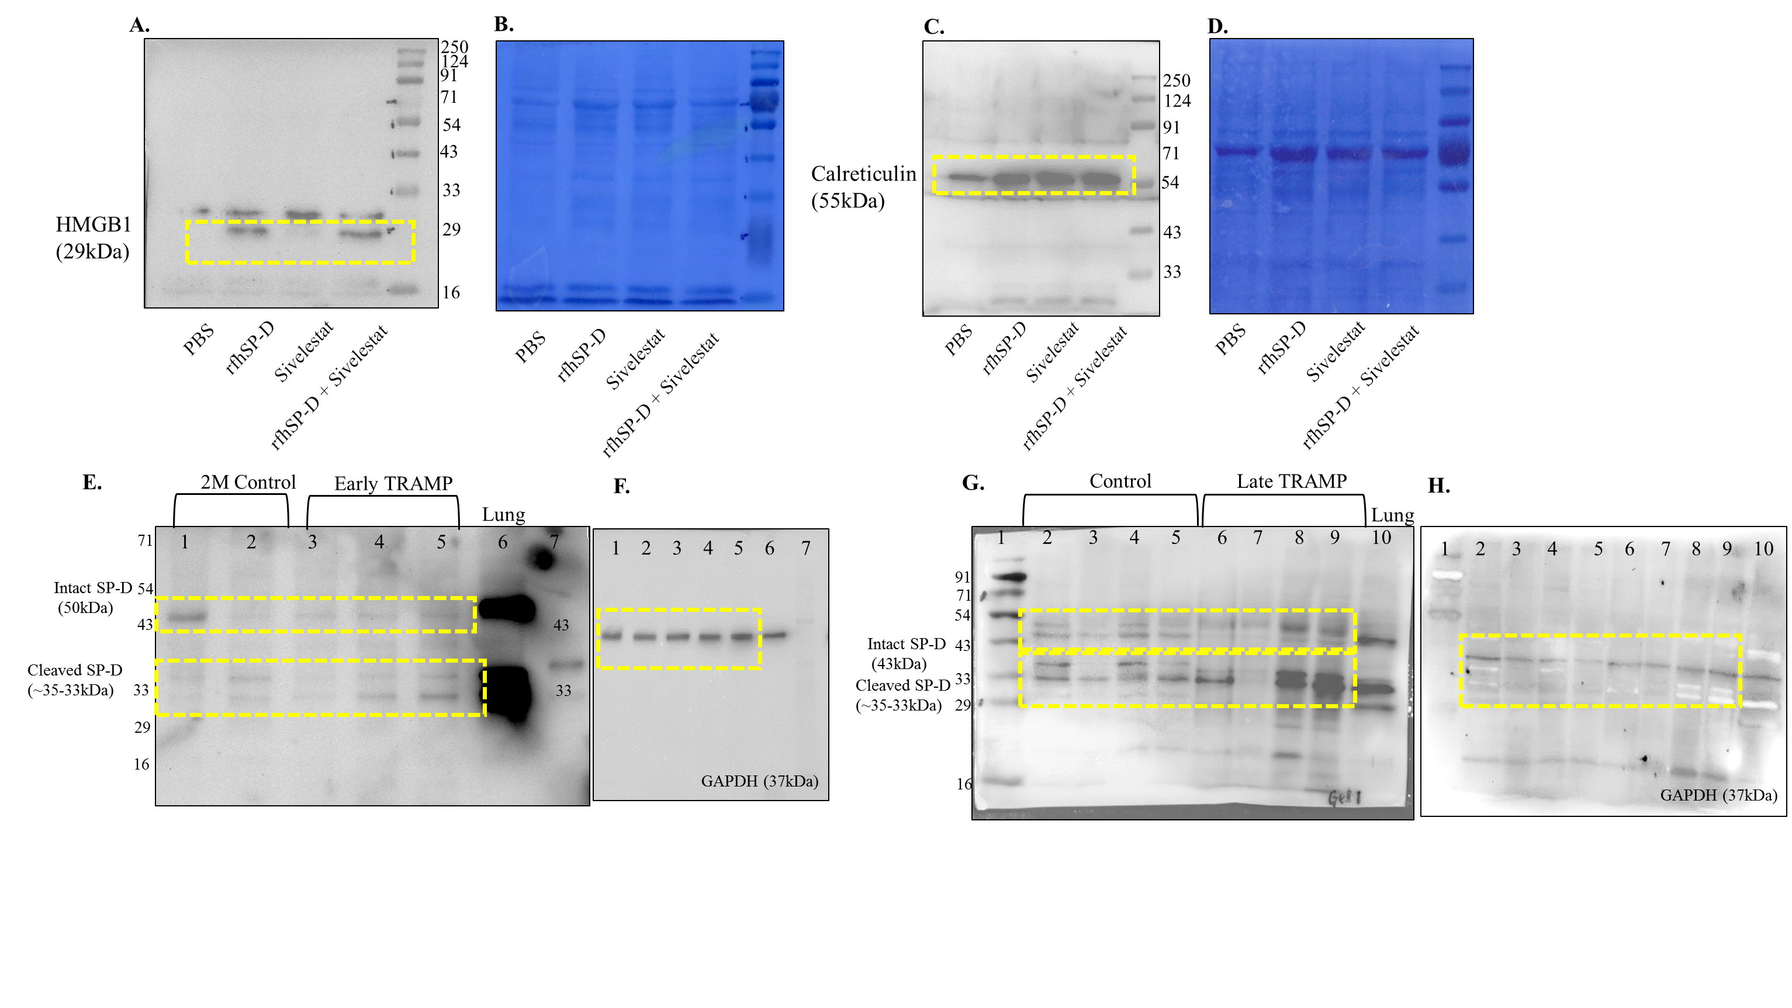

Figure S4: Representative uncropped images of western blots. Uncropped images of western blots from Figure 8B and 8C representing HMGB1 and Calreticulin with their respective CBB staining. (A-D). Uncropped images of the western blots from Figure 3A and 3B representing SP-D staining in the Early TRAMP (E) and Late TRAMP (G) with their respective GAPDH staining (F, H). Lung tissue were used as a positive control for SP-D (Lane 6 of E; Lane 10 of G). Yellow boxes represent the cropped images displayed in main manuscript.

