Supplementary Material

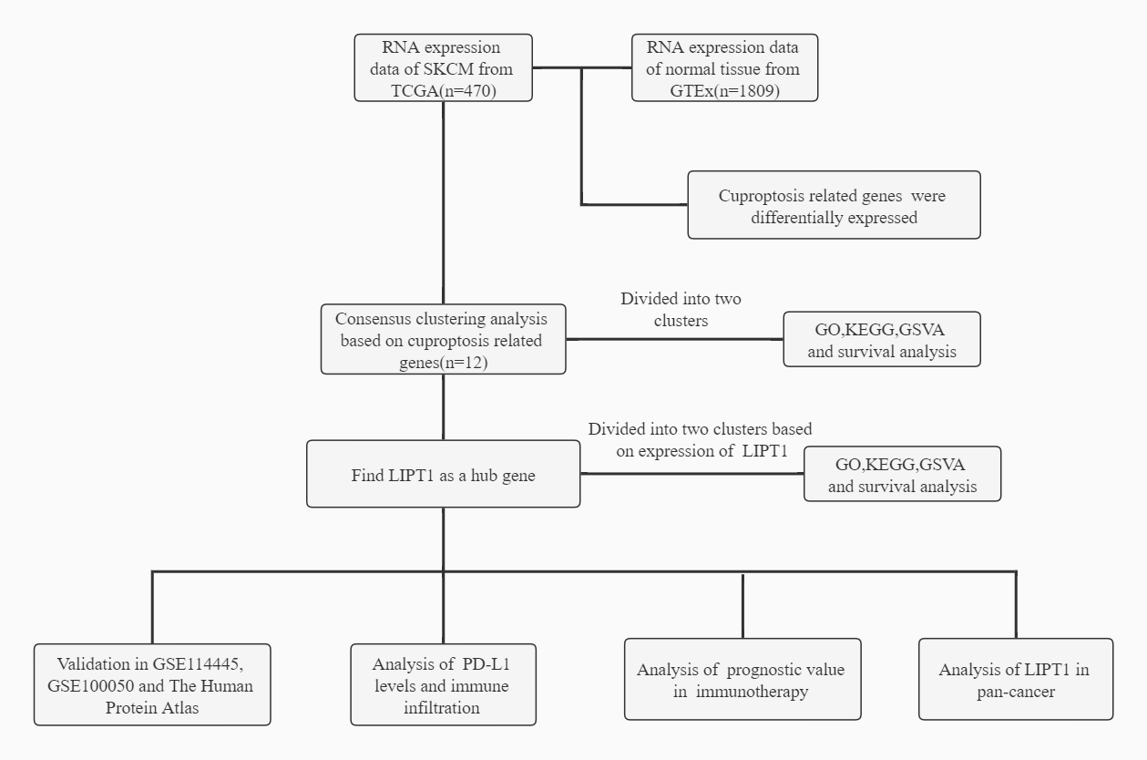

**Supplementary Figure 1.** Schematic depicting our study design.

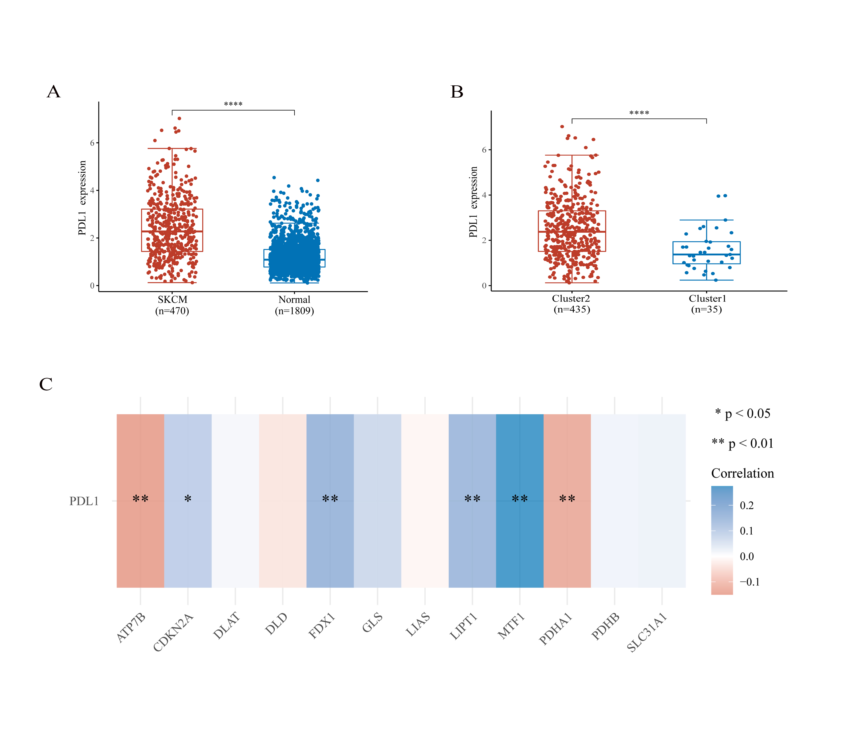

**Supplementary Figure 2.** Correlation between PD-L1 and cuproptosis related genes in Skin Cutaneous Melanoma (SKCM). (A,B) The expression level of PD-L1 in SKCM/normal group (A) and cluster 1/2 (B) in SKCM. (C) The correlation of PD-L1 with cuproptosis related genes in the SKCM.

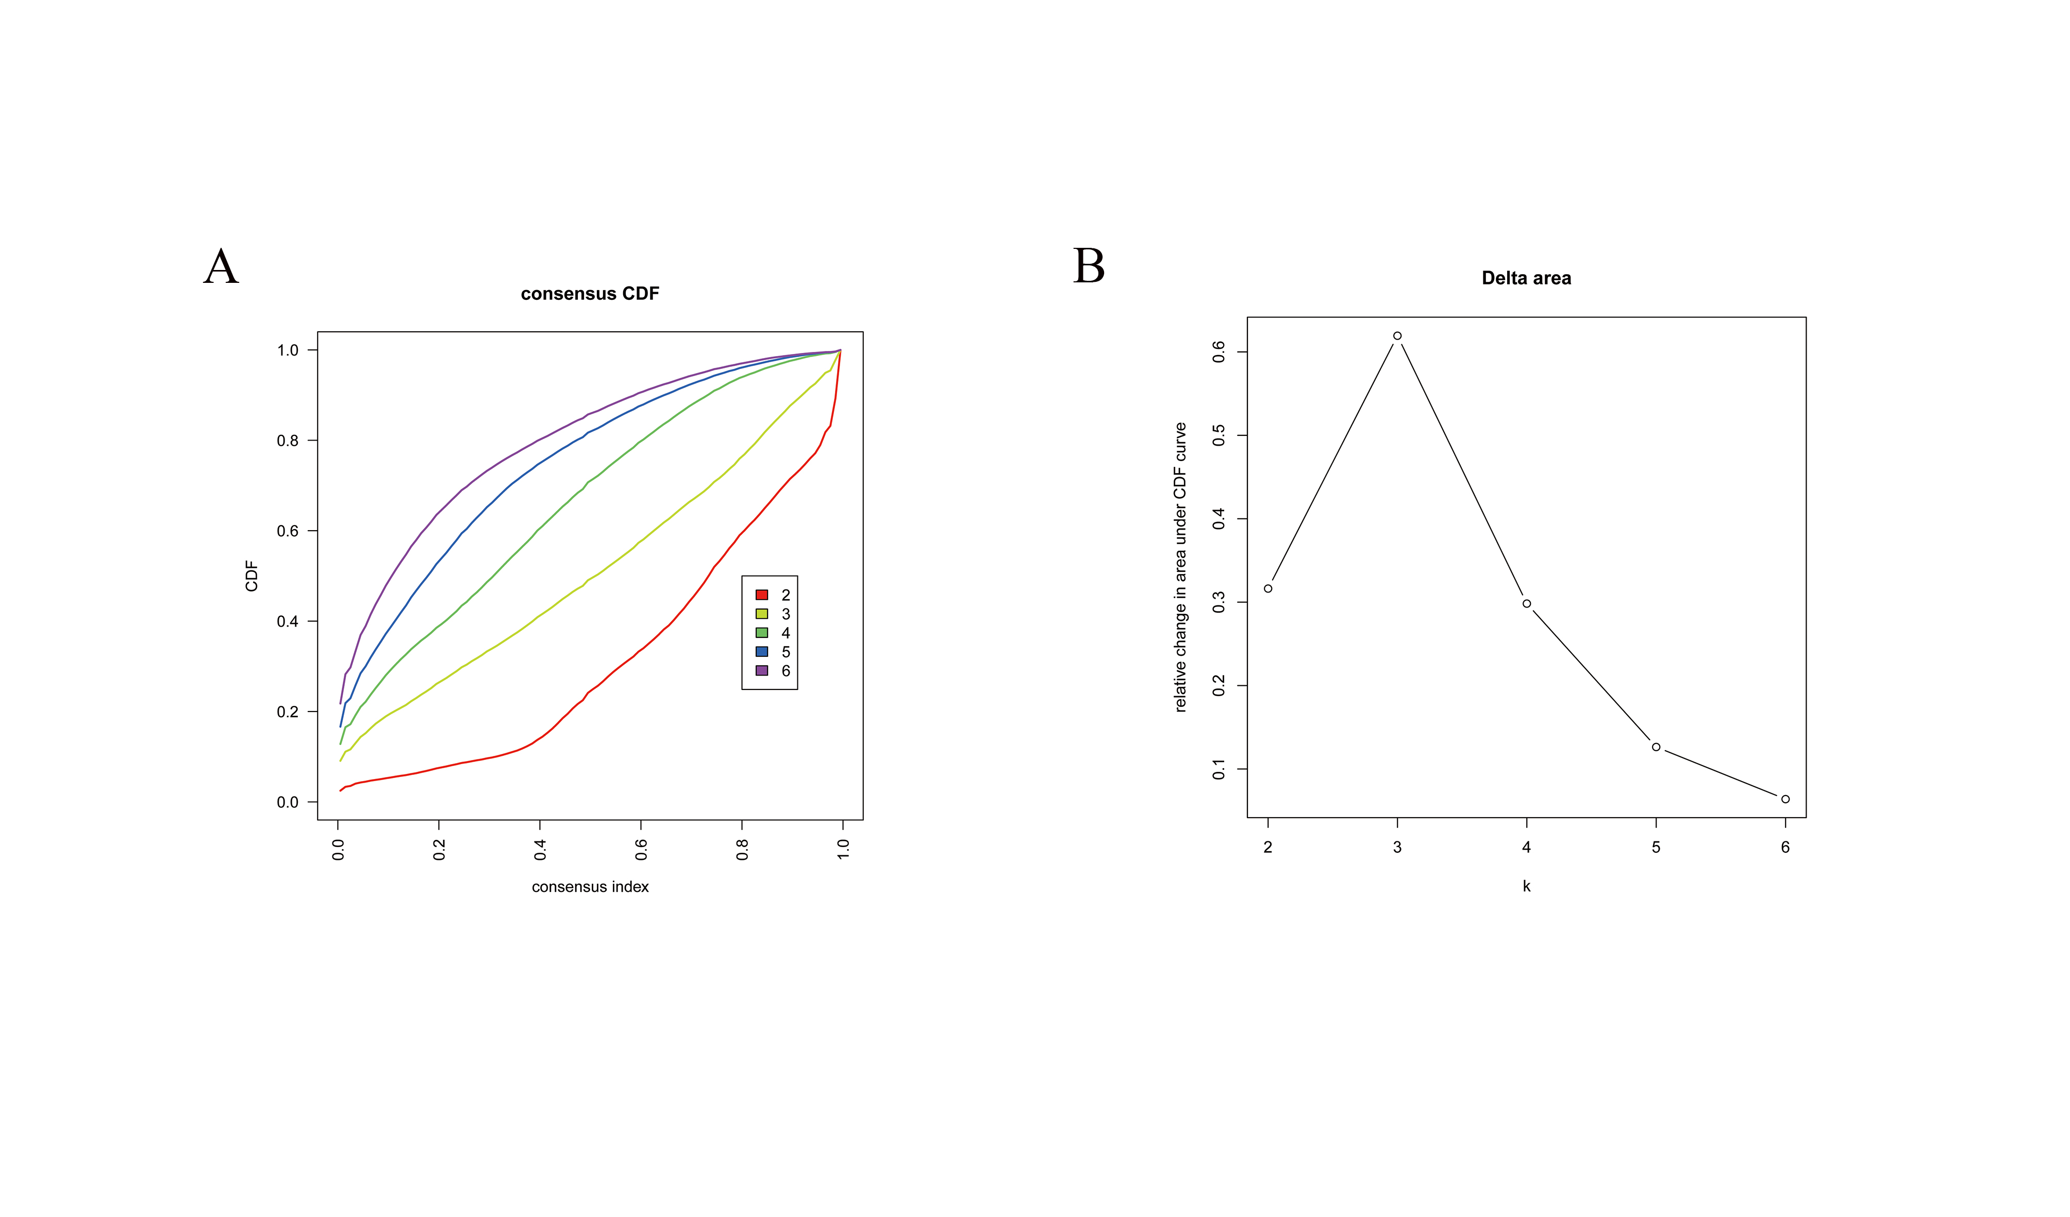

**Supplementary Figure 3**. Consensus clustering applied on cuproptosis related genes. (A,B) Cumulative distribution function curves for k=2–6.