Supplementary Materials

Supplementary Table 1: Genes where Fold Change > 1.5 between Condition and Intact for any Condition

 | Fold Change
 | OA |  |  | RA
 | Lib / Intact | LibFlavo / Intact | SubA / Intact | Lib / Intact | LibFlavo / Intact | SubA / Intact
CXCL8 | 4.12 | 0.30 | 0.62 | 1.99 | -0.54 | -1.15
IL1B | 3.77 | -0.24 | 0.32 | 2.32 | -0.01 | -0.48
CH25H | 2.20 | -1.37 | -0.88 | 1.71 | -1.14 | -1.37
CXCL5 | 2.13 | 0.08 | 0.04 | 1.23 | 0.82 | 0.28
DUSP2 | 1.81 | 0.10 | -0.48 | 0.57 | -1.17 | -1.24
CXCL3 | 1.75 | -0.82 | -0.07 | 1.66 | -0.32 | -0.69
PTGS2 | 1.74 | -0.71 | 0.01 | 0.52 | -1.36 | -0.38
CXCL2 | 1.73 | -1.22 | -0.37 | 0.63 | -1.84 | -1.22
AREG | 1.65 | -1.27 | -0.77 | 2.30 | -1.03 | -0.82
ATF3 | 1.65 | -0.79 | -1.03 | 0.65 | -1.76 | -1.92
AHSP | 1.56 | -0.96 | -1.67 | 0.00 | 0.01 | 0.00
CD83 | 1.48 | 0.15 | 0.68 | 0.48 | -0.31 | -1.15
CD300E | 1.44 | 1.00 | 1.91 | 0.24 | 0.43 | -0.16
SLC16A6 | 1.35 | 0.22 | 1.60 | -0.78 | -1.24 | -0.36
SLC46A2 | 1.34 | 0.46 | 1.85 | -1.14 | -0.59 | 0.06
S100A12 | 1.34 | 1.79 | 0.04 | 0.57 | 0.39 | 1.10
GPR183 | 1.33 | 0.50 | 0.07 | 0.67 | -0.36 | -0.62
CCL7 | 1.30 | 1.60 | 2.78 | -0.44 | -1.62 | -2.83
RGS1 | 1.25 | 0.02 | 0.39 | 0.58 | -1.05 | -1.23
CYTIP | 1.21 | 0.65 | 1.20 | 0.35 | 0.83 | -0.13
BMP2K | 1.20 | 0.17 | 0.92 | -0.94 | -1.32 | -0.10
TLR8 | 1.18 | 0.35 | 1.41 | -0.31 | -0.18 | 0.08
NCEH1 | 1.14 | 0.18 | 1.40 | -1.09 | -1.33 | 0.20
CD28 | 1.14 | -0.45 | 1.11 | -0.79 | -1.05 | -1.04
KCNA3 | 1.12 | 0.37 | 0.80 | 1.62 | 0.96 | 0.78
LYZ | 1.12 | 0.38 | 1.33 | 0.39 | -0.21 | 0.46
DMXL2 | 1.12 | 0.11 | 0.93 | -0.67 | -1.21 | 0.14
TNFAIP3 | 1.11 | -0.63 | -0.14 | 1.17 | -1.11 | -0.97
CTSS | 1.08 | 0.35 | 1.15 | -0.70 | -0.49 | 0.35
RNASE2 | 1.06 | 0.34 | 0.87 | -0.31 | -0.83 | 0.23
CLEC5A | 1.03 | 0.41 | 0.86 | 1.00 | 0.36 | 0.37
CYBB | 1.03 | 0.20 | 1.14 | -1.04 | -0.79 | 0.31
OLR1 | 1.01 | 0.11 | 1.34 | -0.75 | -0.96 | 0.25
OSM | 1.01 | 0.06 | 0.28 | -0.76 | -1.74 | -0.84
SUCNR1 | 1.00 | 0.23 | 1.10 | -0.79 | -1.13 | -0.52
MCEMP1 | 1.00 | 0.40 | 1.34 | 0.98 | 0.57 | 1.32
CLEC4E | 0.95 | 0.08 | 0.22 | -0.28 | -0.77 | -1.23
ZNF460 | 0.94 | 0.30 | 0.34 | 0.27 | -0.44 | 0.46
ARC | 0.93 | -1.50 | -0.52 | 0.56 | -0.71 | -0.40
BCL2A1 | 0.92 | -0.10 | -0.37 | -0.08 | -0.35 | -0.80
DUSP5 | 0.91 | -0.85 | -0.74 | -1.15 | -1.61 | -0.82
FCN1 | 0.90 | 1.34 | 0.60 | 0.91 | 0.82 | 1.05
NLRP3 | 0.88 | 0.06 | 0.65 | 0.40 | -0.26 | -0.04
PIK3AP1 | 0.87 | 0.05 | 0.97 | -1.06 | -1.26 | -0.16
FPR3 | 0.87 | 0.15 | 0.93 | -0.71 | -0.54 | 0.00
AQP9 | 0.86 | 0.04 | 1.45 | -0.14 | -0.41 | -0.39
ENHO | 0.85 | 0.50 | 0.52 | 1.48 | 0.68 | 1.67
PTPRC | 0.85 | 0.27 | 0.82 | -0.28 | -0.31 | -0.26
CCDC88A | 0.85 | -0.02 | 0.79 | -0.72 | -1.16 | -0.64
CX3CR1 | 0.85 | 0.22 | -0.04 | 0.77 | -0.29 | 1.49
EVI2B | 0.85 | 0.28 | 1.02 | -0.93 | -0.95 | -0.41
CD84 | 0.84 | -0.04 | 1.20 | -0.93 | -1.22 | -0.46
NOD2 | 0.84 | -0.16 | 0.66 | -1.23 | -1.14 | -0.39
TCHH | 0.84 | -0.73 | 1.01 | -0.84 | -1.24 | -0.47
EREG | 0.84 | 0.33 | -0.10 | 0.85 | -0.56 | 0.18
MTRNR2L1 | 0.84 | 1.43 | 0.33 | 0.61 | 0.36 | 0.52
P2RY1 | 0.84 | -0.46 | 1.35 | -0.68 | -1.40 | -0.25
S100A9 | 0.83 | 0.09 | 0.97 | 0.20 | -0.16 | 0.77
ALDH1A1 | 0.82 | 0.19 | 0.84 | -0.94 | -1.17 | 0.38
SORL1 | 0.82 | -0.26 | 1.17 | -0.58 | -0.45 | 0.29
MSR1 | 0.81 | 0.03 | 0.93 | -1.12 | -0.94 | -0.06
STARD4 | 0.81 | -0.19 | 1.24 | -1.47 | -1.77 | -0.83
CD163 | 0.81 | -0.26 | 1.27 | -1.51 | -1.87 | -0.04
TLR7 | 0.81 | -0.13 | 1.13 | -1.87 | -2.11 | -0.11
PMAIP1 | 0.80 | -0.86 | -1.29 | 0.60 | -0.48 | -1.10
SOCS1 | 0.80 | -0.97 | -1.54 | 0.60 | -0.90 | -1.13
SIGLEC10 | 0.79 | 0.18 | 1.10 | -0.82 | -0.05 | 0.10
CCR5 | 0.79 | -0.09 | 1.15 | -0.36 | -0.19 | 0.16
CD1E | 0.78 | 0.14 | -0.69 | 0.14 | -0.45 | -0.15
ALG10 | 0.77 | -0.38 | 0.46 | -0.12 | -0.47 | 0.38
TM6SF1 | 0.76 | -0.20 | 0.73 | -0.86 | -0.80 | 0.31
IKZF1 | 0.76 | 0.11 | 0.80 | -0.17 | -0.47 | -0.08
LIPA | 0.76 | -0.01 | 0.99 | -0.73 | -1.52 | -0.51
MPEG1 | 0.75 | -0.34 | 0.77 | -0.33 | -0.58 | 0.59
TRIM58 | 0.75 | -0.15 | 0.84 | -1.08 | -1.21 | 0.00
ITLN1 | 0.74 | -0.07 | 1.37 | 0.38 | -0.32 | 0.71
HLA-DQA1 | 0.74 | 0.25 | 0.73 | -0.20 | -0.85 | -0.74
DOCK2 | 0.73 | -0.16 | 0.66 | -0.93 | -0.65 | -0.05
FCGR3A | 0.73 | -0.12 | 0.96 | -0.44 | -0.57 | 0.56
TLR4 | 0.73 | -0.26 | 0.88 | -0.88 | -1.07 | 0.35
LILRB4 | 0.73 | -0.43 | 0.87 | -0.90 | -1.16 | 0.04
ARHGAP18 | 0.72 | -0.19 | 0.61 | -1.37 | -1.51 | -0.45
LYN | 0.72 | -0.11 | 0.42 | -0.99 | -0.94 | -0.26
L1TD1 | 0.72 | 0.15 | 1.62 | -0.85 | -0.38 | 0.25
ITGAV | 0.70 | -0.05 | 0.49 | -0.99 | -1.23 | -0.82
TNFSF8 | 0.70 | 0.08 | 0.68 | -0.63 | -0.22 | 0.06
REL | 0.70 | 0.00 | 0.41 | -0.06 | -0.54 | 0.19
CD180 | 0.69 | -0.12 | 1.14 | -1.27 | -1.95 | 0.28
OTULINL | 0.69 | -0.30 | 0.74 | -0.52 | -0.40 | 0.32
RBM47 | 0.69 | -0.25 | 0.74 | -1.15 | -1.49 | -0.51
TIMD4 | 0.68 | -0.48 | 0.78 | 0.31 | -0.01 | 0.75
ITGAM | 0.68 | -0.26 | 0.70 | -0.65 | -0.56 | 0.28
SDS | 0.68 | -0.76 | -0.10 | -0.69 | -1.71 | -1.28
SRGN | 0.67 | 0.22 | 0.64 | -0.39 | -0.20 | -0.44
CCR1 | 0.66 | -0.08 | 0.90 | -1.09 | -1.08 | -0.48
OTUD1 | 0.66 | -0.55 | -0.24 | -0.53 | -1.08 | -0.22
TNFAIP6 | 0.66 | 0.46 | -0.29 | -2.22 | -2.24 | -2.55
CYP2S1 | 0.65 | -0.36 | 0.39 | -0.11 | -0.40 | -0.69
SOCS6 | 0.65 | -0.41 | 0.63 | -1.44 | -1.59 | -0.28
SLC4A7 | 0.65 | -0.09 | 0.14 | -0.83 | -1.15 | -0.05
MNDA | 0.65 | 0.25 | 0.79 | -0.78 | -0.93 | -0.17
LAPTM5 | 0.65 | 0.01 | 0.69 | -0.76 | -0.75 | 0.01
CA2 | 0.65 | -0.65 | -0.50 | -1.76 | -2.72 | -3.44
HPSE | 0.65 | -0.09 | 0.55 | -0.61 | -0.38 | 0.37
C2 | 0.64 | -0.50 | 0.76 | -0.97 | -1.39 | 0.09
IL10RA | 0.64 | -0.39 | 0.62 | -0.76 | -0.53 | 0.21
TMPPE | 0.64 | -0.07 | 0.08 | -0.96 | -1.36 | -0.02
SLC25A24 | 0.64 | -0.15 | 0.50 | -1.24 | -1.53 | -0.85
NFE2L3 | 0.64 | 0.19 | 0.55 | -0.55 | -0.61 | -0.48
SELE | 0.63 | -1.79 | 0.64 | -1.78 | -0.69 | -0.79
H2AC8 | 0.63 | -0.32 | -0.55 | -0.35 | -0.35 | -1.62
FFAR4 | 0.63 | -0.41 | 0.96 | -1.38 | -1.09 | -0.77
SLC43A2 | 0.62 | -0.54 | 0.68 | -1.07 | -0.95 | -0.29
LPAR5 | 0.62 | -0.50 | 0.49 | -1.54 | -1.61 | -0.38
SNX10 | 0.62 | -0.01 | 0.82 | -1.03 | -1.53 | -0.76
PHIP | 0.62 | -0.09 | 0.26 | 0.28 | -0.56 | 0.05
SLC7A7 | 0.60 | -0.51 | 0.74 | -0.77 | -0.66 | 0.22
GPR34 | 0.60 | -0.35 | 0.83 | -1.28 | -2.10 | -0.61
LACC1 | 0.60 | -0.13 | 0.42 | -1.69 | -1.91 | -0.73
SMPDL3A | 0.60 | -0.25 | 0.43 | -1.18 | -1.08 | -0.35
VGLL2 | 0.59 | -0.50 | -1.18 | 0.23 | -0.68 | 0.85
NAMPT | 0.59 | -0.19 | -1.03 | -0.57 | -0.94 | -0.97
SKIL | 0.59 | -0.56 | 0.49 | -1.30 | -1.42 | -0.14
VPS13A | 0.59 | -0.65 | -0.34 | -0.18 | -1.37 | -0.41
VPS13C | 0.59 | -0.10 | 0.53 | -0.33 | -0.87 | -0.04
LILRB5 | 0.59 | -0.93 | 0.74 | -1.13 | -1.24 | -0.32
MPZL2 | 0.59 | -0.45 | 1.40 | -0.86 | -1.33 | 0.04
MYO5A | 0.59 | -0.41 | 0.51 | -1.37 | -1.60 | -0.58
CDCP1 | 0.58 | -0.14 | 0.61 | -1.03 | -0.91 | -0.21
IL10 | 0.58 | -0.37 | 0.69 | -0.13 | -0.94 | 0.01
PIK3CG | 0.57 | -0.20 | 0.76 | -1.22 | -1.24 | -0.10
FYB1 | 0.55 | -0.28 | 0.73 | -0.87 | -0.57 | -0.43
MMP3 | 0.55 | -0.81 | 0.67 | -4.56 | -4.97 | -2.10
S100A8 | 0.55 | 0.28 | 0.88 | 0.33 | 0.06 | 0.83
C9orf72 | 0.54 | -0.28 | 0.61 | -1.29 | -1.27 | -0.31
ITGAL | 0.54 | 0.83 | -0.58 | -0.10 | -0.32 | -0.12
CD8A | 0.53 | 0.83 | -0.31 | -0.40 | 0.03 | -0.78
ARL11 | 0.53 | -0.34 | 0.77 | -0.77 | -0.73 | -0.02
DOCK8 | 0.53 | -0.19 | 0.62 | -0.75 | -0.88 | -0.39
LILRB2 | 0.52 | -0.04 | 0.67 | -0.44 | -0.43 | 0.10
ME2 | 0.52 | -0.16 | 0.62 | -1.12 | -1.45 | -0.51
NCKAP1L | 0.51 | -0.40 | 0.63 | -1.15 | -1.29 | -0.13
CXCR4 | 0.50 | -0.57 | 0.05 | 0.63 | -0.99 | -0.75
C5AR1 | 0.49 | -0.39 | 0.67 | -0.26 | -0.55 | -0.21
SOWAHD | 0.49 | 0.07 | 0.87 | -0.56 | -1.10 | -0.47
GPR82 | 0.49 | -0.42 | 0.48 | 0.68 | -0.47 | 0.03
FMNL2 | 0.48 | -0.66 | 0.67 | -1.50 | -1.74 | -0.46
FBP1 | 0.47 | -0.24 | 0.83 | -0.07 | -0.25 | 0.59
ZDBF2 | 0.47 | -0.15 | 0.29 | 0.27 | -0.98 | 0.67
SYK | 0.47 | -0.40 | 0.62 | -0.90 | -0.83 | 0.06
ITGB2 | 0.46 | -0.03 | 0.63 | -0.29 | -0.44 | 0.14
DSC2 | 0.46 | -0.19 | 0.62 | -1.60 | -1.66 | -0.67
CD86 | 0.46 | 0.03 | 0.66 | -0.59 | -0.55 | -0.23
NCF1 | 0.45 | -0.56 | 0.57 | 0.53 | -0.07 | 0.76
CD300LF | 0.45 | -0.17 | 0.71 | -0.40 | -0.48 | 0.05
FGR | 0.44 | -0.01 | 0.65 | -0.28 | -0.25 | -0.10
FPR1 | 0.43 | -0.09 | 0.62 | -0.75 | -0.57 | -0.13
VSIG4 | 0.43 | -0.44 | 0.51 | -0.76 | -0.46 | 0.63
IER5 | 0.43 | -0.79 | -0.20 | 0.62 | -0.93 | -0.53
ADA2 | 0.43 | -0.59 | 0.61 | -1.11 | -1.31 | -0.13
GNLY | 0.42 | 1.05 | -0.52 | 0.47 | 0.65 | 0.71
IGSF6 | 0.42 | -0.46 | 0.79 | -0.99 | -0.74 | -0.35
CD1C | 0.42 | 0.32 | -0.50 | 0.63 | 0.38 | 0.19
DAPP1 | 0.41 | -0.10 | 0.59 | -0.56 | -0.62 | -0.23
LTA4H | 0.41 | -0.42 | 0.89 | -1.15 | -1.34 | -0.14
MS4A7 | 0.40 | -0.40 | 0.59 | -1.40 | -1.23 | -0.09
ABI3 | 0.40 | -0.55 | 0.71 | -0.87 | -0.68 | 0.16
HOXB6 | 0.40 | -0.43 | 0.80 | -0.83 | -1.37 | -0.22
CPVL | 0.39 | -0.23 | 0.61 | -1.08 | -1.15 | -0.01
MRC1 | 0.37 | -0.60 | 0.56 | -0.81 | -1.26 | 0.72
APOBR | 0.37 | -0.58 | 0.65 | -0.65 | -1.12 | -0.61
PTPRJ | 0.36 | -0.73 | 0.63 | -0.94 | -1.24 | -0.69
NFAM1 | 0.36 | -0.78 | 0.71 | -0.55 | -0.57 | 0.27
NDNF | 0.34 | 0.00 | -0.82 | 0.87 | -0.42 | 0.34
JPH4 | 0.33 | -0.88 | 0.67 | -0.95 | -0.46 | 0.21
NLRC4 | 0.32 | -0.58 | 0.94 | -0.37 | -0.46 | 0.37
FFAR2 | 0.30 | -0.59 | 0.32 | 0.60 | 0.34 | 0.53
SCIMP | 0.29 | -0.16 | 0.84 | -0.38 | 0.33 | 0.43
C15orf48 | 0.29 | 0.04 | -0.31 | 0.82 | 0.27 | -0.59
TGFBR1 | 0.27 | -0.74 | 0.59 | -1.57 | -1.90 | -0.76
H3C1 | 0.25 | -1.33 | -1.61 | 0.96 | 0.41 | -2.96
HLA-DOA | 0.23 | -1.27 | 0.69 | -0.73 | -0.90 | 0.03
GZMH | 0.22 | 0.81 | -0.38 | 1.15 | 1.42 | 1.05
ENPP5 | 0.21 | -0.22 | -0.78 | 0.66 | -0.58 | 0.06
MERTK | 0.21 | -0.80 | 0.61 | -1.37 | -1.81 | -0.88
SLC25A19 | 0.21 | -0.66 | 0.71 | -1.88 | -1.51 | -0.29
SLC16A3 | 0.20 | -0.51 | 0.60 | -1.03 | -1.14 | -0.74
FCER1A | 0.20 | -0.25 | -0.99 | 1.04 | 0.14 | -0.13
MARCO | 0.18 | -0.80 | 0.81 | -1.12 | -0.96 | 0.38
LAIR1 | 0.18 | -0.65 | 0.61 | -1.02 | -1.41 | 0.17
CLEC12A | 0.18 | -0.33 | 0.67 | -1.29 | -0.99 | -0.15
CLEC10A | 0.18 | -0.63 | -0.51 | 0.39 | 0.01 | 0.87
CFP | 0.18 | -0.14 | -0.27 | 0.62 | 0.47 | 1.05
IL7R | 0.15 | 0.88 | -1.10 | 0.02 | -0.61 | -1.36
RNASE3 | 0.12 | -0.20 | 0.11 | 0.66 | 0.20 | 0.66
TLR2 | 0.12 | -0.05 | 0.69 | -1.20 | -1.63 | -0.94
GPBAR1 | 0.10 | -0.91 | 0.35 | -0.03 | -0.47 | 0.92
S1PR4 | 0.08 | 0.36 | 0.05 | 0.66 | 0.11 | 0.43
IGFBP1 | 0.06 | -0.43 | 1.38 | -1.88 | -4.21 | -4.76
PLA2G2D | 0.04 | -0.42 | 0.63 | -1.60 | -1.91 | -1.71
SV2B | 0.02 | -1.17 | -0.27 | 0.04 | -1.56 | 0.90
RETN | -0.00 | 0.68 | -0.75 | 0.27 | -0.60 | 0.61
PKP1 | -0.03 | -0.88 | 0.81 | -1.11 | -0.89 | -0.44
PRF1 | -0.05 | 0.39 | -1.10 | 0.89 | 0.97 | 1.22
PRAM1 | -0.07 | -0.47 | 0.59 | -0.89 | -1.64 | -0.15
MMP9 | -0.08 | -0.28 | -0.13 | -0.29 | -0.21 | 0.77
NKG7 | -0.08 | 0.37 | -1.33 | 0.97 | 0.79 | 0.45
KCNJ2 | -0.11 | -0.66 | 0.79 | -0.87 | -1.35 | -0.03
FCMR | -0.24 | 0.73 | -2.12 | -0.47 | -1.04 | -0.97
MATK | -0.30 | -0.45 | -0.28 | 0.62 | 0.41 | -0.28
VWF | -0.38 | -2.17 | 0.65 | -1.39 | -1.43 | -0.93
GZMB | -0.72 | -0.26 | -1.20 | 0.79 | 0.67 | 0.62
CAVIN2 | -1.19 | -1.90 | -0.89 | -0.75 | -1.27 | 0.89
IL33 | -1.22 | -1.59 | -0.16 | -0.59 | -0.58 | 0.90
STC1 | -1.24 | -3.71 | -0.14 | -0.87 | -1.05 | 1.61
XPNPEP2 | -1.79 | -2.10 | -2.30 | 0.89 | -0.34 | 0.73
MFAP5 | -2.16 | -2.24 | -2.26 | 0.54 | 0.32 | 0.73
PROK1 | -2.71 | -2.47 | -3.79 | 0.39 | 1.48 | 1.41
GDF10 | -3.04 | -2.51 | -3.31 | 0.66 | -0.86 | -0.70
PI16 | -3.42 | -3.60 | -2.63 | 1.23 | 0.32 | 1.20
CD300LG | -4.62 | -1.79 | -4.18 | 0.88 | 0.33 | -2.81
CMA1 | -6.07 | -4.85 | -2.66 | -3.10 | -3.81 | 0.65

Supplementary Table 2: Genes where Fold Change > 1.5 between RA and OA under each condition

Intact | Liberase | LibFlavo | SubA
EGR1 | COMP | COL1A1 | FOSB
COL1A1 | SPP1 | CCN1 | SOCS3
COL3A1 | HBA2 | BHLHE40 | CD248
MMP3 | G0S2 | SPP1 | SPP1
CCN1 | FABP4 | HBA2 | IGFBP6
SPARC | HBB | ID1 | FSTL1
PPP1R15A | HLA-B | FABP4 | HBA2
KLF6 | MTRNR2L1 | HBB | G0S2
SPP1 | CLEC14A | HLA-B | THBD
HBA2 | CD93 | ACKR1 | FABP4
RGS1 | C3 | MTRNR2L1 | HBB
MMP1 | FABP5 | TAGLN | HLA-B
FABP4 | ASPN | CLEC14A | CCL2
HBB | MARCKSL1 | CD93 | THY1
HLA-B | CKB | C3 | CDKN1A
RGS2 | ITM2A | IGFBP3 | MTRNR2L1
CCL2 | APLNR | MXRA5 | ADAMTS1
CCR1 | CXCL14 | CILP | C3
THY1 | NKG7 | HSPB6 | IGFBP3
CDKN1A | CXCL2 | ASPN | RAMP2
MTRNR2L1 | HSPA6 | MARCKSL1 | ASPN
SRGN | SOX18 | ITM2A | MARCKSL1
CLEC14A | TNFAIP3 | APLNR | CKB
PHLDA1 | MFAP5 | CXCL14 | MMP9
LRRC15 | DPT | NKG7 | ITM2A
ADAMTS1 | APOD | CXCL2 | APLNR
CD93 | TM4SF1 | HSPA6 | CXCL14
IGFBP3 | FHL1 | SPRY1 | RGS16
APOBR | CD34 | SOX18 | PIM1
PNP | CD300E | MFAP5 | HSPG2
TCIM | PLIN4 | CXCL8 | NKG7
S1PR1 | CRABP2 | PODN | CXCL1
FIBIN | SLC2A3 | APOD | CXCL2
MARCKSL1 | FAM180B | MCAM | FOSL2
APLNR | HMGA1 | TM4SF1 | VCAN
ACTR2 | FBLN2 | SLPI | SPRY1
EVI2B | CLDN5 | FHL1 | AOC3
TNFAIP6 | RARRES2 | CD34 | EHD2
NKG7 | PLVAP | CD300E | MFAP5
CXCL1 | HBA1 | PLIN4 | PODN
CXCL2 | CXCL10 | BCAM | APOD
HSPA6 | VEGFA | CRABP2 | BTN3A1
SPRY1 | CXCL9 | SLC2A3 | MCAM
AOC3 | GBP1 | CCR5 | DBN1
TNFAIP3 | TINAGL1 | FAM180B | CSRNP1
CXCL8 | NES | FBLN2 | SLPI
APOD | LIMD2 | CLDN5 | CD34
MCAM | GPD1 | RARRES2 | PKDCC
ICAM1 | NR4A2 | POSTN | PLIN4
SAMD9L | CXCL3 | CLEC10A | NR4A1
DOK3 | PLIN1 | CH25H | CRABP2
SERPINE1 | EGFL7 | PLVAP | SLC2A3
TNFRSF12A | LOXL1 | HBA1 | FAM180B
CD300E | ESAM | CXCL10 | HOXD4
PLIN4 | GJA4 | THBS1 | FBLN2
NR4A1 | PI16 | FBLN1 | CLDN5
RANBP6 | FGFBP2 | CXCL9 | RARRES2
APOL6 | LCP1 | TINAGL1 | CLEC10A
SLC2A3 | RFLNB | SNCG | FBN1
CCR5 | SOX17 | NES | TAP1
FASN | HCST | HRCT1 | NAMPT
POSTN | FCN1 | NR1D1 | CDC42EP1
FHOD1 | TMC8 | GPD1 | HBA1
CH25H | GBP4 | AMOTL2 | CXCL10
WARS1 | CAMK2N1 | IGFBP7 | VEGFA
SLC20A1 | NBEAL2 | CXCL3 | THBS1
EGR3 | NPR1 | PLIN1 | FBLN1
PLVAP | PIM2 | EGFL7 | CXCL9
TAP1 | LRRC32 | ESAM | LYVE1
NAMPT | ROBO4 | CORO6 | GBP1
CXCL10 | CTSW | GJA4 | NES
VEGFA | ADAM33 | PI16 | CNN3
THBS1 | CD69 | ACVRL1 | LIMD2
MSC | GPIHBP1 | LCP1 | HRCT1
CXCL9 | IL2RG | RFLNB | ITM2C
RBM12 | ITGAX | SOX17 | GPD1
THBS2 | RAC2 | PLK2 | AMOTL2
GBP1 | ADIPOQ | FCN1 | TNFSF10
TINAGL1 | RASAL3 | GBP4 | SYNPO
TLR2 | HES4 | CAMK2N1 | LOX
NES | ADAM8 | EDN1 | DUSP2
LTBP2 | PRF1 | NBEAL2 | EGFL7
GASK1B | TMEM88 | NPR1 | JAG1
GPD1 | TBC1D10C | LRRC32 | SEMA3G
IGFBP7 | CDH5 | ROBO4 | HIC1
NR4A2 | C1orf115 | ADCY4 | LOXL1
CXCL3 | ARHGEF15 | CIITA | GJA4
PLIN1 | ACTN1 | CTSW | HOXD9
EPAS1 | GZMB | ADAM33 | PI16
COL12A1 | SFRP4 | CD69 | FGFBP2
DUSP2 | CTHRC1 | GPIHBP1 | APOL3
CAPZA1 | KIAA0040 | MAPK13 | ACVRL1
FCGR1A | CCL21 | IL2RG | CAVIN2
ESAM | MYOC | ITGAX | SOX17
KPNA2 | COL5A3 | MAPK11 | PLK2
GJA4 | OLFML3 | SPHK1 | MFAP2
PI16 | SPN | RAC2 | C1QTNF3
GPR183 | CD79B | PALM | FCN1
HSPH1 | IGLL5 | ADIPOQ | MSX1
ACVRL1 | GPR84 | RASAL3 | GALNT15
NFKBIE | NRARP | FLNC | GBP4
LCP1 | BCL6B | HES4 | ADAMTS5
RFLNB | GBP5 | ADAM8 | SLC44A2
COL4A2 | ACE | PRF1 | CAMK2N1
NME1 | ANGPTL7 | TMEM88 | HLX
PPRC1 | CCL14 | CD83 | TGM2
LACC1 | BIRC3 | CDH5 | SERPINA1
PLK2 | CILP2 | NOTCH3 | CASKIN2
FCN1 | MAFF | C1orf115 | CLSTN3
COL4A1 | GZMH | ARHGEF15 | NBEAL2
TGFBR1 | IL32 | ACTN1 | NPR1
TMC8 | MZB1 | VWF | OLFML1
SIGLEC10 | HSPB7 | GZMB | NFIL3
PICALM | JCHAIN | CTHRC1 | NRN1
ERAP1 | BTNL9 | CCL8 | CTSW
RESF1 | CD1C | MYOC | ADAM33
GBP4 | FAM167B | MMRN2 | CD69
NACC1 | ADH1B | COL5A3 | CD7
GBP3 | DACT2 | SPN | CD209
CPXM1 | SPON2 | COL15A1 | GPIHBP1
TGM2 | MEOX1 | EPHB4 | IL2RG
CASKIN2 | CX3CL1 | GPR84 | VENTX
ORAI2 | CLEC5A | NRARP | ITGAX
EDEM1 | MAP1LC3C | BCL6B | NOTCH1
PIM2 | ADRA2A | OLFML2A | RAC2
SAMD9 | SLC5A3 | GBP5 | PALM
ROBO4 | KCNA3 | ACE | ADIPOQ
ADCY4 | SHANK3 | CCL14 | FLNC
KBTBD2 | CD3E | BIRC3 | ADAM8
CD69 | S100B | LAG3 | CLIC3
MAPK13 | CD79A | LIMS2 | SLC25A22
IL2RG | CD3D | MAFF | PRF1
ITGAX | ACTA2 | FNDC1 | TMEM88
MAPK11 | IL7R | DYNLT4 | TBC1D10C
SPHK1 | PILRB | GZMH | ITGA7
NOTCH1 | INHBB | HAPLN3 | NOTCH3
TES | CXCR3 | IL32 | ARHGEF15
PVR | LIPE | TIE1 | ACTN1
RAC2 | CIDEC | HSPB7 | SNAI1
ADIPOQ | HSPA12B | MEST | SERTAD4
TRIB2 | CCR2 | IL6 | GZMB
ADAM8 | HCAR2 | BTNL9 | SFRP4
SLC25A22 | PKN3 | CD1C | CTHRC1
LAT2 | ATF3 | FAM167B | CCL8
PTPRC | GZMA | IL27RA | MYOC
SERPINB9 | CCL19 | ADH1B | COL5A3
PRF1 | F2R | SPON2 | SPN
ZWINT | SLAMF8 | MEOX1 | COL15A1
CD83 | THRSP | TFRC | CD79B
MDM2 | HEY1 | ITGB4 | TBKBP1
TBC1D10C | SOX15 | CX3CL1 | GJB6
ACSL1 | ARAP3 | PODXL | NDST1
NRP2 | FAS | CLEC5A | IGLL5
CDH5 | TNFRSF4 | MAP1LC3C | GPR84
SDE2 | LPL | DUSP5 | BCL6B
NOTCH3 | PPP1R14A | ADRA2A | OLFML2A
ARHGEF15 | RASIP1 | KCNA3 | ACAP1
ACTN1 | JAG2 | FAM110D | GBP5
STK17B | AIF1L | SHANK3 | ACE
STAT1 | AQP7 | LGI4 | ANGPTL7
VWF | DLL4 | CD3E | GDPD3
GZMB | SLAMF7 | S100B | AEN
CTHRC1 | PTPN7 | IL1B | BIRC3
CCL8 | DUSP4 | CD3D | LAG3
LCP2 | PEAR1 | ACTA2 | LIMS2
KIAA0040 | RRAD | PILRB | MAFF
MTHFD2 | BAMBI | INHBB | FNDC1
COL5A3 | TCAP | GATA2 | PTHLH
SLC2A6 | TNFAIP8L1 | CXCR3 | GZMH
ATP6V1A | CHAD | NID1 | HAPLN3
SPN | TMEM204 | CD2 | EFNA1
COL15A1 | FOXS1 | LIPE | IL32
MARS2 | TBX2 | CIDEC | MZB1
MMP13 | WNT11 | HSPA12B | HSPB7
CD79B | SOX7 | HLA-DOA | JCHAIN
PENK | PCDH1 | CCR2 | TGFB3
GPR65 | SPRY4 | HCAR2 | MEST
IGLL5 | TNFRSF18 | PKN3 | IL6
GPR84 | C19orf73 | ATF3 | JAK3
NRARP | IL33 | GZMA | BTNL9
BCL6B | ITGA11 | F2R | SOCS2
ACAP1 | NECTIN4 | NOS3 | TRAF4
GBP5 | C11orf21 | GSDMB | CD1C
ZNF217 | LOXL2 | KCTD15 | CX3CR1
MICALL2 | AKAP12 | SLAMF8 | ADH1B
AEN | ADRA2C | SH2D3C | DACT2
BIRC3 | WNT10B | THRSP | ETS1
MAFF | GNLY | HEY1 | MEOX1
FNDC1 | LDLR | ARAP3 | AKNA
GZMH | ITGAL | NFKBID | CX3CL1
OTULIN | KANK3 | AVPR2 | SIT1
HAPLN3 | XPNPEP2 | TNFRSF4 | PODXL
FZD5 | S100A12 | GPT | CLEC5A
IL32 | MATK | SUSD2 | PLAT
MZB1 | KCNIP2 | AKR1C3 | MAP1LC3C
HMGCS1 | ADAMTS4 | TSPAN33 | DUSP5
TIE1 | SPOCK2 | PPP1R14A | ADRA2A
RRM2B | MATN2 | RASIP1 | SLC5A3
HSPB7 | SEMA6B | PTGIS | ATP2A3
JCHAIN | GPRC5B | JAG2 | PTGS2
IL6 | HIP1R | AIF1L | KCNA3
MSMO1 | GDF10 | AQP7 | PNMA2
JAK3 | C2CD4B | CYP26B1 | PLPP1
BTNL9 | KDR | DLL4 | LGI4
FICD | IRX6 | SLAMF7 | CDC20
CD1C | RBP7 | PTPN7 | OSM
FAM167B | TPBGL | DUSP4 | CD3E
CCDC88A | RNF207 | GPR4 | S100B
ADH1B | GPR68 | DIPK2B | CD79A
LBR | CD8A | SLFN13 | IL1B
ETS1 | CST7 | PEAR1 | TMEM47
MEOX1 | SCRN1 | RRAD | CD3D
TFRC | SYTL1 | BAMBI | ACTA2
SELL | DPP4 | SIK1B | IL7R
HMGCR | CHRDL1 | TNFAIP8L1 | PILRB
SIT1 | CD48 | KRT18 | INHBB
GNB4 | LOXL4 | TMEM204 | ADM5
CDKN2B | APLN | FOXS1 | NXPH3
PODXL | SLC38A5 | TBX2 | SEMA6C
CHST15 | CALHM5 | WNT11 | CXCR3
CLEC5A | SEMA3F | SOX7 | NID1
DUSP5 | TBX3 | PCDH1 | BMP2
ZC3HAV1 | GALNT16 | SPRY4 | LIPE
PTGS2 | KCNA1 | IL33 | VGLL2
KCNA3 | BCL2A1 | ITGA11 | LIF
ARHGAP18 | CD300LG | C11orf21 | S1PR2
TTPAL | TRAF3IP3 | LOXL2 | CIDEC
SMC4 | CCDC163 | AKAP12 | HSPA12B
SLC25A24 | PNMT | ADRA2C | CCR2
ST14 | ADH1C | WNT10B | HCAR2
SHANK3 | S1PR4 | PCDHB8 | PKN3
CDC20 | FOSL1 | LDLR | ATF3
OSM | MMP15 | ITGAL | GZMA
SPRED1 | RNF125 | KANK3 | ITGB3
CD3E | CST6 | S100A12 | GABRE
CD79A | C1QTNF2 | MATK | CCL19
CKAP2 | ZAP70 | SPNS2 | PRDM8
NPC1 | AQP9 | KCNIP2 | NOS3
INHBA | ITGB7 | ADAMTS4 | ITIH5
IL1B | ICAM3 | SPOCK2 | SLAMF8
CD3D | MEIS3 | MATN2 | SH2D3C
ACTA2 | AVPR1A | TM4SF18 | CD24
PPIL1 | ISG20 | SEMA6B | THRSP
IL7R | CD27 | GPRC5B | HEY1
GAPT | CD1E | GDF10 | FAS
PILRB | CNN1 | C2CD4B | KCNA6
SQLE | GZMK | KDR | TNFRSF4
MICALL1 | CDK18 | ABLIM1 | EFNB2
SGPL1 | FAM167A | IRX6 | SEPTIN1
CEMIP | CCR7 | LMCD1 | MKI67
CXCR3 | FNDC5 | CD8A | SCNN1D
NID1 | MDFI | KCNJ8 | RGS11
BMP2 | ITGA4 | CST7 | NLRC5
LIPE | EPHA2 | SAP25 | GJD3
STARD4 | CD36 | PRRG3 | PPP1R14A
CIDEC | GPAM | SYTL1 | LRRC4
PIK3AP1 |  | DPP4 | PTGIS
HSPA12B |  | NUAK1 | JAG2
HLA-DOA |  | DIPK1B | AIF1L
CCR2 |  | CHRDL1 | AQP7
CKS2 |  | APLN | DLL4
HCAR2 |  | FUT7 | BAHCC1
ATF3 |  | RAC3 | SLAMF7
GZMA |  | CALHM5 | PTPN7
C3orf80 |  | STC1 | DUSP4
PIK3CG |  | SEMA3F | GPR4
CCL19 |  | PTX3 | BAMBI
F2R |  | TBX3 | RETN
DSC2 |  | HID1 | SIK1B
NOD2 |  | TMEM132A | ZNF853
NOS3 |  | BCL2A1 | TNFAIP8L1
GSDMB |  | CD300LG | CHAD
TUBA1C |  | MYCT1 | FOXS1
UNC5B |  | CCDC163 | WNT11
SLAMF8 |  | FST | SOX7
SUCNR1 |  | CARD10 | SPRY4
SH2D3C |  | PTPRB | TNFRSF18
TMEM87B |  | ADH1C | FMO2
CD24 |  | EXOC3L1 | IL33
NBN |  | SULT1C4 | C11orf21
THRSP |  | MMP15 | PLXNB1
HEY1 |  | MGLL | LOXL2
ARAP3 |  | JAM2 | AKAP12
NFKBID |  | NEURL1B | ADRA2C
FCGR1B |  | C1QTNF2 | NKAPL
FAS |  | SCN4B | WNT10B
AVPR2 |  | CA2 | GNLY
FYB1 |  | ZAP70 | TUBA4A
TNFRSF4 |  | AQP9 | SMOC1
SEMA4A |  | LHX6 | DCUN1D3
MKI67 |  | ECSCR | LDLR
DUSP10 |  | POMC | ITGAL
NLRC5 |  | MEIS3 | CCZ1B
FPR1 |  | AVPR1A | XPNPEP2
RASIP1 |  | CYTL1 | SYNM
LRRC4 |  | H3C1 | S100A12
JAG2 |  | CD1E | KCNIP2
UBE2C |  | CNN1 | ADAMTS4
AQP7 |  | GZMK | SPOCK2
PSME4 |  | HEYL | MATN2
CYP26B1 |  | LRRC70 | PAFAH1B3
SCYL2 |  | FNDC5 | SEMA6B
PODNL1 |  | MDFI | CDT1
SLAMF7 |  | ITGA4 | GPRC5B
PTPN7 |  | EPHA2 | AOX1
DUSP4 |  | CD36 | HIP1R
GPR4 |  | SLCO2A1 | GDF10
NABP1 |  | MAOA | C2CD4B
ZBED4 |  | PACSIN3 | EPHB3
DIPK2B |  | SEPTIN5 | ABLIM1
CYRIB |  |  | IRX6
JCAD |  |  | RNF207
SIK1B |  |  | TMEM121
CCNYL1 |  |  | CCIN
WDFY1 |  |  | LMCD1
SNX10 |  |  | GPR68
GPRIN3 |  |  | CD8A
TNFAIP8L1 |  |  | CA12
BEX2 |  |  | CST7
CBL |  |  | CRIM1
FOXS1 |  |  | SCRN1
DSE |  |  | HOXC6
HEATR3 |  |  | PRRG3
TBX2 |  |  | SYTL1
MXD1 |  |  | DPP4
SOX7 |  |  | DIPK1B
PCDH1 |  |  | CHRDL1
IKZF1 |  |  | GP1BA
SPRY4 |  |  | CD48
NECTIN4 |  |  | LOXL4
C11orf21 |  |  | APLN
LOXL2 |  |  | SLC38A5
GNLY |  |  | PIK3C2B
SGTB |  |  | RAC3
CLEC4E |  |  | CALHM5
CDH11 |  |  | STC1
LDLR |  |  | TK1
RGS3 |  |  | PLD6
ITGAL |  |  | CD1D
CCZ1B |  |  | ARID5B
TNFRSF10D |  |  | TBX3
S100A12 |  |  | C21orf91
SPNS2 |  |  | FGF7
KCNIP2 |  |  | DMRT2
ADAMTS4 |  |  | RASSF5
SPOCK2 |  |  | GALNT16
MATN2 |  |  | SH2D2A
STK17A |  |  | KIF20A
TM4SF18 |  |  | KCNA1
SEMA6B |  |  | HEY2
MAPK12 |  |  | BCL2A1
COL8A1 |  |  | CD300LG
C2CD4B |  |  | ODF3L1
BAZ1A |  |  | TRAF3IP3
TASL |  |  | CCDC163
SERPINE2 |  |  | FST
KDR |  |  | ADH1C
EPHB3 |  |  | S1PR4
RNF207 |  |  | SULT1C4
SLC16A6 |  |  | TOP2A
SLC19A3 |  |  | FOSL1
GPR68 |  |  | FZD6
CD8A |  |  | CST6
CRIM1 |  |  | CALCRL
SYTL1 |  |  | C1QTNF2
NUAK1 |  |  | SCN4B
CD48 |  |  | SPAG4
APLN |  |  | TSPAN11
SLC38A5 |  |  | ZAP70
TLR1 |  |  | ITGB7
RAC3 |  |  | HYAL3
TK1 |  |  | FBLIM1
SEMA3F |  |  | ICAM3
PTX3 |  |  | DGKE
CD1D |  |  | MEIS3
TBX3 |  |  | GPR17
FGF7 |  |  | AVPR1A
DOCK8 |  |  | ISG20
PTPRJ |  |  | DTX4
TMEM132A |  |  | CD27
DLX5 |  |  | CD1E
SH2D2A |  |  | STXBP1
KIF20A |  |  | CNN1
PLK1 |  |  | COL27A1
EGR2 |  |  | GZMK
SIX4 |  |  | RAI14
BCL2A1 |  |  | CRISPLD2
CD300LG |  |  | HEYL
MYCT1 |  |  | BIRC5
EML4 |  |  | LRRC70
ADGRE2 |  |  | CCR7
RUNX3 |  |  | VN1R1
TRAF3IP3 |  |  | FNDC5
CTPS1 |  |  | SPRED3
CCDC163 |  |  | ITGA4
UHRF1BP1 |  |  | ADAMTSL5
BMP2K |  |  | CD36
EXOC3L1 |  |  | MPDZ
PROB1 |  |  | SEPTIN4
FAM166B |  |  | MT1H
TOP2A |  |  | DHRS13
FOSL1 |  |  | PACSIN3
MMP15 |  |  | TLE2
TET3 |  |  | RNASEH2A
ZNF267 |  |  | EBF3
KLHL5
RNF125
CST6
SEZ6L2
NEURL1B
CDC6
SPAG4
CA2
TYMS
ZAP70
AQP9
JAK2
LHX6
ITGB7
ICAM3
DMKN
CXCL6
AVPR1A
PRAG1
CD1E
CGAS
SPAG5
PHF6
PRKACB
ZNF697
GZMK
ADRB1
ESPL1
CDK18
HEYL
RGS4
BIRC5
SPRED3
MDFI
ITGA4
SHLD3
EPHA2
CD36
DAPP1
SEPTIN4
SRD5A1
SHTN1
PRKX
URB2
ENTPD7
SLC46A2
GPAM
TRAF3
RPP40
IFNE

Supplementary Figure 1: FastQC Sequence Counts

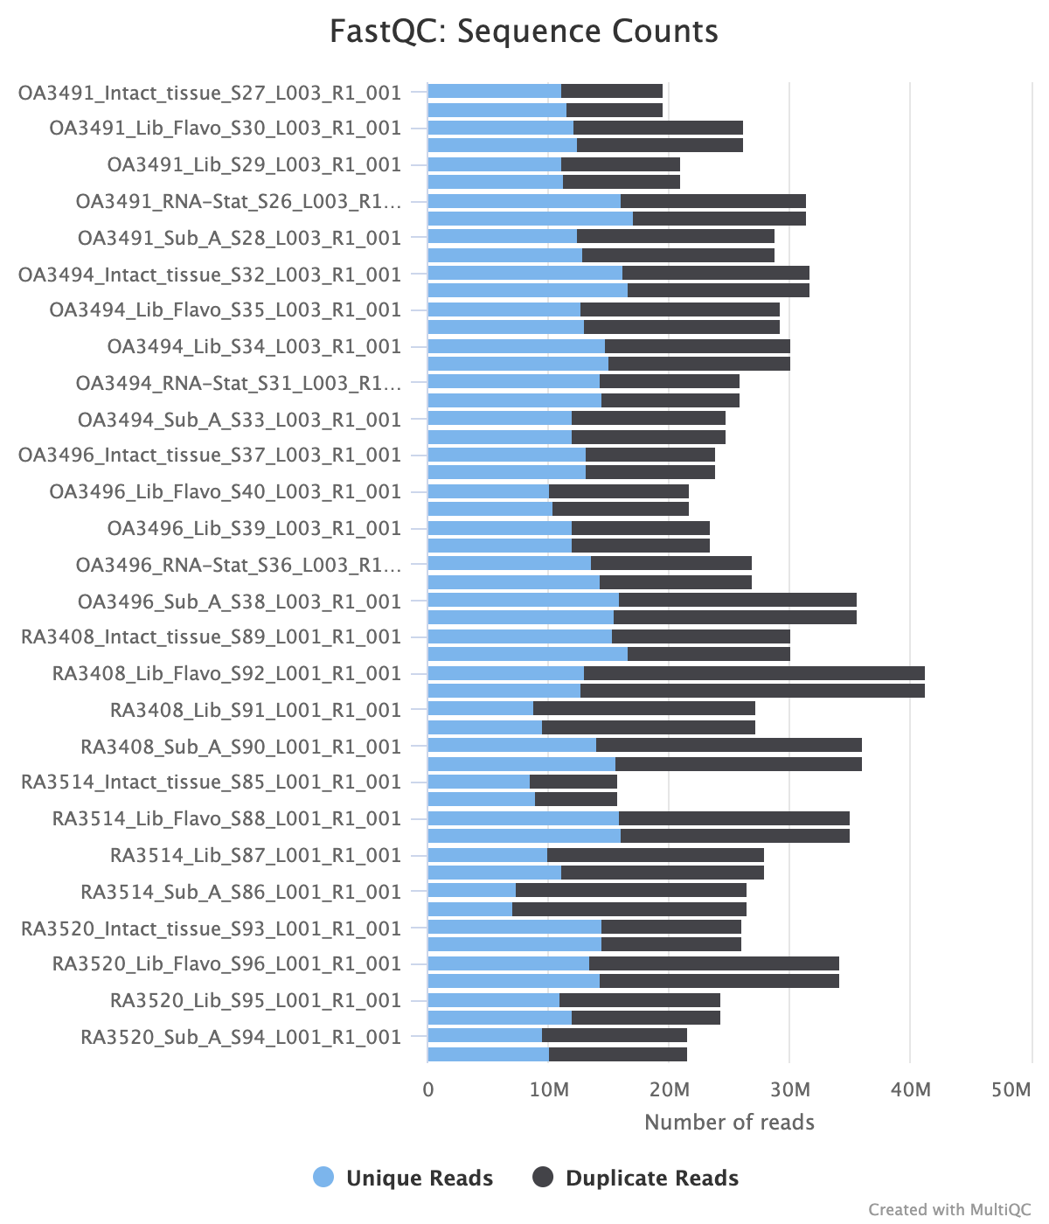

Supplementary Figure 2: STAR Alignment Scores
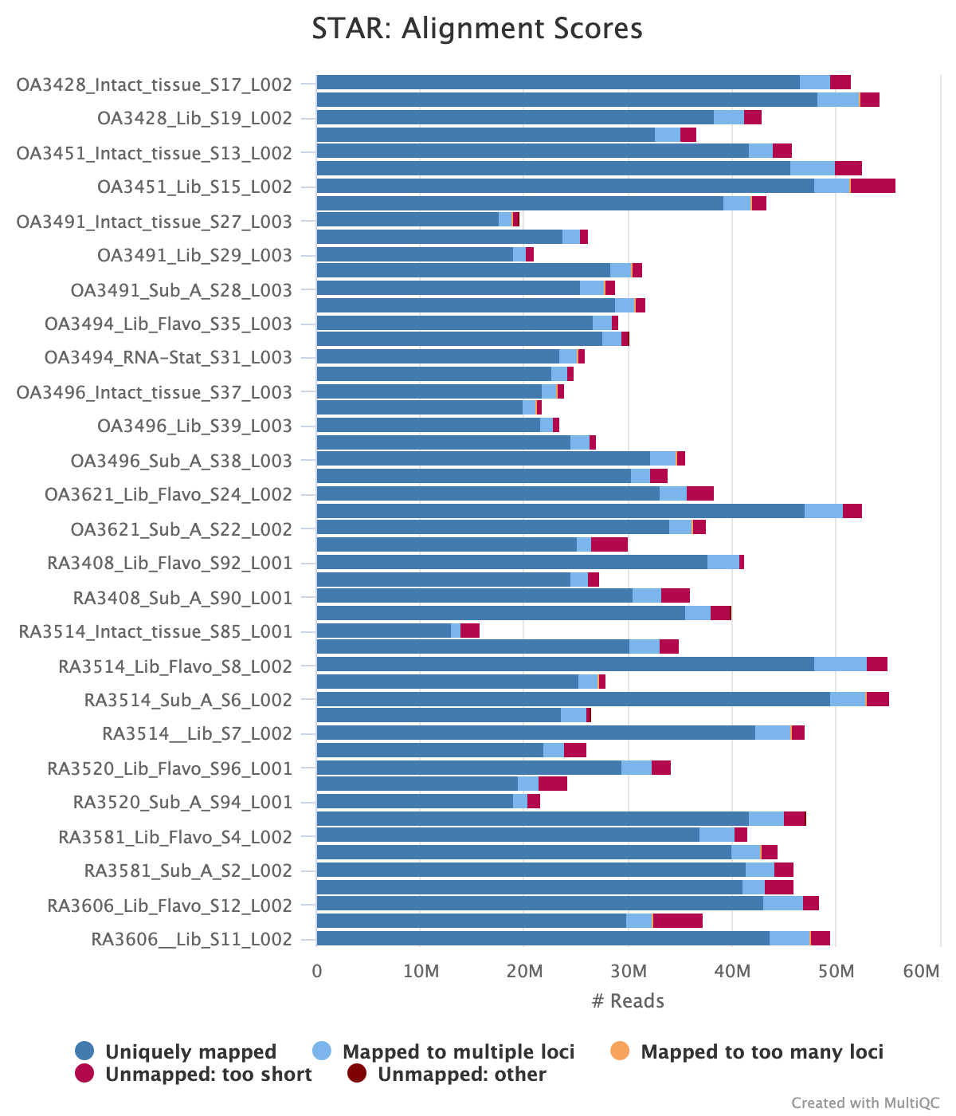

Supplementary Figure 3: HTseq Count Assignments

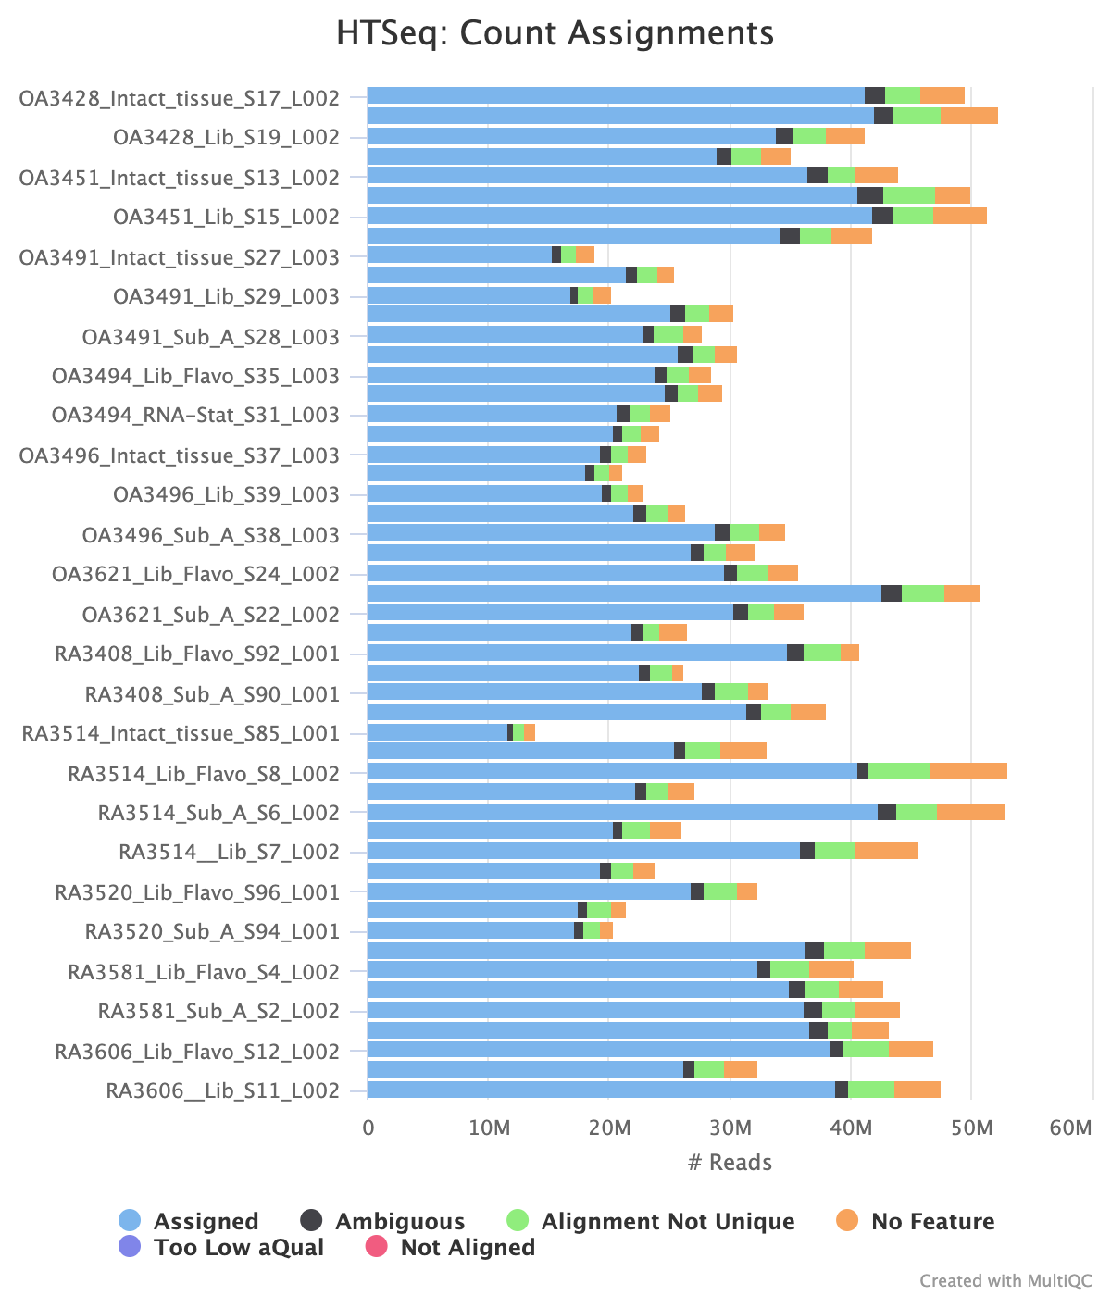

Supplementary Figure 4: Mitochondrial and rRNA Reads

