Supplementary material

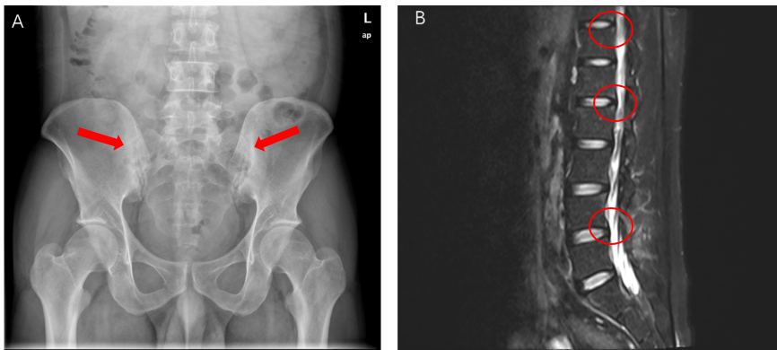

Figure S1: A. Radiography of the sacroiliac joints; B. MRI of the spine

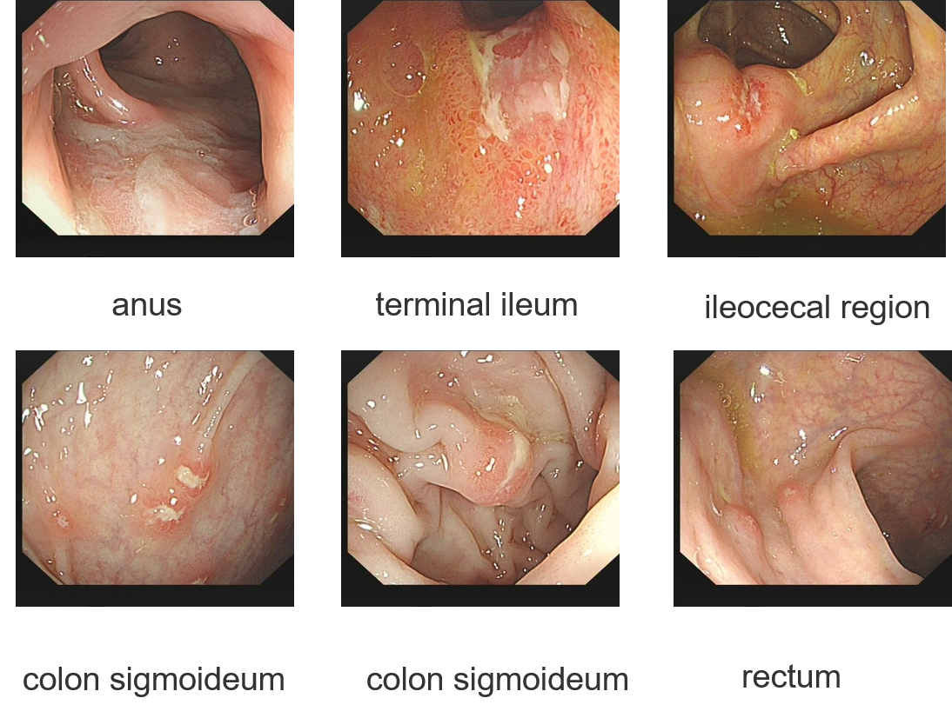

Figure S2: Colonoscopy images