Supplementary Material

**Supplementary Table 1.** The number of *Pteropus poliocephalus* feeding fixes, and the duration each transmitter recorded usable GPS and accelerometer data for each individual (n = 9). Individual FFOX05 left the study area (within a 75 km radius from the center of the Adelaide Botanic Park roost; -34.916, 138.607) before the transmitter began collecting data and hence this individual produced no usable data.

|  |  |  |  |  |
| --- | --- | --- | --- | --- |
| ID | Date of first fix | Date of last usable fix | Duration (days) | N fixes |
| Female |  |  |  | N = 392 |
| FFOX01 | 15/12/2019 | 27/03/2020 | 104 | 150 |
| FFOX02 | 18/12/2019 | 21/04/2020 | 126 | 68 |
| FFOX03 | 22/12/2019 | 23/05/2020 | 154 | 70 |
| FFOX04 | 16/12/2019 | 28/04/2020 | 135 | 104 |
| Male |  |  |  | N = 97 |
| FFOX06 | 20/12/2019 | 12/02/2020 | 55 | 28 |
| FFOX07 | 21/12/2019 | 26/12/2019 | 6 | 14 |
| FFOX08 | 21/12/2019 | 23/12/2019 | 3 | 3 |
| FFOX09 | 21/12/2019 | 15/03/2020 | 86 | 46 |
| FFOX010 | 20/12/2019 | 25/01/2020 | 37 | 6 |
| Total |  |  |  | 489 |

## Supplementary Table 2. Inaccessible feeding fixes (n = 35), from 9 GPS tracked *Pteropus poliocephalus* between December 2019 – May 2020, in the Adelaide region (500 m - 75 km radius from the center of the Adelaide Botanic Park roost; -34.916, 138.607), the land-use categories they pertain to and the reason for inaccessibility.

|  |  |  |  |
| --- | --- | --- | --- |
| **Foraging fix ID** | **Individual** | **Land-use category** | **Reason for inaccessibility** |
| F3_040 | 3 | Agriculture | Private property |
| F3_055 | 3 | Agriculture | Private property |
| F4_002 | 4 | Agriculture | Private property |
| F1_145 | 1 | Mining | Dangerous/steep terrain |
| F1_148 | 1 | Reserve | Dangerous/steep terrain |
| F3_028 | 3 | Reserve | Restricted access – water catchment area |
| F3_029 | 3 | Reserve | Restricted access – water catchment area |
| F3_037 | 3 | Reserve | Restricted access – water catchment area |
| F4_077 | 4 | Reserve | Dangerous/steep terrain |
| F1_058 | 1 | Reserve | Could not get close enough to distinguish between 2 trees |
| F1_086 | 1 | Reserve | Could not get close enough to distinguish between 2 trees |
| F1_092 | 1 | Residential | Dangerous/steep terrain |
| F1_132 | 1 | Residential | Private property, no one home |
| F10_005 | 10 | Residential | Private property, no one home |
| F3_001 | 3 | Residential | Private road – no access signage |
| F3_013 | 3 | Residential | Dangerous/steep terrain |
| F3_020 | 3 | Residential | Private property, no one home |
| F3_032 | 3 | Residential | Rural residential private property |
| F3_058 | 3 | Residential | Private property, no one home |
| F3_069 | 3 | Residential | Private property, no one home |
| F4_082 | 4 | Residential | Private property, no one home |
| F4_086 | 4 | Residential | No tree at location |
| F4_103 | 4 | Residential | Private property with signage |
| F6_003 | 6 | Residential | Private property, no one home |
| F6_005 | 6 | Residential | Dangerous/steep terrain |
| F6_006 | 6 | Residential | Dangerous/steep terrain |
| F6_008 | 6 | Residential | Dangerous/steep terrain |
| F6_020 | 6 | Residential | Private property, no one home |
| F6_021 | 6 | Residential | Private property, no one home |
| F6_025 | 6 | Residential | Private property, no one home |
| F2_059 | 2 | Residential | Private property, no one home |
| F2_067 | 2 | Residential | Dangerous/steep terrain |
| F1_127 | 1 | Road/river | Private property, no one home |
| F7_006 | 7 | Road/river | Within locked fence on golf course |
| F3_014 | 3 | Utilities | Restricted access – Kangaroo Creek reservoir |

## Supplementary Table 3: Contingency table showing the number of unique food plant species of four geographic origins (locally indigenous to South Australia, non-indigenous Australian native, non-Australian, and unknown) visited by 9 GPS tracked *Pteropus poliocephalus* in the Adelaide region (500 m - 75 km radius from the center of the Adelaide Botanic Park roost; -34.916, 138.607) between December 2019 – May 2020.

|  |  |  |  |  |  |
| --- | --- | --- | --- | --- | --- |
|  | Locally indigenous | Non-indigenous | Non-Australian | Unknown | Total number of unique species |
| Residential | 10 | 8 | 10 | 0 | 28 |
| Road/river | 5 | 6 | 8 | 1 | 20 |
| Reserve | 2 | 6 | 1 | 1 | 10 |
| Primary production | 1 | 2 | 1 | 1 | 5 |
| Utilities | 1 | 2 | 0 | 1 | 4 |
| Vacant | 3 | 2 | 2 | 1 | 8 |
| Recreation | 2 | 1 | 1 | 0 | 4 |
| Institution | 3 | 1 | 2 | 0 | 6 |
| Mining | 0 | 0 | 1 | 0 | 1 |
| Total number of unique species | 27 | 28 | 26 | 5 | 86 |

## Supplementary Table 4: Contingency table showing the number of feeding fixes to food plants of four geographic origins (locally indigenous to South Australia, non-indigenous Australian native, non-Australian, and unknown). Data shown is from 9 GPS tracked *Pteropus poliocephalus* in the Adelaide region (500 m - 75 km radius from the center of the Adelaide Botanic Park roost; -34.916, 138.607) between December 2019 – May 2020.

|  |  |  |  |  |  |
| --- | --- | --- | --- | --- | --- |
|  | Locally indigenous | Non-indigenous | Non-Australian | Unknown | Total number of fixes |
| Residential | 42 | 21 | 27 | 0 | 90 |
| Road/river | 29 | 8 | 8 | 1 | 46 |
| Reserve | 33 | 2 | 2 | 1 | 38 |
| Primary production | 29 | 1 | 1 | 3 | 34 |
| Utilities | 20 | 1 | 0 | 2 | 23 |
| Vacant | 3 | 7 | 2 | 2 | 14 |
| Recreation | 8 | 2 | 1 | 0 | 11 |
| Institution | 1 | 5 | 2 | 0 | 8 |
| Mining | 1 | 0 | 0 | 0 | 1 |
| Total number of fixes | 166 | 47 | 43 | 9 | 265 |

## Supplementary Table 5. A list of the n = 49 food plant species visited, their geographic origin in relation to Adelaide, South Australia, and the number of visitations to each by 9 GPS tracked *Pteropus poliocephalus* in the Adelaide region (500 m - 75 km radius from the center of the Adelaide Botanic Park roost; -34.916, 138.607) between December 2019 – May 2020.

|  |  |  |
| --- | --- | --- |
| **Species Latin name** | **Geographic origin** | **Number of visitations** |
| *Callistemon* ‘Harkness’ | Locally indigenous | 1 |
| *Corymbia citriodora* | Non-indigenous Australian native | 8 |
| *Corymbia maculata* | Non-indigenous Australian native | 4 |
| *Corymbia* spp. | Unknown | 3 |
| *Eucalyptus baxteri* | Locally indigenous | 3 |
| *Eucalyptus camaldulensis* | Locally indigenous | 43 |
| *Eucalyptus cinerea* | Non-indigenous Australian native | 1 |
| *Eucalyptus cladocalyx* | Locally indigenous | 3 |
| *Eucalyptus dalrympleana* | Locally indigenous | 1 |
| *Eucalyptus eremophila* | Non-indigenous Australian native | 1 |
| *Eucalyptus fasciculosa* | Locally indigenous | 2 |
| *Eucalyptus globulus* | Non-indigenous Australian native | 1 |
| *Eucalyptus leucoxylon* | Locally indigenous | 92 |
| *Eucalyptus microcarpa* | Locally indigenous | 2 |
| *Eucalyptus nitens* | Non-indigenous Australian native | 1 |
| *Eucalyptus obliqua* | Locally indigenous | 12 |
| *Eucalyptus occidentalis* | Non-indigenous Australian native | 1 |
| *Eucalyptus saligna* | Non-indigenous Australian native | 3 |
| *Eucalyptus salubris* | Non-indigenous Australian native | 1 |
| *Eucalyptus torquata* | Non-indigenous Australian native | 1 |
| *Eucalyptus viminalis* | Locally indigenous | 6 |
| *Eucalyptus* spp. | 1 locally indigenous, 9 unknown | 10 |
| *Lophostemon confertus* | Non-indigenous Australian native | 4 |
| *Fraxinus angustifolia* | Non-Australian | 2 |
| *Magnolia* spp. | Non-Australian | 1 |
| *Crataegus* spp. *(monogyna)* | Non-Australian | 1 |
| *Cotoneaster pannosus* | Non-Australian | 1 |
| *Rosa* spp. | Non-Australian | 1 |
| *Camellia* spp. | Non-Australian | 1 |
| *Hymenosporum flavum* | Non-Australian | 1 |
| *Jacaranda* *mimosifolia* | Non-Australian | 1 |
| *Syzygium* spp. (*smithii*) | Non-indigenous Australian native | 1 |
| *Ficus carica* | Non-Australian | 16 |
| *F. macrophylla* | Non-indigenous Australian native | 7 |
| *Ficus microcarpa* | Non-indigenous Australian native | 1 |
| *Ficus platypoda* | Non-indigenous Australian native | 3 |
| *Ficus rubiginosa* | Non-indigenous Australian native | 2 |
| *Ficus virens* | Non-indigenous Australian native | 2 |
| *Ficus* spp. | Non-indigenous Australian native | 2 |
| *Prunus* spp. | Non-Australian | 3 |
| *Pyrus* spp. | Non-Australian | 1 |
| *Pyrus calleryana* | Non-Australian | 1 |
| *Photinia* spp. | Non-Australian | 1 |
| *Phoenix canariensis* | Non-Australian | 2 |
| *Phoenix roebelenii* | Non-Australian | 1 |
| *Olea europaea* | Non-Australian | 1 |
| *Celtis* spp. | Non-Australian | 2 |
| *Vitis* spp. | Non-Australian | 1 |
| *Platanus acerifolia* | Non-Australian | 5 |
| **Total** |  | **265** |

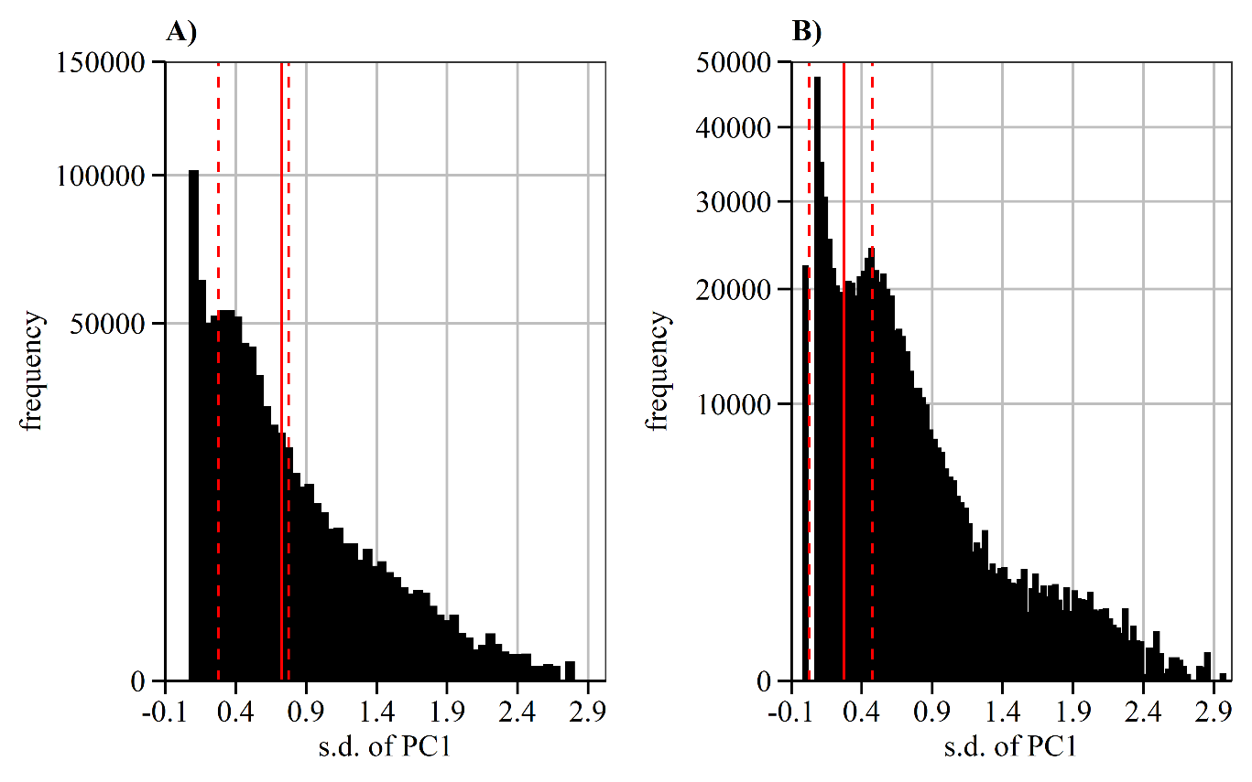

**Supplementary Figure 1.** Frequency histograms showing how activity level from accelerometer data was assigned to *Pteropus poliocephalus* GPS location fixes. Two principal component analyses (PCA) were conducted sequentially on bursts of acceleration data (three axes: X, Y and Z) from 9 tracked individuals in Adelaide, South Australia between December 2019-May 2020. Histograms of PC1 were used to discriminate peaks (dashed lines) and troughs used as thresholds (solid line) to delineate levels of activity. Panel **A)** shows the first PCA; values of PC1 above the threshold were assigned as ‘high’ level activity, movement likely associated with flight. Panel **B)** shows the second PCA applied to the remaining data; values of PC1 above the new threshold were assigned as ‘moderate’ activity likely associated with tree-based movements including feeding, and values below the threshold were assigned as ‘low’ activity, likely associated with activities including rest.