Supplementary Material

## Supplementary Figures

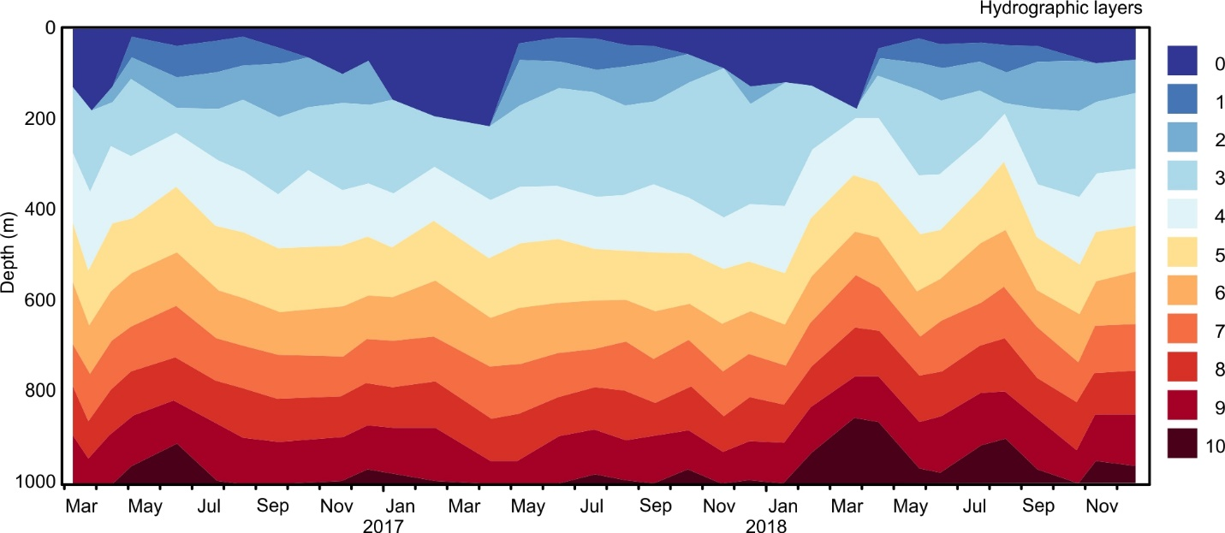

**Supplementary Figure S1**. Hydrographic envelope vertical layer. Vertical layers are defined based in density layers and the CTD-measured fluorescence. See Table 1 in the main text. Layer 0 corresponds to the Mixed Layer.

**Supplementary Figure S2**. Animated gif with the 3-coordinate graphical representatin of the samples from the Chl-*a* maximum samples. The samples from each of the different seasons can be grouped without including any sample from any other season.

