Supplementary Material

**Unveiling co-infection in cystic fibrosis airways: Transcriptomic analysis of *Pseudomonas aeruginosa* and *Staphylococcus aureus* dual-species biofilms**

Andreia Patrícia Magalhães1,2, Angela França1,2*, Maria Olívia Pereira1,2, Nuno Cerca1,2

1 Centre of Biological Engineering, LIBRO – Laboratório de Investigação em Biofilmes Rosário Oliveira, University of Minho, Campus de Gualtar, 4710-057 Braga, Portugal

2 LABBELS –Associate Laboratory, Braga, Guimarães, Portugal

**\* Correspondence:** Angela França, [afranca@ceb.uminho.pt](mailto:afranca@ceb.uminho.pt)

**Running Title:** Transcriptome of *P.aeruginosa*/*S.aureus* biofilms

**Supplementary Table 1.** Summary of the sequencing results. S, single; M, mixed

|  |  |  |  |  |  |
| --- | --- | --- | --- | --- | --- |
| **Sample Identity** | **Sample type** | **Read type** | **Total count Reads** | **Reads mapped in pairs** | **Reads mapped in broken pairs** |
| Pa_S1 | *P. aeruginosa* | 150 × 2 paired-end | 133,397,784 | 128,429,678 | 2,656,657 |
| Pa_S2 | *P. aeruginosa* | 150 × 2 paired-end | 109,742,548 | 100,748,864 | 2,915,604 |
| Pa_M1 | *P. aeruginosa+S. aureus*1* | 150 × 2 paired-end | 134,531,674 | 127,208,514 | 3,110,422 |
| Pa_M2 | *P. aeruginosa+S. aureus*1* | 150 × 2 paired-end | 139,925,400 | 130,754,942 | 6,192,986 |
| Sa_S1 | *S. aureus* | 150 × 2 paired-end | 79,384,900 | 76,685,234 | 1,186,500 |
| Sa_S2 | *S. aureus* | 150 × 2 paired-end | 79,325,532 | 76,919,300 | 1,100,071 |
| Sa_M1 | *P. aeruginosa+S. aureus*2* | 150 × 2 paired-end | 134,531,674 | 212,054 | 13,540 |
| Sa_M2 | *P. aeruginosa+S. aureus*2* | 150 × 2 paired-end | 139,925,400 | 520,816 | 32,570 |

*1RNA-Seq reads alignment was performed using only the *P. aeruginosa* genome.

*2RNA-Seq reads alignment was performed using only the *S. aureus* genome.

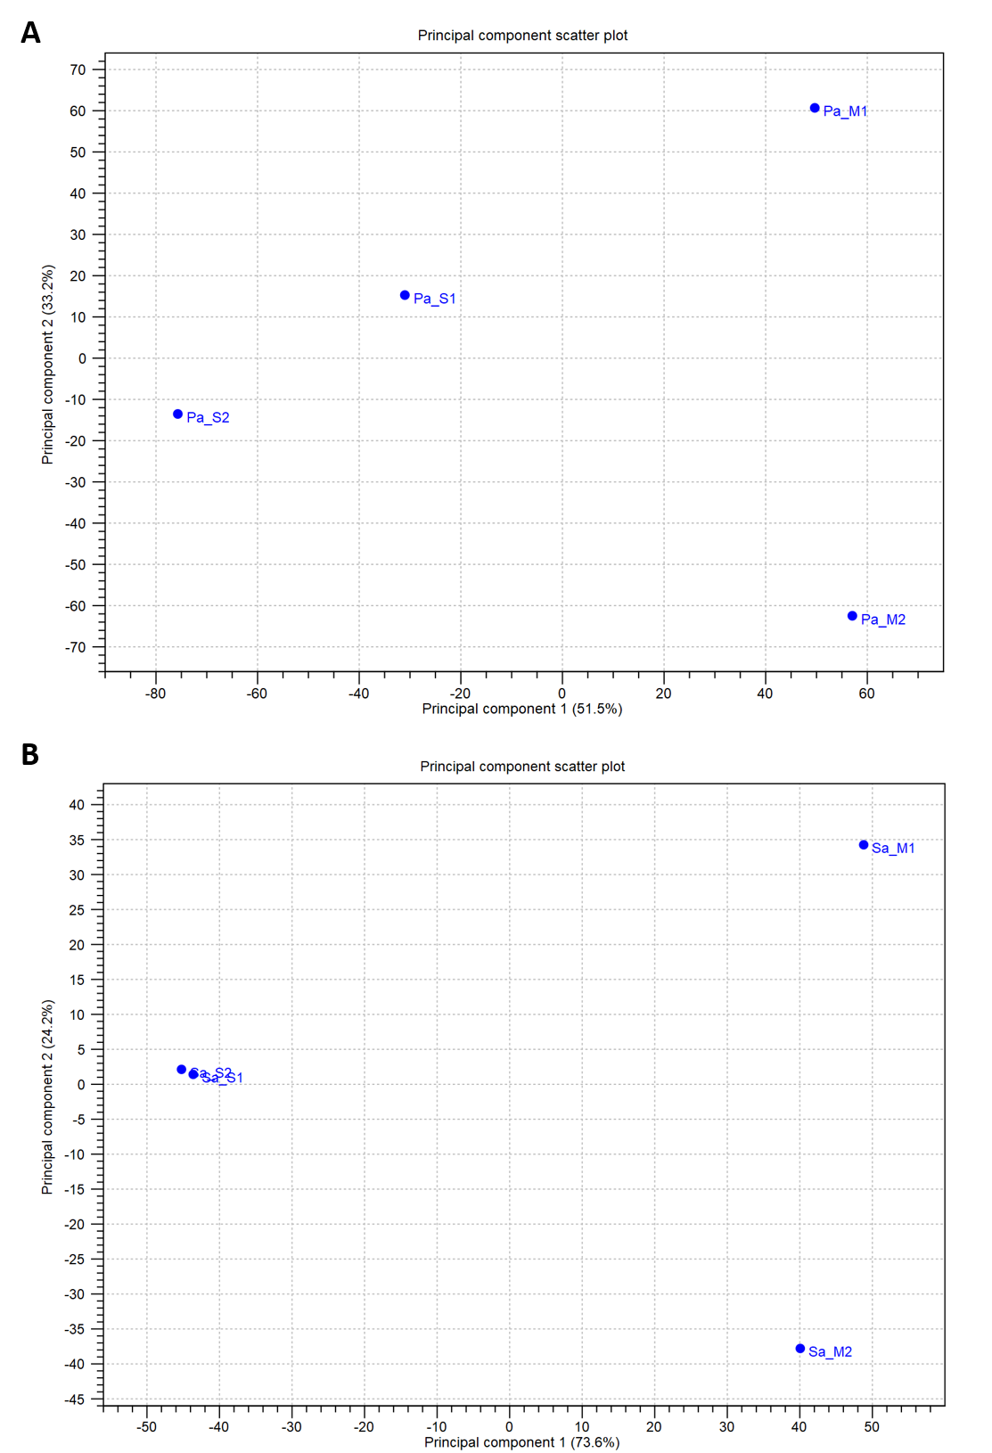

**Supplementary Figure 1.** Principal component analysis (PCA) of each biological replicate of **(A)** *P. aeruginosa* (Pa) *and* **(B)***S. aureus* (Sa)cultured under single- (S1 and S2) and dual-species (M1 and M2). PCA was performed using CLC genomics workbench version 21.

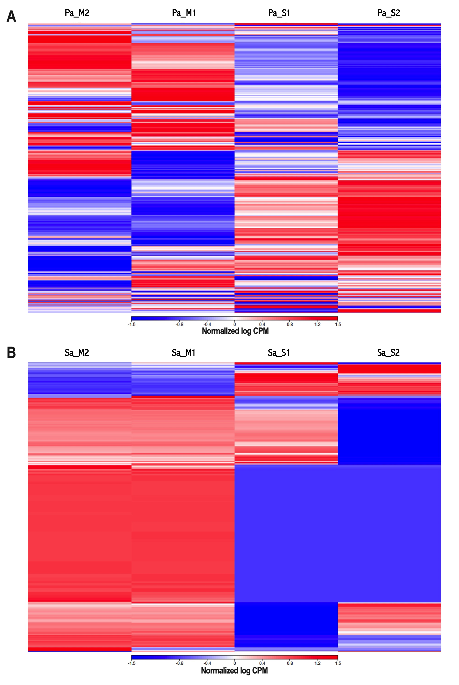

**Supplementary Figure 2.** Heat map of each biological replicate showing the gene expression pattern of *P. aeruginosa* (Pa)**(A)** and *S. aureus* (Sa) **(B)** samples in single- (S1 and S2) and dual-species (M1 and M2) growth conditions. Heat maps were performed using CLC genomics workbench version 21. CPM, counts per million.

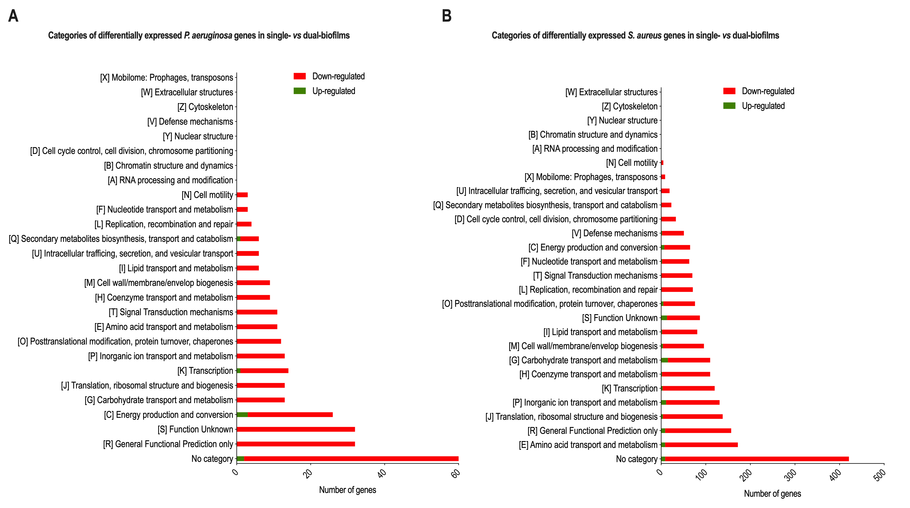**Supplementary Figure 3.** The number of up- and downregulated genes per COG category from *P. aeruginosa* **(A)** and *S. aureus* **(B)** samples. Differentially expressed genes (fold-change ≥ 2 and p < 0.05) are relative to single- *versus* dual-species biofilms.