Joint association of low vitamin K1 and D status with first stroke in general hypertensive adults: results from the China Stroke Primary Prevention Trial (CSPPT)

Supplemental materials

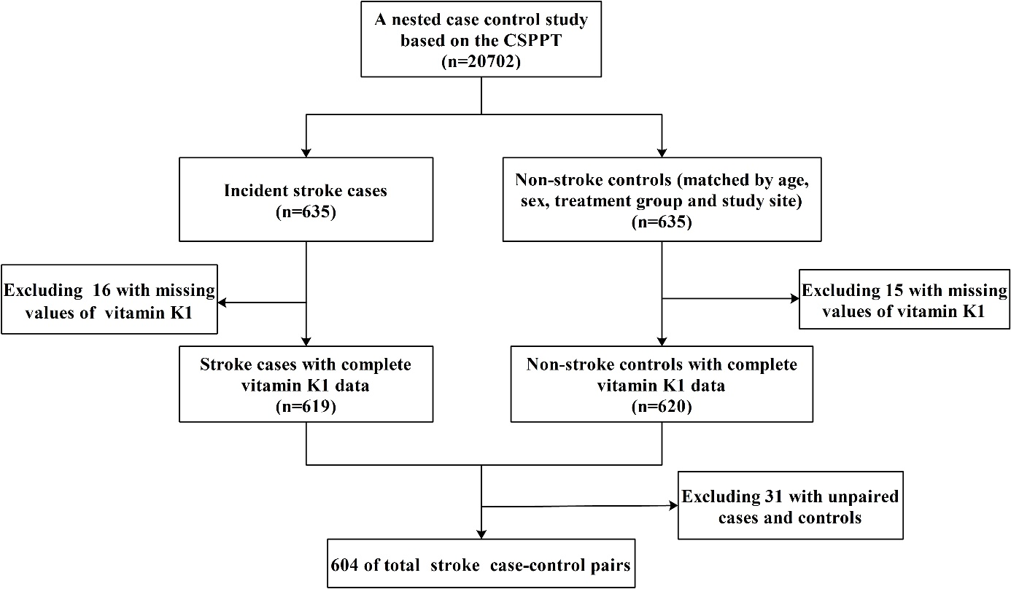
Supplemental Figure 1 Flow chart of the study participants using a nested case–control design (CSPPT: China Stroke Primary Prevention Trial).

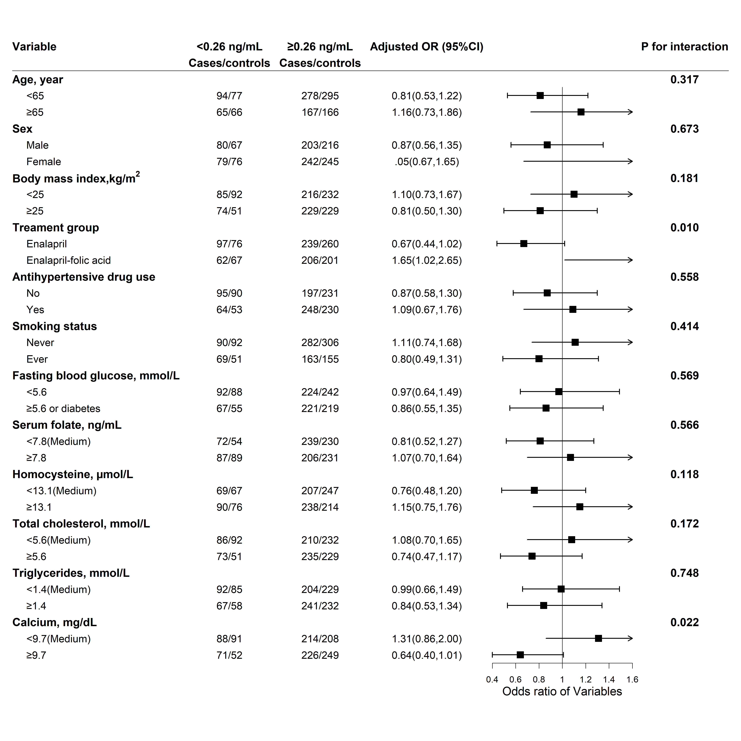
Supplemental Figure 2 Forest plots on the association of plasma vitamin K1 with the risk of incident total stroke (adjusted OR and 95%CI), stratified by pertinent covariables. In addition to the matching factors (age, sex, treatment group, study site), the models adjusted for body mass index, baseline systolic blood pressure, time-averaged systolic blood pressure and diastolic blood pressure during treatment, baseline fasting blood glucose, total cholesterol, triglycerides, folate, antihypertensive treatment, smoking status and antiplatelet drug usage at baseline. CI: confidence interval; OR: odds ratio.

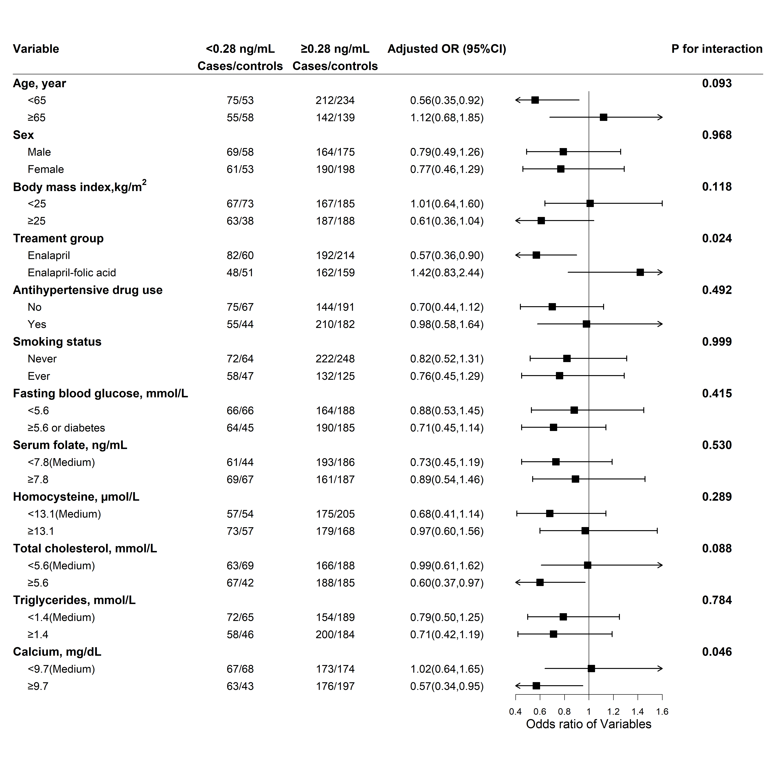
Supplemental Figure 3 Forest plots on the association of plasma vitamin K1 with the risk of incident ischemic stroke (adjusted OR and 95%CI), stratified by pertinent covariables. In addition to the matching factors (age, sex, treatment group, study site), the models adjusted for body mass index, baseline systolic blood pressure, time-averaged systolic blood pressure and diastolic blood pressure during treatment, baseline fasting blood glucose, total cholesterol, triglycerides, folate, antihypertensive treatment, smoking status and antiplatelet drug usage at baseline. CI: confidence interval; OR: odds ratio.

