Supplementary Material

# Supplementary text

## Details on the experimental setup of long-term microplastic exposure

Coral colonies were reared under laboratory conditions in the ‘Ocean2100’ facility at Justus Liebig University Giessen, Germany (10:14 light:dark photoperiod, light intensity (PAR) 200 µmol photons m-2 s-1, and temperature 26 ± 0.5 °C) for at least six months before the experiment (see details on coral colonies in Table S1) in accordance with the institutional animals’ care guidelines. Corals were fragmented with a small angle grinder to ~3.5 cm branches for *A. muricata*, *P. verrucosa*, and *H. coerulea* and ~1 cm cubes for *P. lutea*. Fragments were glued to self-made concrete bases using a two-component glue (CoraFix SuperFast, Grotech, Germany) to ease the handling. A total of 90 nubbins were prepared for *Acropora*, *Pocillopora*, and *Porites*, cut equally from three original colonies. For *Heliopora,* 30nubbins were cut from a single colony due to the lack of replicate colonies. The coral fragments were allocated equally to the tanks. Corals were randomly distributed within the tanks and shuffled once a week to avoid position effects. As one colony of *P. verrucosa* experienced a high mortality rate during the experiment, it was excluded from the analyses. A subset of coral fragments was analyzed in this study (one fragment per species per colony per tank). This resulted in a total of n = 27 fragments studied in each, the control and the long-term microplastic exposure treatment (Acropora: n = 9, Pocillopora: n = 6, Porites: n = 9, Heliopora: n = 3), with each fragment treated as replicate. The physiological responses of the full set of coral fragments were examined in a separate study (Reichert et al., 2019). The six experimental tanks were equipped with a flow pump for horizontal water movement (RW-8, Jebao, China; 700 L h-1) and a feed pump (S 400, Resun, China; 400 L h-1) for a vertical water circulation that re-immersed floating microplastic particles. A UV clarifier (RWUVC/78/4000, RuWal Aquatech, Italy; 33000 mWs-1 cm-2 at 4000 L h-1) was upstream of the inlet of the six experimental tanks to reduce pathogens. On the outflow side, a fleece membrane was installed downstream of the 65 µm filters to retain even smaller plastic particles that might have been generated by fragmentation over time. Small gastropods (*Nassarius* spp., *Euplica* spp., *Turbo* spp., and *Stomatella auricula*) were used to limit algae growth. If necessary, coral nubbins were inspected daily and cleaned from algae and detritus. The connection to a reef mesocosm system included a large ‘buffer’ tank, harboring corals, fish, and a deep sand bed, together with a protein skimmer and a calcium reactor (pH 6.2–6.4, coral rubble) and provided near-natural water conditions. The system was set up with artificial seawater (Coral ocean plus, ATI, Germany), and water parameters were checked once a week (alkalinity: 2.52 mmol L-1, Ca2+: 410 mg L-1, Mg2+: 1230 mg L-1, PO43-:  0.03 mg L-1, NO3-:  0.02 mg L-1, NO2-:  0.01 mg L-1, NH4+  0,025 mg L-1, salinity: 34). After six months of long-term exposure, several of the coral fragments were snap-frozen in liquid nitrogen, as described in Reichert et al. (2019). The remaining coral fragments were further kept under the same experimental conditions to a total long-term exposure period of 15 months, except for omitted periodical quantification of photosynthetic activity, determination of calcification, and growth assessment.

## Microplastic particles

The size of microplastic particles used (184 ± 95 µm (diameter: mean ± SD)) is similar to natural marine conditions where small microplastics (<1 mm) dominate the total microplastic concentration (Hartmann et al., 2019; Koelmans et al., 2020). Accordingly, reef microplastics are often present in sizes (<500 µm (Ding et al., 2019; Huang et al., 2019; Saliu et al., 2018)) similar to the plankton diet of corals (Houlbrèque and Ferrier-Pagès, 2009; Palardy et al., 2005). A concentration of ~200 microplastic particles L-1 (≈ 0.25 mg L-1) was chosen for the long-term exposure as this concentration is close to natural conditions anticipated for the years 2030 to 2060 (Isobe et al., 2019).

## Determination of corals’ surface area

3D models of the coral fragments were constructed in the Artec Studio 11 software (Artec 3D, Luxembourg). Coral fragments were scanned directly after the feeding incubation. Fragments were placed on a motorized turntable within a lightbox and scanned within ~90 s from 45- and 90-degree angles. From the calculated 3D model, the socket, and necrotic and bleached tissue, were removed with the “Eraser” tool, resulting in the living coral tissue only. The final 3D models were saved as OBJ files, and surface area values were determined (“compute geometric measures” command) in MeshLab (v1.3.4 beta; Cignoni et al., 2008).

# Supplementary Figures and Tables

## Supplementary Figures

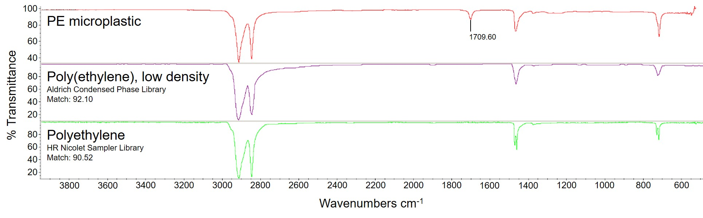

Figure S1: FTIR spectrum of the polyethylene (PE) microplastic particles used in the experiment (top, red), compared to reference spectra of low-density polyethylene (middle, purple and bottom, green). The PE microplastics has a distinct peak at 1709.60 cm-1, indicating the C=O stretching of the polymer. Image source: Reichert et al., 2022

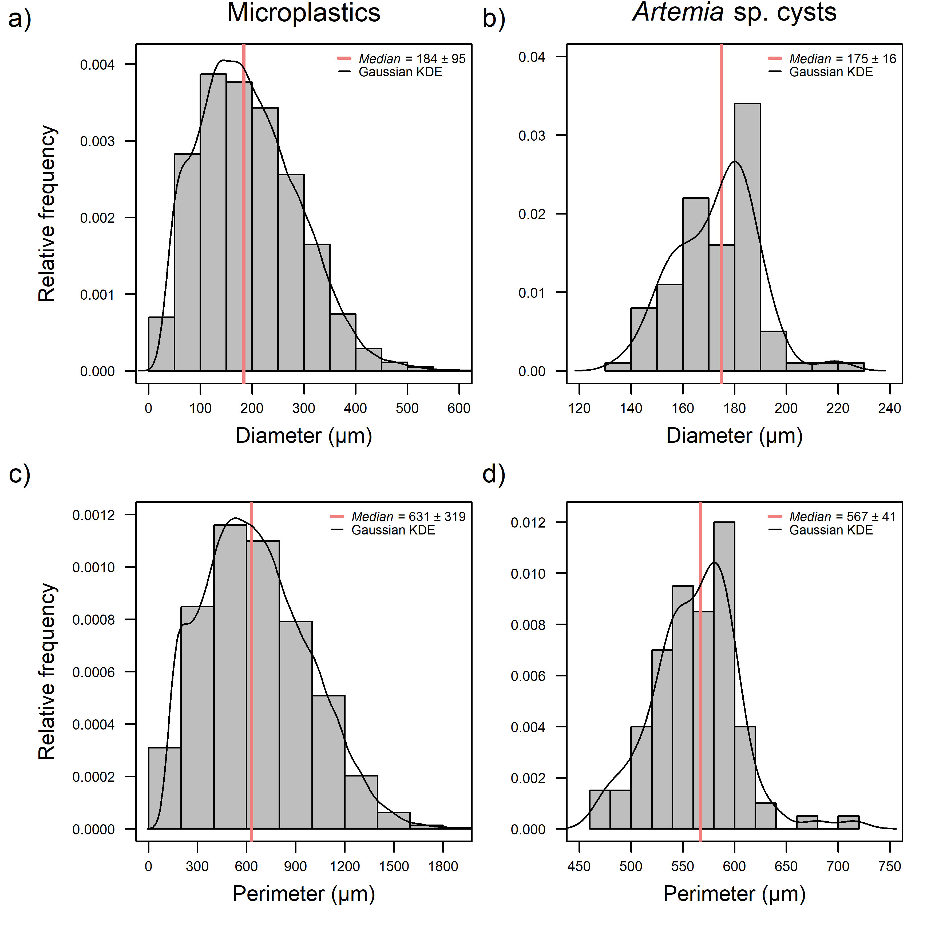

Figure S2: Particle characteristics. Comparison of size distributions of microplastics (a, c) and *Artemia* sp. cysts (b, d) depicted as histograms of diameters (a, b) and perimeters (c, d) with relative frequency values. KDE  kernel density estimation. Statistical values (median ± SD in µm) based on n  20474 (microplastics) and n  100 (*Artemia* sp. cysts).



Figure S3: Schematic drawing of 24 h pulse exposure setup in side view (a) and top view (b). Two consecutive rows of five feeding chambers (1) are located in a water bath. Four pumps (2) are located in the corners of the water bath for circulation of the water tempered by a heating rod (3). The feeding chambers are equipped with aeration, a stir bar, and a coral fragment. Control chambers were equipped with fishing lines only and lack the fragment.

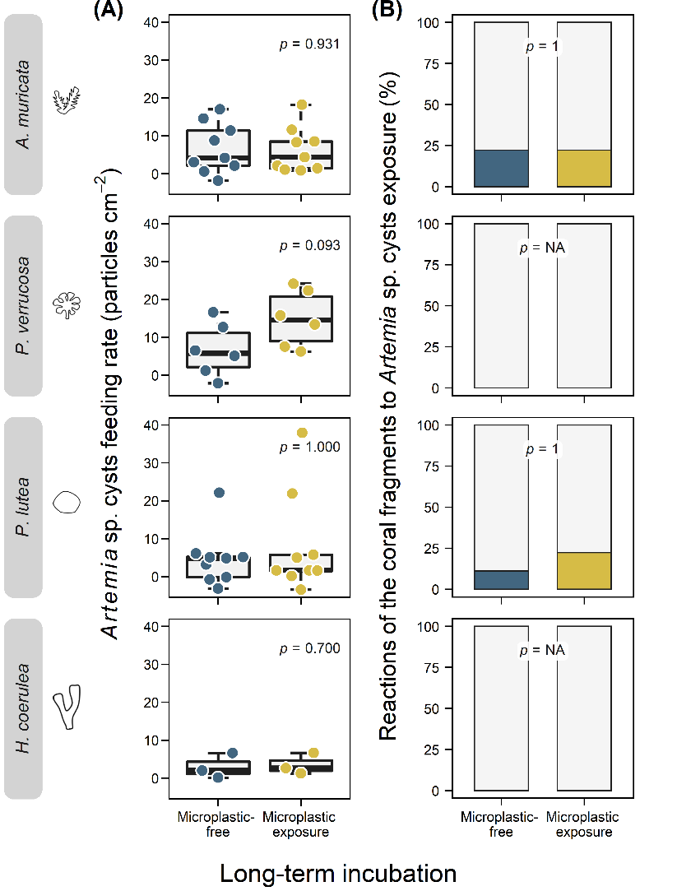

Figure S4: Impacts of long-term exposure to microplastics (in yellow) and microplastic-free control conditions (in blue) on coral feeding on control feed and defense behavior of the four coral species *A. muricata*, *P. verrucosa*, *P. lutea*, and *H. coerulea*. A: Coral feeding rates on *Artemia* sp. cysts (particles cm-2) after long-term exposure to microplastics and microplastic-free control conditions. Data is displayed as box-and-whisker plots with raw data points. *P*-values are derived from Wilcoxon tests. Detailed statistical results are given in Table S5. B: Corals’ defense reactions to control feed (% of fragments that show reactions) after long-term exposure to microplastic and microplastic-free control conditions. Data is displayed as percent stacked bar charts, and p-values are derived from Fisher’s exact tests. Detailed statistical results are given in Table S12.



Figure S5: Coral feeding rates on *Artemia* sp. cysts (orange, control) and microplastics (yellow, treatment) for the four coral species *A. muricata*, *P. verrucosa*, *P. lutea*, and *H. coerulea*. Data is displayed as box-and-whisker plots with raw data points. The *p*‑values are derived from Wilcoxon tests, and the asterisks indicate significance levels (*p*  .05: *, *p*  .01: **, *p*  .001: ***). Detailed statistical results are given in Table S6.



Figure S6: Interspecific differences in feeding rates for the four coral species, *A. muricata*, *P. verrucosa*, *P. lutea*, and *H. coerulea*. Rates are given for feeding on *Artemia* sp. cysts (left, orange) and microplastics (right, yellow). Data is displayed as box-and-whisker plots with raw data points. The *p*‑values are derived from Kruskal‑Wallis tests followed by Dunn post hoc tests. Detailed statistical results are given in Table S7 and 8.



Figure S7: Interspecific differences in the ability to discriminate microplastics from natural food for the four coral species, *A. muricata*, *P. verrucosa*, *P. lutea*, and *H. coerulea,* in the two long-term conditions (microplastic-free and microplastic exposure). Data is displayed as box-and-whisker plots with raw data points, and the *p*‑values are derived from Kruskal-Wallis tests followed by Dunn post hoc tests. Detailed statistical results are given in Table S10 and 11.

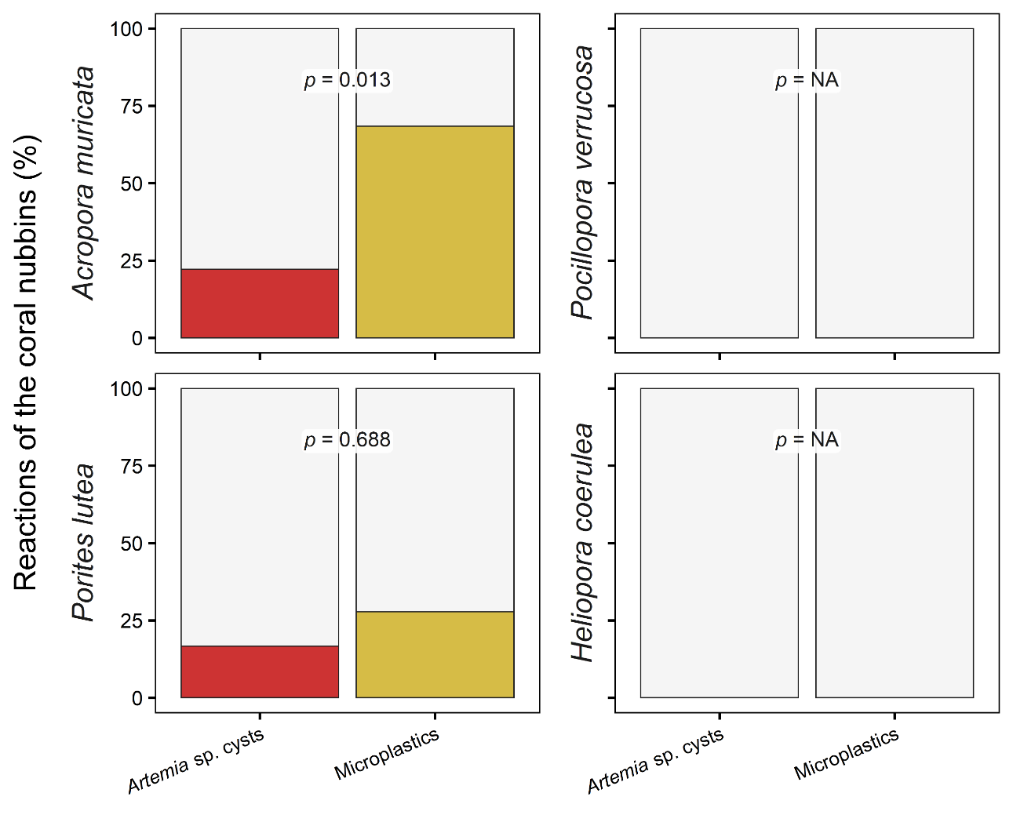

Figure S8: Corals’ defense reactions (% of fragments that show reactions) to control feed (*Artemia* sp. cysts, left, orange) and microplastics (right, yellow) of the four coral species *A. muricata*, *P. verrucosa*, *P. lutea*, and *H. coerulea*. Data is displayed as percent stacked bar charts, and p-values are derived from chi-squared tests. Detailed statistical results are given in Table S13.



Figure S9: Coral feeding rates on *Artemia* sp. cysts (orange) and on microplastics (yellow) separated for the occurrence of defense reactions of the coral species *A. muricata* and *P. lutea*. *P. verrucosa* and *H. coerulea* showed no defense reactions. Data is displayed as box-and-whisker plots with raw data points, and *p*-values are derived from Wilcoxon tests. Asterisks indicate significance levels (*p*  .05: *, *p*  .01: **, *p*  .001: ***). Detailed statistical results are given in Table S14.

## Supplementary Tables

**Table S1: CITES numbers and origin of coral colonies studied.** Origin, dates of collections, CITES numbers, and arrival date at the aquarium facilities at Justus Liebig University are given for the colonies studied. * details on colonies are not available due to collections prior to the implementation of the CITES regulations.

|  |  |  |  |  |  |  |
| --- | --- | --- | --- | --- | --- | --- |
| Species | Colony |  | Origin | Collection | Arrival | CITES number |
| *Acropora muricata* | A |  | Indonesia | 12/2007 | 12/2007 | 14846/IV/SATS-LN/2007 |
| *Acropora muricata* | B* |  | Zoo Frankfurt, Germany | NA | 05/2015 | NA |
| *Acropora muricata* | C |  | Indonesia | 12/2007 | 12/2007 | 14846/IV/SATS-LN/2007 |
| *Pocillopora verrucosa* | A |  | Saudi Arabia | 05/2015 | 06/2015 | 15-SA-000882-PD |
| *Pocillopora verrucosa* | B |  | Indonesia | 04/2014 | 05/2014 | 14NL214371/11 |
| *Pocillopora verrucosa* | C |  | Indonesia | 12/2007 | 12/2007 | 14846/IV/SATS-LN/2007 |
| *Porites lutea* | A |  | Indonesia | 05/2014 | 05/2014 | 14-NL-216270-11 |
| *Porites lutea* | B |  | Indonesia | 05/2014 | 05/2014 | 14-NL-216270-11 |
| *Porites lutea* | C |  | Indonesia | 05/2014 | 05/2014 | 14-NL-216270-11 |
| *Heliopora coerulea* | A* |  | Zoo Frankfurt, Germany | NA | 05/2015 | NA |

**Table S2: Working steps for particle counting.** The steps from image acquisition to image processing to automatic particle counting are presented with an example image, the goal of each step, the tools used and their settings.

|  |  |  |  |  |
| --- | --- | --- | --- | --- |
| Example image | Aim | Software | Tool | Settings |
|  | Documentation of particles | Keyence Terminal Software, Keyence, Japan | Keyence VHX-2000 digital microscope | Magnification: 50x Lens: VH-Z20W  2D stitching mode  Manually specify area  Autofocus: off  Mount Polarizer  Safe Images as TIFF |
|  | Adjust white balance  Adjust brightness  Noise reduction | RawTherapee Image Manipulation Program,  https://rawtherapee.com  ImageJ Fiji, https://fiji.sc | Adjust white balance  Stack Deflicker  Non Local Means Denoise  Thresholded Blur | Manual selection of white background  -1  Sigma = 12  Smoothing factor = 1  Radius = 3  Threshold = 11  Softness = 0.10  Strength = 1 |
|  | Background removal  Enhance contrast | ImageJ Fiji | Color Thresholder  Enhance Local Contrast | Pass:  Y = 0-83  U = 119-133  V = 121-134  Color space: YUV  Deselect: fast |
|  | Noise reduction | ImageJ Fiji | Thresholded Blur  Bi-Exponential Edge-Preserving Smoother | Radius = 3  Threshold = 11  Softness = 0.10  Strength = 1  Range filter = gauss  Photometric SD = 4.0  Spatial decay = 0.01  Iteration = 1 |
|  | Separate aggregated particles  Count particles | ImageJ Fiji | Greylevel Watershed  Watershed Irregular Features  Extended Particle Analyzer | Watershed = ‘0 1 0 95 0 0’  Display = ‘0’  Erosion = 1  Convexity threshold = 0  Separator size = 27-300  Area = 60-19150  Perimeter = 20-590  Circularity = 0.29-1.00  Roundness = 0.2-1.00  Solidity = 0.59-0.985  Aspect ratio = 1.045-Infinity |

**Table S3:** **3D scanning and post-processing settings for calculating 3D models of the four coral species *A. muricata*, *P. verrucosa*, *P. lutea*, and *H. coerulea* in Artec Studio 11.**

|  |  |  |  |  |
| --- | --- | --- | --- | --- |
| Parameter | *A. muricata* | *P. lutea* | *P. verrucosa* | *H. coerulea* |
| Scan sensitivity | 4 | 4 | 5 | 4 |
| Fine registration (FR) algorithm | Texture and geometry | | | |
| FR: Refine serial | on | | | |
| FR: Loop closure | off | | | |
| Global registration (GR) algorithm | Texture and geometry | | | |
| GR: Min. distance | 10 | | | |
| GR: Iterations | 1•105 | | | |
| Outlier removal: Std. Dev. | 3 | 5 | NA | 5 |
| Outlier removal: Resolution | 0.2 | 0.2 | NA | 0.2 |
| Sharp fusion: Resolution | 0.2 | 0.2 | 0.2 | 0.3 |
| Sharp fusion: Fill holes | By radius | | | |
| Sharp fusion: Max. hole radius | 3 | | | |
| Sharp fusion: Remove targets | off | | | |
| Small object filter mode | Leave biggest object | | | |
| Generate texture atlas | on | | | |
| Inpaint missing texture | off | | | |
| Remove targets | off | | | |
| Output texture size | 4096 • 4096 | | | |

**Table S4:** **Comparison of feeding rates on microplastics between both long-term conditions (microplastic-free control vs. microplastic exposure) for the species *A. muricata*, *P. verrucosa*, *P. lutea*, and *H. coerulea*.** Values of Wilcoxon test statistics (alternative hypothesis: two sided) and effect sizes rounded to three decimal places. *n*obs = number of observations; CI = 95% confidence interval.

|  |  |  |  |  |  |  |  |  |  |  |  |
| --- | --- | --- | --- | --- | --- | --- | --- | --- | --- | --- | --- |
|  | Comparison | | | | |  |  |  |  |  |  |
| Species | Long-term conditions | (*n*obs) | vs. | Long-term conditions | (*n*obs) | *t*-value | *p*-value | CI low | CI high | Effect size (*r*-value) | Magnitude of effect size |
| *A. muricata* | control | (9) | – | microplastics | (10) | 57 | 0.356 | -0.978 | 2.146 | 0.225 | small |
| *P. verrucosa* | control | (9) | – | microplastics | (9) | 49 | 0.485 | -1.58 | 2.951 | 0.231 | small |
| *P. lutea* | control | (6) | – | microplastics | (6) | 23 | 0.489 | -1.13 | 2.963 | 0.177 | small |
| *H. coerulea* | control | (3) | – | microplastics | (3) | 2 | 0.4 | -3.274 | 0.911 | 0.445 | moderate |
| Overall | control | (27) | – | microplastics | (28) | 442 | 0.288 | -0.306 | 1.241 | 0.145 | small |

**Table S5:** **Comparison of feeding rates on *Artemia* sp. cysts between both long-term conditions (microplastic-free control vs. microplastic exposure) for the species** ***A. muricata*, *P. verrucosa*, *P. lutea*, and *H. coerulea***. Values of Wilcoxon test statistics (alternative hypothesis: two sided) and effect sizes rounded to three decimal places. *n*obs = number of observations; CI = 95% confidence interval.

|  |  |  |  |  |  |  |  |  |  |  |  |
| --- | --- | --- | --- | --- | --- | --- | --- | --- | --- | --- | --- |
|  | Comparison | | | | |  |  |  |  |  |  |
| Species | Long-term conditions | (*n*obs) | vs. | Long-term conditions | (*n*obs) | *t*-value | *p*-value | CI low | CI high | Effect size (*r*-value) | Magnitude of  effect size |
| *A. muricata* | control | (9) | – | microplastics | (9) | 39 | 0.931 | -7.692 | 6.194 | 0.031 | small |
| *P. verrucosa* | control | (9) | – | microplastics | (9) | 41 | 0.093 | -0.827 | 17.896 | 0.508 | large |
| *P. lutea* | control | (6) | – | microplastics | (6) | 29 | 1 | -4.453 | 8.961 | 0.010 | small |
| *H. coerulea* | control | (3) | – | microplastics | (3) | 6 | 0.7 | -5.362 | 6.536 | 0.267 | small |
| Overall | control | (27) | – | microplastics | (27) | 423 | 0.318 | -1.603 | 5.164 | 0.138 | small |

**Table S6:** **The two pulse exposure conditions (microplastics vs. *Artemia* sp. cysts) were compared for each of the four coral species** ***A. muricata*, *P. verrucosa*, *P. lutea*, and *H. coerulea*.** Values of Wilcoxon test statistics (alternative hypothesis: two sided) and effect sizes rounded to three decimal places. Bold numbers indicate significant differences (*p* ≤ 0.05). *n*obs = number of observations; CI = 95% confidence interval.

|  |  |  |  |  |  |  |  |  |  |  |  |
| --- | --- | --- | --- | --- | --- | --- | --- | --- | --- | --- | --- |
|  | Comparison | | | | |  |  |  |  |  |  |
| Species | Pulse exposure condition | (*n*obs) | vs. | Pulse exposure condition | (*n*obs) | *t*-value | *p*-value | CI low | CI high | Effect size (*r*-value) | Magnitude of  effect size |
| *A. muricata* | microplastics | (19) | – | *Artemia* cysts | (18) | 65 | **<0.001** | -8.512 | -1.177 | 0.53 | large |
| *P. verrucosa* | microplastics | (18) | – | *Artemia* cysts | (18) | 16 | **<0.001** | -15.409 | -4.731 | 0.66 | large |
| *P. lutea* | microplastics | (12) | – | *Artemia* cysts | (12) | 109 | 0.1 | -5.004 | 0.31 | 0.279 | small |
| *H. coerulea* | microplastics | (6) | – | *Artemia* cysts | (6) | 4 | **0.03** | -6.654 | -0.187 | 0.647 | large |

**Table S7:** **Feeding rates during the two pulse exposure conditions** **(microplastics and *Artemia* sp. cysts) were compared separately among the four coral species *A. muricata*, *P. verrucosa*, *P. lutea*, and *H. coerulea*.** Values of Kruskal-Wallis test statistics and effect sizes rounded to three decimal places. *n*obs = number of observations; η2*H* = eta-squared based on the Kruskal-Wallis *H* test.

|  |  |  |  |  |  |  |
| --- | --- | --- | --- | --- | --- | --- |
| Pulse exposure condition | *n*obs | Statistic (χ2) | Degrees of freedom | *p*-value | Effect size (η2*H*) | Magnitude of  effect size |
| microplastics | 55 | 1.929 | 3 | 0.587 | -0.021 | small |
| *Artemia* sp. cysts | 54 | 5.497 | 3 | 0.139 | 0.05 | small |

**Table S8:** **Feeding rates during the two pulse exposure conditions** **(microplastics and *Artemia* sp. cysts) were compared pairwise among the four coral species *A. muricata*, *P. verrucosa*, *P. lutea*, and *H. coerulea*.** Values of the Dunn post hoc test statistics rounded to three decimal places, and *p*-values were adjusted according to the Benjamini-Hochberg method (1995). *n*obs = number of observations.

|  |  |  |  |  |  |  |  |  |
| --- | --- | --- | --- | --- | --- | --- | --- | --- |
|  | Comparison | | | | |  |  |  |
| Pulse exposure condition | Species | (*n*obs) | vs. | Species | (*n*obs) | *z*-value | *p*-value | Adjusted *p*-value |
| *Artemia* sp. cysts | *A. muricata* | (18) | – | *P. verrucosa* | (12) | 1.402 | 0.161 | 0.322 |
| *Artemia* sp. cysts | *A. muricata* | (18) | – | *P. lutea* | (18) | -0.816 | 0.415 | 0.498 |
| *Artemia* sp. cysts | *A. muricata* | (18) | – | *H. coerulea* | (6) | -0.824 | 0.41 | 0.498 |
| *Artemia* sp. cysts | *P. verrucosa* | (12) | – | *P. lutea* | (18) | -2.132 | 0.033 | 0.198 |
| *Artemia* sp. cysts | *P. verrucosa* | (12) | – | *H. coerulea* | (6) | -1.822 | 0.068 | 0.205 |
| *Artemia* sp. cysts | *P. lutea* | (18) | – | *H. coerulea* | (6) | -0.247 | 0.805 | 0.805 |
| Microplastics | *A. muricata* | (19) | – | *P. verrucosa* | (12) | -0.423 | 0.672 | 0.841 |
| Microplastics | *A. muricata* | (19) | – | *P. lutea* | (18) | -0.2 | 0.841 | 0.841 |
| Microplastics | *A. muricata* | (19) | – | *H. coerulea* | (6) | -1.355 | 0.175 | 0.677 |
| Microplastics | *P. verrucosa* | (12) | – | *P. lutea* | (18) | 0.242 | 0.809 | 0.841 |
| Microplastics | *P. verrucosa* | (12) | – | *H. coerulea* | (6) | -0.957 | 0.339 | 0.677 |
| Microplastics | *P. lutea* | (18) | – | *H. coerulea* | (6) | -1.206 | 0.228 | 0.677 |

**Table S9:** **Comparison of ratios (no. of fed microplastic particles per fed *Artemia* sp. cyst) between the two long-term conditions (microplastic-free control vs. microplastic exposure) for the four coral species *A. muricata*, *P. verrucosa*, *P. lutea*, and *H. coerulea***. Values of Wilcoxon tests (alternative hypothesis: two sided) are rounded to three decimal places. *n*obs = number of observations; CI = 95% confidence interval.

|  |  |  |  |  |  |  |  |  |  |  |  |  |  |  |  |  |  |
| --- | --- | --- | --- | --- | --- | --- | --- | --- | --- | --- | --- | --- | --- | --- | --- | --- | --- |
|  | Comparison | | | | |  | |  | |  | |  | |  | |  | |
| Species | Long-term conditions | (*n*obs) | vs. | Long-term conditions | (*n*obs) | *t*-value | *p*-value | | CI low | | CI high | | Effect size  (*r*-value) | | Magnitude of  effect size | |
| *A. muricata* | control | (9) | – | microplastics | (9) | 39 | 0.931 | | -0.729 | | 0.291 | | 0.031 | | small | |
| *P. verrucosa* | control | (6) | – | microplastics | (6) | 11 | 0.31 | | -0.634 | | 0.182 | | 0.324 | | moderate | |
| *P. lutea* | control | (9) | – | microplastics | (8) | 23 | 0.236 | | -0.68 | | 0.22 | | 0.303 | | moderate | |
| *H. coerulea* | control | (3) | – | microplastics | (3) | 6 | 0.7 | | -5.882 | | 1.493 | | 0.267 | | small | |
| Overall | control | (27) | – | microplastics | (26) | 301 | 0.382 | | -0.283 | | 0.097 | | 0.122 | | small | |

**Table S10:** **Differences in the ability to discriminate between microplastics and natural food were compared among the four coral species *A. muricata*, *P. verrucosa*, *P. lutea*, and *H. coerulea***. Values of Kruskal-Wallis tests and effect sizes rounded to three decimal places. *n*obs = number of observations; CI = 95% confidence interval; η2*H* = eta-squared based on the Kruskal-Wallis *H* test.

|  |  |  |  |  |  |  |
| --- | --- | --- | --- | --- | --- | --- |
| Long-term conditions | *n*obs | Statistic (χ2) | Degrees of freedom | *p*-value | Effect size (η2*H*) | Magnitude of  effect size |
| Microplastic-free | 27 | 2.586 | 3 | 0.46 | -0.018 | small |
| Microplastic exposure | 26 | 6.383 | 3 | 0.094 | 0.154 | large |

**Table S11:** **Differences in the ability to discriminate between microplastics and natural food were compared pairwise** **among the four coral species *A. muricata*, *P. verrucosa*, *P. lutea*, and *H. coerulea***. Dunn’s post hoc test results rounded to three decimal places, and *p*-values were adjusted according to the Benjamini-Hochberg method (1995). *n*obs = number of observations.

|  |  |  |  |  |  |  |  |  |
| --- | --- | --- | --- | --- | --- | --- | --- | --- |
|  | Comparison | | | | |  |  |  |
| Long-term conditions | Species | (*n*obs) | vs. | Species | (*n*obs) | *z*-value | *p*-value | Adjusted  *p*-value |
| microplastic-free | *A. muricata* | (9) | – | *P. verrucosa* | (6) | -1.461 | 0.144 | 0.502 |
| microplastic-free | *A. muricata* | (9) | – | *P. lutea* | (9) | -0.089 | 0.929 | 0.929 |
| microplastic-free | *A. muricata* | (9) | – | *H. coerulea* | (3) | -0.525 | 0.6 | 0.773 |
| microplastic-free | *P. verrucosa* | (6) | – | *P. lutea* | (9) | 1.381 | 0.167 | 0.502 |
| microplastic-free | *P. verrucosa* | (6) | – | *H. coerulea* | (3) | 0.594 | 0.553 | 0.773 |
| microplastic-free | *P. lutea* | (9) | – | *H. coerulea* | (3) | -0.462 | 0.644 | 0.773 |
| microplastics | *A. muricata* | (9) | – | *P. verrucosa* | (6) | -0.469 | 0.639 | 0.639 |
| microplastics | *A. muricata* | (9) | – | *P. lutea* | (8) | 1.162 | 0.245 | 0.294 |
| microplastics | *A. muricata* | (9) | – | *H. coerulea* | (3) | -1.613 | 0.107 | 0.266 |
| microplastics | *P. verrucosa* | (6) | – | *P. lutea* | (8) | 1.503 | 0.133 | 0.266 |
| microplastics | *P. verrucosa* | (6) | – | *H. coerulea* | (3) | -1.171 | 0.242 | 0.294 |
| microplastics | *P. lutea* | (8) | – | *H. coerulea* | (3) | -2.422 | 0.015 | 0.093 |

**Table S12:** **Differences in the occurrence of reactions to the two long-term exposure conditions (microplastic-free control and microplastic exposure) for the two coral species *A. muricata* and *P. lutea*, separated by pulse exposure condition.** *P. verrucosa* and *H. coerulea* did not show physiological reactions and were not tested. Values of Fisher’s exact test statistics (alternative hypothesis: two sided) and effect sizes (odds ratios with CI’s) rounded to three decimal places. *n*obs = number of observations; CI = 95% confidence interval; OR = odds ratio.

|  |  |  |  |  |  |  |  |  |
| --- | --- | --- | --- | --- | --- | --- | --- | --- |
| Species | Pulse exposure condition | *n*obs | *p*-value | CI low | CI high | OR | OR CI low | OR CI high |
| *A. muricata* | microplastics | 19 | 0.35 | 0.296 | 45.353 | 3.2 | 0.419 | 24.417 |
| *P. lutea* | microplastics | 18 | 1 | 0.141 | 26.987 | 1.75 | 0.215 | 14.224 |
| *A. muricata* | *Artemia* sp. cysts | 18 | 1 | 0.057 | 17.581 | 1 | 0.108 | 9.229 |
| *P. lutea* | *Artemia* sp. cysts | 18 | 1 | 0.094 | 151.255 | 2.286 | 0.169 | 30.959 |

**Table S13:** **The occurrence of reactions in the two coral species *A. muricata* and *P. lutea* were compared between the two pulse exposure treatments (microplastics vs. *Artemia* sp. cysts).** *P. verrucosa* and *H. coerulea* did not show physiological reactions at all. Values of Chi-squared test statistics and effect sizes (odds ratios with CI’s) rounded to three decimal places. Bold numbers indicate significant differences (*p* ≤ 0.05). *n*obs = number of observations; CI = 95% confidence interval; OR = odds ratio.

|  |  |  |  |  |  |  |  |
| --- | --- | --- | --- | --- | --- | --- | --- |
| Species | *n*obs | Statistic (χ2) | Degrees of freedom | *p*-value | OR | OR CI low | OR CI high |
| *A. muricata* | 37 | 6.19 | 1 | **0.013** | 7.583 | 1.738 | 33.089 |
| *P. lutea* | 36 | 0.161 | 1 | 0.688 | 1.923 | 0.383 | 9.646 |

**Table S14:** **The feeding rates of the two coral species *A. muricata* and *P. lutea* were compared between the two possible states of reactions (yes vs. no).** *P. verrucosa* and *H. coerulea* did not show physiological reactions at all. Values of Wilcoxon test statistics (alternative hypothesis: two sided) and effect sizes rounded to three decimal places. Bold numbers indicate significant differences (*p* ≤ 0.05). yes = reactions are present; no = no reactions present; *n*obs = number of observations; CI = 95% confidence interval.

|  |  |  |  |  |  |  |  |  |  |  |  |
| --- | --- | --- | --- | --- | --- | --- | --- | --- | --- | --- | --- |
|  | Comparison | | | | |  |  |  |  |  |  |
| Species | Reactions | (*n*obs) | vs. | Reactions | (*n*obs) | *z*-value | *p*-value | CI low | CI high | Effect size (*r*-value) | Magnitude of effect size |
| *A. muricata* | yes | (17) | – | no | (20) | 105 | **0.048** | -0.401 | -0.001 | 0.326 | moderate |
| *P. lutea* | yes | (8) | – | no | (28) | 86 | 0.339 | -0.35 | 0.099 | 0.165 | small |

**S4 Bibliography of the supplementary text**

Benjamini, Y., and Hochberg, Y. (1995). Controlling the False Discovery Rate: A Practical and Powerful Approach to Multiple Testing. *J. R. Stat. Soc. Ser. B* 57, 289–300. doi:10.1111/j.2517-6161.1995.tb02031.x.

Cignoni, P., Cignoni, P., Callieri, M., Callieri, M., Corsini, M., Corsini, M., et al. (2008). MeshLab: an open-source mesh processing tool. in *Eurographics Italian Chapter Conference*, eds. V. Scarano, R. De Chiara, and U. Erra (Salerno: The Eurographics Association), 129–136. doi:10.2312/LocalChapterEvents/ItalChap/ItalianChapConf2008/129-136.

Ding, J., Jiang, F., Li, J., Wang, Z., Sun, C., Wang, Z., et al. (2019). Microplastics in the Coral Reef Systems from Xisha Islands of South China Sea. *Environ. Sci. Technol.* 53, 8036–8046. doi:10.1021/acs.est.9b01452.

Hartmann, N. B., Hüffer, T., Thompson, R. C., Hassellöv, M., Verschoor, A., Daugaard, A. E., et al. (2019). Are We Speaking the Same Language? Recommendations for a Definition and Categorization Framework for Plastic Debris. *Environ. Sci. Technol.* 53, 1039–1047. doi:10.1021/acs.est.8b05297.

Houlbrèque, F., and Ferrier-Pagès, C. (2009). Heterotrophy in tropical scleractinian corals. *Biol. Rev.* 84, 1–17. doi:10.1111/j.1469-185X.2008.00058.x.

Huang, Y., Yan, M., Xu, K., Nie, H., Gong, H., and Wang, J. (2019). Distribution characteristics of microplastics in Zhubi Reef from South China Sea. *Environ. Pollut.* 255, 113133. doi:10.1016/j.envpol.2019.113133.

Isobe, A., Iwasaki, S., Uchida, K., and Tokai, T. (2019). Abundance of non-conservative microplastics in the upper ocean from 1957 to 2066. *Nat. Commun.* 10, 417. doi:10.1038/s41467-019-08316-9.

Koelmans, A. A., Redondo-Hasselerharm, P. E., Mohamed Nor, N. H., and Kooi, M. (2020). Solving the Nonalignment of Methods and Approaches Used in Microplastic Research to Consistently Characterize Risk. *Environ. Sci. Technol.* 54, 12307–12315. doi:10.1021/acs.est.0c02982.

Palardy, J. E., Grottoli, A. G., and Matthews, K. A. (2005). Effects of upwelling, depth, morphology and polyp size on feeding in three species of Panamanian corals. *Mar. Ecol. Prog. Ser.* 300, 79–89. doi:10.3354/meps300079.

Reichert, J., Arnold, A. L., Hammer, N., Miller, I. B., Rades, M., Schubert, P., et al. (2022). Reef‐building corals act as long‐term sink for microplastic. *Glob. Chang. Biol.* 28, 33–45. doi:10.1111/gcb.15920.

Reichert, J., Arnold, A. L., Hoogenboom, M. O., Schubert, P., and Wilke, T. (2019). Impacts of microplastics on growth and health of hermatypic corals are species-specific. *Environ. Pollut.* 254, 113074. doi:10.1016/j.envpol.2019.113074.

Saliu, F., Montano, S., Garavaglia, M. G., Lasagni, M., Seveso, D., and Galli, P. (2018). Microplastic and charred microplastic in the Faafu Atoll, Maldives. *Mar. Pollut. Bull.* 136, 464–471. doi:10.1016/j.marpolbul.2018.09.023.