Table A1 Characteristics of school-aged children in this study
Characteristics |  | n | Distribution
Gender, boys |  | 997 | 418 (41.9)
Prepuberty age, years |  | 997 | 9.03±0.98
Prepuberty BMI, kg/m² |  | 997 | 18.37±3.30
Feeding mode
Exclusive breastfeeding |  | 949 | 438 (46.2)
Mixed feeding |  | 949 | 352 (37.1)
Formula milk |  | 949 | 159 (16.7)
Birthweight, kg |  | 940 | 3.42±0.47
Delivery mode, caesarean section |  | 947 | 459 (48.5)
Gestational age, <37 weeks |  | 947 | 41 (4.3)
Parental education
Junior school or below |  | 918 | 160 (17.5)
High school |  | 918 | 340 (37.0)
Vocational college |  | 918 | 248 (27.0)
Bachelor or postgraduate |  | 918 | 170 (18.6)
Family income
<5000 |  | 997 | 164 (16.4)
5000-10000 |  | 997 | 548 (55.0)
≥10000 |  | 997 | 285 (28.6)
BMI genetic score (7 SNPs) |  | 997 | 4.48±1.37
Puberty genetic score (17 SNPs) |  | 997 | 15.32±2.47

Table A2 Estimates of causal effect of prepuberty BMI on early onset of puberty at by different Mendelian Randomization sensitivity analysis.
Analysis Method |  | Girls |  |  |  |  | Boys
Analysis Method |  | Coefficient | Standard Error | OR (95%CI)  for early puberty | p-value |  | Coefficient | Standard Error | OR (95%CI)  for early puberty | p-value
Inverse-variance weighted
Fixed-effect |  | 0.09 | 0.02 | 1.09 (0.85, 1.12) | 0.210 |  | 0.12 | 0.03 | 0.89 (0.56, 1.39) | 0.603
Random-effects |  | 0.09 | 0.02 | 1.09 (0.85, 1.12) | 0.210 |  | 0.12 | 0.03 | 0.89 (0.56, 1.39) | 0.603
Egger regression, intercept
Fixed-effect |  | 0.01 | 0.01 | 1.01 (0.98, 1.02) | 0.320 |  | 0.01 | 0.01 | 1.01 (0.98, 1.02) | 0.390
Random-effects |  | 0.01 | 0.01 | 1.01 (0.98, 1.02) | 0.320 |  | 0.01 | 0.01 | 1.01 (0.98, 1.02) | 0.387
Egger regression, slope
Fixed-effect |  | 0.03 | 0.08 | 1.08 (0.88, 1.21) | 0.60 |  | 0.00 | 0.09 | 1.10 (0.88, 1.27) | 0.98
Random-effects |  | 0.03 | 0.08 | 1.08 (0.88, 1.21) | 0.60 |  | 0.00 | 0.10 | 1.11 (0.82, 1.22) | 0.98
Simple median |  | 0.06 | 0.07 | 1.08 (0.92, 1.23) | 0.41 |  | 0.14 | 0.09 | 1.10 (0.96, 1.38) | 0.12
Weighted mesian |  | 0.04 | 0.06 | 1.06 (0.94, 1.17) | 0.43 |  | 0.05 | 0.08 | 1.08 (0.91, 1.23) | 0.49

Table A3 Summary of coefficients used for bidirectional Mendelian randomization analysis.
Instrumental variables |  | Genetic score with intermediate trait |  |  | Genetic score with outcomes |  |  | Two-stage IV analysis  (Early puberty # or Z-BMI)
Instrumental variables |  | Coefficient (95%CI) | p-value | F-value | Coefficient (95%CI) | p-value | F-value | Coefficient (95%CI) | p-value
BMI genetic score (7 SNPs)
boys |  | 0.13 (-0.03, 0.35) | 0.388 | 0.746 | 0.01 (-0.01, 0.02) | 0.364 | 0.827 | 0.08 (-0.07, 1.88) | 0.365
girls |  | 0.17 (0.02, 0.33) | 0.031 | 2.424 | 0.03 (0.01, 0.05) | 0.004 | 8.245 | 0.18 (0.01, 0.29) | 0.005
Adjusted for age, puberty-related PRS, birthweight, delivery mode, infant feeding, family income, parental BMI and education.
# Defined as testicular volume >=3ml

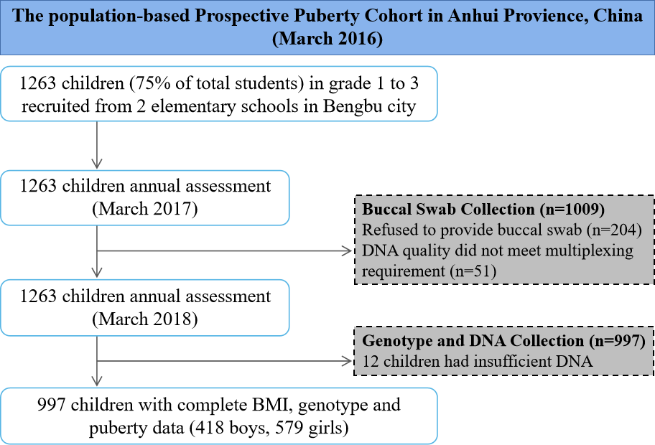
Figure A1

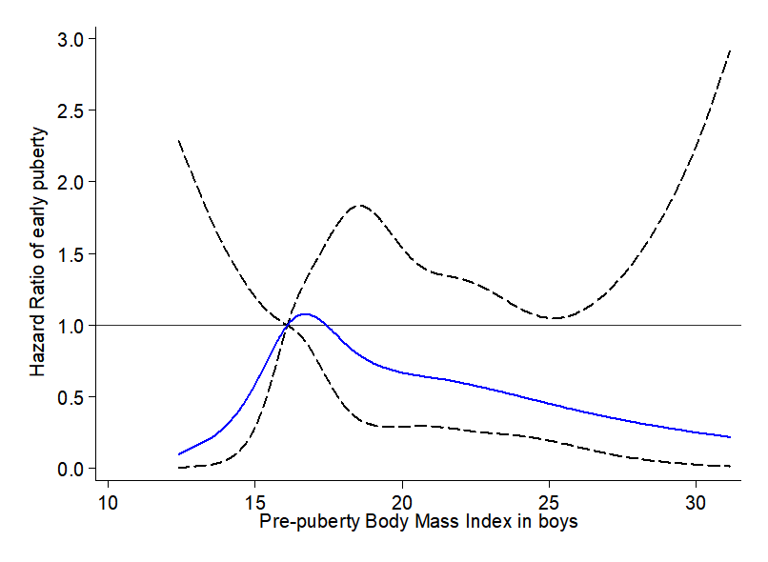
Figure A2 Restricted cubic spline for the association between prepuberty BMI and the HR for early testicular development among boys defined as testicular volume >=3ml.
Note: The curves are based on restricted cubic spline Cox regression with five knots of BMI and a reference BMI of 16.10 kg/m² (P₂₅). Individuals with BMI below the 1st or above the 99th percentiles were excluded. Analyses were adjusted for age, BMI- and puberty-related PRS, birthweight, delivery mode, infant feeding, family income, parental BMI and education.

