**Supplementary figures**

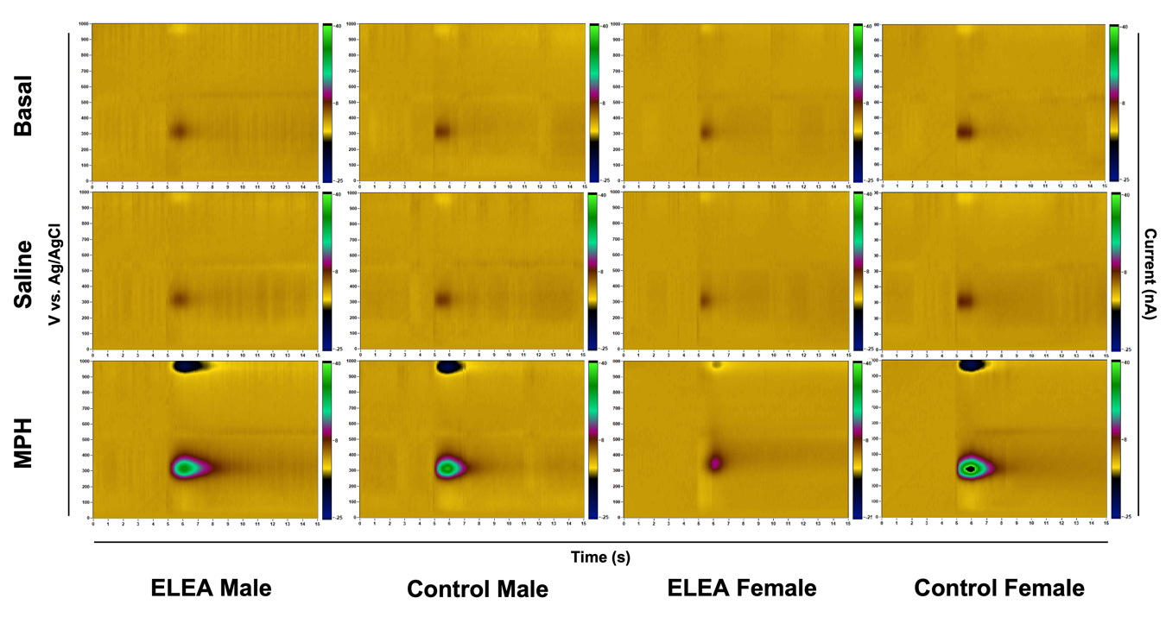**Supp. Figure 1**

Color plots of representative peak high of striatal DA release evoked by electrical stimulation in basal, saline (1 mL/Kg, i.p.) and MPH (5 mg/Kg, i.p.) conditions. MPH color plot represents the highest peak registered, at 45 min.

**Supp. Figure 2**

DA and DOPAC content of NAcc. There were no differences within the experimental groups.

**Supp. Figure 3**

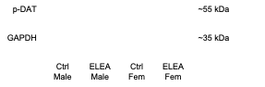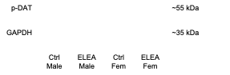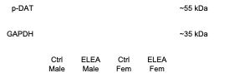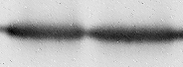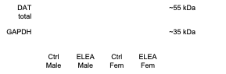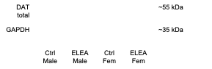

pDAT and total DAT protein levels expression from mesocorticolimbic system. No differences were observed in DAT expression within the mesocorticolimbic system.