Supplementary Material

# Ocean circulation model and particle tracking analysis

We used the output from the simulation in JCOPE-T DA (Japan Coastal Prediction Experiment, version T DA) (Miyazawa et al., 2021), which is a regional model of ocean circulation around Japan conducted by JAMSTEC (Japan Agency for Marine Earth Science and Technology). The model has the resolutions of 1/36° horizontally and 46 levels vertically with the generalized sigma-coordinates. The simulation is driven by wind stress, heat and freshwater fluxes. The wind stress and heat fluxes are calculated with the bulk formula (Li et al., 2010) from the hourly wind and temperature data provided by Global Forecast System (GFS) of National Centers for Environmental Prediction (NCEP) The freshwater flux is determined to represent the effects of precipitation and evaporation. The lateral boundary conditions are given by the analysis data of a JAMSTEC operational forecast model (JCOPE2M) (Hihara et al., 2017). The data used here assimilates the following observed data by a 3D-VAR method (Miyazawa et al., 2021): satellite SSH anomaly (Altika, Jason-3, Sentinel-3a, and -3b satellites), SST (Himawari-8 SST and MGDSST), and T/S data (Global Temperature–Salinity Profile Program). The fresh water discharge from the land is represented as water volume fluxes at river more than 100 mouth grids with monthly mean climatological discharge volumes.

To examine the change of the outflow of suspended matter from Sagami Bay with the change of the wind-driven circulation field resulting from typhoon passage, we conducted a dispersion simulation for particles on the surface flow field reproduced by JCOPE-T DA. In the initial state, virtual particles representing suspended matter are aligned along the northern coast of Sagami Bay. The horizontal particle dispersion at the surface is simulated using a particle tracking method provided by Ocean Parcels (https://oceanparcels.org/). This method calculates temporally varying particle locations by solving the Lagrangian equation for the Lagrange coordinates labeled by each particle with the aid of the Runge-Kutta method.

**References**

Hihara, T., Miyazawa, Y., and Miyama, T. (2017). Application Study of High-resolution Ocean Current Modeling toward the Frontal Wave Prediction.

Li, Y., Gao, Z., Lenschow, D. H., and Chen, F. (2010). An improved approach for parameterizing surface-layer turbulent transfer coefficients in numerical models. *Boundary-layer Meteorol.* 137, 153–165.

Miyazawa, Y., Varlamov, S. M., Miyama, T., Kurihara, Y., Murakami, H., and Kachi, M. (2021). A Nowcast/Forecast System for Japan’s Coasts Using Daily Assimilation of Remote Sensing and In Situ Data. *Remote Sens.* 13, 2431.

# 

# Supplementary Figures

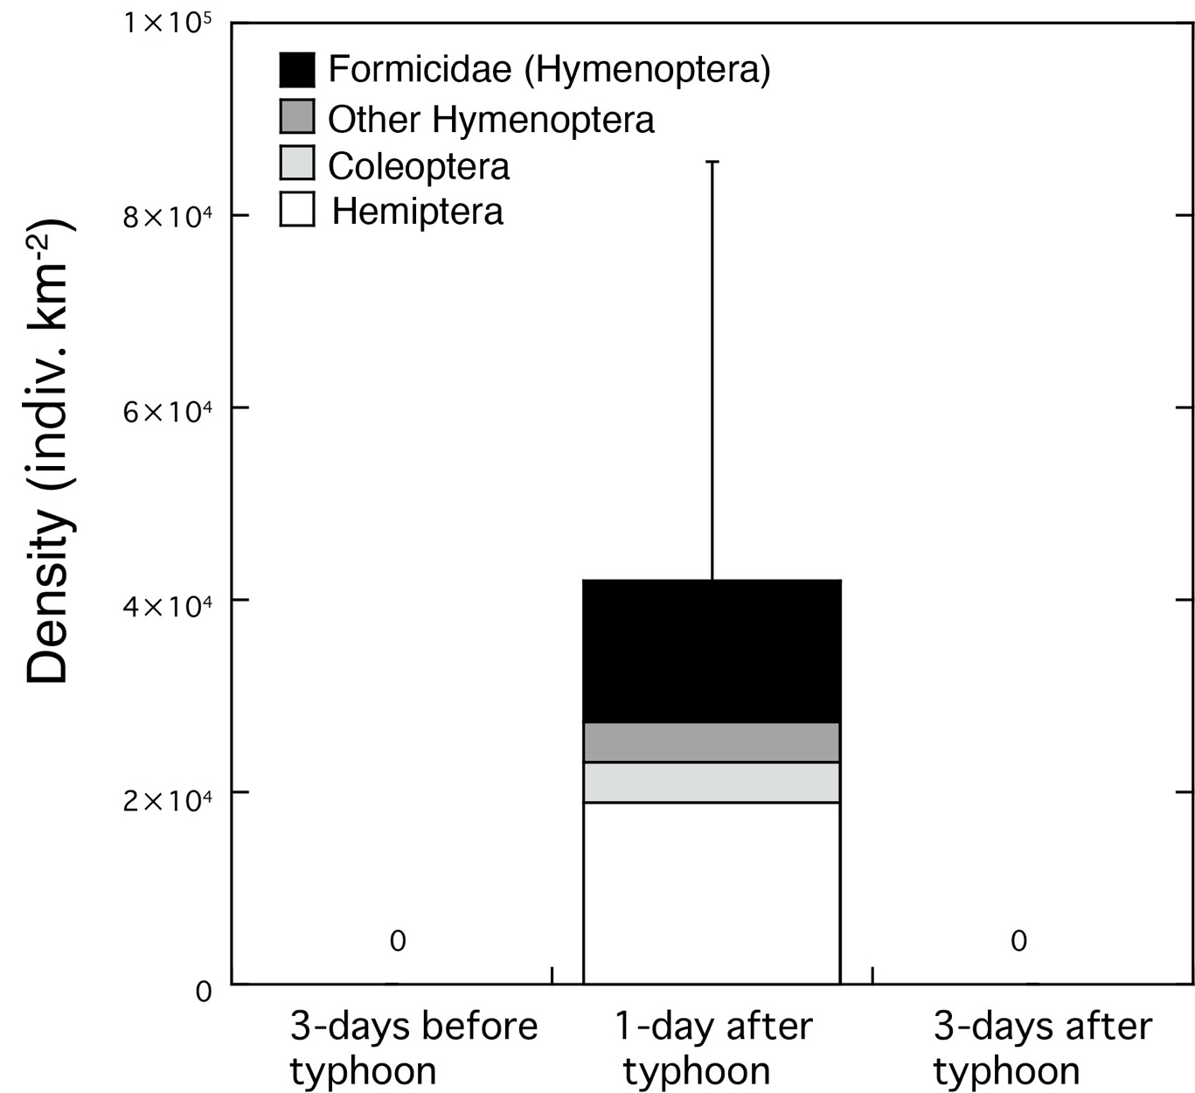

**Figure S1.** Changes in the density (individuals km-2) of insects collected by neuston net 3-days before and 1-day and 3-days after the typhoon. Error bars represent standard deviation (SD) of insect density for triplicate measurements. Each legend category indicates the proportion of each taxon per mean. The mean density (±SD) of insects 1-day after the storm was 42,027 ± 43,420 individuals km-2. Hemiptera were the most dominant group, contributing with 45% to the total insect density, followed by Formicidae (Hymenoptera, 35%). Insects were not collected before the typhoon or 3-days after the typhoon.

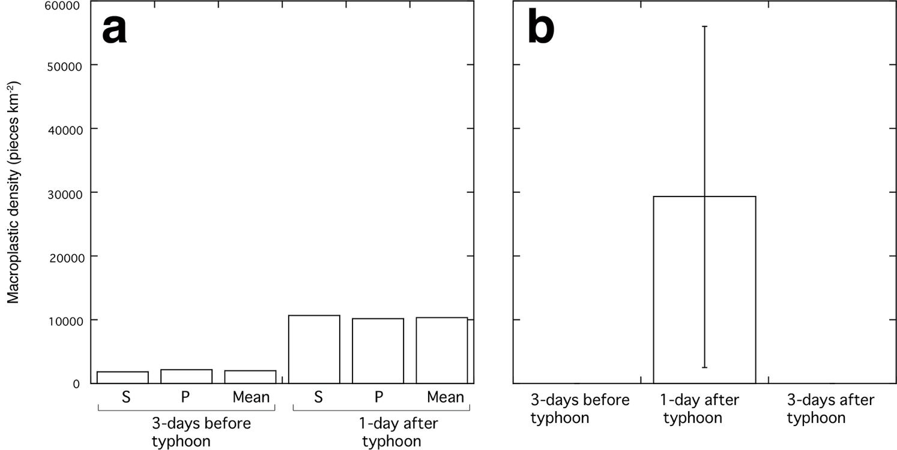

**Figure S2.** Changes in the density (pieces km-2) of (a) macroplastics observed visually from the ship 3-days before and 1-day after typhoon passage and (b) macroplastics collected by neuston net 3-days before and 1-day and 3-days after the typhoon. S and P on (a) donate starboard side and port side of the ship, respectively.

# Supplementary Videos’ captions

**Video S1.** Particle tracking simulations at the surface of Sagami Bay before the typhoon passage (September 2nd 2019, 9JST).

**Video S2.** Particle tracking simulations at the surface of Sagami Bay after the typhoon passage (September 9th 2019, 4JST).