Physical origin of dual-emission of Au–Ag bimetallic nanoclusters

Supplementary Material

# Supplementary Figures



**Supplementary Figure S1.** Thermalgravimetric analysis (TGA) of AgxAu@DT NCs with different ratio of Ag to Au.

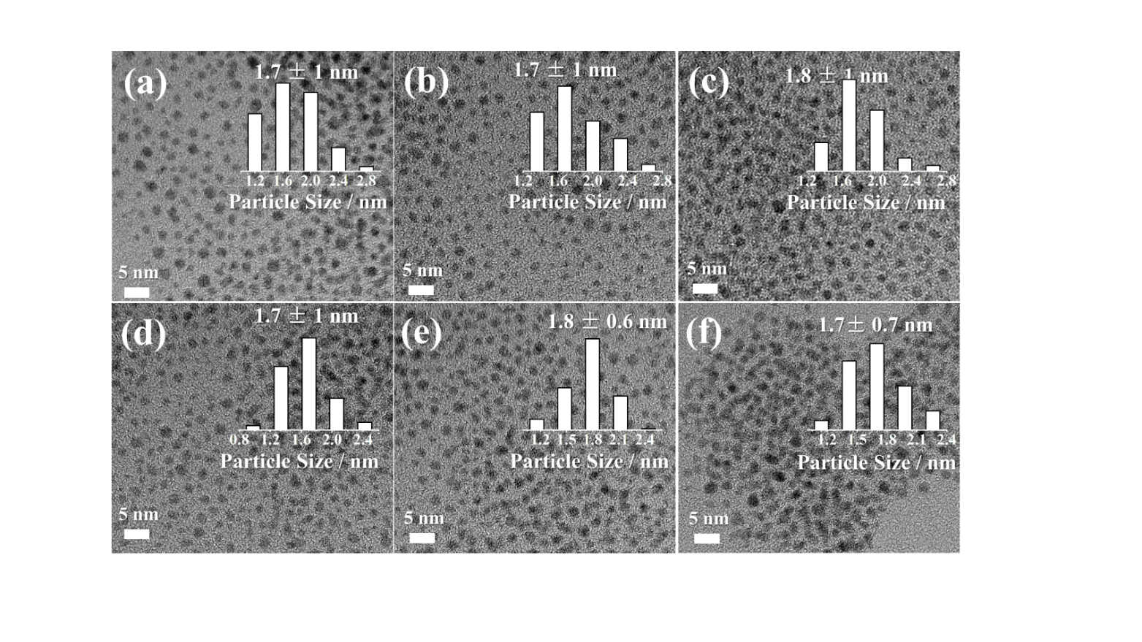

**Supplementary Figure S2.** HRTEM micrograph of Ag0Au@DT (a), Ag0.25Au@DT @DT (b), Ag0.5Au@DT (c), Ag1Au@DT (d), Ag2Au@DT NCs (e) and Ag4Au@DT NCs (f), respectively. The scale bar is 10 nm. The inset shows the size distribution.



**Supplementary Figure S3.** XPS spectrum of S 2p for Ag0Au@DT (a), Ag0.25Au@DT @DT (b), Ag0.5Au@DT (c), Ag1Au@DT (d), Ag2Au@DT NCs (e) and Ag4Au@DT NCs (f), respectively.



**Supplementary Figure S4.** Photoluminescence spectra of as-synthesized Ag1Au@DT NCs after adding increasing amount (0, 0.5, 0.75, 1.0, 1.25, 1.5, 1.75, 2.0 and 2.25 nmol) of 50 mM K2S aqueous solution. The inset displays the relationship between photoluminescence (440 nm and 630 nm) intensity and the added mole amount of K2S.



**Supplementary Figure S5.** PL emission spectra of Ag1Au@DT NCs synthesized at increasing DT concentration (0.25, 0.5, 1, 2, 4, 8, 18, 36 and 72 equivalent to metal, respectively). The inset displays the relationship between photoluminescence (440 nm and 630 nm) intensity and the amount of DT equivalent to metal.

# Supplementary Tables

## Supplementary Table S1. The ratio of Ag to Au of AgxAu@DT NCs determined by ICP-OES analysis.

|  |  |  |  |  |  |
| --- | --- | --- | --- | --- | --- |
| ***Sample*** | | ***The molar ratio of Ag-Au*** | | | ***Stoichiometric Formulaa*** |
| ***Feed*** | | ***ICP*** |
| ***Ag0Au@DT NCs*** | ***0*** | | ***-*** | | ***Ag0Au1 DT0.9*** |
| ***Ag0.25Au@DT NCs*** | ***0.25*** | | ***0.11*** | | ***Ag0.1Au1DT1.2*** |
| ***Ag0.5Au@DT NCs*** | ***0.5*** | | ***0.23*** | | ***Ag0.2Au1DT1.4*** |
| ***Ag1Au@DT NCs*** | ***1*** | | ***0.47*** | | ***Ag0.5Au1DT1.5*** |
| ***Ag2Au@DT NCs*** | ***2*** | | ***1.02*** | | ***Ag1Au1DT2.2*** |
| ***Ag4Au@DT NCs*** | ***4*** | | ***1.25*** | | ***Ag1.3Au1DT2.7*** |

aStoichiometric formula was estimated by the calculation of DT to metal weight ratio (TG analysis) and Ag to Au molar ratio (ICP analysis) of AgxAu@DT NCs.

**Supplementary Table S2.** XPS peak parameters for the S state (**Supplementary Figure S4**) of AgxAu@DT NCs.

|  |  |  |  |  |
| --- | --- | --- | --- | --- |
| ***Sample*** | ***Atom*** | ***Item*** | ***Position (eV)*** | ***Content (%)*** |
| ***Ag0Au@DT NCs*** | ***S 2p*** | ***Ag(I)-SR*** | ***161.6*** | - |
| ***Au(I)-SR*** | ***162.3*** | ***100*** |
| ***Ag0.25Au@DT NCs*** | ***Ag(I)-SR*** | ***161.6*** | ***27.3*** |
| ***Au(I)-SR*** | ***162.2*** | ***72.7*** |
| ***Ag0.5Au@DT NCs*** | ***Ag(I)-SR*** | ***161.7*** | ***48.7*** |
| ***Au(I)-SR*** | ***162.3*** | ***51.3*** |
| ***Ag1Au@DT NCs*** | ***Ag(I)-SR*** | ***161.7*** | ***63.2*** |
| ***Au(I)-SR*** | ***162.3*** | ***36.8*** |
| ***Ag2Au@DT NCs*** | ***Ag(I)-SR*** | ***161.8*** | ***74.4*** |
| ***Au(I)-SR*** | ***162.5*** | ***25.6*** |
| ***Ag4Au@DT NCs*** | ***Ag(I)-SR*** | ***161.7*** | ***88.5*** |
| ***Au(I)-SR*** | ***162.7*** | ***10.5*** |

**Supplementary Table S3.** XPS peak parameters for the O (**Figure 4b**) states of Ag***x***Au@DT NCs

|  |  |  |  |  |
| --- | --- | --- | --- | --- |
| ***Sample*** | ***Atom*** | ***Item*** | ***Position (eV)*** | ***Content (%)*** |
| ***Ag0Au@DT NCs*** | ***O 1s*** | ***Au+-OH*** | ***531.8*** | ***52.4*** |
| ***Ag+-H2O*** | ***-*** | - |
| ***Au0-H2O*** | ***533.2*** | ***47.6*** |
| ***Ag0.25Au@DT NCs*** | ***Au+-OH*** | ***531.8*** | ***39.7*** |
| ***Ag+-H2O*** | ***532.3*** | ***25.0*** |
| ***Au0-H2O*** | ***533.2*** | ***35.3*** |
| ***Ag0.4Au@DT NCs*** | ***Au+-OH*** | ***-*** | ***-*** |
| ***Ag+-H2O*** | ***532.3*** | ***100*** |
| ***Au0-H2O*** | ***-*** | ***-*** |