**A holistic study on the effect of annealing temperature and time on CH3NH3PbI3-based perovskite solar cell characteristics**

Mohammad Ali AKHAVAN KAZEMI1, Arash JAMALI2 and Frédéric SAUVAGE1*

1. Laboratoire de Réactivité et Chimie des Solides (LRCS), UMR CNRS 7314 - Institut de Chimie de Picardie FR 3085, Université de Picardie Jules Verne, 33 rue Saint Leu, 80039 Amiens Cedex, France.
2. Plateforme de microscopie électronique, Université de Picardie Jules Verne, HUB de l’Energie, 15 rue Baudelocque, 80039 Amiens Cedex 1, France

E-mail: [frederic.sauvage@u-picardie.fr](mailto:frederic.sauvage@u-picardie.fr)

**Supplementary information**



**Figure S1.** Evolution of the UV−visible absorption spectrum as a function of annealing temperature.

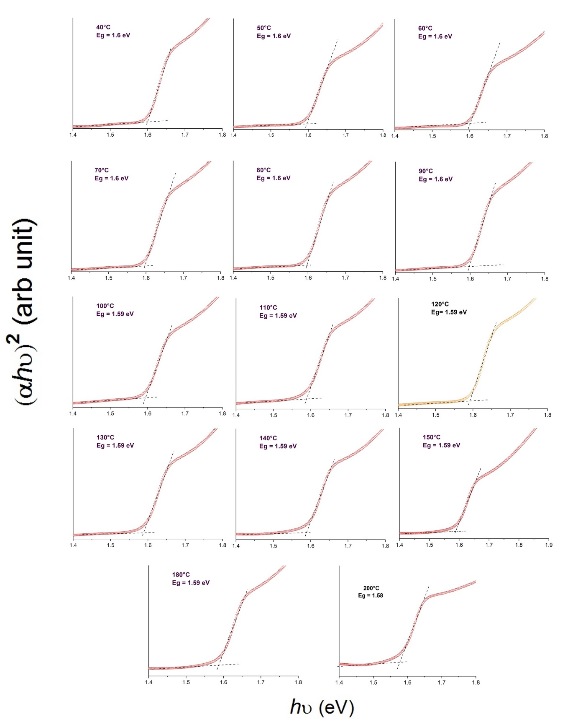

**Figure S2.** Tauc plot comparison for different MAPbI3 film annealed at different temperatures

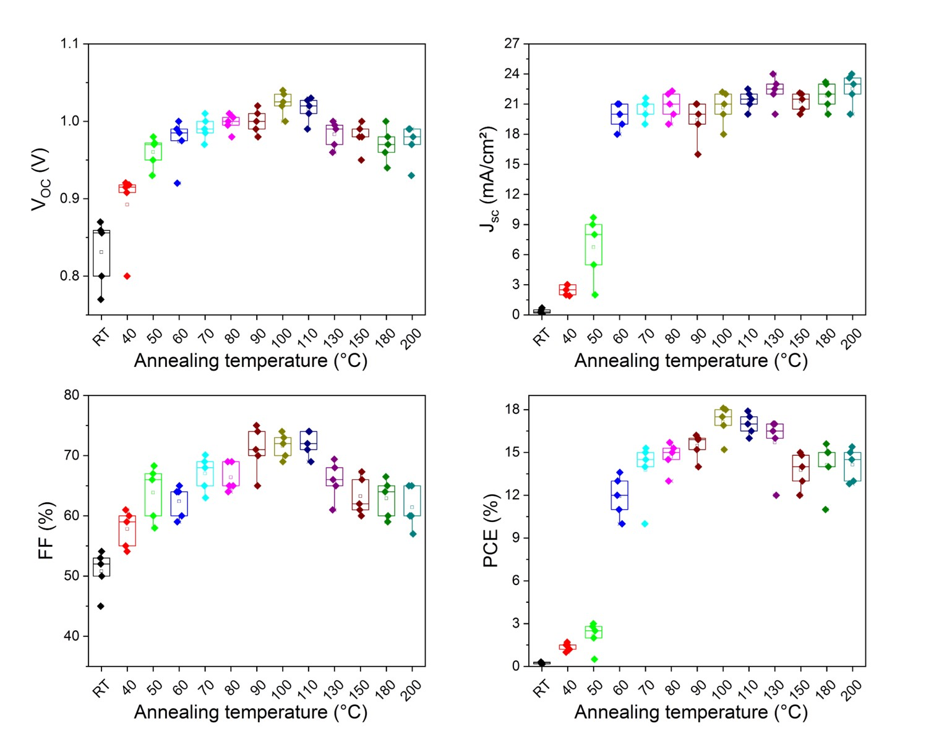

**Figure S3** . Statistics parameters of *Jsc*, *Voc*, *FF*, and PCE for the PSCs prepared with different annealing temperatures.

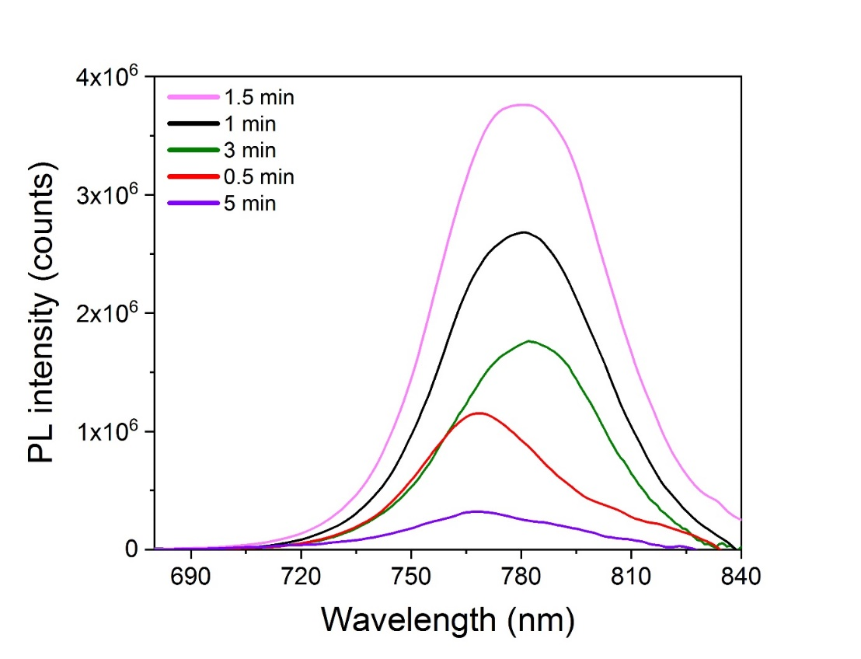

**Figure S4** . Comparison of steady-state PL measured at 450 nm excitation for MAPbI3 film annealed at 200°C as a function of time

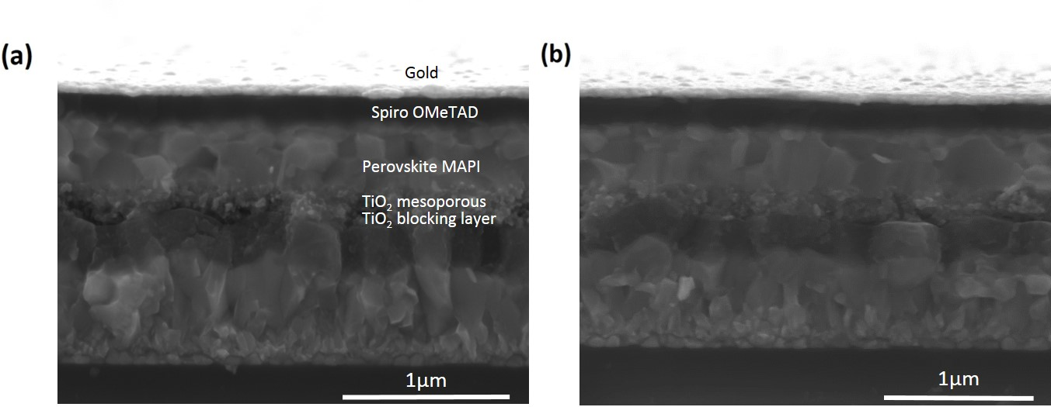

**Figure S5**. High magnification cross-sectional SEM images of (a) MAPbI3 film annealed at 100°C during 30 minutes (b) MAPbI3 film annealed at 200°C for 1.5 minutes.

**Table S1**. Summary of opto-electronic parameters obtained for the films annealed between the room-temperature and 200 °C.

|  |  |  |  |  |
| --- | --- | --- | --- | --- |
| Annealing Temperature | Bandgap  (eV) | PL band  (nm) | FWHM of PL (nm) | Urbach energy (meV) |
| RT | - | 735 | 85 | - |
| 40°C | 1.60 | 770 | 61 | 59.5 |
| 50°C | 1.60 | 774 | 57 | 64.5 |
| 60°C | 1.60 | 773 | 57 | 56.5 |
| 70°C | 1.60 | 772 | 52 | 64.0 |
| 80°C | 1.60 | 771 | 57 | 62.0 |
| 90°C | 1.60 | 780 | 55 | 61.8 |
| 100°C | 1.59 | 780 | 47 | 81.0 |
| 110°C | 1.59 | 781 | 46 | 83.0 |
| 120°C | 1.59 | 770 | 47 | 84.0 |
| 130°C | 1.59 | 770 | 47 | 87.5 |
| 140°C | 1.59 | 775 | 47 | 86.2 |
| 150°C | 1.59 | 780 | 50 | 90.5 |
| 180°C | 1.59 | - | - | 96.2 |
| 200°C | 1.58 | 780 | 49 | 103.5 |

**Table S2.** Summary of device performances obtained in reverse scan under AM 1.5G conditions for different annealing temperatures of MAPbI3 film between room-temperature and 200°C.

|  |  |  |  |  |
| --- | --- | --- | --- | --- |
| T (°C) | Voc (V) | Jsc (mA/cm2) | FF (%) | PCE (%) |
| RT | 0.87 | 0.7 | 54.6 | 0.3 |
| 40 | 0.92 | 3.0 | 61.0 | 1.7 |
| 50 | 0.98 | 9.7 | 68.3 | 3.0 |
| 60 | 1.00 | 21.0 | 65.0 | 13.6 |
| 70 | 1.01 | 21.6 | 70.1 | 15.3 |
| 80 | 1.01 | 22.3 | 69.0 | 15.7 |
| 90 | 1.02 | 21.0 | 75.0 | 16.2 |
| 100 | 1.04 | 22.2 | 74.3 | 18.1 |
| 110 | 1.03 | 22.5 | 74 | 17.9 |
| 130 | 1.00 | 24.0 | 69.4 | 17.0 |
| 150 | 1.00 | 22.1 | 67.3 | 15.0 |
| 180 | 1.00 | 23.2 | 66.5 | 15.6 |
| 200 | 0.99 | 24.0 | 65.0 | 15.4 |