Supplementary Material

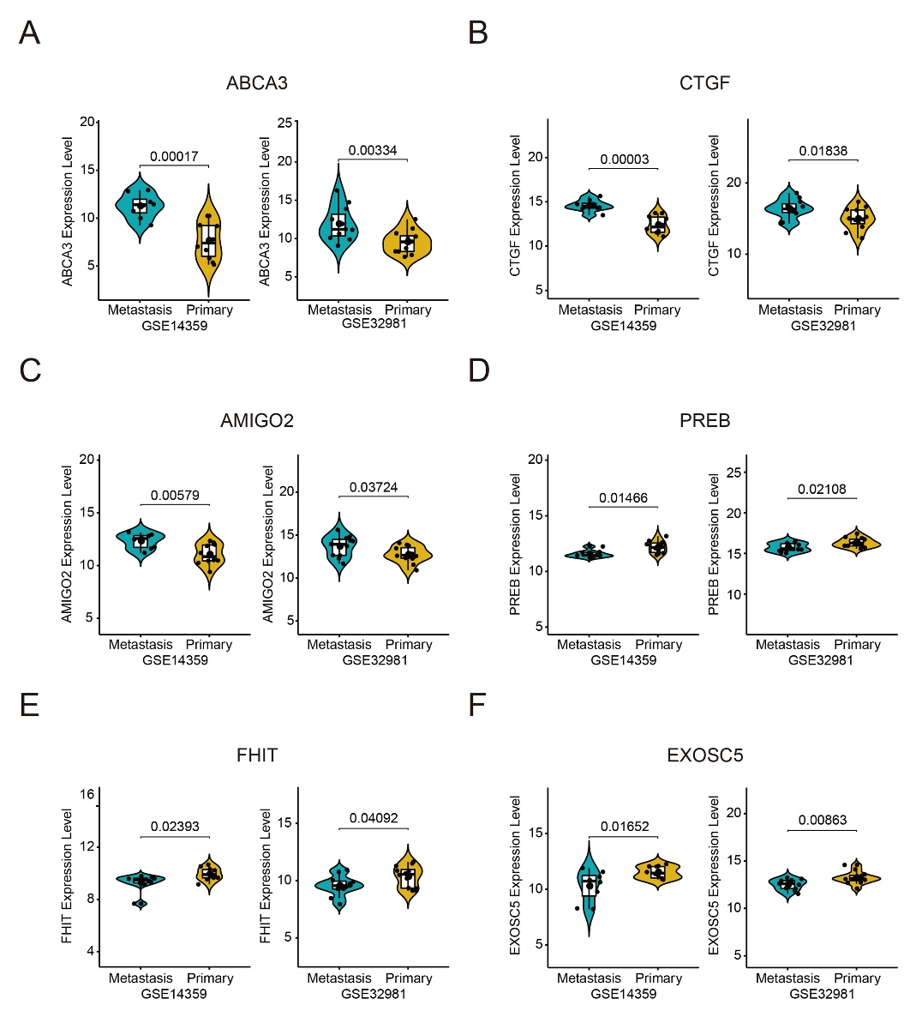

**Supplementary Figure 1.** The expression of the six MRGs in primary and metastatic osteosarcoma samples in the GSE14359 and GSE32981 datasets. (A-F) *ABCA3*, *CTGF*, *AMIGO2*, *PREB*, *FHIT*, and *EXOSC5* expression in primary and metastatic osteosarcoma.

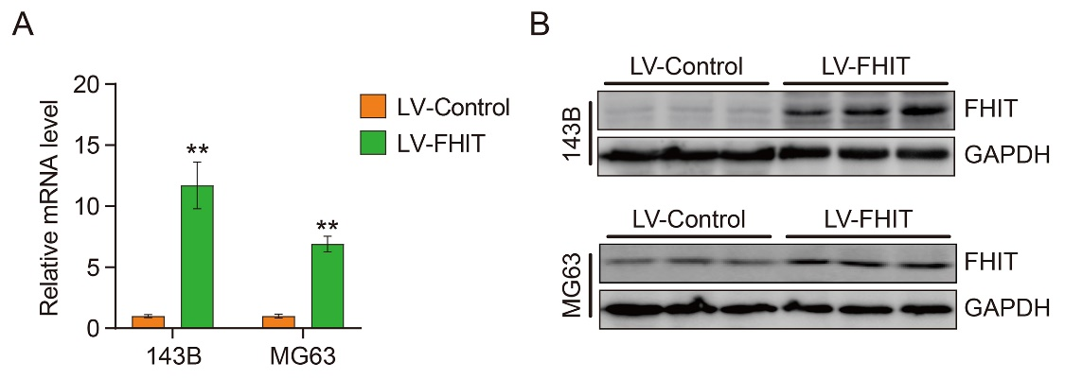

**Supplementary Figure 2.** The mRNA (A) and protein (B) expression levels of FHIT were significantly increased in stably transfected 143B and MG63 osteosarcoma cells.