Supplementary Material
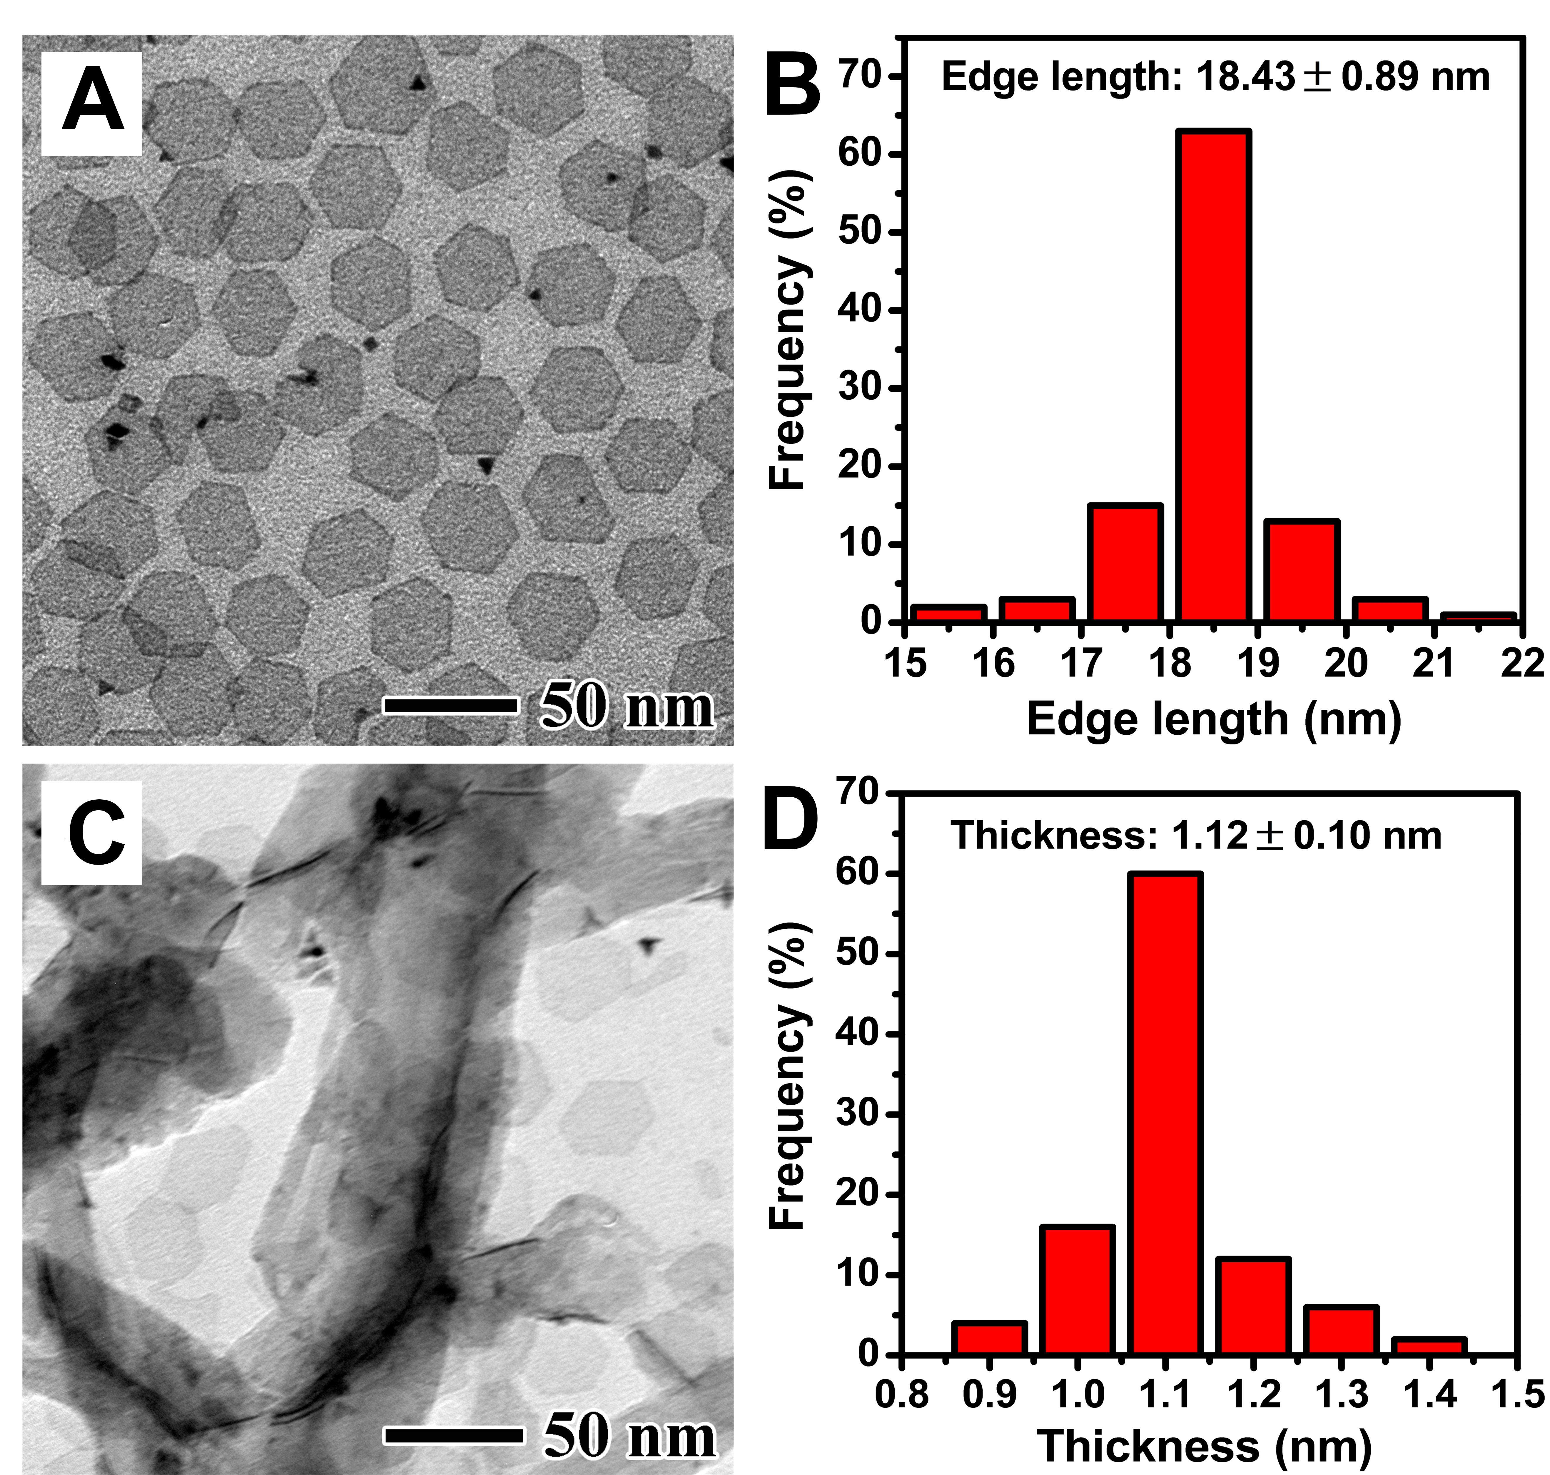
Figure S1. TEM images of the Pd nanoplates seeds that (A) lay flat on the TEM grid and (C) attached vertically on the carbon nanotubes. The corresponding (B) edge length and (D) thickness distributions of the Pd seeds.

Figure S2. The XRD patterns of the Pd@PtM (M = Rh, Ni, Pd, or Cu) multimetallic nanorings.

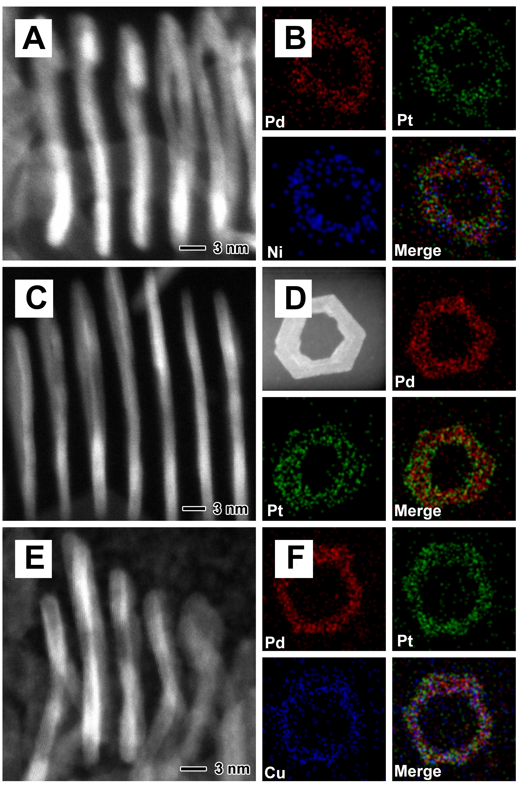
Figure S3. HAADF-STEM images of the vertically standing nanorings and EDX mapping images of the planar nanorings for (A, B) Pd@PtNi nanorings, (C, D) Pd@PtPd nanorings, and (E, F) Pd@PtCu nanorings, respectively.

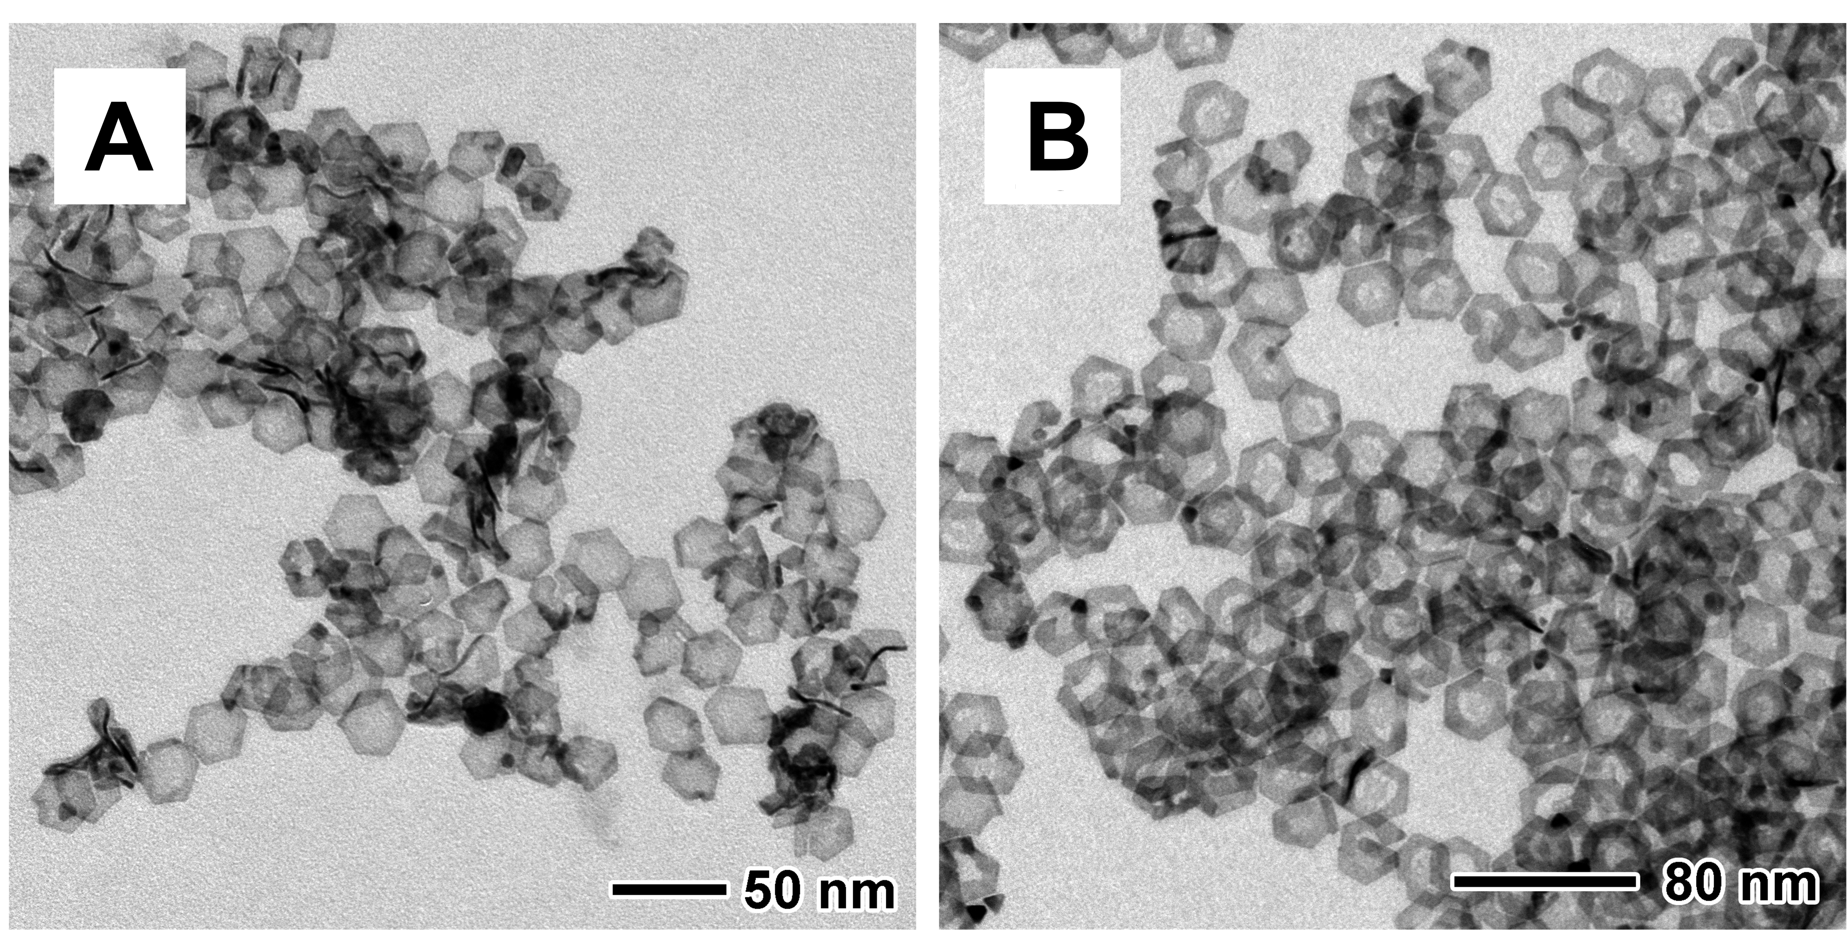
Figure S4. TEM images of Pd@PtRh nanoplates prepared in (A) CO atmosphere and BA solution, (B) Ar atmosphere and BAL solution

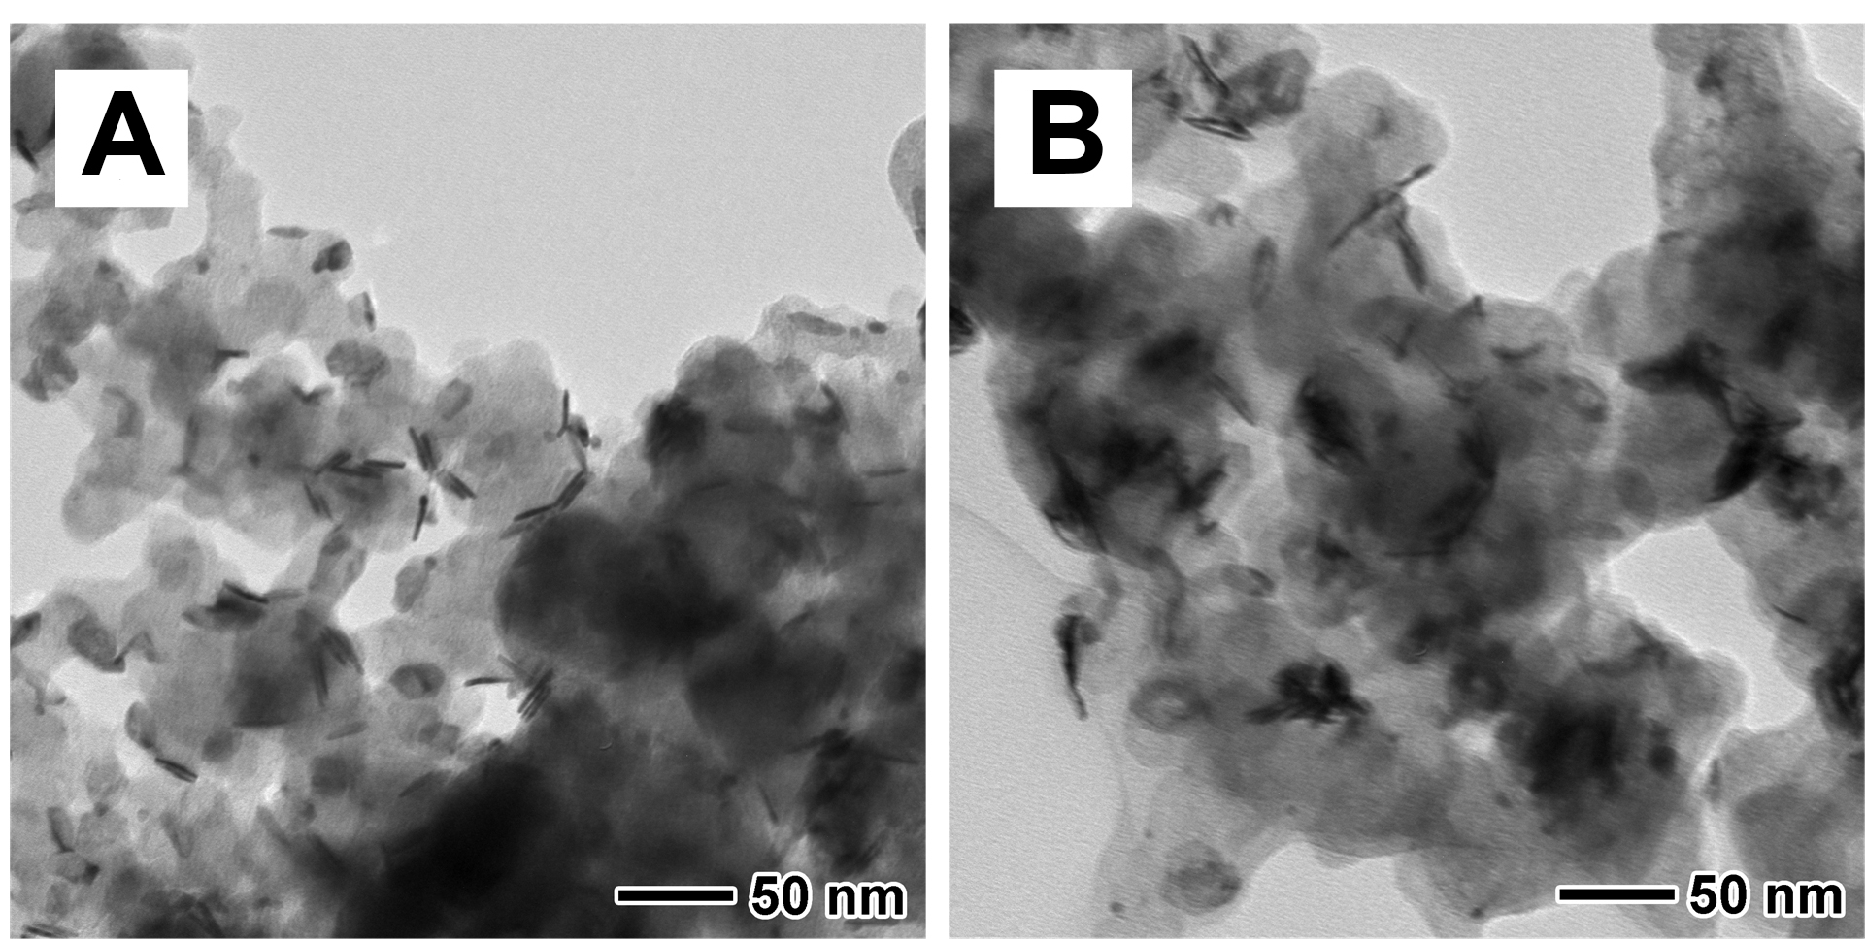
Figure S5. TEM images of carbon supported (A) Pd@PtRh nanoplate and (B) Pd@PtRh nanoring catalysts.
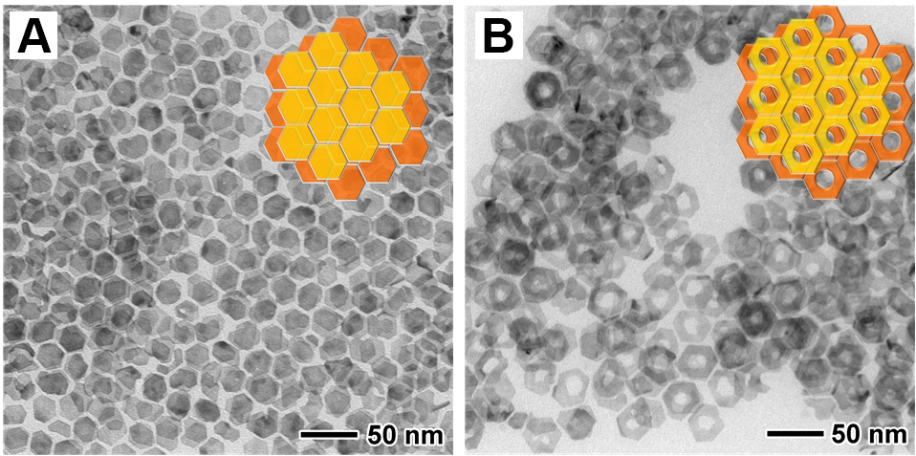
Figure S6. TEM images of a few layers of (A) Pd@PtRh nanoplates and (B) nanorings which are both assembled in a face-to-face way. The insets show the corresponding models.

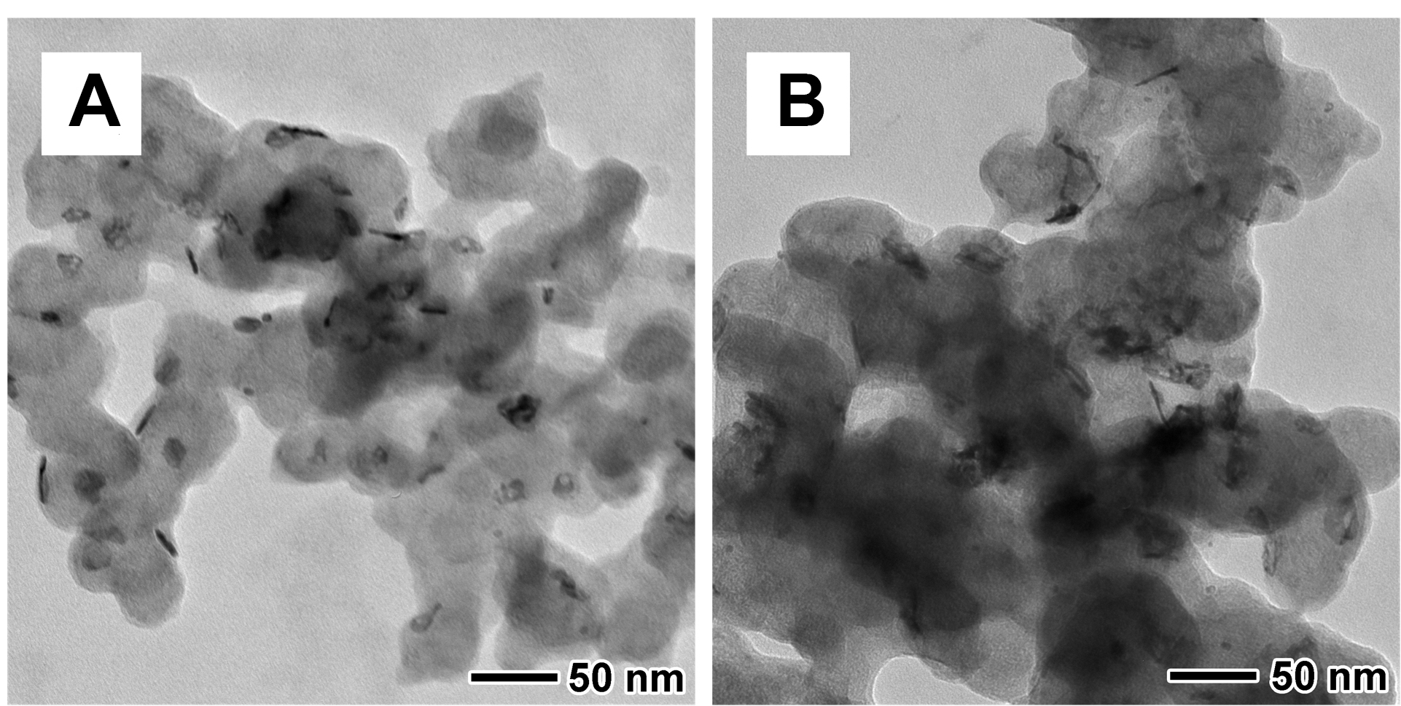
Figure S7. Representative TEM images for the (A) Pd@PtRh nanoplates and (B) Pd@PtRh nanorings after electrochemical durability tests.

Table S1. ICP-AES data of the Pd@PtM (M = Rh, Ni, Cu) nanorings for Pt/M ratio.
Pt : M  (M = Rh, Ni, Cu) | molar ratio of the metal  precursors | atomic ratio of Pt/M
Pd@PtRh | 75 : 25 | 88.2 : 11.8
Pd@PtNi | 50 : 50 | 72.9 : 27.1
Pd@PtCu | 50 : 50 | 67.7 : 32.3

Table S2. ECSAs of Pd@PtRh nanorings, nanoplates and Pt/C calculated from H_{UPD} charge, and the specific and mass activities of these three catalysts for EOR.
Samples | ECSA (m²/g) | i_{s} (mA/cm²) | i_{m} (A/mg_{metal}) | i_{m} (A/mg_{Pt})
Pt/C | 83.3 | 0.422 | 0.352 | 0.352
Pd@PtRh nanoplates | 56 | 0.558 | 0.31 | 0.63
Pd@PtRh nanorings | 182 | 0.802 | 1.46 | 3.07

Table S3. Comparison of EOR performance of Pd@PtRh nanorings in this work with state of art electrocatalysts in the literatures.
Samples | Conditon | i_{s} (mA/cm²) | i_{m} (A/mg_{Pt}) | Ref.
Pd@PtRh nanorings | 0.5 M H₂SO₄ + 0.5 M EtOH | 0.802 | 3.07 | This work
Pt₃Sn NFs-L/C | 0.1 M HClO₄ + 0.5 M EtOH | 2.10 | 1.46 | ACS Catal. 2020, 10, 5, 3455–3461
Rh @ Pt_{3.5L} | 0.1 M HClO₄ + 0.2 M EtOH | 0.81 | 1.18 | Adv. Funct. Mater. 2019, 29, 1806300
Pt–Rh–Ni/C | 0.5 M H₂SO₄ + 0.5 M EtOH | / | 0.65 | Electrochimica Acta 2020, 351, 136223
Rh@Pt d-CNCs/C | 0.1 M HClO₄ +0.2 M EtOH | 2.62 | 0.86 | J. Mater. Chem. A, 2019,7, 17987-17994
Pt-0.5SnO_{x}/NCNC | 0.5 M H₂SO₄ + 0.5 M EtOH | / | 1.19 | ACS Catal. 2018, 8, 9, 8477–8483
Pt-Mo-Ni NWs | 0.5 M H₂SO₄ + 2 M EtOH | 2.57 | 0.87 | Sci. Adv. 2017, 3, e1603068-e1603076

