Supplementary material

Table of contents

Supplementary Tables 3
Supplementary Figures 7

Supplementary Tables

Supplementary Table 1. List of crop commodities considered in the analysis.
Crop commodity | Crop category
Barley | Cereals
Groundnut | Legumes
Maize | Cereals
Potato | Root vegetables
Sugar beet | Root vegetables
Rice | Cereals
Sunflower | Oil and protein crops
Sorghum | Cereals
Soybean | Oil and protein crops
Wheat | Cereals

Supplementary Table 2. Fraction of total production in major use groups food, feed and processing. Fraction of total production in major use groups food, feed and processing for the crops in this study according to FAOSTAT and the total fraction of the three use classes compared to total global production in the year 2015. Other uses, i.e. seed production, waste, losses, stock variation, and industrial use, are typically minor fractions and not displayed here.
Crop commodities | Food | Feed | Processing | Total of three use types
Barley | 5.4 | 56.1 | 19.0 | 80.5
Groundnuts (Shelled Eq) | 39.5 | 4.7 | 40.8 | 84.9
Maize and products | 12.9 | 56.0 | 4.4 | 73.3
Potatoes and products | 63.0 | 12.3 | 2.4 | 77.7
Rice (Milled Equivalent) | 77.9 | 6.4 | 1.3 | 85.6
Sorghum and products | 38.8 | 45.2 | 6.0 | 90.0
Soybeans | 3.1 | 6.6 | 82.9 | 92.7
Sugar beet | 0.1 | 5.6 | 91.8 | 97.5
Sunflower seed | 1.2 | 5.8 | 81.0 | 88.0
Wheat and products | 62.9 | 19.5 | 1.4 | 83.8
Total for selected crops | 39.2 | 25.9 | 17.2 | 82.3

Supplementary Table 3. Description of cost components for crop commodities. Data on listed production costs originally reflect national level prices that is derived and collected directly from the sources listed below as open-source empirical data at the farm level. National scale information was then adjusted internally in the present analysis, with the use of the intensification factor (IF) to estimate sub-national variability of production costs.
Cost variable code | Cost Variables | Description | Data source
SDC | Seed costs |  | USDA,  Indian ministry of agriculture,  UK Farm Business Survey,  FADN,  Russian Federal State Statistics Service Rosstat,  World Bank national accounts data,  OECD National Accounts data files, FAO
TFRC | Fertiliser costs | Nitrogen Costs
 |  | Phosphorus Costs
 |  | Other fertilizer costs
PPC | Plant protection costs | Pesticides
 |  | Other chemicals
TLAC | Labour Costs | Paid
 |  | Unpaid
TFLC | Fuel and lubricant Costs
TIRC | Irrigation
TFIN | Financing | Insurance
 |  | Taxes
 |  | Capital costs
INFC | Infrastructure (Buildings) | Heating, lighting
TMAC | Machinery | Repairs | KTBL
 |  | Depreciation
 |  | Interest

Supplementary Table 4. Listed data sources with corresponding links for access to farm physical and financial data.
Data source | Data access link
Agricultural advisory board for engineering and building - KTBL | https://daten.ktbl.de/vrpflanze/home.action
Farm Accountancy Data Network - FADN | https://agridata.ec.europa.eu/extensions/DashboardFarmEconomyFocusCrops/DashboardFarmEconomyFocusCrops.html
Food and Agriculture Organisation | http://www.fao.org/faostat/en/#data/QC
Indian ministry of agriculture | https://eands.dacnet.nic.in/Cost_of_Cultivation.htm
Organisation for Economic Co-operation and Development - OECD National Accounts data files | https://stats.oecd.org/Index.aspx?DataSetCode=NAAG
Russian Federal State Statistics Service - Rosstat | http://old.gks.ru/wps/wcm/connect/rosstat_main/rosstat/en/figures/agriculture/
UK Farm Business Survey - FBS | http://www.farmbusinesssurvey.co.uk/benchmarking/Default.aspx?module=Profit_
United States Department of Agriculture - USDA | https://www.ers.usda.gov/data-products/commodity-costs-and-returns/
World Bank national accounts data | https://data.worldbank.org/
Supplementary Table 5. Fertiliser price analogues per country. Similarly to the rest of the cost elements in this analysis (except for Machinery expenses derived from KTBL), are estimated using financial information from the baseline country that is equalised through the use of PPP index. Here, PPP is used as a spatial price deflator to estimate fertiliser costs from the real price perspective in which their value is expressed in terms of a bundle of goods and services (consumer goods and services, government services and capital goods). Effects of remoteness/transportation costs and tariffs on fertiliser costs per country are not explicitly included in the calculations of the present analysis.
a. Cereals fertiliser cost analogues
EU country | FADN reported | Modelled
Latvia | 19.80% | 19.64%
Estonia | 18.90% | 18.29%
United Kingdom | 19.60% | 18.87%
Bulgaria | 17.80% | 19.07%
Finland | 17.30% | 18.69%
Hungary | 17.40% | 19.96%
Germany | 14.80% | 17.91%
Sweden | 22.20% | 17.83%
Spain | 23.70% | 18.19%
France | 24.10% | 17.89%
Poland | 26.60% | 19.14%
Ireland | 26.50% | 18.86%
Lithuania | 27.50% | 19.09%
Austria | 13.70% | 4.26%
Italy | 14.80% | 4.27%
Denmark | 7.50% | 18.78%
Czech Republic | 14.50% | 25.77%
Romania | 17.40% | 4.63%
Portugal | 18.10% | 4.28%
Greece | 23.60% | 3.90%
Cyprus | 27.40% | 3.89%
b. Root plants (potatoes and sugar beet)
EU country | FADN reported | Modelled
Estonia | 7.61% | 8.01%
Latvia | 6.56% | 6.12%
Denmark | 6.95% | 8.24%
Netherlands | 6.65% | 8.24%
Germany | 11.33% | 7.95%
Czech Republic | 11.35% | 7.95%
Hungary | 11.85% | 8.24%
Finland | 12.16% | 8.24%
Bulgaria | 12.63% | 7.95%
Belgium | 13.69% | 8.24%
Austria | 11.02% | 5.45%
Italy | 11.02% | 5.45%
United Kingdom | 14.19% | 8.46%
Sweden | 13.97% | 7.95%
Cyprus | 12.28% | 5.24%
Romania | 13.46% | 5.80%
France | 16.78% | 7.95%
Spain | 17.14% | 7.95%
Greece | 15.43% | 5.26%
Poland | 18.86% | 8.25%
Portugal | 16.44% | 5.45%

Supplementary Figures

Supplementary Figure 1. Relationship between cropland field size and a. technological adoption (number of tractors in use), b. GDP per capita.
a. Relationship between technological adoption (number of tractors in use) and cropland field size
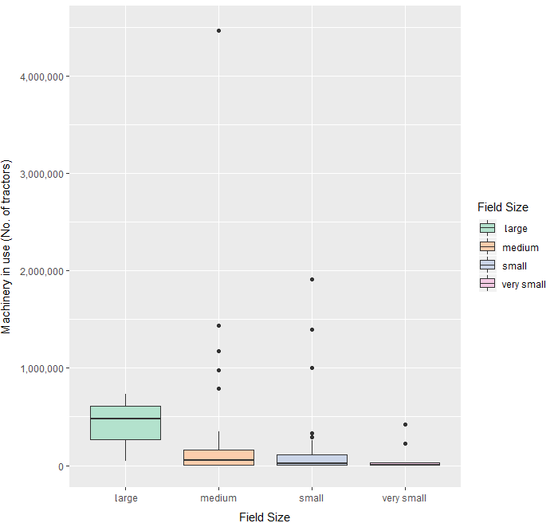
b. Relationship between GDP per capita (current US$ in 2017) and cropland field size
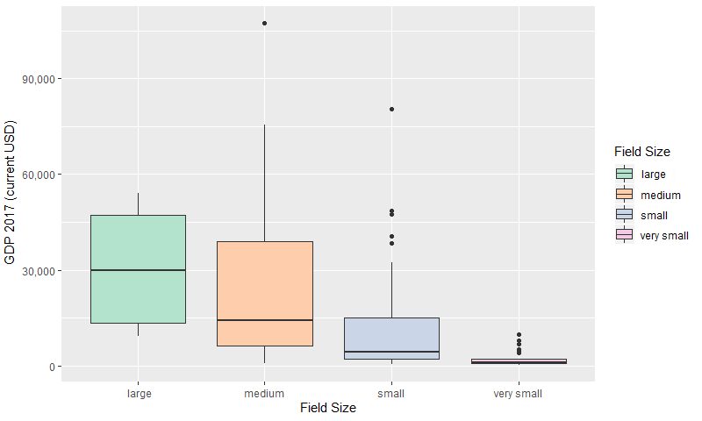

Supplementary Figure 2. Intensification factor per crop and water regime in the business as usual and the land sparing and sharing production scenarios (grouped by crop commodity). Boxplots display the distribution of intensity of production index (IF) in the business as usual and the two land sparing-sharing production scenarios for the 10 crops considered, arranged by crop commodity.
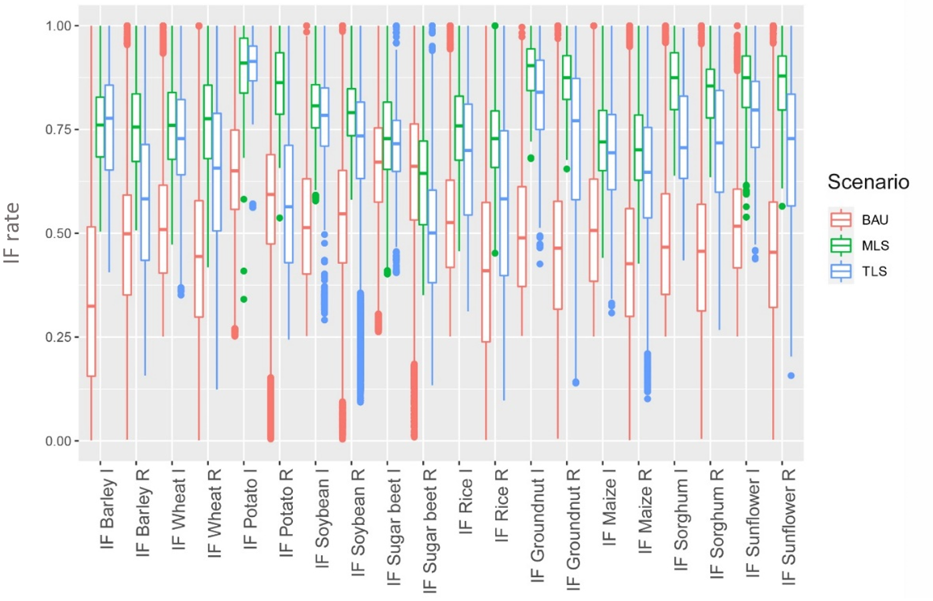

Supplementary Figure 3. Changes in total costs per hectare for the 10 crops at a global scale. The stacked bars represent the average changes of cost per hectare (ha) (increase and decrease) for the 10 crops and the two land allocation scenarios. Changes in costs per ha occur in cases that production is more intensive in MLS and TLS than in BAU, costs per hectare increase due to increased corresponding production input requirements (e.g. nutrients). However, costs per ha decrease when production systems become less intensive after the optimisation of cropland allocation.
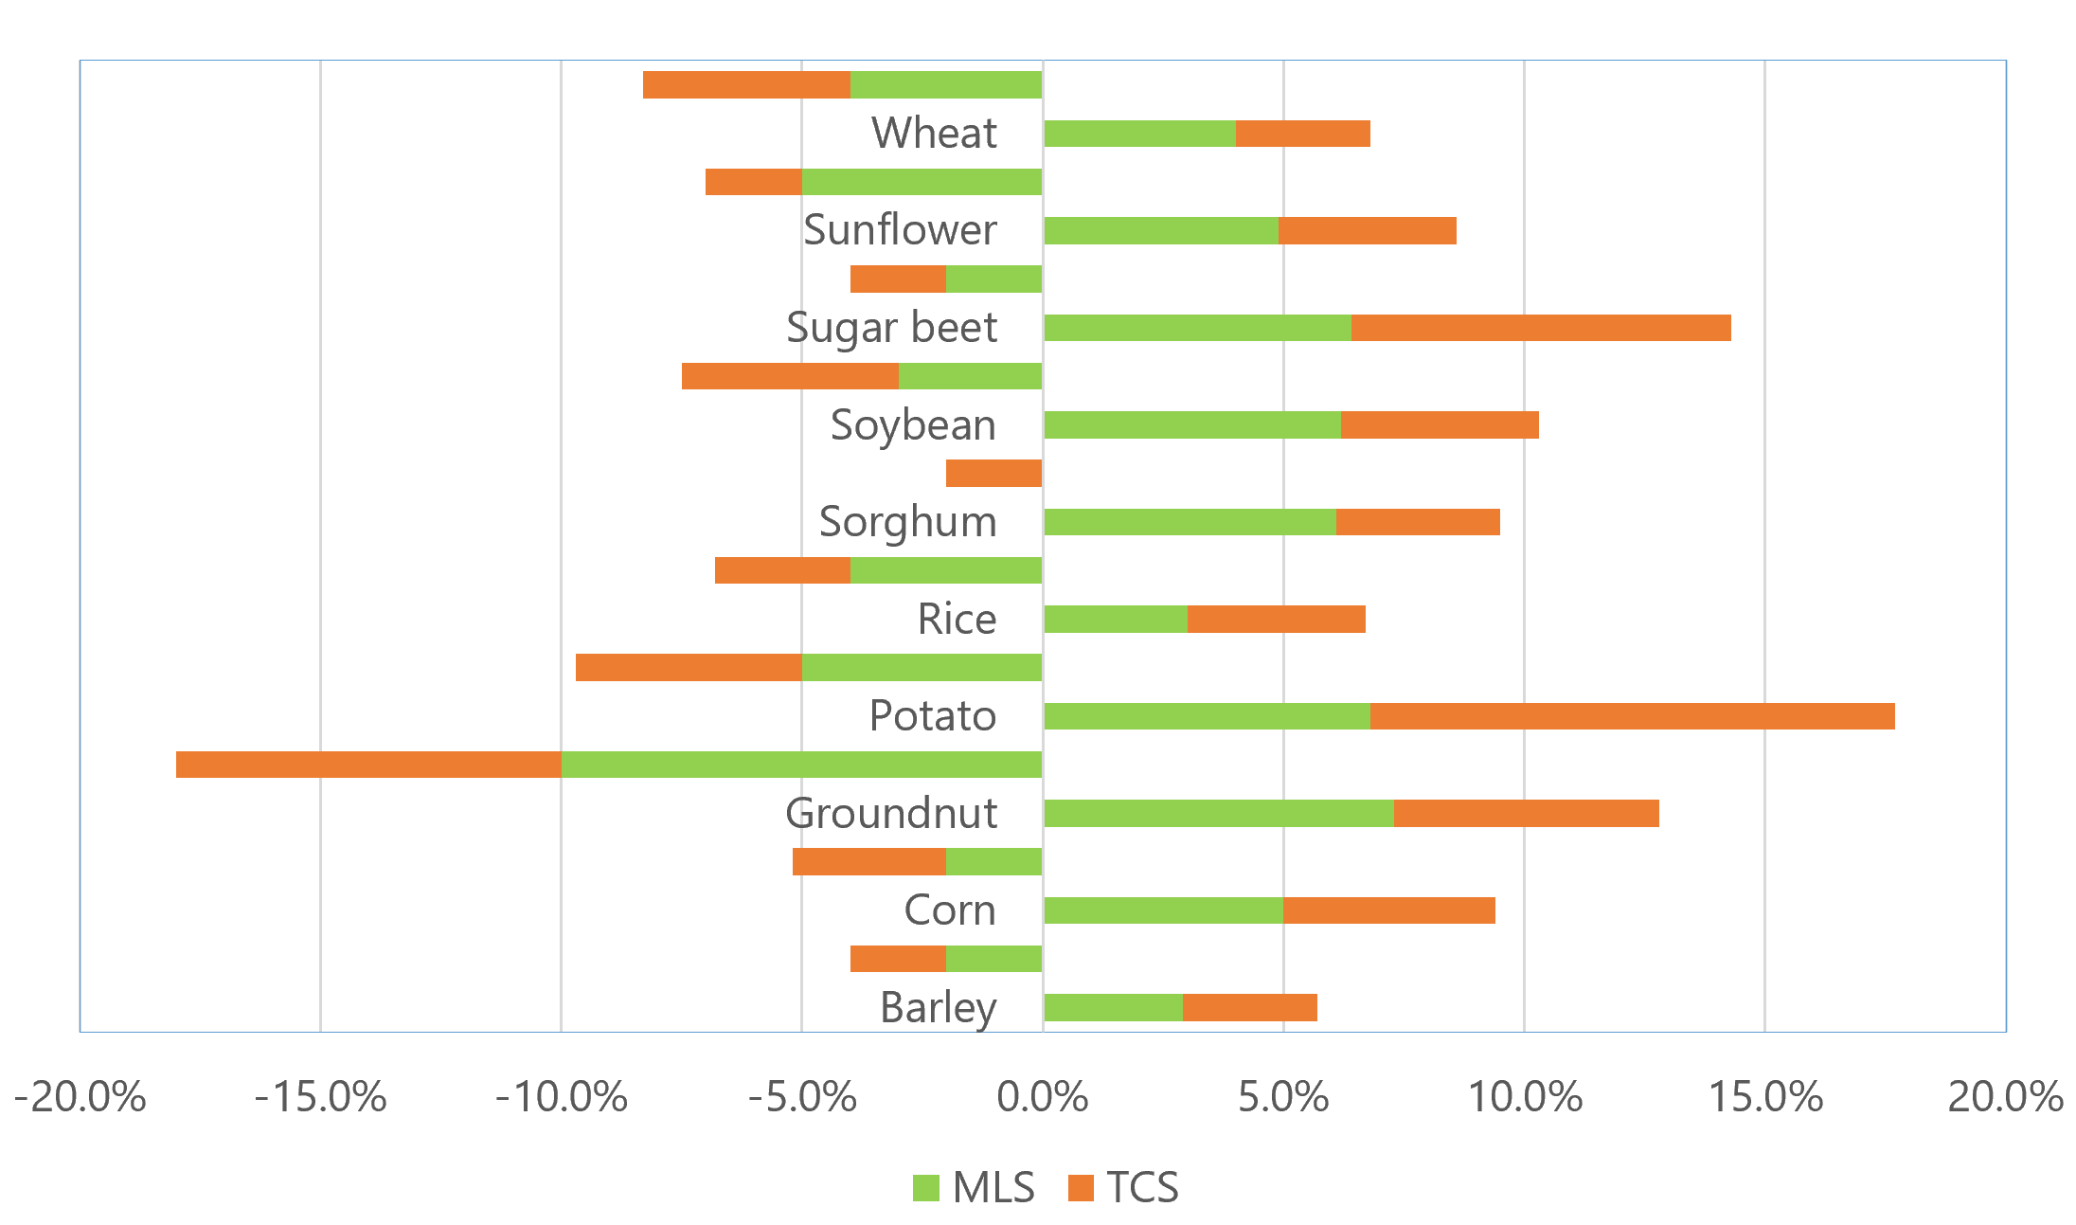
Supplementary Figure 4. Global distribution of total costs (10⁶ USD) per simulation unit in the business as usual and the land sparing and sharing scenarios.
- BAU total costs (10⁶ USD)
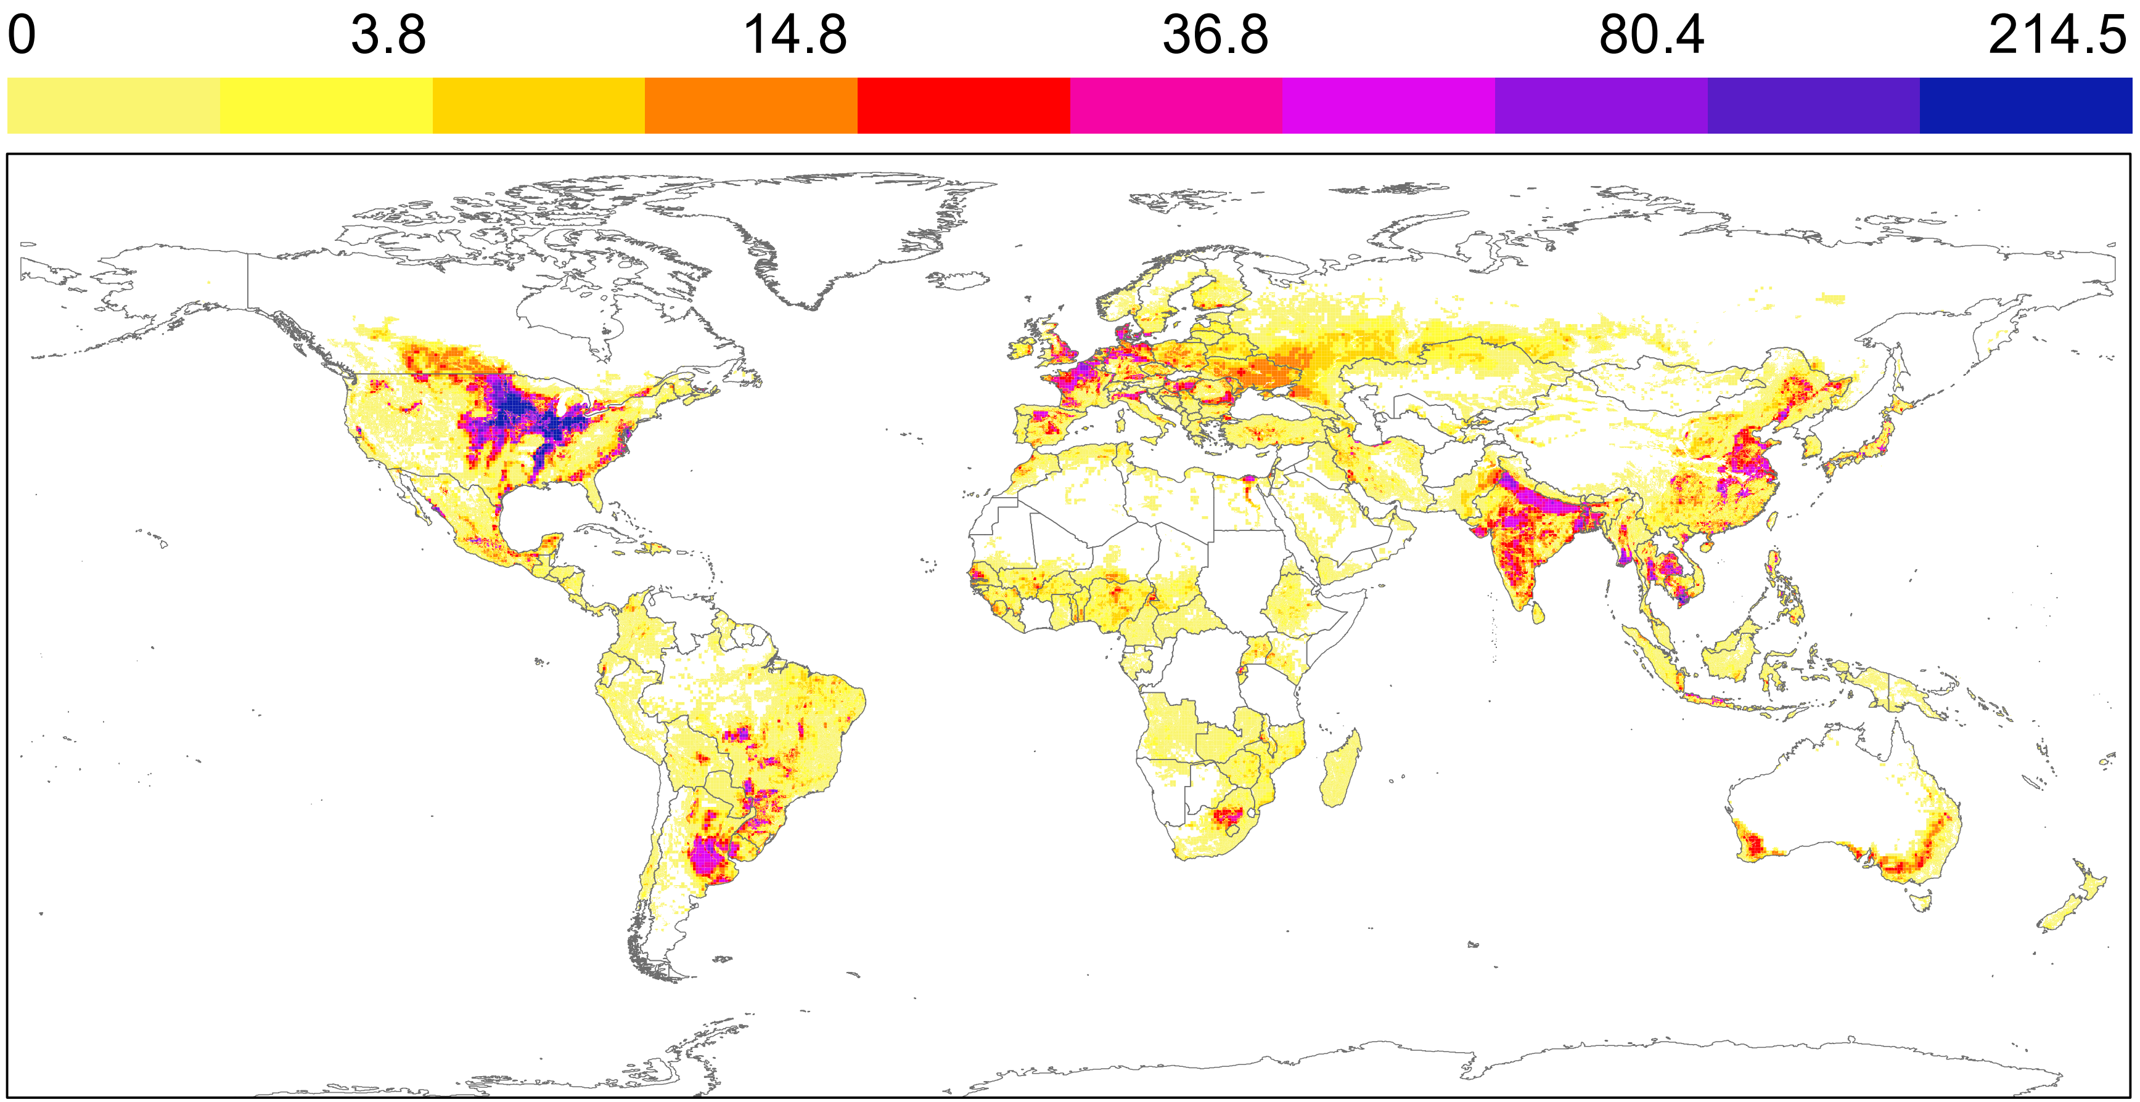
- MLS total costs (10⁶ USD)
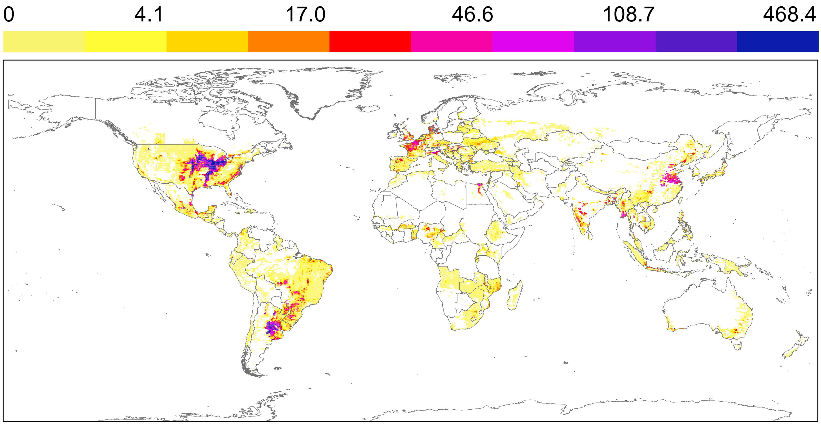
- TLS total costs (10⁶ USD)
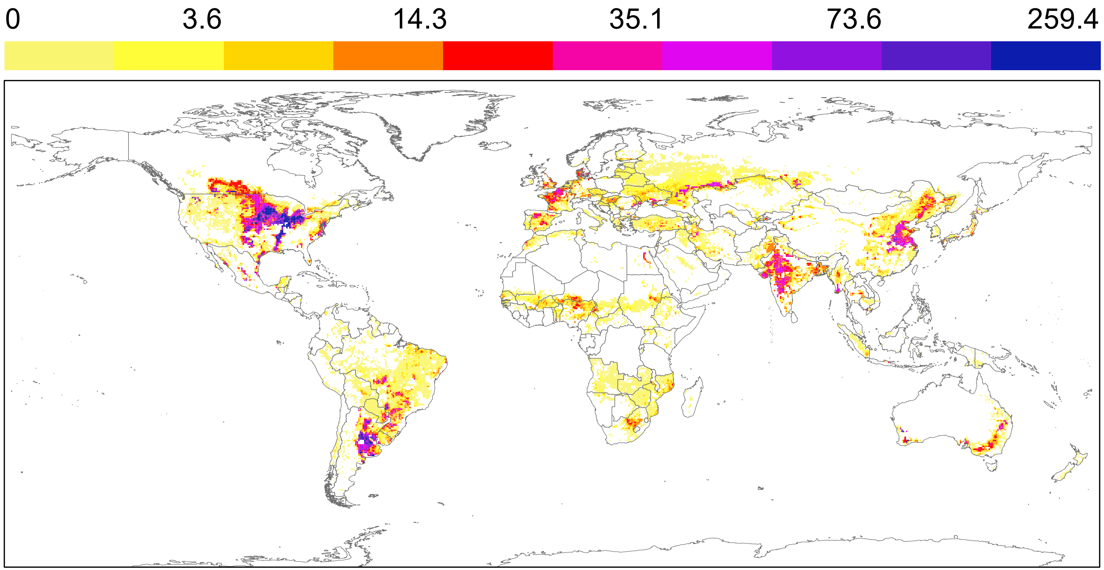

Supplementary Figure 5. Cost estimates cross validation per crop commodity and country against FAOSTAT reported producer’s prices. Trendlines represent estimated costs of production per crop and country under BAU, and the equivalent FAOSTAT producers’ reported prices. Data points represent estimated costs of production under MLS and TLS production scenarios. Generally, the estimated costs fall within expected numerical regions and do not exceed the reported producers’ prices from FAOSTAT. Outlying estimations include mainly Mexico and countries in Africa (Zimbabwe, Morocco and Botswana) and regard production of barley, groundnut, maize and sorghum. Issues are likely to be related with strong contractions in currency (sharp inflation-deflation changes or change of currency) as well as the corresponding purchasing power parities index that were used to populate the database using information from the countries baseline.

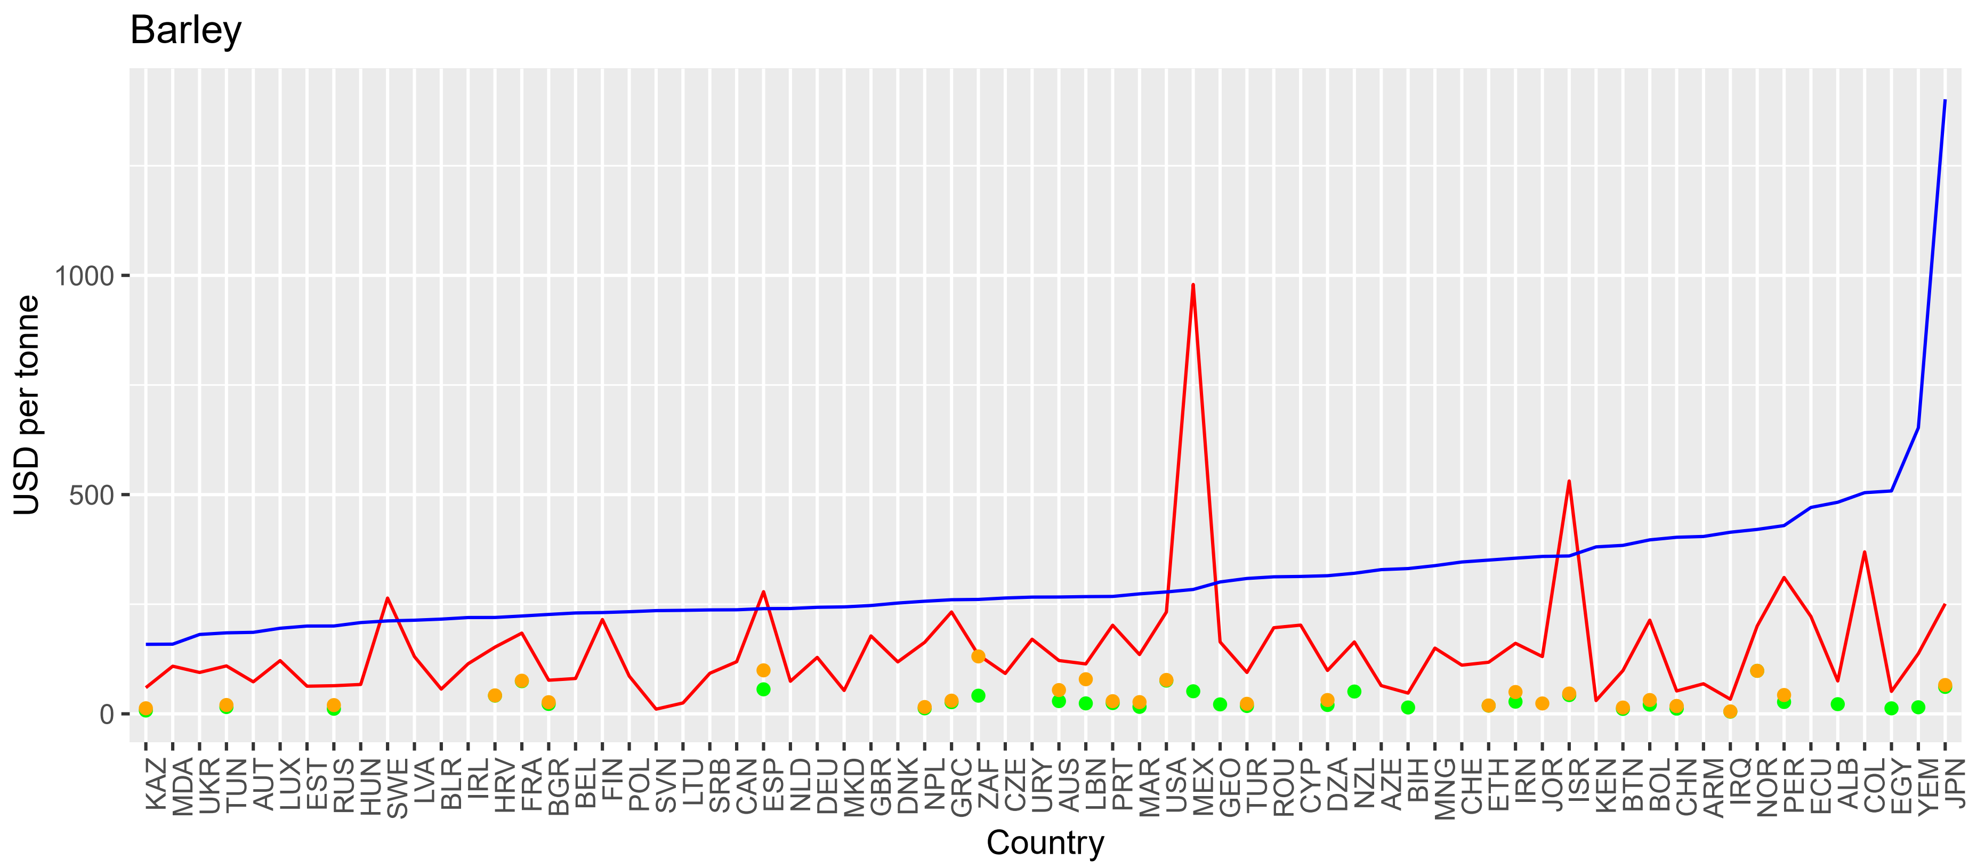
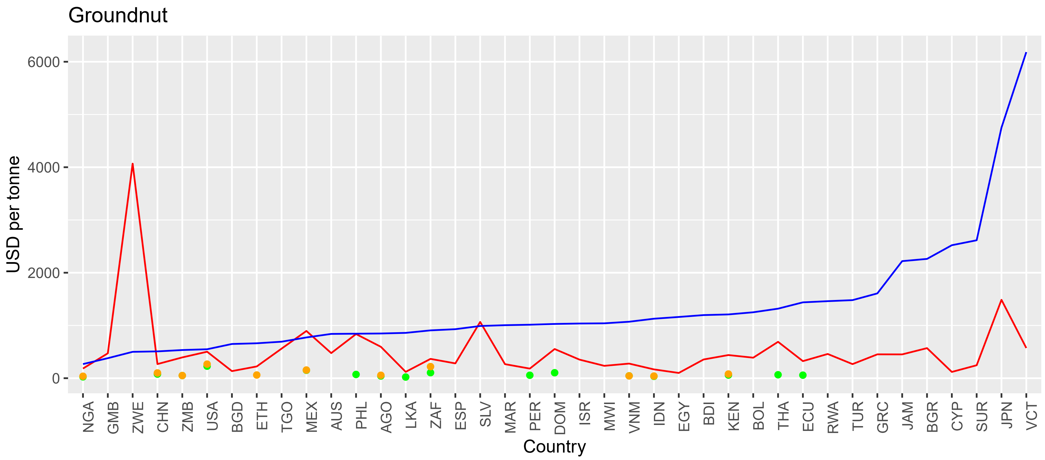
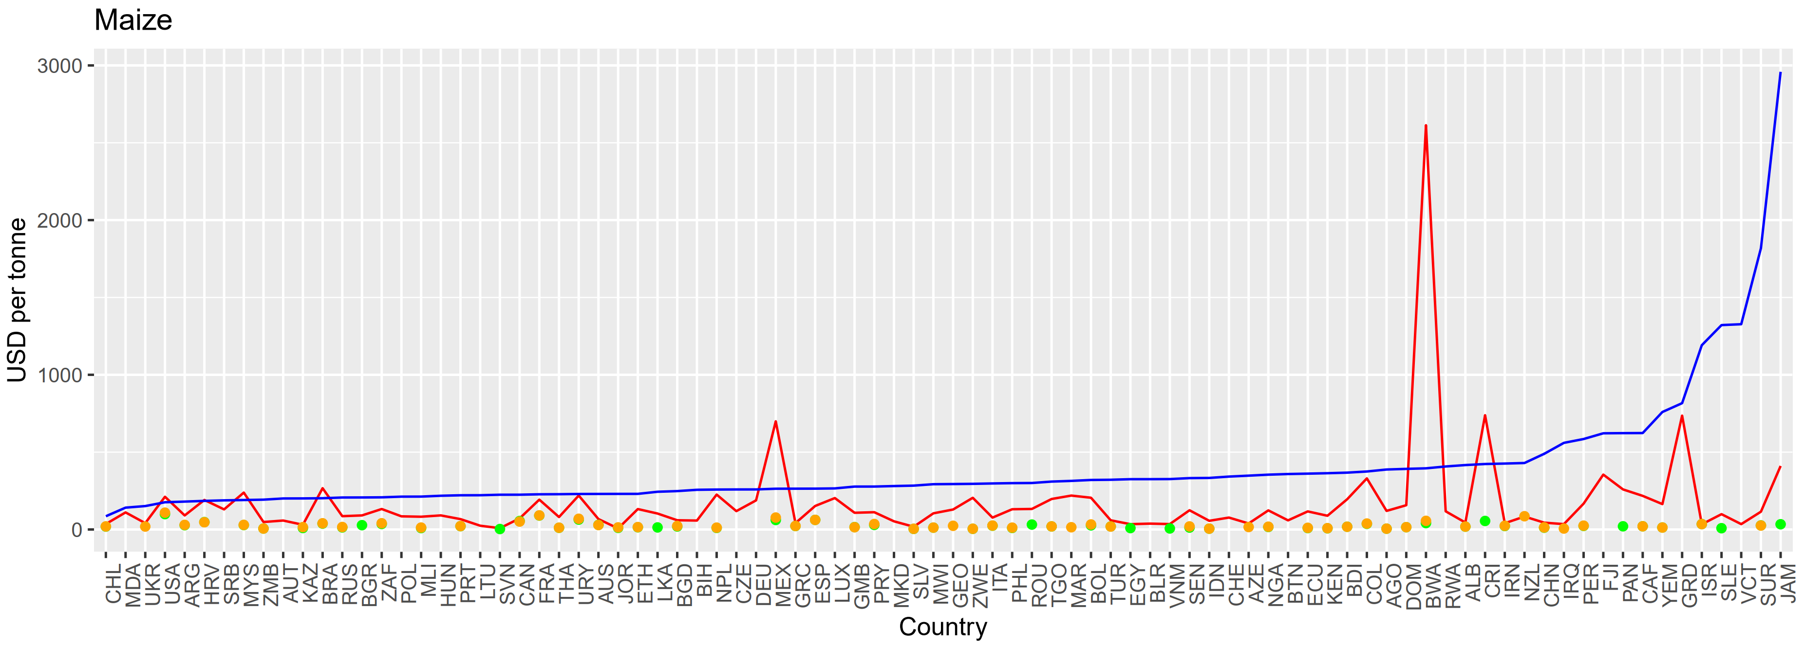
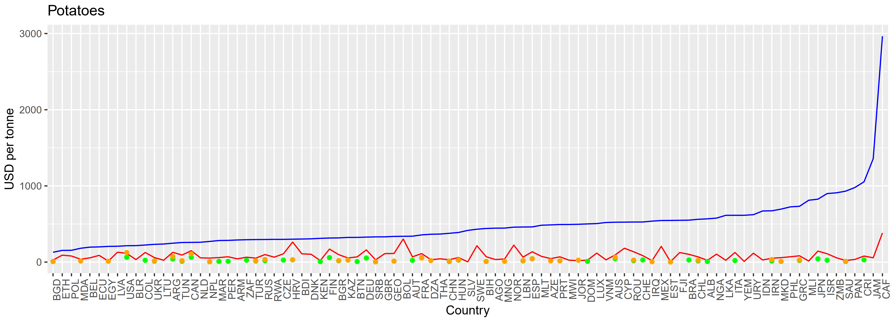
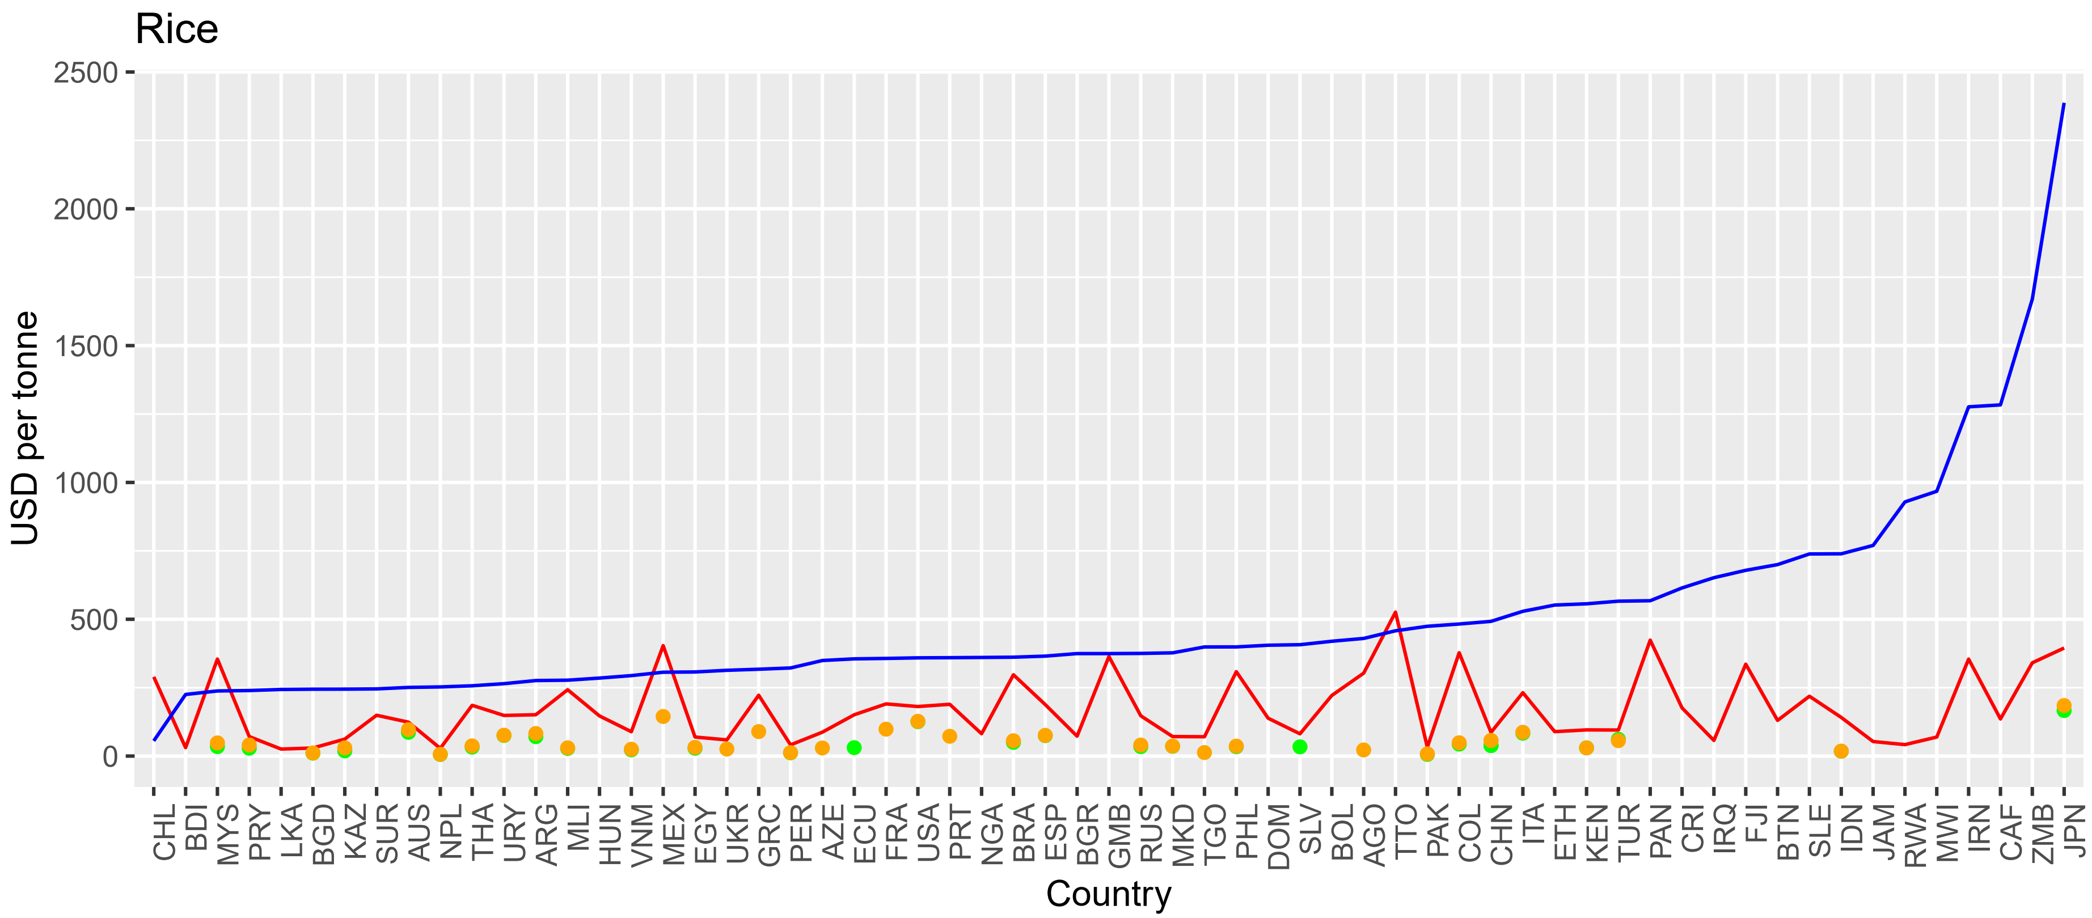

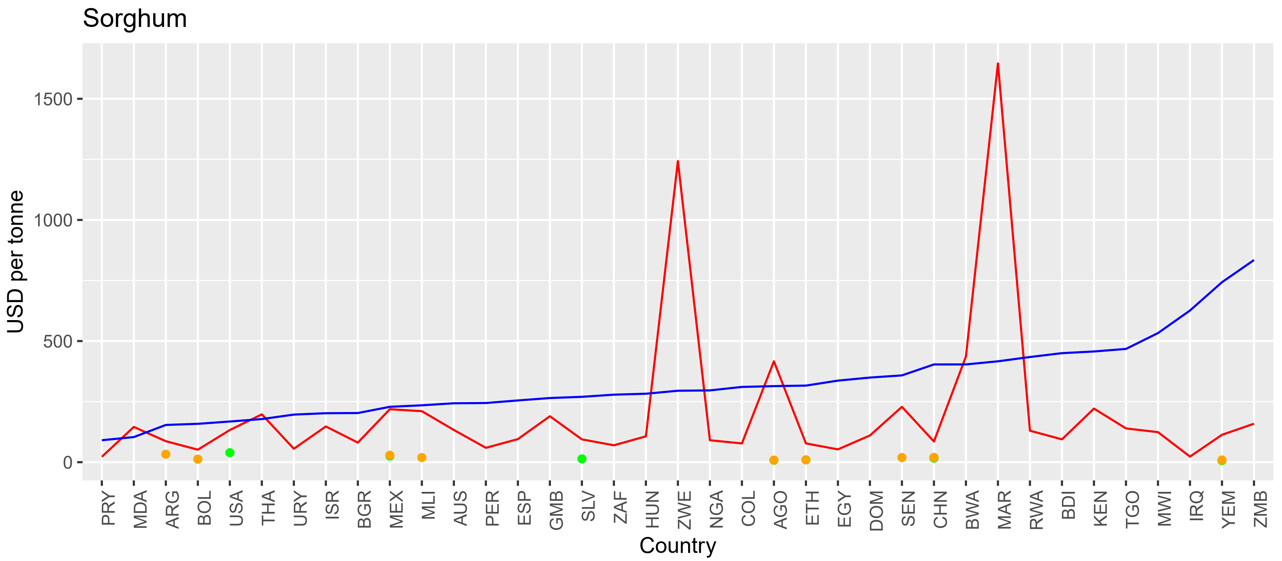
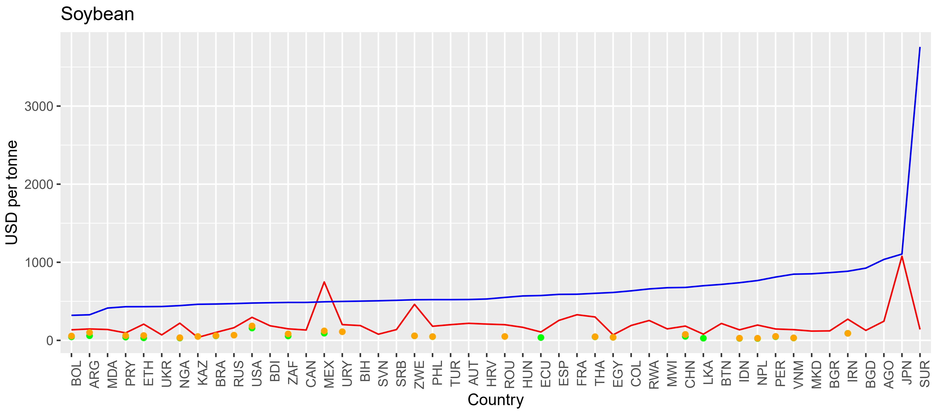
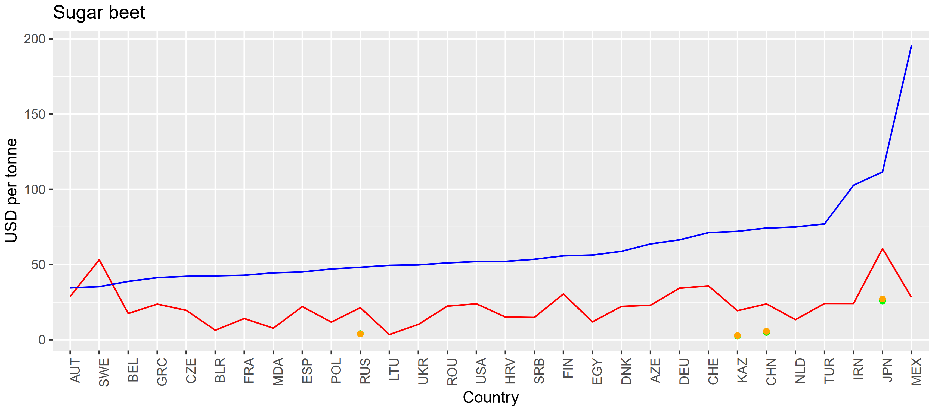
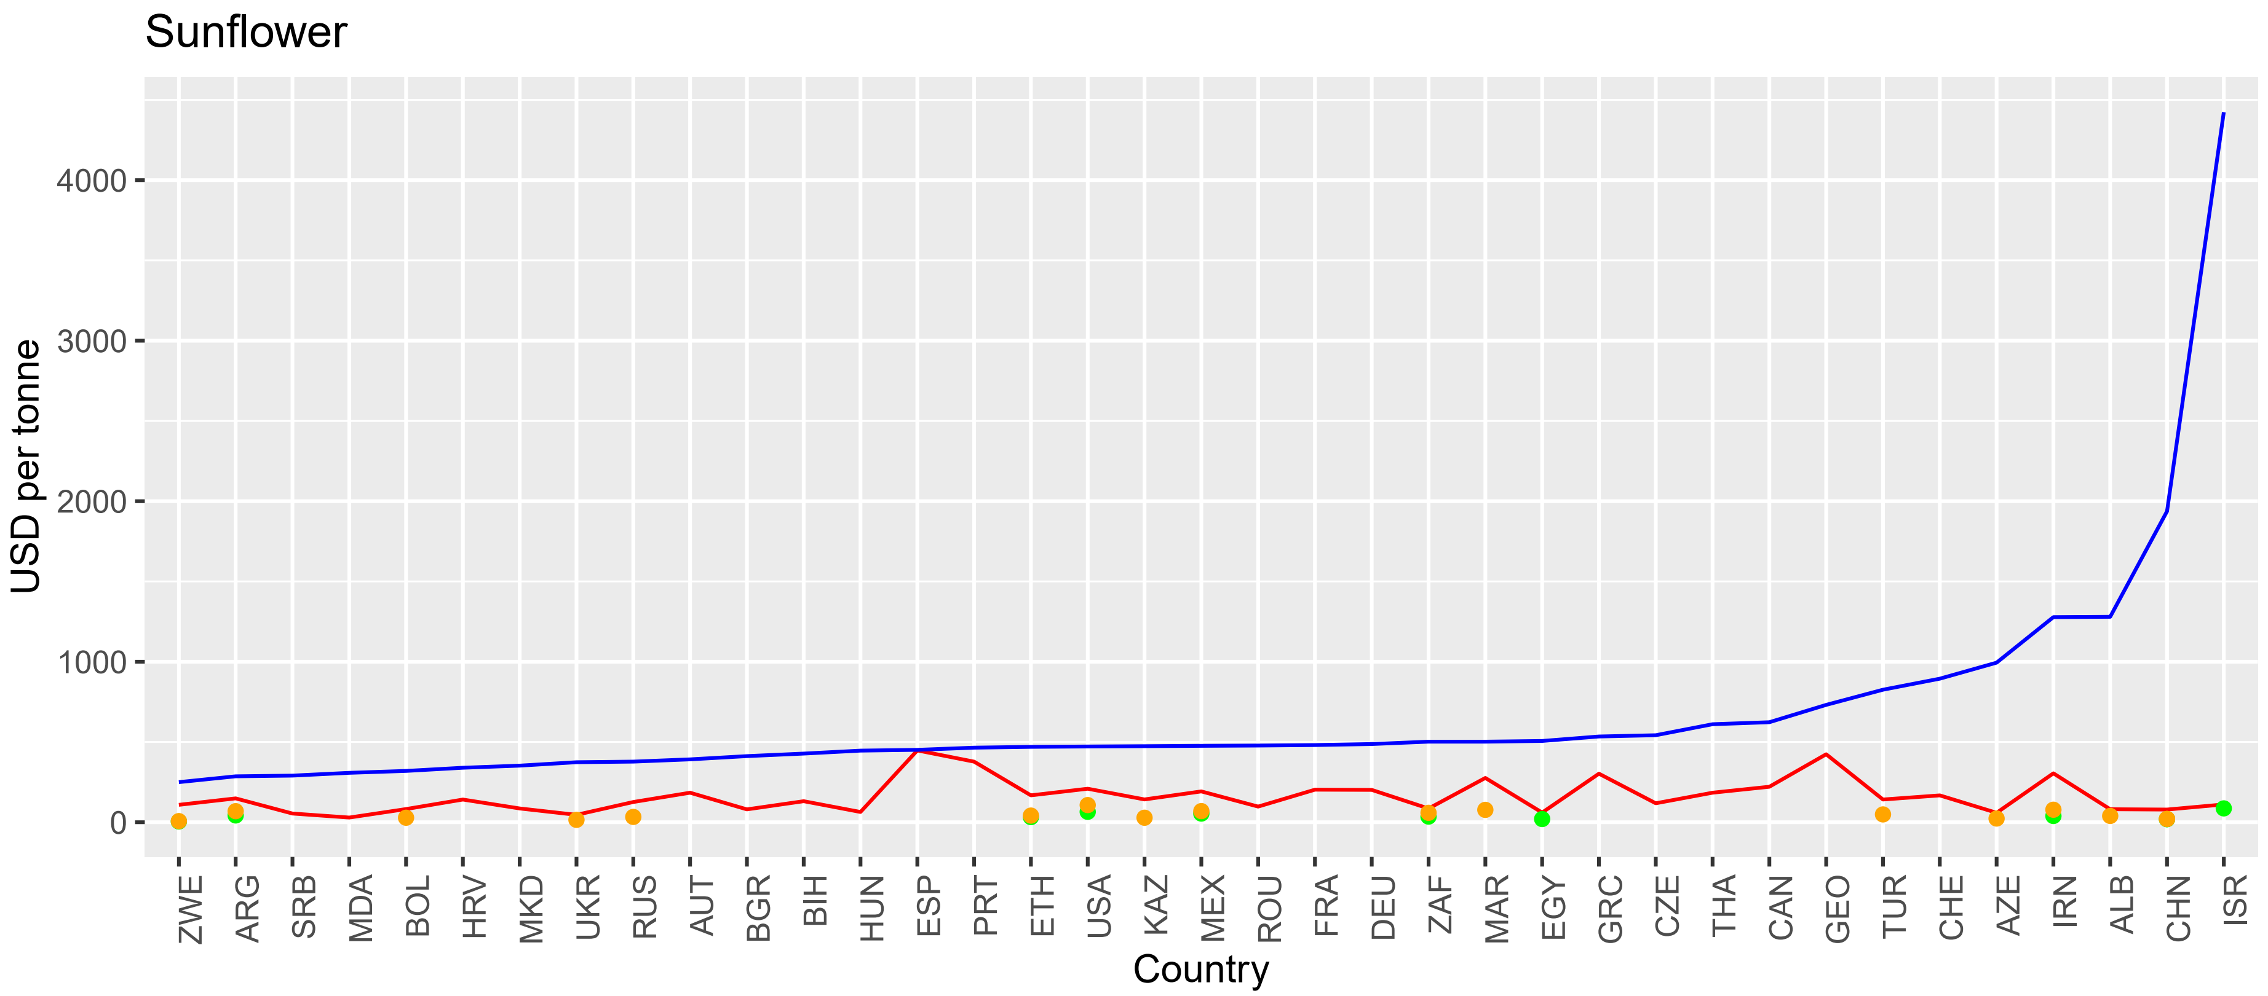
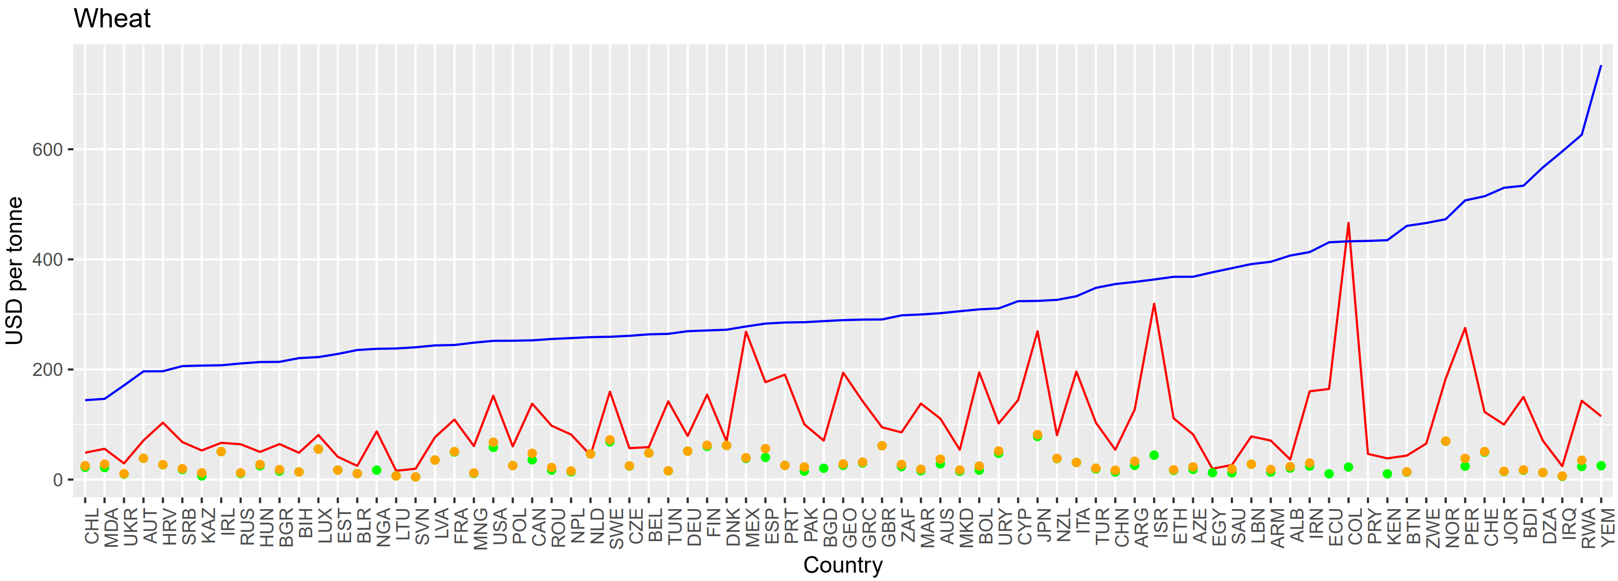

Supplementary Figure 6. Machinery expenses price analogues cross validation. Bars show reported (USDA) and modelled (KTBL) percentages of machinery expenses (repairs, interest) relative to the total costs of production per crop in the US. Here we consider 8 out of 10 of the considered crops in the analysis as we miss information on ground truth machinery costs for potatoes and sunflower. Grains, rice and sugar beet have minor differences while soybean points the largest deviation. Such differences are expected due to the extrapolation method where country-level averages were used for soil hardness proxies. In large countries, like the US, we expect a lot of variation in tillage resistance because of land heterogeneity and thus, prices for machinery expenses would also fluctuate on that basis.
