Supplemental Information
Supplemental Table S1. Average FA values (± standard deviation) for each white matter tract used in analyses.
White Matter Tract | Mean FA (± SD)
Anterior Corona Radiata (Left) | 0.435 ± 0.023
Anterior Corona Radiata (Right) | 0.437 ± 0.023
Anterior Limb of Internal Capsule (Left) | 0.556 ± 0.20
Anterior Limb of Internal Capsule (Right) | 0.554 ± 0.019
Body of Corpus Callosum | 0.645 ± 0.028
Cerebral Peduncle (Left) | 0.685 ± 0.024
Cerebral Peduncle (Right) | 0.688 ± 0.026
Cingulum – Cingulate Gyrus (Left) | 0.594 ± 0.029
Cingulum – Cingulate Gyrus (Right) | 0.552 ± 0.028
Cingulum – Hippocampus (Left) | 0.438 ± 0.034
Cingulum – Hippocampus (Right) | 0.463 ± 0.037
Corticospinal Tract (Left) | 0.536 ± 0.027
Corticospinal Tract (Right) | 0.537 ± 0.029
External Capsule (Left) | 0.443 ± 0.019
External Capsule (Right) | 0.445 ± 0.020
Fornix – Column & Body | 0.481 ± 0.042
Fornix/Stria Terminalis (Left) | 0.508 ± 0.028
Fornix/Stria Terminalis (Right) | 0.510 ± 0.028
Genu of Corpus Callosum | 0.633 ± 0.028
Inferior Cerebellar Peduncle (Left) | 0.503 ± 0.022
Inferior Cerebellar Peduncle (Right) | 0.501 ± 0.024
Medial Lemniscus (Left) | 0.558 ± 0.023
Medial Lemniscus (Right) | 0.559 ± 0.022
Middle Cerebellar Peduncle | 0.577 ± 0.017
Pontine Crossing Tract | 0.463 ± 0.022
Posterior Corona Radiata (Left) | 0.469 ± 0.021
Posterior Corona Radiata (Right) | 0.473 ± 0.023
Posterior Limb of Internal Capsule (Left) | 0.645 ± 0.019
Posterior Limb of Internal Capsule (Right) | 0.654 ± 0.021
Posterior Thalamic Radiata (Left) | 0.560 ± 0.025
Posterior Thalamic Radiata (Right) | 0.563 ± 0.025
Retrolenticular part of Internal Capsule (Left) | 0.566 ± 0.021
Retrolenticular part of Internal Capsule (Right) | 0.563 ± 0.024
Sagittal Stratum (Left) | 0.517 ± 0.023
Sagittal Stratum (Right) | 0.524 ± 0.026
Splenium of Corpus Callosum | 0.714 ± 0.019
Superior Cerebellar Peduncle (Left) | 0.637 ± 0.025
Superior Cerebellar Peduncle (Right) | 0.635 ± 0.025
Superior Corona Radiata (Left) | 0.482 ± 0.021
Superior Corona Radiata (Right) | 0.479 ± 0.021
Superior Fronto-Occipital Fasciculus (Left) | 0.496 ± 0.027
Superior Fronto-Occipital Fasciculus (Right) | 0.505 ± 0.025
Superior Longitudinal Fasciculus (Left) | 0.485 ± 0.019
Superior Longitudinal Fasciculus (Right) | 0.490 ± 0.021
Tapetum (Left) | 0.549 ± 0.041
Tapetum (Right) | 0.518 ± 0.045
Uncinate Fasciculus (Left) | 0.527 ± 0.035
Uncinate Fasciculus (Right) | 0.515 ± 0.039

Supplemental Figure 1. We conducted an attrition analysis using childhood neurocognitive functioning (the Wechsler Intelligence Scale for Children–Revised; WISC–R) and socioeconomic status (SES) to determine whether participants in the Phase 45 data collection were representative of the original cohort. a) No significant differences in WISC–R were found between the full cohort, those still alive, or those seen at Phase 45. Those who were deceased by the Phase 45 data collection had significantly lower scores on the WISC–R than those who were still alive (t=2.09, P=.04). b) No significant differences were found between the full cohort, those deceased, those alive, or those seen at Phase 45 on childhood SES.
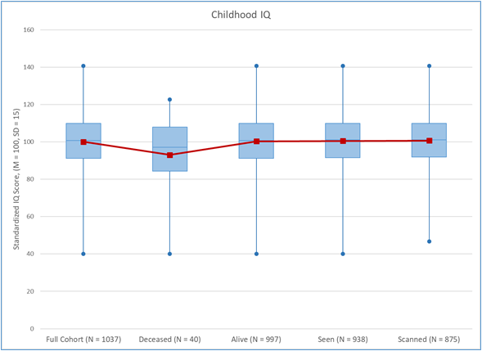
a
b
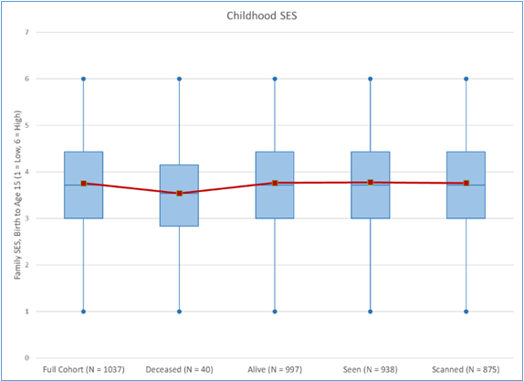

Supplemental Figure 2. Variable distributions of VO₂Max (N = 801) and Nyberg Health Index scores (N= 854) in men and women. a) Men had an average VO₂Max of 31.65 mL/min/kg and women had an average of 22.14 mL/min/kg. b) Men had an average Nyberg Health Index score of 4.8 and women had an average score of 5.12.
a b
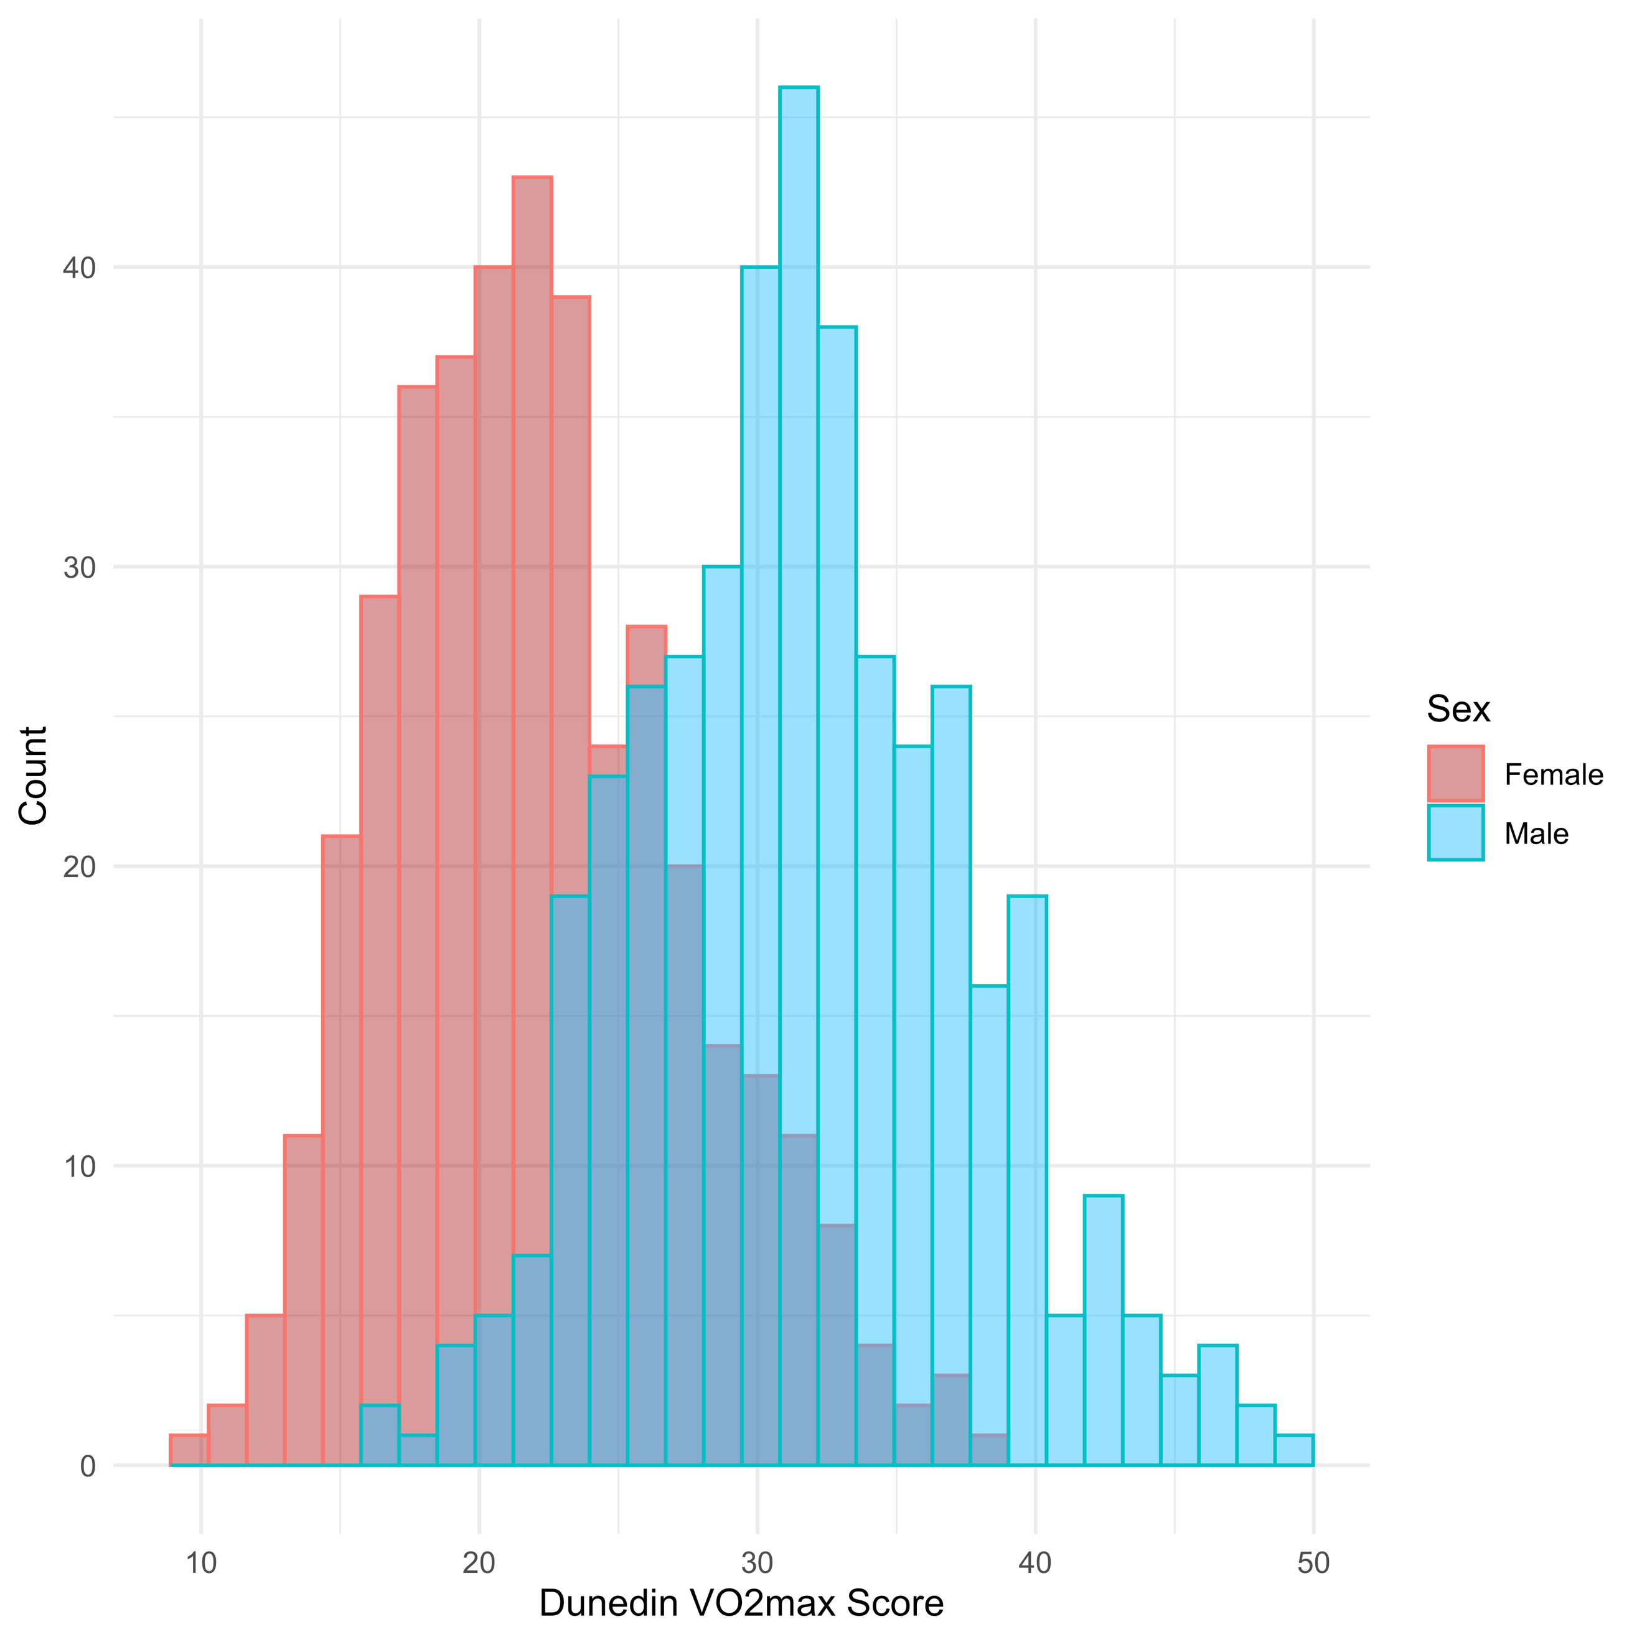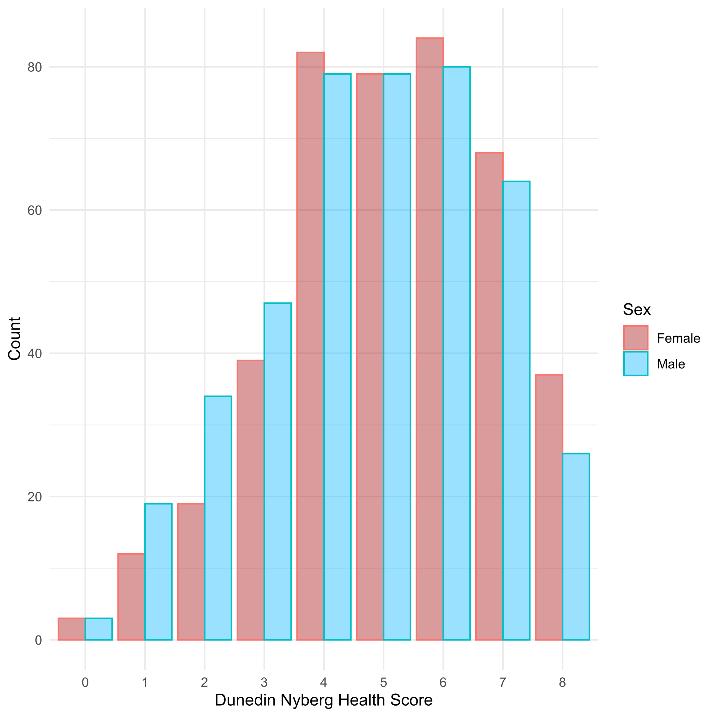

Supplemental Figure 3. Heat map of correlations between all white matter tracts used in analyses.

