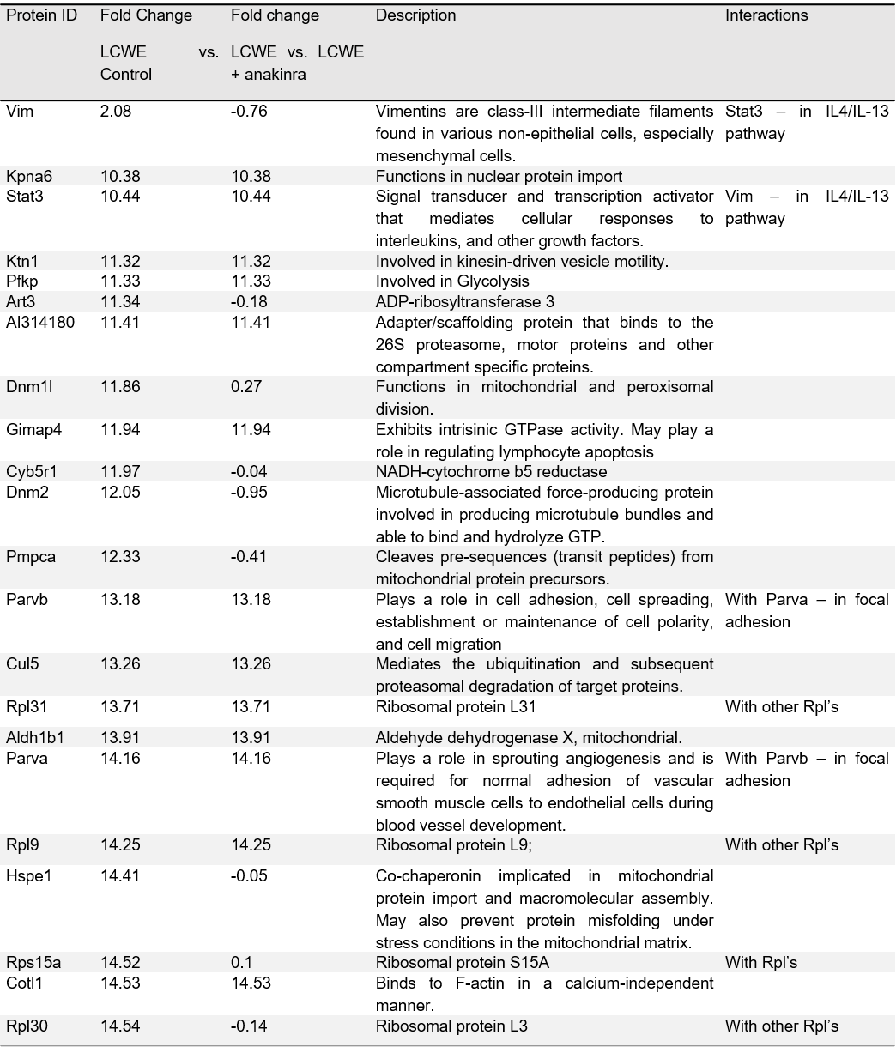

**Supplementary Table 1.** Proteins up regulated in LCWE injected mice as compared to saline injected controls.