Supplementary Material

Supplementary Figures
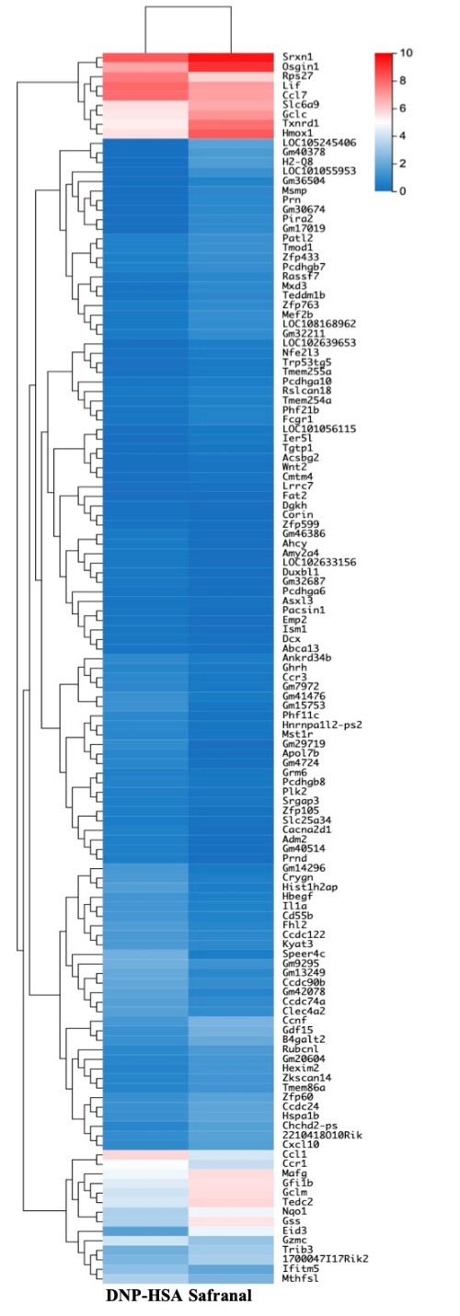
supplementary 1 Effect of Safranal on Cxcl10 in lung tissues. (A) Heatmap of genes expression shows effect of safranal treated BMMC on representative differentially expressed genes comparing to DNP-HSA treated. False Dicovery Rate (FDR) ≤ 0.05 and |Log2Ratio| ≥ 1.
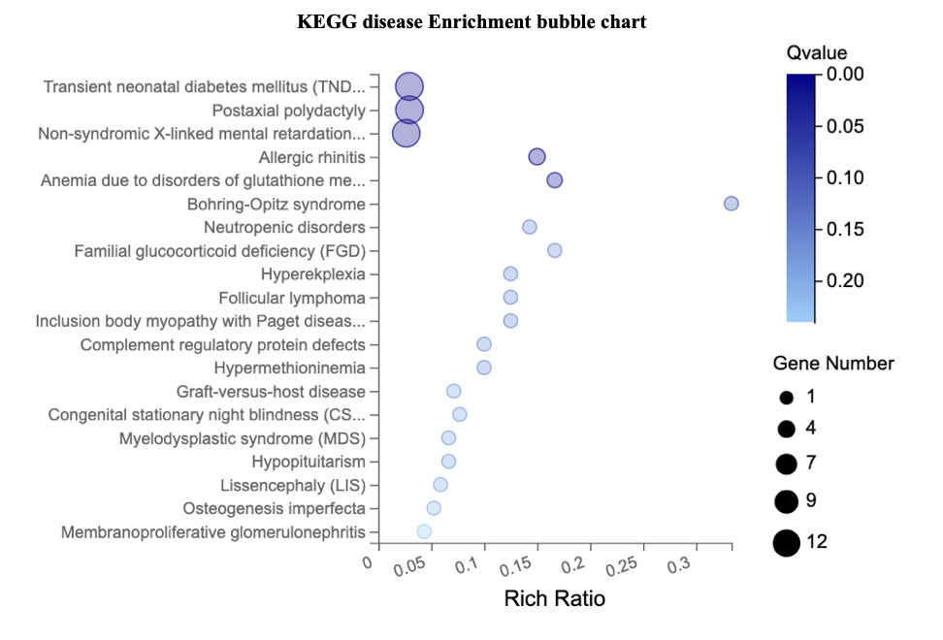Supplementary2 KEGG diseases enrichment bubble chart. (A) safranal regulated genes that are related to transient neonatal diabetes, postaxial polydactyly and allergic rhinitis etc.

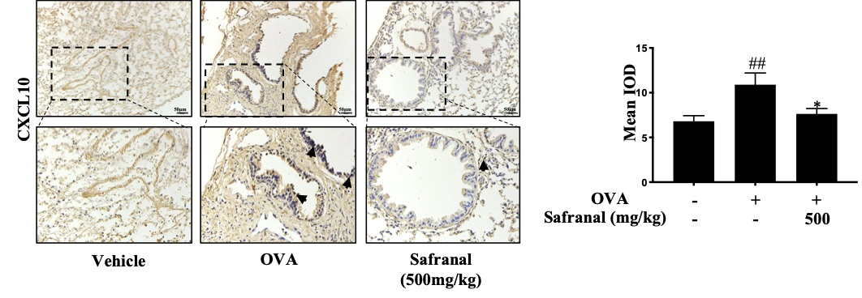
supplementary 3 Effect of Safranal on Cxcl10 in lung tissues. (A) IHC staining of Cxcl10. The result showed decreased of CD4 in safranal treated group. The data are presented as the means ± S.E.M. of n=10. ##p<0.01 compared to nontreated group. *p<0.05 compared to OVA treated group. The scale labels shown are 50μm.
RNA-sequencing data can be found at: https://www.ncbi.nlm.nih.gov/bioproject/PRJNA639182.

