**Search Component-1-1: Bladder**

urinary bladder[MeSH Terms] OR urinary bladder[tiab] OR (urinary[tiab] AND bladder[tiab]) OR bladder[tiab] OR bladder detrusor muscle[tiab] OR cystostomy[MeSH Terms] OR cystostomy[tiab] OR Cystostomies[tiab] OR Urinary Catheterization[MeSH Terms] OR Urinary Catheterization[tiab] OR (Urinary[tiab] AND Catheterization[tiab]) OR Urinary Catheterizations[tiab] OR (urinary[tiab] AND catheterizations[tiab]) OR urothelium[MeSH Terms] OR urothelium[tiab] OR urinary tract epithelium[tiab] OR (urinary tract[tiab] AND epithelium[tiab]) OR bladder tissue[tiab] OR (bladder[tiab] AND tissue[tiab]) OR urinary bladder tissue[tiab] OR (urinary bladder[tiab] AND tissue[tiab]) OR bladder augmentation[tiab] OR (bladder[tiab] AND augmentation[tiab]) OR urinary bladder augmentation[tiab] OR (urinary bladder[tiab] AND augmentation[tiab]) OR bladder compliance[tiab] OR (bladder[tiab] AND compliance[tiab]) OR urinary bladder compliance[tiab] OR (urinary bladder[tiab] AND compliance[tiab]) OR bladder capacity[tiab] OR (bladder[tiab] AND capacity[tiab]) OR urinary bladder capacity[tiab] OR (urinary bladder[tiab] AND capacity[tiab]) OR bladder wall[tiab] OR (bladder[tiab] AND wall[tiab]) OR urinary bladder wall[tiab] OR (Urinary bladder[tiab] AND wall[tiab]) OR cystectomy[MeSH Terms] OR cystectomy[tiab] OR cystoplasty[tiab]

**Search Component-1-2: Urethra**

urethra[MeSH Terms] OR urethra[tiab] OR urethras[tiab] OR urethral stricture[MeSH Terms] OR urethral stricture[tiab] OR (urethral[tiab] AND stricture[tiab]) OR urethral strictures[tiab] OR (urethral[tiab] AND strictures[tiab]) OR urethral stenosis[tiab] OR (urethral[tiab] AND stenosis[tiab]) OR anterior urethral strictures[tiab] OR (anterior[tiab] AND urethral strictures[tiab]) OR anterior urethral stricture[tiab] OR (anterior[tiab] AND urethral stricture[tiab]) OR posterior urethral stricture[tiab] OR (posterior[tiab] AND urethral stricture[tiab]) OR posterior urethral strictures[tiab] OR (posterior[tiab] AND urethral strictures[tiab]) OR urinary catheterization[MeSH Terms] OR urinary catheterization[tiab] OR (urinary[tiab] AND catheterization[tiab]) OR urinary catheterizations[tiab] OR (urinary[tiab] AND catheterizations[tiab]) OR urethral catheterizations[tiab] OR (urethral[tiab] AND catheterizations[tiab]) OR urethral catheterization[tiab] OR (urethral[tiab] AND catheterization[tiab]) OR foley catheterization[tiab] OR (foley[tiab] AND catheterization[tiab]) OR intermittent urethral catheterization[tiab] OR urethral stent[tiab] OR (urethral[tiab] AND stent[tiab]) OR urethral stents[tiab] OR (urethral[tiab] AND stents[tiab]) OR urethral obstruction[MeSH Terms] OR urethral obstruction[tiab] OR (urethral[tiab] AND obstruction[tiab]) OR urethral obstructions[tiab] OR (urethral[tiab] AND obstructions[tiab]) OR meatal stenosis[tiab] OR (meatal[tiab] AND stenosis[tiab]) OR Urethroplasty

**Search Component-1-3: Ureter**

Ureter[MeSH Terms] OR ureter[tiab] OR ureters[tiab] OR ureterostomy[MeSH Terms] OR ureterostomy[tiab] OR ureterostomies[tiab] OR urinary diversion[MeSH Terms] OR urinary diversion[tiab] OR (urinary[tiab] AND diversion[tiab]) OR urinary diversions[tiab] OR (urinary[tiab] AND diversions[tiab]) OR ileal conduit[tiab] OR (ileal[tiab] AND conduit[tiab]) OR ileal conduits[tiab] OR (ileal[tiab] AND conduits[tiab]) OR ureteral[tiab] OR ureterotomy[tiab] OR ureterotomies[tiab]

**Search Component-2: Tissue engineering and Scaffolding**

tissue engineering[MeSH Terms] OR tissue engineering[tiab] OR (tissue[tiab] AND engineering[tiab]) OR organ culture techniques[MeSH Terms] OR organ culture techniques[tiab] OR (organ culture[tiab] AND techniques[tiab]) OR organ culture technique[tiab] OR (organ culture[tiab] AND technique[tiab]) OR organ culture[tiab] OR (organ[tiab] AND culture[tiab]) OR culture technique[tiab] OR (culture[tiab] AND technique[tiab]) OR culture techniques[tiab] OR (culture[tiab] AND techniques[tiab]) OR organoids[MeSH Terms] OR organoids[tiab] OR organoid[tiab] OR guided tissue regeneration[MeSH Terms] OR guided tissue regeneration[tiab] OR (guided[tiab] AND tissue egeneration[tiab]) OR tissue regeneration[tiab] OR (tissue[tiab] AND regeneration[tiab]) OR regeneration[MeSH Terms] OR regeneration[tiab] OR bioengineering[MeSH Terms] OR bioengineering[tiab] OR Bio-Engineering[tiab] OR biological engineering[tiab] OR (biological[tiab] AND engineering[tiab]) OR tissue scaffolds[MeSH Terms] OR tissue scaffolds[tiab] OR (tissue[tiab] AND scaffolds[tiab]) OR tissue scaffold[tiab] OR (tissue[tiab] AND scaffold[tiab]) OR tissue scaffolding[tiab] OR (tissue[tiab] AND scaffolding[tiab]) OR tissue scaffoldings[tiab] OR (tissue[tiab] AND scaffoldings[tiab]) OR matrix[tiab] OR matrices[tiab] OR biomatrix[tiab] OR biomatrices[tiab] OR extracellular matrix[MeSH Terms] OR extracellular matrix[tiab] OR (extracellular[tiab] AND matrix[tiab]) OR ECM[tiab] OR biocompatible materials[MeSH Terms] OR biocompatible materials[tiab] OR (biocompatible[tiab] AND materials[tiab]) OR biocompatible material[tiab] OR (biocompatible[tiab] AND material[tiab]) OR biomaterials[tiab] OR biomaterial[tiab] OR bioartificial materials[tiab] OR (bioartificial[tiab] AND materials[tiab]) OR bioartificial material[tiab] OR (bioartificial[tiab] AND material[tiab]) OR transplants[MeSH Terms] OR transplants[tiab] OR transplant[tiab] OR graft[tiab] OR grafts[tiab] OR tissue transplants[tiab] OR (tissue[tiab] AND transplants[tiab]) OR tissue transplant[tiab] OR (tissue[tiab] AND transplant[tiab]) OR tissue grafts[tiab] OR (tissue[tiab] AND grafts[tiab]) OR tissue graft[tiab] OR (tissue[tiab] AND graft[tiab]) OR organ transplants[tiab] OR (organ[tiab] AND transplants[tiab]) OR organ transplant[tiab] OR (organ[tiab] AND transplant[tiab]) OR organ grafts[tiab] OR (organ[tiab] AND grafts[tiab]) OR organ graft[tiab] OR (organ[tiab] AND graft[tiab]) OR autografts[MeSH Terms] OR autografts[tiab] OR autograft[tiab] OR autologous transplants[tiab] OR (autologous[tiab] AND transplants[tiab]) OR autologous transplant[tiab] OR (autologous[tiab] AND transplant[tiab]) OR autotransplants[tiab] OR autotransplant[tiab] OR biomimetic materials[MeSH Terms] OR biomimetic materials[tiab] OR (biomimetic[tiab] AND materials[tiab) OR biomimetic material[tiab] OR (biomimetic[tiab] AND material[tiab]) OR biomimicry materials[tiab] OR (biomimicry[tiab] AND materials[tiab]) OR biomimicry material[tiab] OR (biomimicry[tiab] AND material[tiab]) OR artificial organs[MeSH Terms] OR artificial organs[tiab] OR (artificial[tiab] AND organs[tiab]) OR artificial organ[tiab] OR (artificial[tiab] AND organ[tiab]) OR bio-artificial[tiab] OR bioartificial[tiab] OR bioartificial organs[MeSH Terms] OR bioartificial organs[tiab] OR (bioartificial[tiab] AND organs[tiab]) OR bioartificial organ[tiab] OR (bioartificial[tiab] AND organ[tiab]) OR biomimetics[MeSH Terms] OR biomimetics[tiab] OR biomimetic[tiab] OR bio-inspired engineering[tiab] OR (bio-inspired[tiab] AND engineering[tiab]) OR bioinspired engineering[tiab] OR (bioinspired[tiab] AND engineering[tiab]) OR biomimicry engineering[tiab] OR (biomimicry[tiab] AND engineering[tiab]) OR biological mimetic[tiab] OR (biological[tiab] AND mimetic[tiab]) OR biological mimetics[tiab] OR (biological[tiab] AND mimetics[tiab]) OR regenerative medicine[MeSH Terms] OR regenerative medicine[tiab] OR (regenerative[tiab] AND medicine[tiab]) OR reconstruction[tiab] OR reconstructed[tiab] OR reconstructing[tiab] OR tissue engineered[tiab] OR (tissue[tiab] AND engineered[tiab]) OR bioengineered substitutes[tiab] OR (bioengineered[tiab] AND substitutes[tiab]) OR bioengineered substitute[tiab] OR (bioengineered[tiab] AND substitute[tiab]) OR cell-free scaffold[tiab] OR cell-free scaffolds[tiab] OR bare scaffold[tiab] OR bare scaffolds[tiab] OR cell-seeded scaffold[tiab] OR (cell-seeded[tiab] AND scaffold[tiab]) OR cell-seeded scaffolds[tiab] OR (cell-seeded[tiab] AND scaffolds[tiab]) OR cell-seeded matrix[tiab] OR (cell-seeded[tiab] AND matrix[tiab]) OR cell-seeded matrices[tiab] OR (cell-seeded[tiab] AND matrices[tiab]) OR hybrid scaffold[tiab] OR hybrid scaffolds[tiab] OR hybrid matrix[tiab] OR hybrid matrices[tiab] OR composite scaffold[tiab] OR composite scaffolds[tiab] OR (composite[tiab] AND scaffolds[tiab]) OR (composite[tiab] AND scaffold[tiab]) OR composite matrix[tiab] OR composite matrices

**Search Component-3: Electrospinning**

electrospinning[tiab] OR electrospinning process[tiab] OR (electrospinning[tiab] AND process[tiab]) OR electrospinning procedure[tiab] OR (electrospinning[tiab] AND procedure[tiab]) OR electrospinning method[tiab] OR (electrospinning[tiab] AND method[tiab]) OR electrospinning fabrication[tiab] OR (electrospinning[tiab] AND fabrication[tiab]) OR electrospinning nanofiber[tiab] OR (electrospinning[tiab] AND nanofiber[tiab]) OR electrospun[tiab] OR electro-spun[tiab] OR electrospun mat[tiab] OR (electrospun[tiab] AND mat[tiab]) OR electrospun mats[tiab] OR (electrospun[tiab] AND mats[tiab]) OR electrospun nanofiber[tiab] OR (electrospun[tiab] AND nanofiber[tiab]) OR electrospun nanofibers[tiab] OR (electrospun[tiab] AND nanofibers[tiab]) OR electrospun membrane[tiab] OR (electrospun[tiab] AND membrane[tiab]) OR electrospun membranes[tiab] OR (electrospun[tiab] AND membranes[tiab]) OR electrospun construct[tiab] OR (electrospun[tiab] AND construct[tiab]) OR electrospun constructs[tiab] OR (electrospun[tiab] AND constructs[tiab]) OR electrospun scaffold[tiab] OR (electrospun[tiab] AND scaffold[tiab]) OR electrospun scaffolds[tiab] OR (electrospun[tiab] AND scaffolds[tiab]) OR electrospun structure[tiab] OR (electrospun[tiab] AND structure[tiab]) OR electrospun structures[tiab] OR (electrospun[tiab] AND structures[tiab]) OR nanostructures[MeSH Terms] OR nanostructures[tiab] OR nanostructure[tiab] OR nanostructured materials[tiab] OR (nanostructured[tiab] AND materials[tiab]) OR nanostructured material[tiab] OR (nanostructured[tiab] AND material[tiab]) OR nanomaterials[tiab] OR nanomaterial[tiab] OR nanofibers[MeSH Terms] OR nanofibers[tiab] OR nanofiber[tiab] OR nano-scaffold[tiab] OR nanoscaffold[tiab] OR nano-matrix[tiab] OR nanomatrix[tiab] OR nano-scale[tiab] OR nanoscale [tiab] OR nano[tiab]

* Search Component-1-1 **AND** Search Component-2 **AND** Search Component-3: Supplementary Figure 1
* Search Component-1-2 **AND** Search Component-2 **AND** Search Component-3: Supplementary Figure 2
* Search Component-1-3 **AND** Search Component-2 **AND** Search Component-3: Supplementary Figure 3

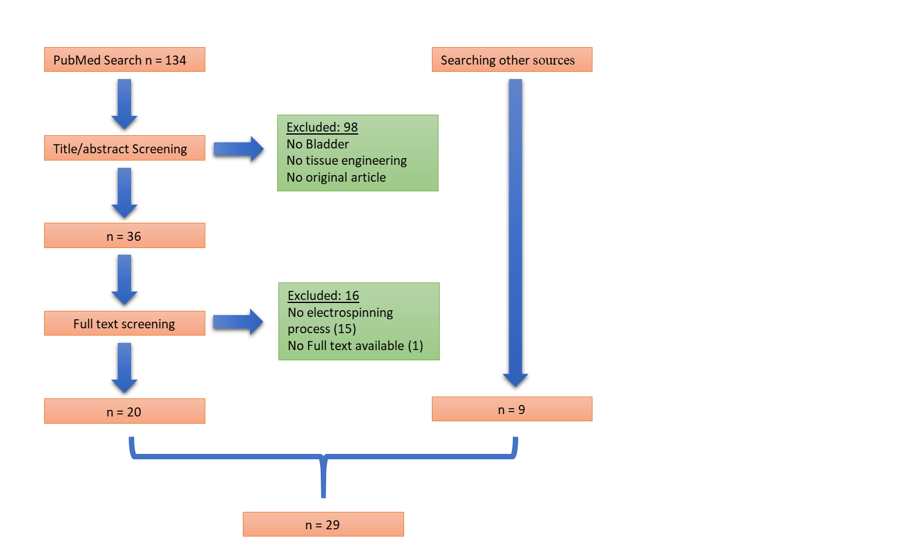

Supplementary Figure 1. Flowchart of search and screening procedure for studies concerning bladder tissue engineering using the electrospinning method (5th of May 2019).

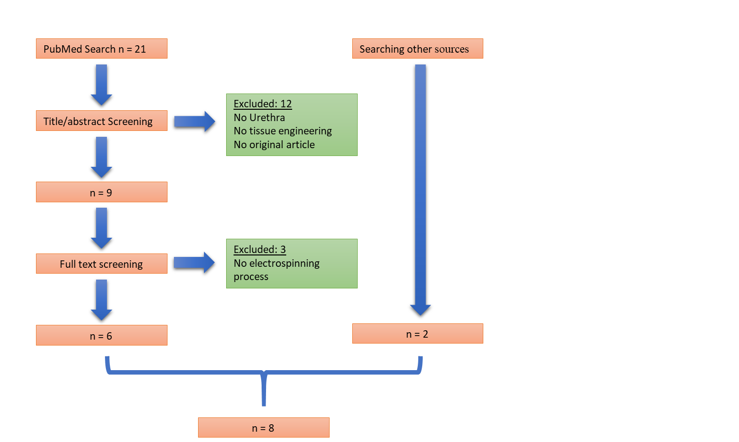

Supplementary Figure 2. Flowchart of search and screening procedure for studies concerning urethra tissue engineering using the electrospinning method (5th of May 2019).

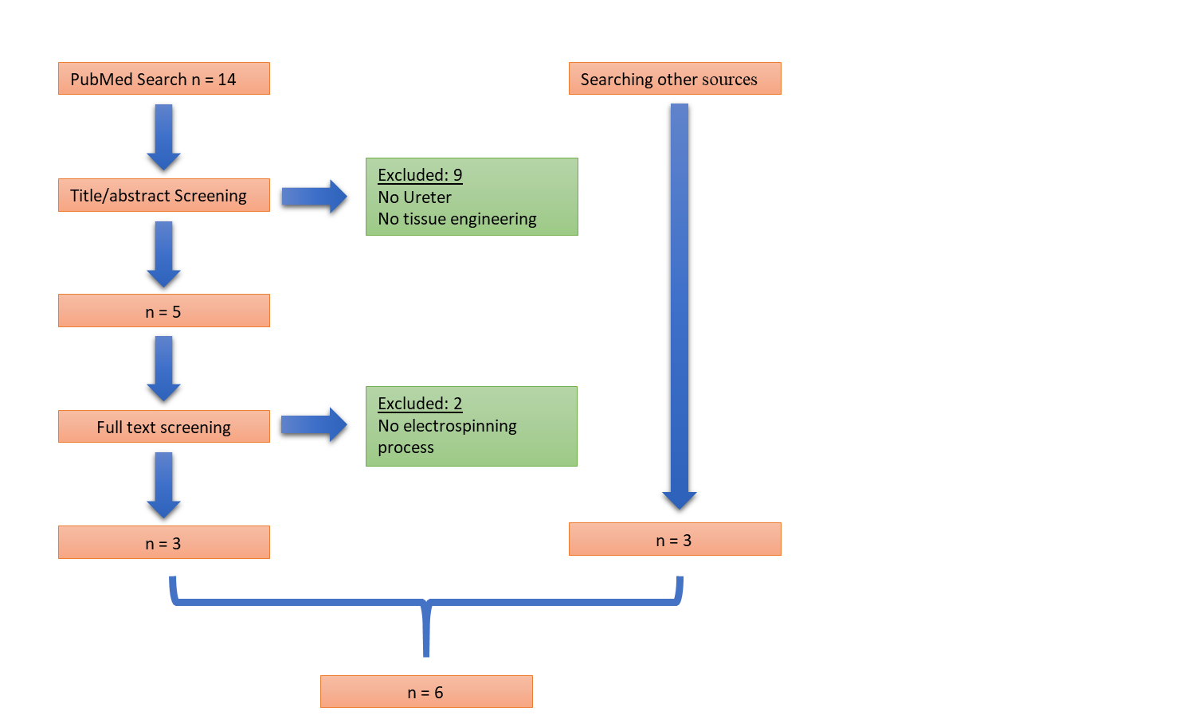

Supplementary Figure 3. Flowchart of search and screening procedure for studies concerning ureter tissue engineering using the electrospinning method (5th of May 2019).