Supplementary Data

Supplementary Table 1: Microplastic fragment counts g⁻¹ of dry sediment from 16 sample sites in the GAB, where n = the number of subsamples taken from each site core.

MP fragments (g⁻¹ dry sediment)
Site name | Core number | n | Mean | Minimum | Maximum | Variance | Std Error
A | 1 | 3 | 1.0 | 0 | 2.1 | 11.2 | 6.12
B | 1 | 3 | 0 | 0 | 0 | 0 | 0.00
 | 2 | 3 | 1.5 | 0 | 2.6 | 18.1 | 7.77
 | 3 | 3 | 0.1 | 0 | 0.2 | 0.1 | 0.67
 | 4 | 3 | 0.1 | 0 | 0.2 | 0.1 | 0.67
 | 5 | 3 | 0.8 | 0 | 1.2 | 4.8 | 4.00
 | 6 | 3 | 4.6 | 0 | 13.6 | 607.6 | 45.0
C | 1 | 3 | 0.3 | 0.2 | 0.4 | 0.1 | 0.67
 | 2 | 3 | 0.1 | 0 | 0.2 | 0.1 | 0.67
D | 1 | 3 | 0.3 | 0 | 0.9 | 2.7 | 3.00
 | 2 | 3 | 0.9 | 0 | 2.0 | 10.1 | 5.81
E | 1 | 4 | 1.4 | 0 | 4.6 | 47.7 | 10.9
 | 2 | 4 | 6.2 | 3.5 | 8.9 | 78.0 | 14.0
 | 3 | 4 | 1.1 | 0 | 3.3 | 22.1 | 7.43
F | 1 | 3 | 0 | 0 | 0 | 0 | 0.00
 | 2 | 3 | 0.2 | 0 | 0.6 | 1.2 | 2.00

Supplementary Table 2: Microplastic fiber counts per g⁻¹ of dry sediment from 16 sites in the GAB, where n = the number of subsamples taken from each site core.

MP fibers (g⁻¹ dry sediment)
Site name | Core number | n | Mean | Minimum | Maximum | Variance | Std Error
A | 1 | 3 | 0 | 0 | 0 | 0.0 | 0.00
B | 1 | 3 | 0 | 0 | 0 | 0.0 | 0.00
 | 2 | 3 | 0.1 | 0 | 0.2 | 0.13 | 0.67
 | 3 | 3 | 0.1 | 0 | 0.4 | 0.53 | 1.33
 | 4 | 3 | 0.5 | 0 | 1.4 | 5.7 | 4.37
 | 5 | 3 | 0.1 | 0 | 0.3 | 0.30 | 1.00
 | 6 | 3 | 0 | 0 | 0 | 0.0 | 0.00
C | 1 | 3 | 0 | 0 | 0 | 0.0 | 0.00
 | 2 | 3 | 0 | 0 | 0 | 0.0 | 0.00
D | 1 | 3 | 0 | 0 | 0 | 0.0 | 0.00
 | 2 | 3 | 0.8 | 0 | 2.0 | 12.0 | 6.23
E | 1 | 4 | 0.2 | 0 | 0.7 | 1.10 | 1.68
 | 2 | 4 | 0.2 | 0 | 0.7 | 1.20 | 1.75
 | 3 | 4 | 0 | 0 | 0 | 0.0 | 0.00
F | 1 | 3 | 0 | 0 | 0 | 0.0 | 0.00
 | 2 | 3 | 0.1 | 0 | 0.4 | 0.53 | 1.33

Supplementary Table 3: Explanatory variable information for each of the sediment cores analyzed.

Site name | Core number | Longitude | Latitude | Shipping activity*  (no. of ships) | Surface plastic plume (simulated particles/m²) | Fishing effort#  (kW/day)
A | 1 | 130.5927 | -34.8665 | 29 | 0.033976 | 2,083
B | 1 | 130.9026 | -35.0490 | 19 | 0.033976 | 151
 | 2 | 130.9026 | -35.0490 | 19 | 0.033976 | 151
 | 3 | 130.9055 | -35.0490 | 19 | 0.033976 | 151
 | 4 | 130.9054 | -35.0479 | 19 | 0.033976 | 151
 | 5 | 130.9049 | -35.0494 | 19 | 0.033976 | 151
 | 6 | 130.9048 | -35.0509 | 19 | 0.033976 | 151
C | 1 | 130.9186 | -35.0392 | 19 | 0.033976 | 151
 | 2 | 130.9178 | -35.0406 | 19 | 0.033976 | 151
D | 1 | 131.6942 | -35.0208 | 25 | 0.022593 | 27
 | 2 | 131.6947 | -35.0211 | 25 | 0.022593 | 27
E | 1 | 132.1348 | -35.5136 | 316 | 0.045003 | 480
 | 2 | 132.1348 | -35.5136 | 316 | 0.045003 | 480
 | 3 | 132.1348 | -35.5136 | 316 | 0.045003 | 480
F | 1 | 132.1497 | -35.4527 | 820 | 0.022593 | 186
 | 2 | 132.1516 | -35.4537 | 820 | 0.022593 | 186
* Shipping frequency data was from 2014 AIS (automatic information systems) ship counts (National Environmental Research Program, 2014).
≠ Modeled surface plume data (Wilcox et al., 2015). Note this is based on a simulation of plastic releases from coastal sources. It is expected to provide an accurate picture of relative density.
# Modeled fishing effort data (Bell et al., 2016).

Supplementary Table 4: Verification of MP fragments with O-PTIR. Identified plastic type found at each site, with visual representation and sizing of the MP sample fragments analyzed.

Site name | Plastic type | Optical image  (from mIRage) | Fluorescent image
A | Cis-polyisoprene (rubber)
B | Cis-polyisoprene (rubber) |  | 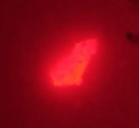
 | Cis-polyisoprene (rubber) |  | 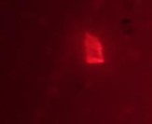
C | Cis-polyisoprene (rubber)
D | Polyurethane
 | Polyurethane
E | Polyester |  | 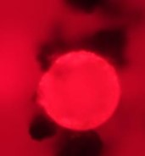
F | Polypropylene |  | 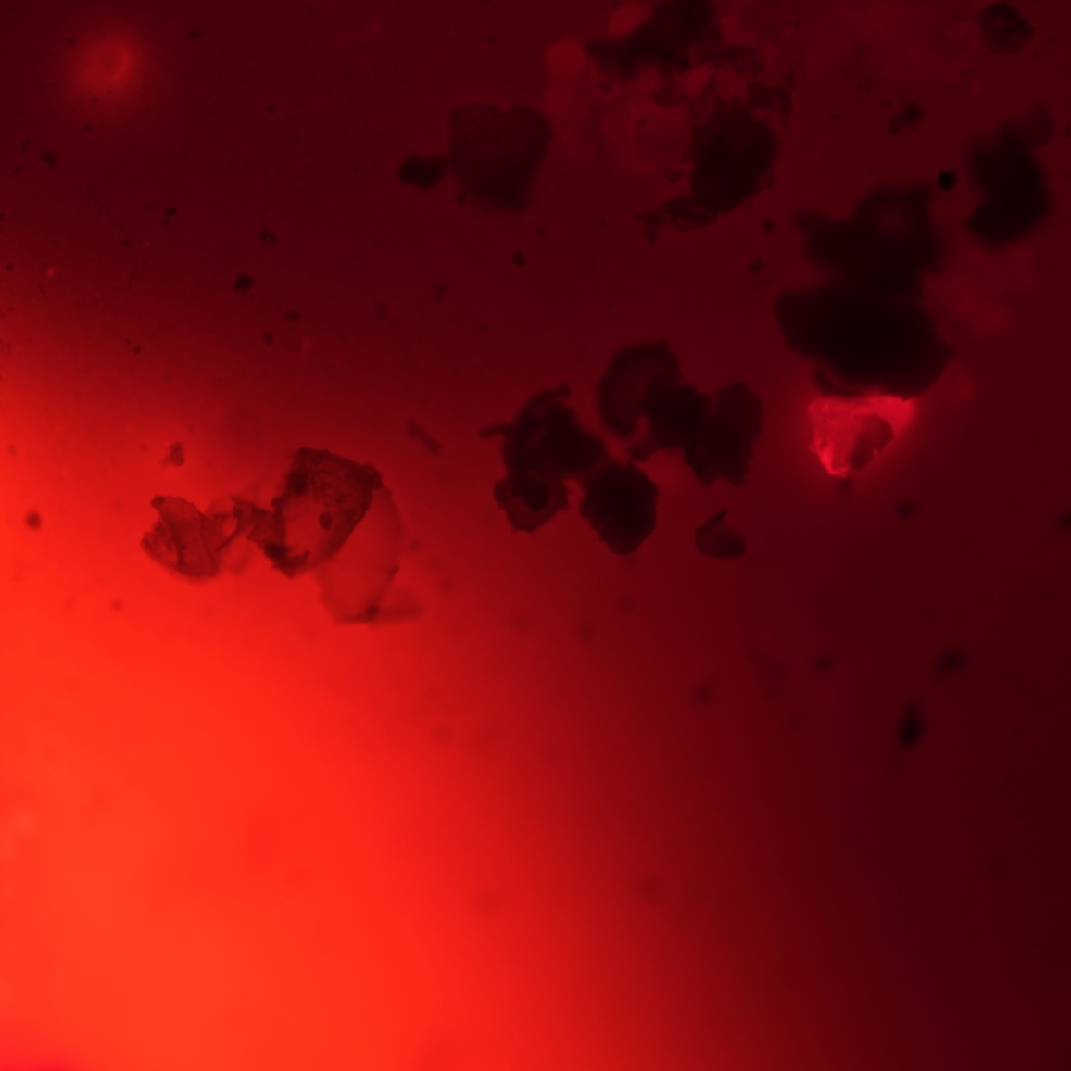

Supplementary Figure 1. Site A - comparison of MP fragment spectra with literature spectra.
Sample PTIR spectra were most similar to polyisoprene FTIR from literature sources (Bio-Rad Laboratories Inc., 2020).

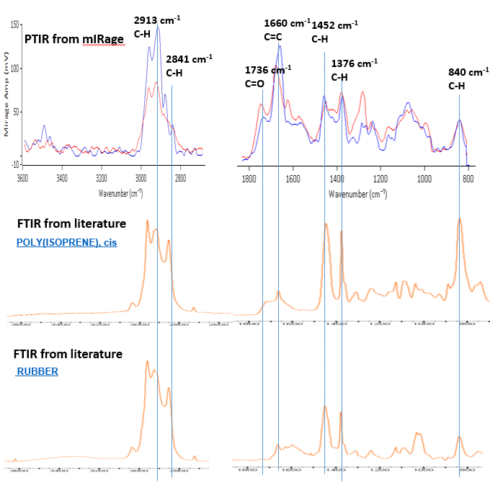

Supplementary Figure 2. Site B - comparison of MP fragment spectra with literature spectra. Sample PTIR spectra were most similar to polyisoprene FTIR from literature sources (Bio-Rad Laboratories Inc., 2020). With the exception of some additional bands, e.g., at 1562 cm⁻¹, which may have come from additives.

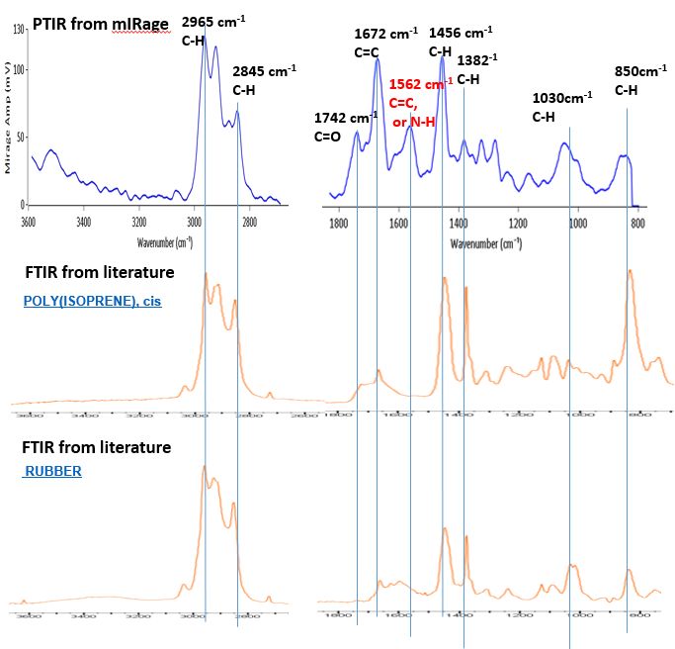

Supplementary Figure 3: Site C - comparison of MP fragment spectra with literature spectra.
Sample PTIR spectra were most similar to polyisoprene FTIR from literature sources (Bio-Rad Laboratories Inc., 2020).

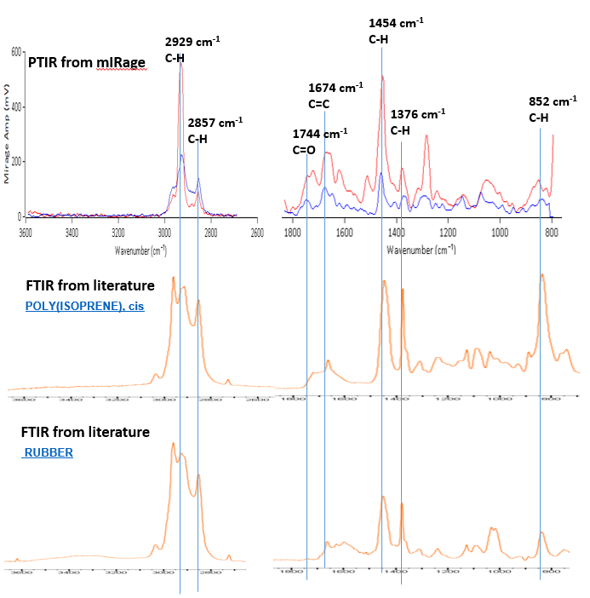

Supplementary Figure 4. Site D - comparison of MP fragment spectra with literature spectra. Sample PTIR spectra were most similar to polyurethane FTIR from literature sources (Jung et al., 2018; Bio-Rad Laboratories Inc., 2020).

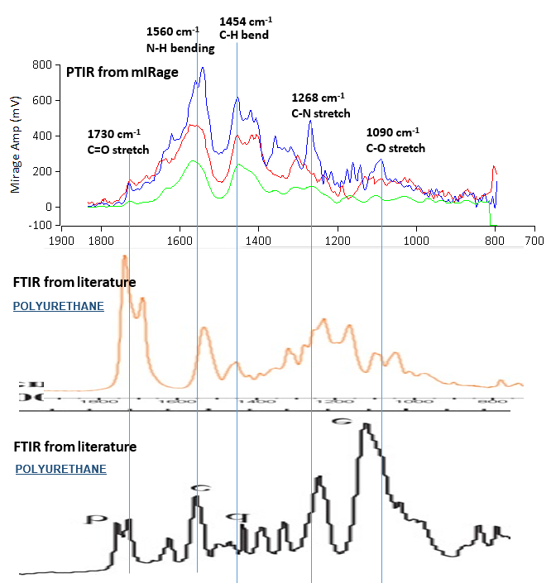

Supplementary Figure 5. Site E - comparison of MP fragment spectra with literature spectra. Sample PTIR spectra were most similar to polyester FTIR from literature sources (Bio-Rad Laboratories Inc., 2020).

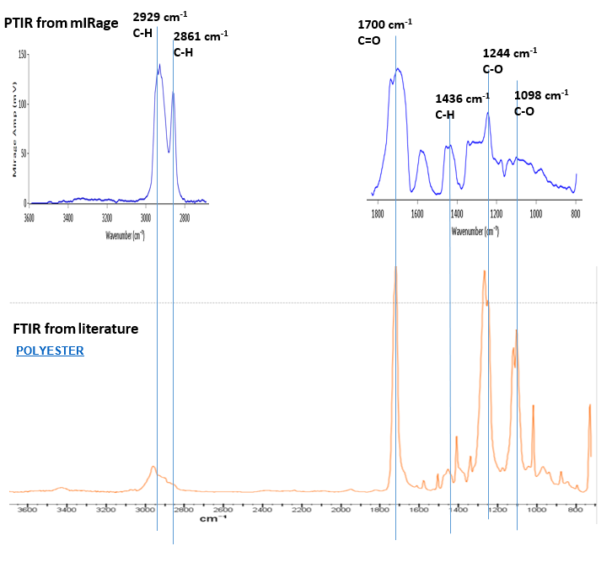

Supplementary Figure 6: Site F - comparison of MP fragment spectra with literature spectra.
Sample PTIR spectra were most similar to polypropylene FTIR from literature sources (Jung et al., 2018). With the exception of some additional bands, e.g., at 1710 cm⁻¹, which may have come from additives.

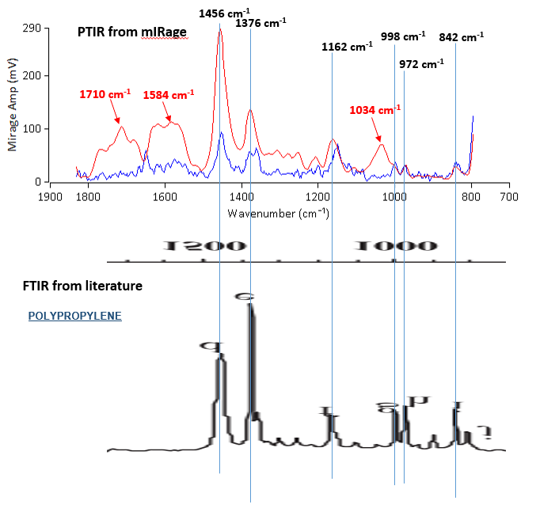

References
Bell, J.D., Watson, R.A., and Ye, Y. (2016). Global fishing capacity and fishing effort from 1950 to 2012. Fish and Fisheries 18(3), 489-505. doi: 10.1111/faf.12187.
Bio-Rad Laboratories Inc. (2020). SpectraBase [Online]. Available: http://spectrabase.com/ [Accessed April 15, 2020].
Jung, M.R., Horgen, F.D., Orski, S.V., Rodriguez C, V., Beers, K.L., Balazs, G.H., et al. (2018). Validation of ATR FT-IR to identify polymers of plastic marine debris, including those ingested by marine organisms. Marine Pollution Bulletin 127, 704-716. doi: https://doi.org/10.1016/j.marpolbul.2017.12.061.
National Environmental Research Program (2014). AIS Shipping 2014 [Online]. Geoserver. Available: https://www.cmar.csiro.au/geoserver/nerp/wms?service=WMS&version=1.1.0&request=GetMap&layers=nerp:ais_shipping_2014&styles=&bbox=105.0,-49.0,165.0,-5.0&width=768&height=563&srs=EPSG:4326&format=application/openlayers [Accessed October 21st, 2018].
Wilcox, C., Van Sebille, E., and Hardesty, B.D. (2015). Plastic in seabirds is pervasive and increasing. Proceedings of the National Academy of Sciences 112(38), 11899-11904. doi: 10.1073/pnas.1502108112

