SNX-2112 suppresses the proliferation of the esophageal cancer stem-like cells, which is enhanced by STAT3 silencing
Dan-dan Xu, Su-hong Chen, Peng-jun Zhou, Ying Wang, Zhen-dong Zhao, Xia Wang, Hui-qing Huang, Xue Xue, Qiu-ying Liu, Yi-fei Wang, Rong Zhang

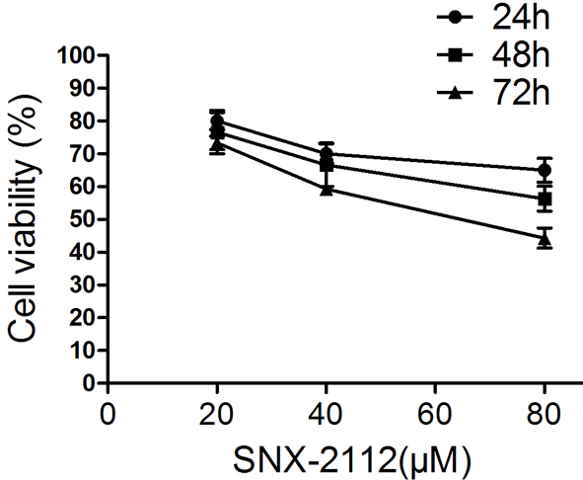
Fig.1

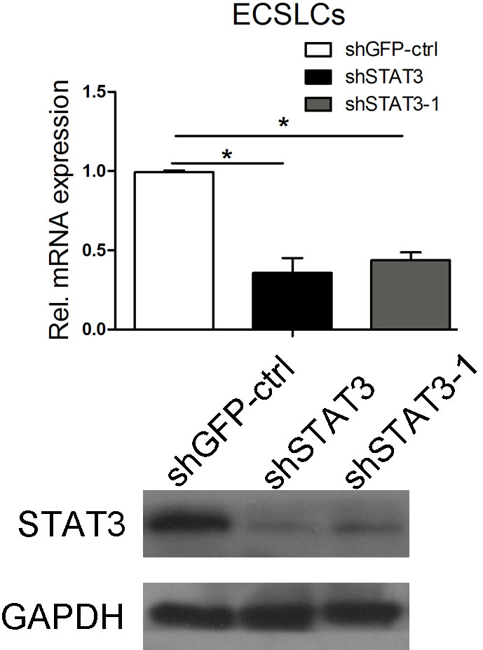
Fig.2

Summary of patients information
Numbers of age range (46-49) was 1, Numbers of age range (50-55) was 2, numbers of age range (56-59) was 1, numbers of age range (60-65) was 6, numbers of age range (66-69) was 1.
T classification Numbers of 2 cla. was 5 and numbers of 3 cla. was 6.
N classification Numbers of 0 cal. was 1, numbers of 1 cla. was 5, numbers of 2 cla. was 4, numbers of 3 cla. was 1.
M classification Numbers of M0 was 5, numbers of M1 was 6.
T tumor grade Numbers of G1 was 5, numbers of G2 was 4 and numbers of G3 was 2.
Location Numbers of middle was 4 and numbers of lower was 4 and numbers of upper was 3.
Abbreviations: T, tumor; N, node; M, metastasis.

