**Supplementary File**

**A systematic way to infer the regulation relations of miRNAs on target genes and critical miRNAs in cancers**

Peng Xu1,2, Qian Wu1, Jian Yu1, Yongsheng Rao1, Zheng Kou1, Gang Fang1, Xiaolong Shi1, Wenbin Liu1*, Henry Han3*

1Institute of computational science and technology, Guangzhou University, Guangzhou, Guangdong, 510006, China.

2School of computer science of information technology, Qiannan Normal University for Nationalities, Duyun, Guizhou, 558000, China.

3Department of computer and information science, Fordham University, New York, NY, 10023, USA.

*Correspondence author: wbliu6910@126.com, [xhan9@fordham.edu](mailto:xhan9@fordham.edu)

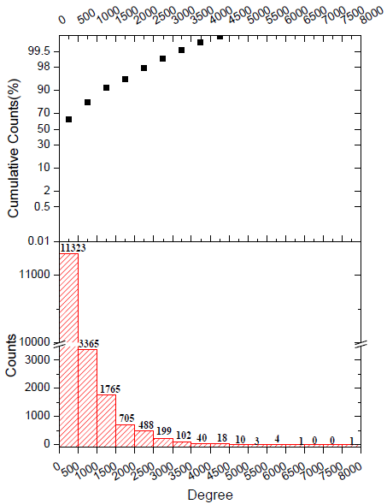

Figure S1. String database：PPI: 19576 nodes, 11353056 interactions . The protein ID in PPI network were converted to Gene symbol ID by R software package “biomaRt”, al last 10048286 interactions were got between the 18014 nodes.