**Figure S1.** Flow chart of study patients’ selection.

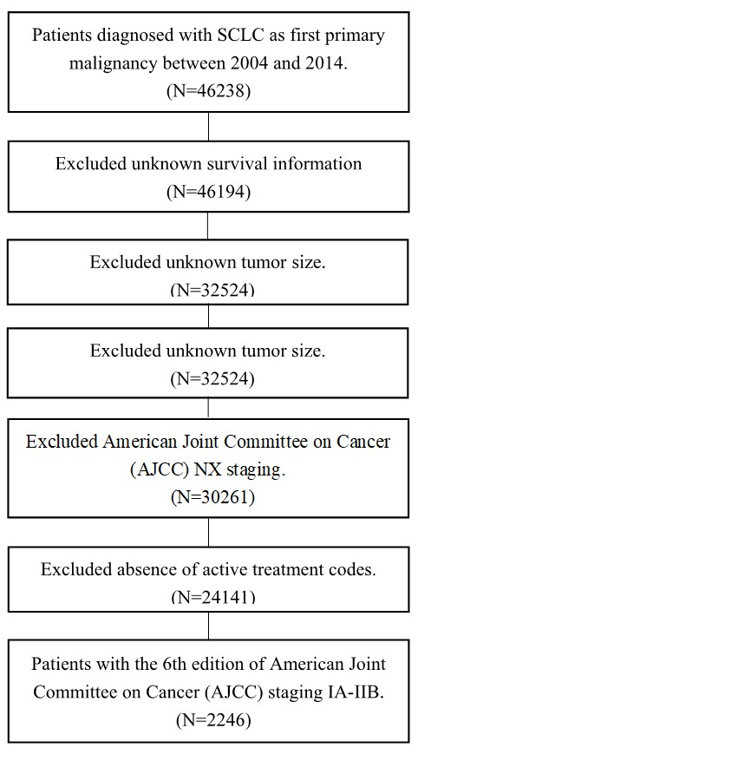

**Figure S2.** Kaplan-Meier survival curves for I-II stage SCLC patients with or without surgery across five propensity score strata. A. propensity score quintile 1 group; B. propensity score quintile 2 group; C. propensity score quintile 3 group; D. propensity score quintile 4 group; and E. propensity score quintile 5 group.

**C:\课题合作\王子平\SCLC列线图\是否手术\图片\分层合图.tiff**

**Figure S3.** Propensity score distributions (**A**) before matching, and (**B**) after matching.

C:\课题合作\王子平\SCLC列线图\是否手术\fig2 密度曲线.tiff

**Figure S4.** Kaplan-Meier survival curves for I-II stage SCLC patients with or without surgery after propensity score matching.

C:\课题合作\王子平\SCLC列线图\是否手术\图片\匹配后 KM曲线.tiff

**Figure S5.** Transformation of Continuous Variables in Univariate Analysis Using Restricted Cubic Splines relating to (**A**) age and (**B**) tumor size.

**C:\课题合作\王子平\SCLC列线图\是否手术\图片\补充图片 立方样条.tiff**

**Table S1.** Cox proportional hazard multivariable regression model parameters.

|  |  |  |
| --- | --- | --- |
| Covariate | Beta coefficient | P |
| Age a | 0.031 | <0.001 |
| Age’ | -0.003 | 0.692 |
| Tumor size b | 0.100 | 0.012 |
| Tumor size’ | -0.064 | 0.264 |
| Regional extension | 0.246 | <0.001 |
| N1 stage | 0.083 | 0.208 |
| Surgery | -1.252 | <0.001 |
| Chemotherapy | -0.261 | 0.002 |
| Radiotherapy | -0.697 | <0.001 |
| Surgery : Radiotherapy | 0.581 | <0.001 |
| Surgery : N1 stage | 0.716 | <0.001 |

a Age modeled using restricted cubic spline function with three knots, requiring two independent coefficients: age and age’.

b Tumor size modeled using restricted cubic spline function with three knots, requiring two independent coefficients: tumor size and tumor size’.