Supplement 2 – Correlation between *Spartina alterniflora* nitrogen density with a) leaf biomass, and b) leaf % nitrogen. Supplement 2a shows that live biomass was correlated with nitrogen density across marshes (ρ=+0.952, P<0.0001), and this correlation remained significant even when the marsh with the highest nitrogen density (Site 9) was removed (ρ=+0.902, P<0.0001). Supplement 2b shows that percent nitrogen was not significantly correlated with nitrogen density (ρ=+0.238, P=0.41). Biomass may be more strongly correlated with nitrogen density because it was more variable across marshes; live biomass at the site with the highest value was 5.5 times greater than the biomass at the site with the lowest value, but %N at the site with the highest value was only 1.5 times the site with the lowest value.

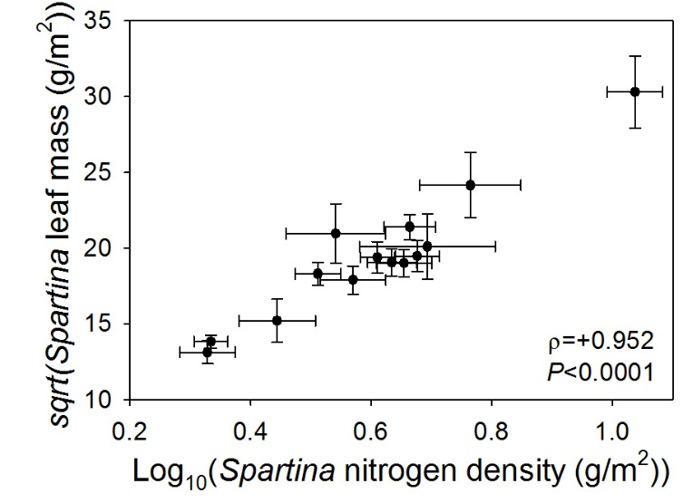

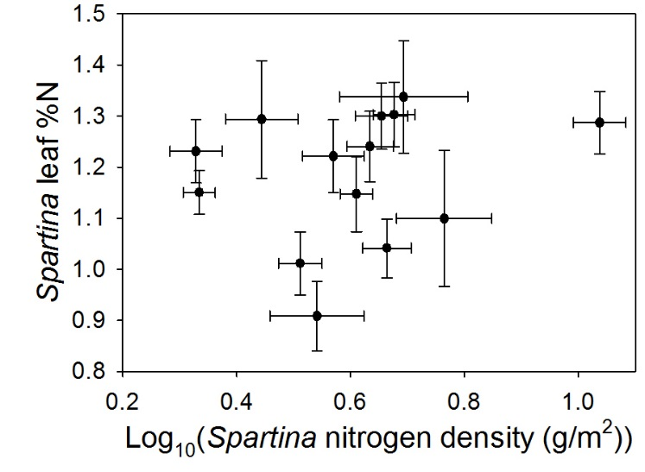

b

a