**Supplement 1**

Table 1: Marsh study locations and a map of where those sites are located

|  |  |  |  |  |  |
| --- | --- | --- | --- | --- | --- |
| **Site #** | **Site Name** | **State** | **Latitude** | **Longitude** | **# sample plots** |
| 1 | Fore River Sanctuary | ME | 43º 39’ 50.56” N | 70º 18’ 48.16” W | 12 |
| 2 | Urban Forestry Center | NH | 43º 02’ 55.36” N | 70º 45’ 58.05” W | 7 |
| 3 | Awcomin Marsh | NH | 43º 00’ 11.34” N | 70º 45’ 12.06” W | 12 |
| 4 | Plum Island LTER | MA | 42º 44’ 25.67” N | 70º 51’ 03.72” W | 12 |
| 5 | Fogland Nature Preserve | RI | 41º 32’ 46.43” N | 71º 12’ 34.30” W | 12 |
| 6 | Colt State Park | RI | 41º 40’ 52.30” N | 71º 17’ 44.95” W | 11 |
| 7 | Foxhill Salt Marsh | RI | 41º 29’ 25.75” N | 71º 23’ 36.37” W | 12 |
| 8 | Caumsett State Historic Park | NY | 40º 56’ 32.0” N | 73º 28’ 56.0” W | 12 |
| 9 | Jamaica Bay Wildlife Refuge | NY | 40° 37' 23.24"N | 73° 49' 46.86"W | 11 |
| 10 | Horseshoe Cove | NJ | 40° 26' 56.95"N | 73° 59' 56.75"W | 7 |
| 11 | Tuckerton | NJ | 39° 33' 1.79"N | 74° 20' 11.85"W | 7 |
| 12 | Little Creek Wildlife area | DE | 39° 10’ 30.8” N | 75º 24’ 57.04” W | 12 |
| 13 | Delaware Seashore State Park | DE | 38° 38' 3.26"N | 75° 4' 10.27"W | 12 |
| 14 | Virginia Coast Reserve | VA | 37º 27’ 42.12” N | 75º 50’ 16.44” W | 12 |

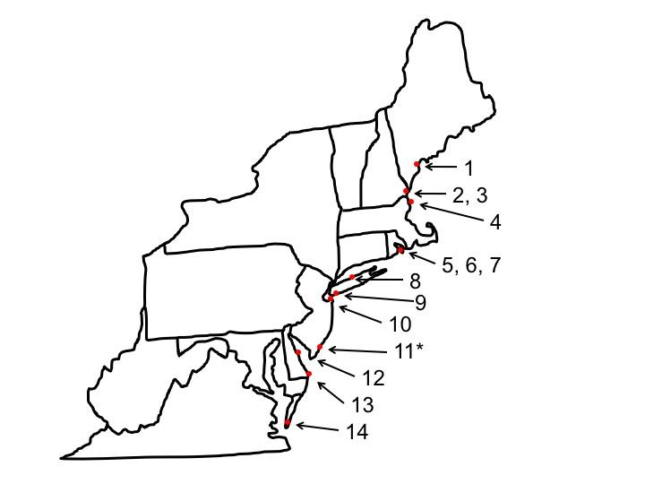

Table 2 – Arthropod species found at each survey site. 1 = Species present at a site, 0 = Species absent from a site. The names for each site can be found in Table 1. Species codes for each arthropod are as follows: A = Amphipoda: Taltridae: *Orchestia grillus*; Dp = Hemiptera: Delphacidae: *Delphacodes penedetecta*; G = Araneae: Linyphiidae: *Grammonota trivittata*; I = Isopoda: Armadillidae: *Venezillo parvus*; It = Diptera: Chloropidae: *Incertella* sp.1; P = Araneae: Lycosidae: *Pardosa littoralis*; Pd = Hemiptera: Delphacidae: *Prokelisia dolus*; Pm = Hemiptera: Delphacidae: *Prokelisia marginata*; Sa = Hemiptera: Saldidae: *Saldula interstitialis*; Tg = Hemiptera: Miridae: *Trigonotylus uhleri*; V = Hemiptera: Miridae: *Tytthus vagus*.

|  |  |  |  |  |  |  |  |  |  |  |  |
| --- | --- | --- | --- | --- | --- | --- | --- | --- | --- | --- | --- |
| Survey Site | A | Dp | G | I | It | P | Pd | Pm | Sa | Tg | V |
| 1 | 1 | 0 | 1 | 0 | 1 | 1 | 1 | 1 | 1 | 1 | 1 |
| 2 | 1 | 0 | 1 | 1 | 1 | 1 | 1 | 1 | 1 | 1 | 1 |
| 3 | 1 | 0 | 1 | 1 | 1 | 1 | 1 | 1 | 1 | 1 | 1 |
| 4 | 1 | 1 | 1 | 1 | 1 | 1 | 1 | 1 | 1 | 1 | 1 |
| 5 | 1 | 0 | 1 | 1 | 1 | 1 | 1 | 1 | 1 | 1 | 1 |
| 6 | 1 | 0 | 1 | 1 | 1 | 1 | 1 | 1 | 1 | 1 | 1 |
| 7 | 1 | 1 | 1 | 0 | 1 | 1 | 1 | 1 | 1 | 1 | 1 |
| 8 | 1 | 0 | 1 | 1 | 1 | 1 | 1 | 1 | 1 | 1 | 1 |
| 9 | 1 | 0 | 1 | 1 | 1 | 1 | 1 | 1 | 1 | 1 | 1 |
| 10 | 1 | 0 | 1 | 0 | 1 | 1 | 1 | 1 | 1 | 1 | 1 |
| 11 | 1 | 1 | 1 | 1 | 1 | 1 | 1 | 1 | 1 | 1 | 1 |
| 12 | 1 | 1 | 1 | 1 | 1 | 1 | 1 | 1 | 1 | 1 | 1 |
| 13 | 1 | 1 | 1 | 1 | 1 | 0 | 1 | 1 | 1 | 1 | 1 |
| 14 | 1 | 1 | 1 | 0 | 1 | 0 | 1 | 1 | 1 | 1 | 1 |