Supplemental Information

EthA/R-independent killing of Mycobacterium tuberculosis by ethionamide

Running Title: EthA/R-independent killing by ethionamide

Authors: Michelle Lay Teng Ang^{1,2}, Siti Zarina Zainul Rahim^{1,2}, Paola Florez de Sessions³, Wenwei Lin^{1,2}, Vanessa Koh^{1,2}, Kevin Pethe⁴, Martin Lloyd Hibberd^{3,5} and Sylvie Alonso^{1,2*}.

Affiliations: ¹Department of Microbiology and Immunology, Yong Loo Lin School of Medicine, ²Immunology programme, Life Sciences Institute, National University of Singapore, ³Genome Institute of Singapore, ⁴Lee Kong Chian School of Medicine and School of Biological Sciences, Nanyang Technological University, Singapore, ⁵Department of Pathogen Molecular Biology, London School of Hygiene & Tropical Medicine, UK.

*Correspondence:
Sylvie Alonso
micas@nus.edu.sg; Fax: +65 67782684.

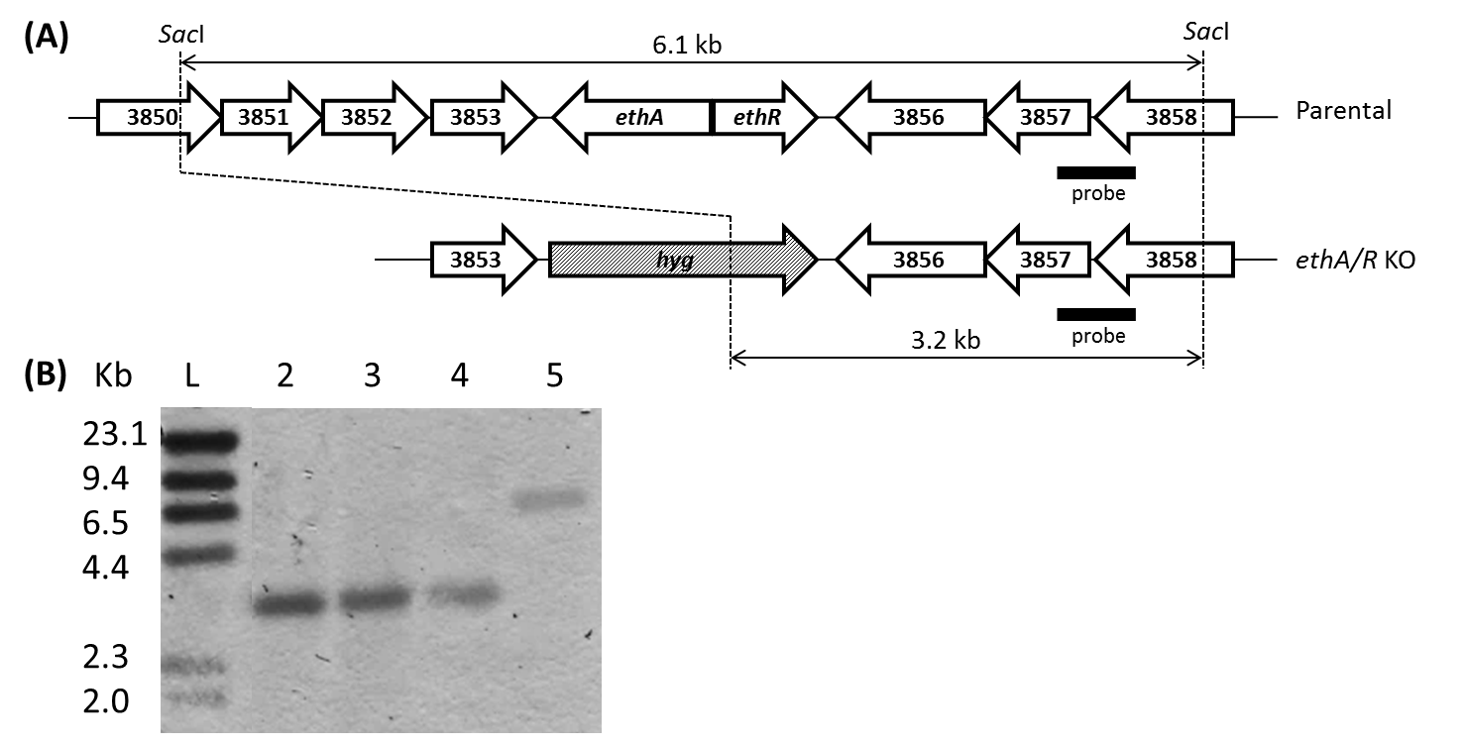

Figure S1: Construction of ethA/R KO mutants in BCG, MTB Erdman, H37Rv and CDC1551.
A) Chromosomal organization of ethA/R is identical in BCG and the three MTB backgrounds. The arrows depict the lengths and directions of ethA, ethR and their neighbouring genes. Black bar corresponds to the probe used for Southern Blot analysis. B) Southern Blot analysis of chromosomal DNA. L, DNA Molecular Ladder; 1, BCG ethA/R KO; 2, MTB Erdman ethA/R KO; 3, MTB H37Rv ethA/R KO; 4, MTB CDC1551 ethA/R KO ; 5, BCG WT.

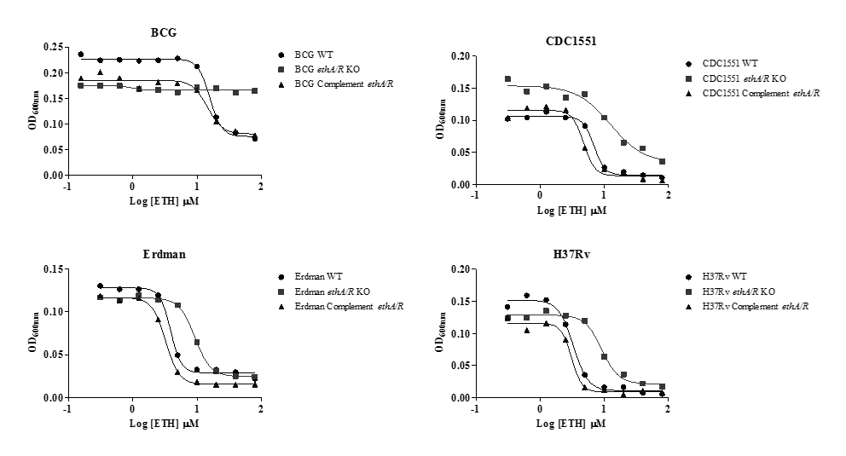

Figure S2: Minimum Inhibitory Concentrations (MIC) of Ethionamide (ETH) and other drugs on ethA/R KO mutants.
The assay was performed in 7H9-ADS. OD600 values were measured after 5 days incubation at 37ºC. “BCG/CDC1551/Erdman/H37Rv complement” refers to ethA/R KO BCG/CDC1551/Erdman/H37Rv complemented with ethA/R.

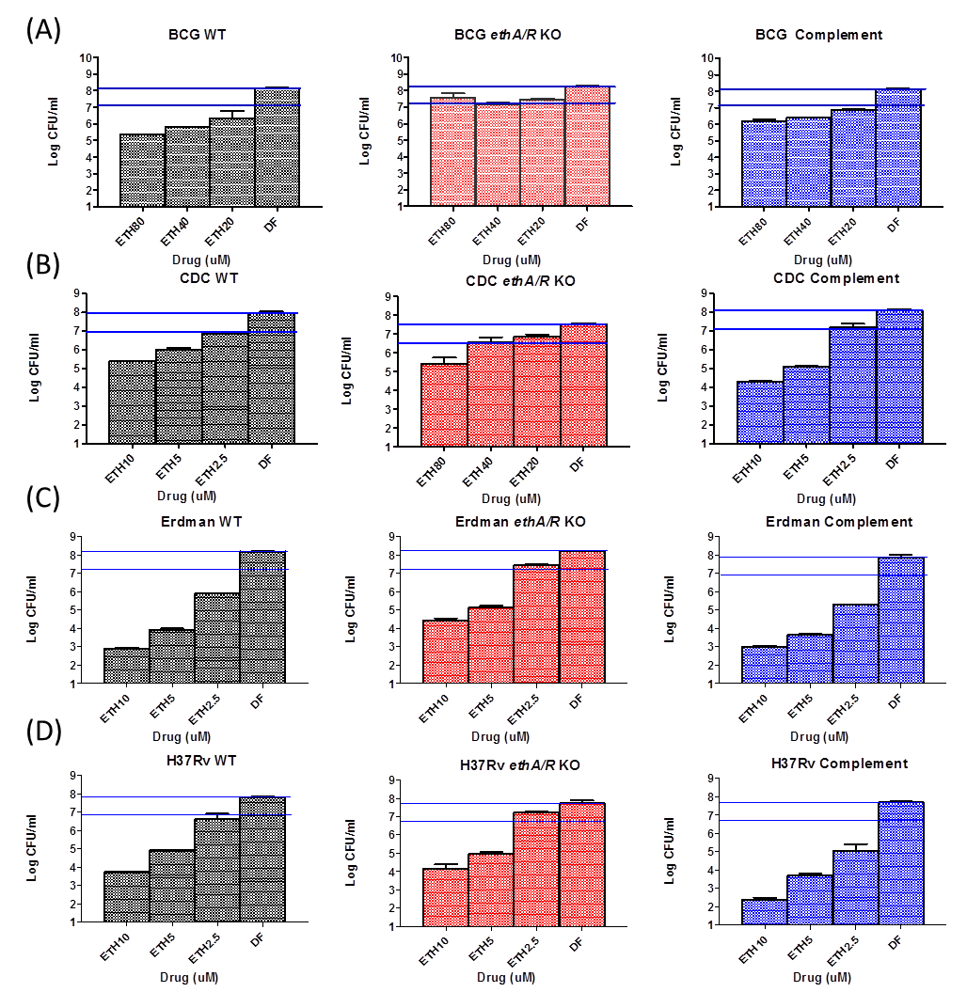
Figure S3: CFU-based MIC₉₀ of ETH on ethA/R KO mutants.
BCG (A) or MTB (B-D) suspensions were incubated for 5 days in the presence of the indicated ETH concentrations and then plated onto 7H11 agar for colony counting after 16 days incubation. Horizontal lines represent 1 log reduction in CFU compared to the drug-free (DF) control. “BCG/CDC1551/Erdman/H37Rv complement” refers to ethA/R KO BCG/CDC1551/Erdman/H37Rv complemented with ethA/R.

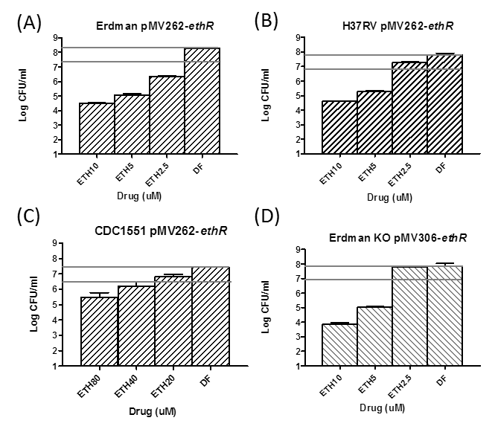

Figure S4: CFU-based MIC₉₀ of ETH on ethA/R KO mutants expressing ethR.
Same legend as in Figure S3. EthR was over-expressed (pMV262-ethR construct) in Erdman (A), H37Rv (B) and CDC1551 (C) WT strains. EthR was expressed at parental level (pMV306-ethR construct) in the ethA/R KO Erdman strain (D).

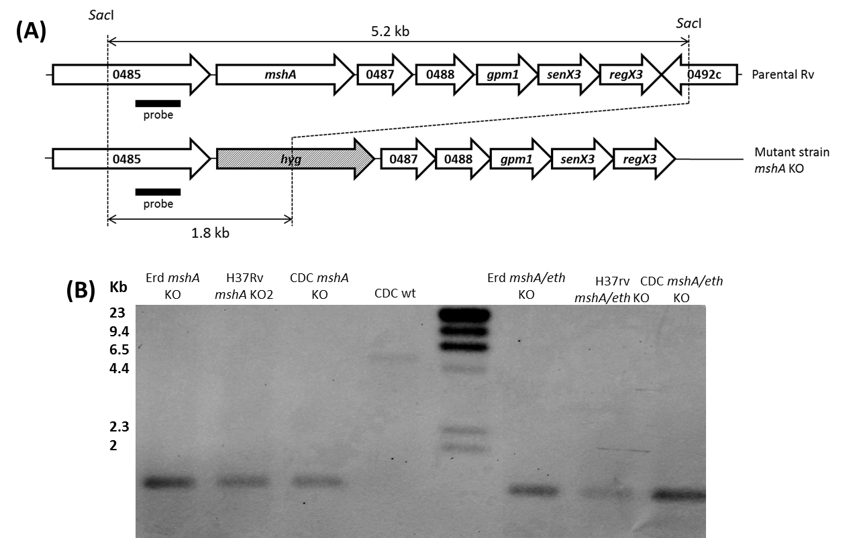

Figure S5: Construction of mshA KO and mshA/ethA/R double KO mutants in MTB Erdman, MTB H37RV and MTB CDC1551
A) Chromosomal organization of mshA was identical in the three MTB backgrounds. The arrows depict the lengths and directions of mshA and its neighbouring genes. Black bar corresponds to the probe used for Southern Blot analysis. B) Southern Blot analysis of chromosomal DNA. 1, MTB Erdman mshA KO; 2, MTB H37Rv mshA KO; 3, MTB CDC1551 mshA KO; 4, MTB CDC1551 WT ; L, DNA Molecular Ladder; 5, MTB Erdman mshA/ethA/R double KO; 6, MTB H37Rv mshA/ethA/R double KO; 3, MTB CDC1551 mshA/ethA/R double KO.

Figure S6: ETH MIC curves on mshA KO and mshA ethA/R (m/e) double KO mutants.
Drug susceptibility assay was performed in 7H9-OADC medium as described in M&M. OD600 values were read after 7 days incubation.

Table S1: Primers used in this study.
FP: Forward primer; RP: Reverse primer. RE: Restriction Enzyme. RE sites in primer sequences are underlined.
ETH^{R} Isolate | Gene Name / Gene | Known Function | Type of Mutations | No. of mutations
760C1 | Erdman_0718 / fabD2 | Malonyl CoA-acyl carrier protein transacylase | NS- SNPs | 1
 | Erdman_3212 / - | Malonyl CoA-acyl carrier protein transacylase | NS- SNPs | 2
 | Erdman_3280 / gltx | Glutamyl-tRNA synthetase | NS- SNPs | 1
760C3 | Erdman_0263 / - | Transmembrane protein | NS- SNPs | 1
 | Erdman_0324 / - | Transmembrane protein | NS- SNPs | 1
 | Erdman_0532 / mshA | Mannosyl transferase | NS- SNPs | 1
 | Erdman_0693 / recD | Exonuclease V alpha chain | NS- SNPs | 1
 | Erdman_1821 / argB | Acetylglutamate kinase | NS- SNPs | 1
 | Erdman_3922 / - | Transcriptional regulator | NS- SNPs | 1
760C5 | Erdman_0532 / mshA | Mannosyl transferase | NS- SNPs | 1
 | Erdman_0300 / fadE6 | Acyl-CoA dehydrogenase | NS- SNPs | 1
 | Erdman_0324 / - | Transmembrane protein | NS- SNPs | 1
 | Erdman_0588 / galE3 | UDP-glucose 4-epimerase | NS- SNPs | 1
 | Erdman_1484 / - | Thioredoxin | NS- SNPs | 1
 | Erdman_2261 / pks12 | Polyketide synthase | NS- SNPs | 1
 | Erdman_2922 / - | Prophage protein | NS- SNPs | 1
 | Erdman_3212 / - | Malonyl CoA-acyl carrier protein transacylase | NS- SNPs | 1
 | Erdman_3794 / - | REP13E12 repeat-containing protein | NS- SNPs | 1
770A1 | Erdman_0532 / mshA | Mannosyl transferase | NS- SNPs | 1
 | Erdman_0819 / - | Transcriptional regulator | NS- SNPs | 1
 | Erdman_1488 / glgP | Glycogen phosphorylase | NS- SNPs | 1
 | Erdman_2377 / murE | UDP-N-acetylmuramoylalanyl-D-glutamate-2,6-diaminopimelate ligase | NS- SNPs | 1
 | Erdman_2459 / cobD | Cobalamin biosynthesis protein | NS- SNPs | 1
 | Erdman_2997 / recX | Recombination regulator | NS- SNPs | 1
 | Erdman_3212 / - | Malonyl CoA-acyl carrier protein transacylase | NS- SNPs | 2
 | Erdman_3992 / topA | DNA topoisomerase I | NS- SNPs | 1
770A3 | Erdman_0532 / mshA | Mannosyl transferase | NS- SNPs | 1
 | Erdman_1118 / pabB | Para-aminobenzoate synthase component I | NS- SNPs | 1
 | Erdman_1647 / moxR1 | Transcriptional regulator | NS- SNPs | 1
 | Erdman_1703 / pks5 | Polyketide synthase | NS- SNPs | 1
 | Erdman_2580 / plcB | Membrane-associated phospholipase C | NS- SNPs | 1
 | Erdman_3212 / - | Malonyl CoA-acyl carrier protein transacylase | NS- SNPs | 1
 | Erdman_4088 / ligC | ATP-dependent DNA ligase | NS- SNPs | 1
 | Erdman_4115 / tyrA | Prephenate dehydrogenase | NS- SNPs | 1
60C72 | Erdman_0532 / mshA | Mannosyl transferase | INDEL | 1
80C73 | Erdman_0532 / mshA | Mannosyl transferase | INDEL | 1

Table S2: Mutations identified in spontaneous ETH-resistant mutants.
Spontaneous ETH-resistant mutants were derived from Erdman ethA/R KO mutant, screened for wildtype inhA gene, and 7 individual mutants were fully sequenced to identify novel genes involved in ETH bio-activation. Identified mutations were restricted to INDELs and NS-SNPs. The gene list was further refined by eliminating conservative NS-SNPs. Genes in bold are highlighted to reflect recurring (but random) mutations in selected mutants. INDEL – Insertion/Deletion, NS-SNPs – non-synonymous single nucleotide polymorphisms. Gene name, gene and known function were referenced and extracted from Pubmed Genbank. (http://www.ncbi.nlm.nih.gov/nuccore/379026087).

 | 7H9-ADS | 7H9-ADS | 7H9-OADC | 7H9-OADC
 | INH | ETH | INH | ETH
CDC1551 | 0.22 | 6.90 | 0.26 | 7.18
CDC1551 ethA/R KO | 0.22 | 12.40 | 0.20 | 31.04
Erdman | 0.15 | 3.89 | 0.18 | 3.04
CDC1551 ethA/R KO | 0.11 | 9.29 | 0.18 | 19.69
H37Rv | 0.20 | 3.30 | 0.20 | 3.30
H37Rv ethA/R KO | 0.20 | 9.16 | 0.28 | 12.55

Table S3: MIC₅₀ values of INH and ETH in 7H9-ADS and 7H9-OADC in parental and ethA/R KO strains.
Drug assays were set up in 96-well plates using a broth microdilution method and their OD600 values were read with a spectrophotometry microplate reader after 5-7 days. OD600 values were tabulated into PRISM for fitting of MIC curves, and MIC₅₀ values were read from PRISM.

