Supplementary materials
Site of plant collection: Ţalaat ‘Ammār

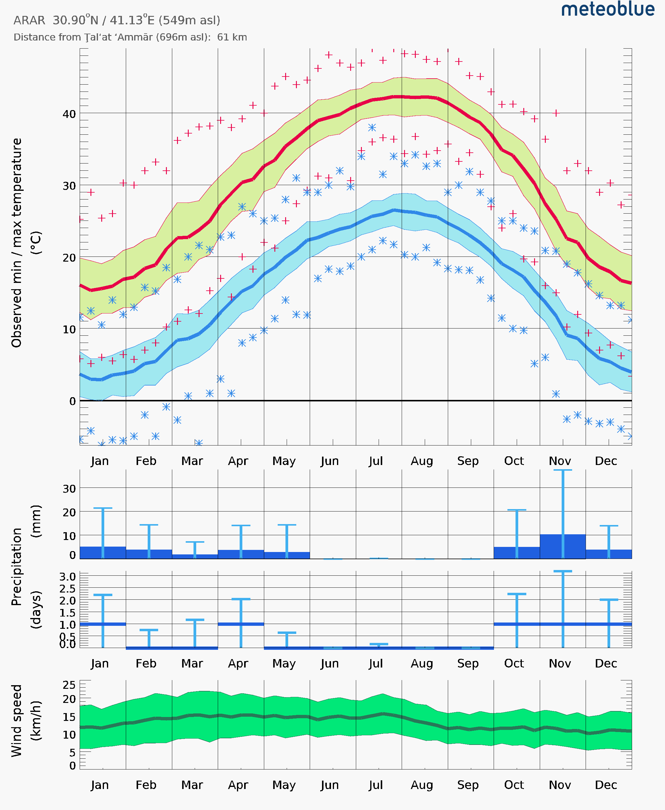
Observed climate data for Ţalaat ‘Ammār (site situated about 15 Km from Wadi Al-Aqraa)

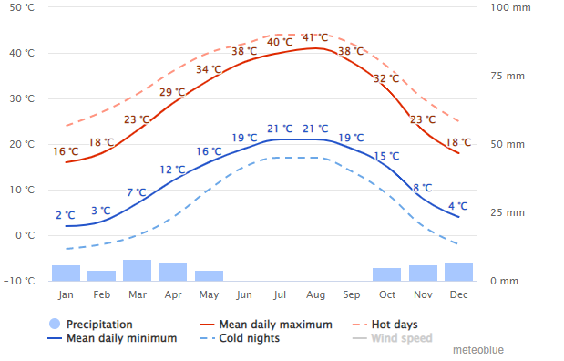

Modelled climate data for Ţalaat ‘Ammār (Population 12)

Years | Precipitation (mm)
2018 | 260.1
2019 | 266.051
2020 | 43.635
2021 | 50.519
2022 | 127.45

AP = Annual precipitation (mm/yr) for Ţalaat ‘Ammār (site situated about 15 Km from Wadi Al-Aqraa)
Source: https://guillermo-ortega.users.earthengine.app/view/agroclim-scanner

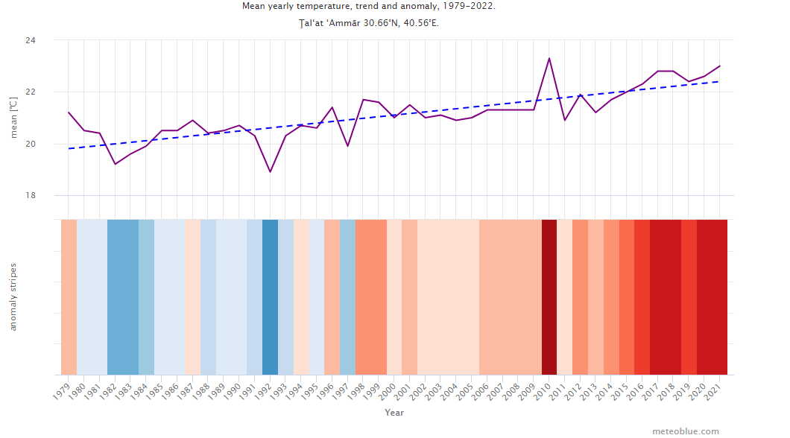
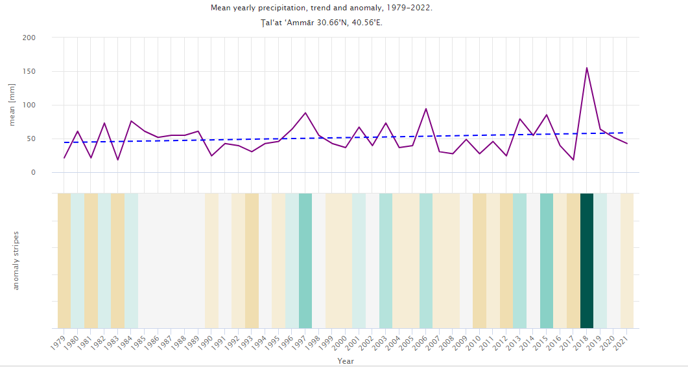
Mean Yearly temperature and precipitation for Ţalaat ‘Ammār (Population 12): Trends and anomalies

