**Special appendix D**

**Quoted sources**

**1**

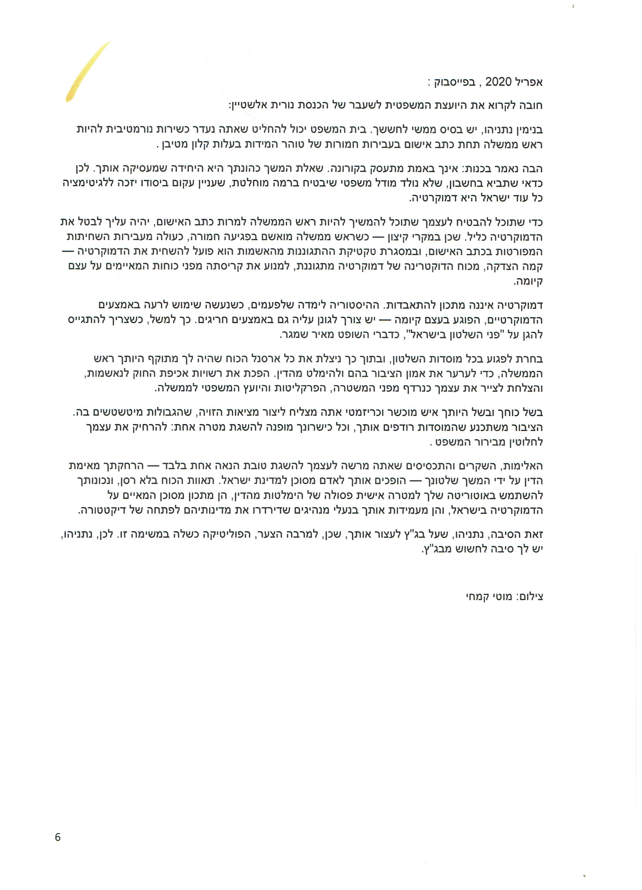

**2**

**3**

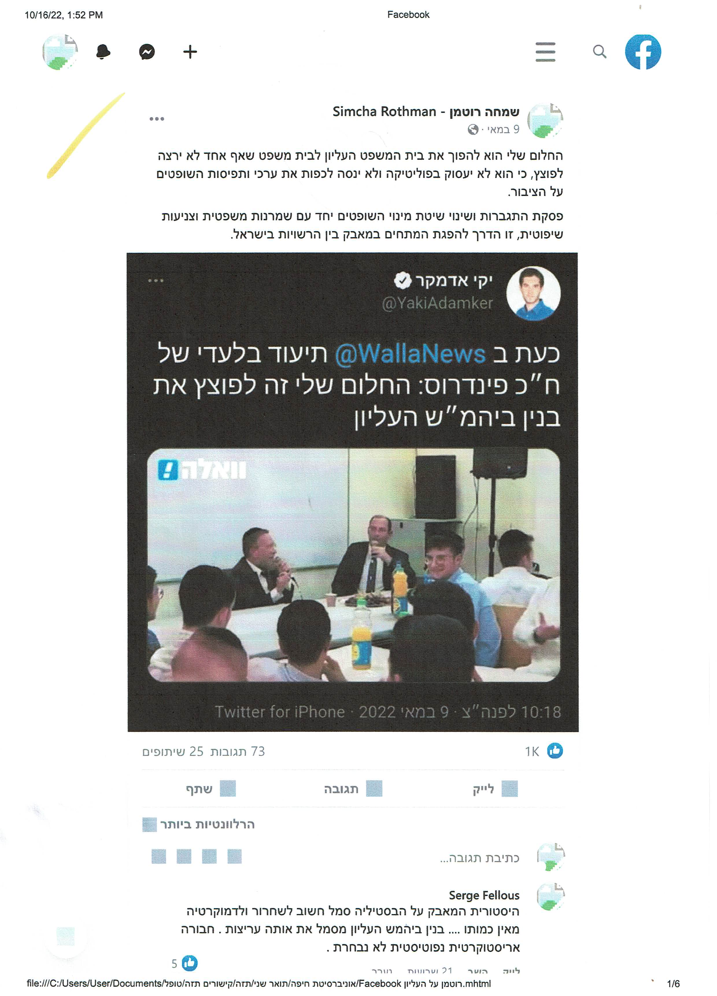

**4**

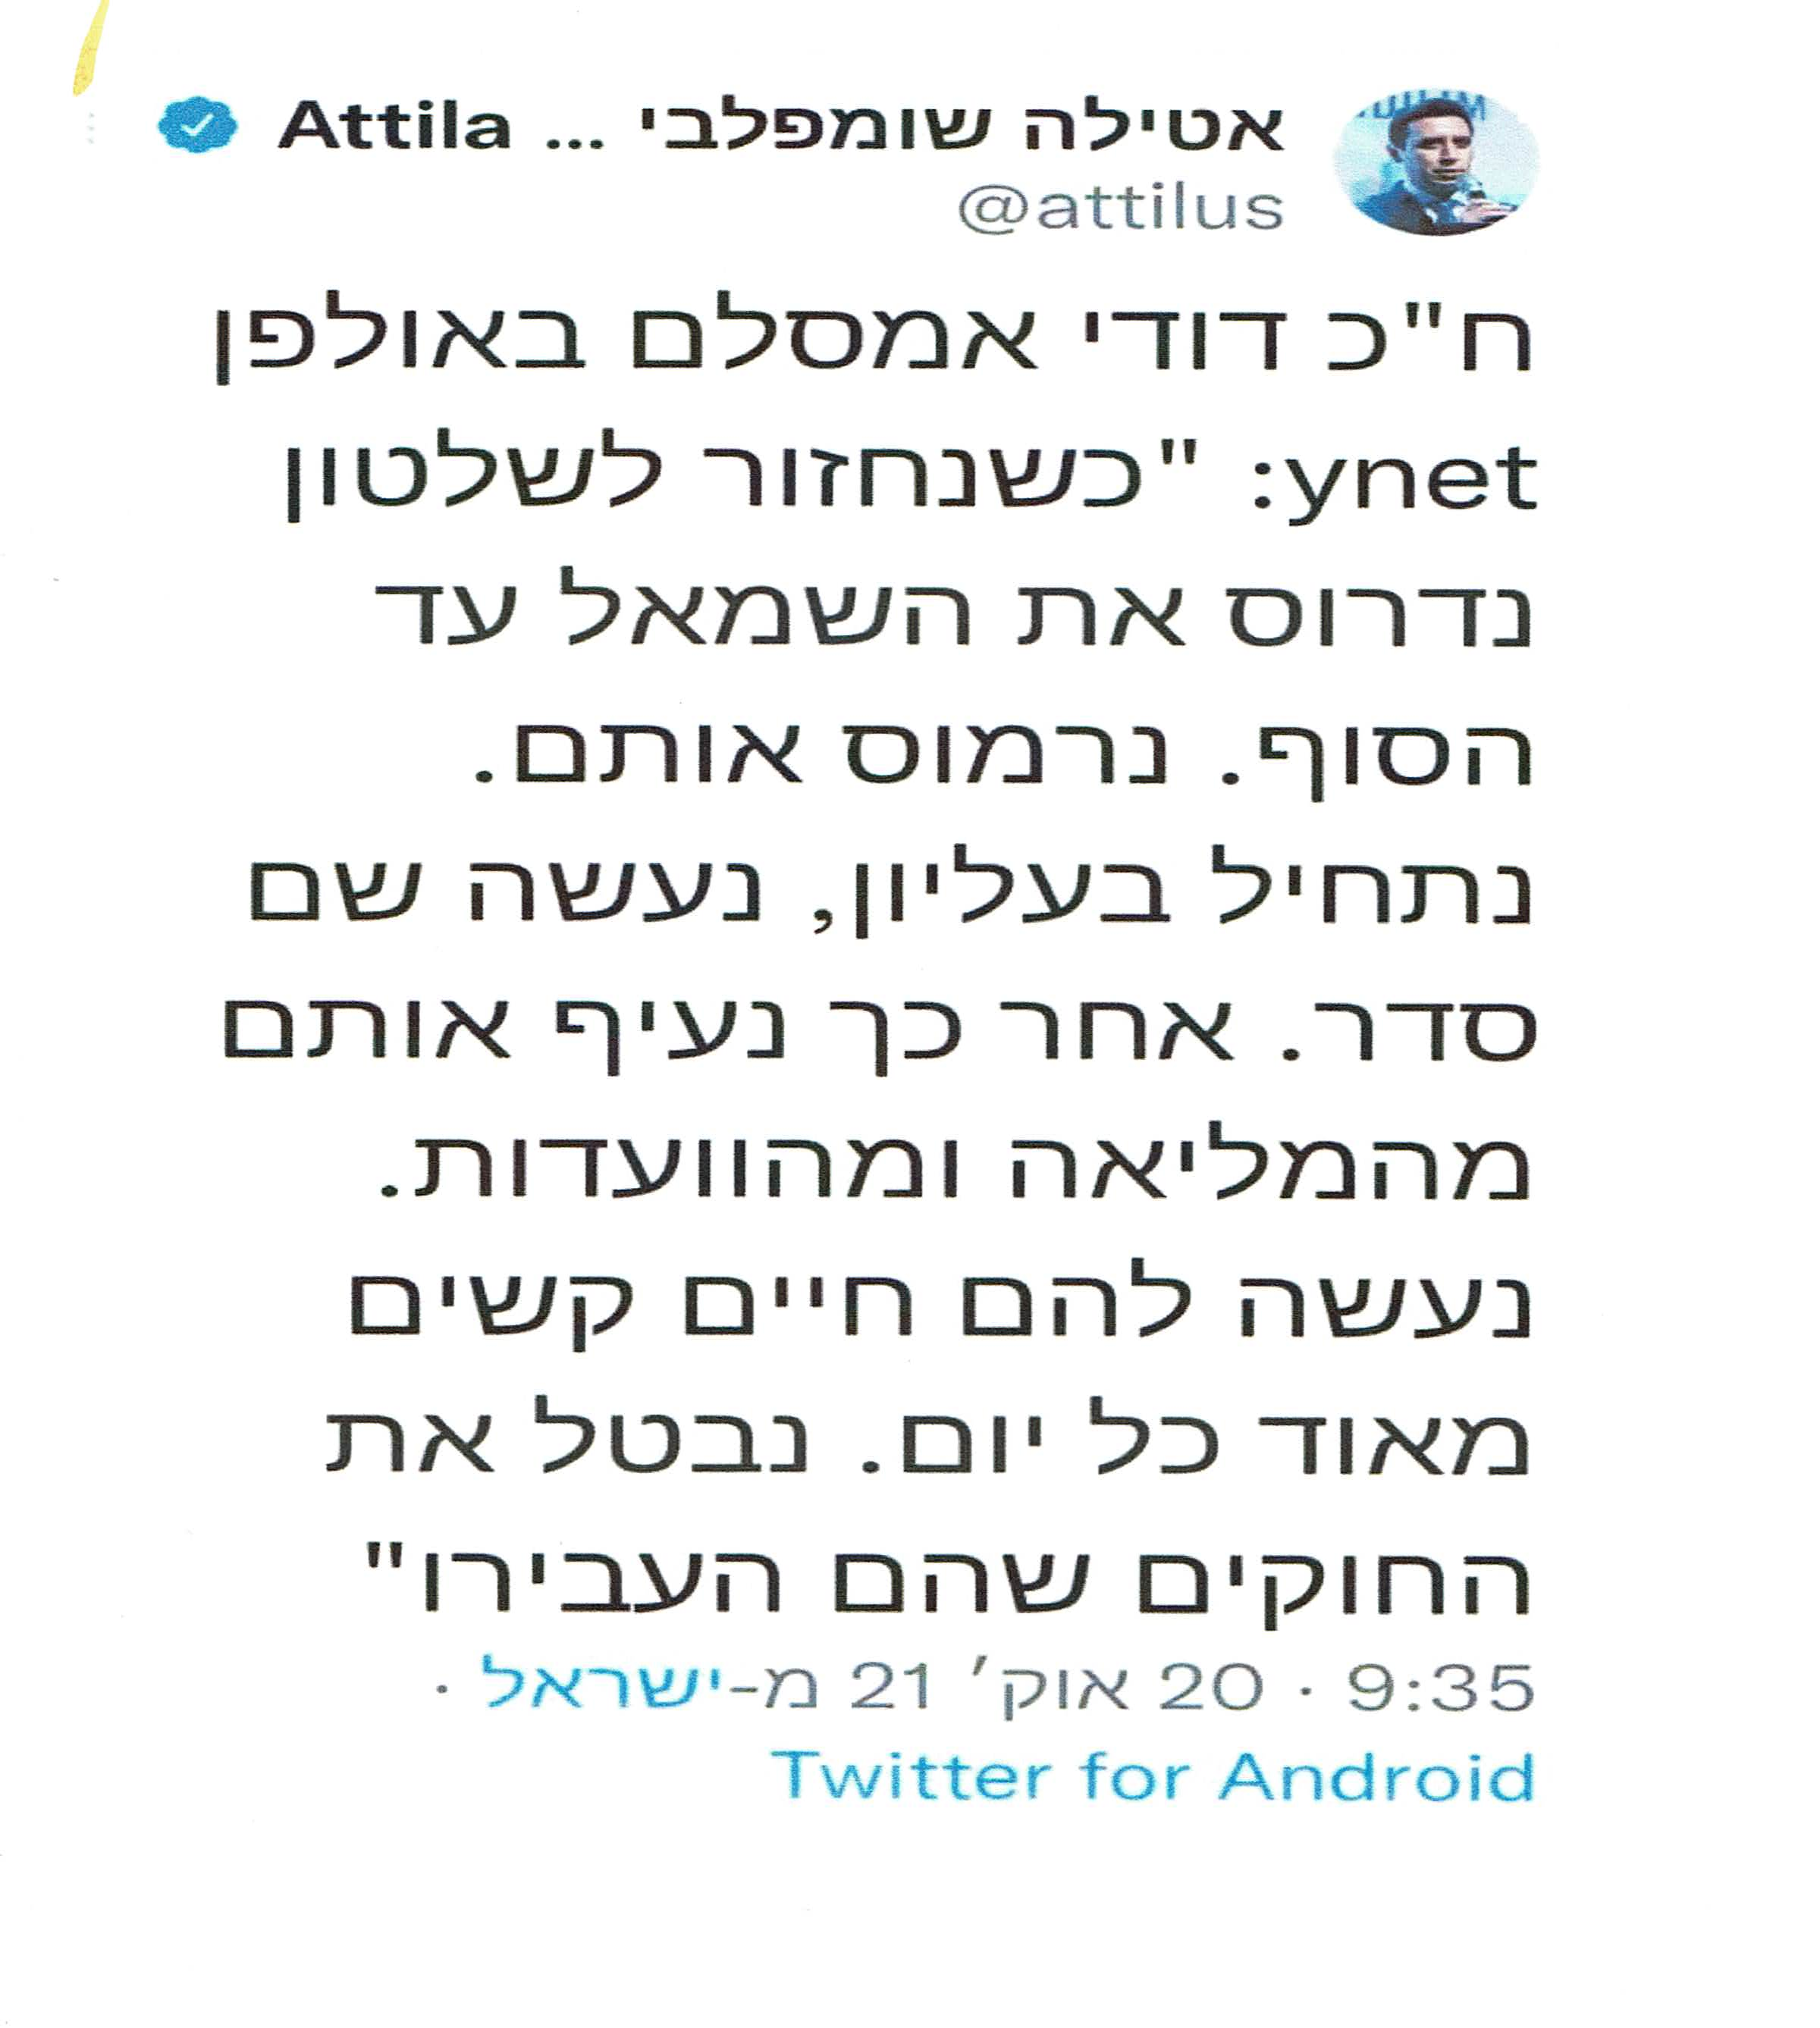

**5**

