Supplementary material
Table S1 The isolation rate of fungal species varied among different plant species and sites.
Strain name | IFs (%) | BY | FF | HD | PA | SV | AA
Edenia gomezpompae | 7.7 | 1 | 1 | 2 | 0 | 3 | 1
Exserohilum sp. | 1.9 | 1 | 0 | 0 | 0 | 1 | 0
Stagonosporopsis sp. | 1.9 | 1 | 0 | 0 | 0 | 1 | 0
Paraphoma radicina | 3.8 | 2 | 0 | 0 | 2 | 0 | 0
Knufia tsunedae | 1.9 | 1 | 0 | 0 | 1 | 0 | 0
Zopfiella marina | 3.8 | 0 | 0 | 2 | 2 | 0 | 0
Meyerozyma guilliermondii | 7.7 | 0 | 1 | 3 | 3 | 1 | 0
Cladosporium sp. | 7.7 | 1 | 2 | 1 | 1 | 0 | 3
Exserohilum pedicellatum | 1.9 | 0 | 1 | 0 | 1 | 0 | 0
Bipolaris sp. | 3.8 | 1 | 1 | 0 | 0 | 2 | 0
Alternaria sp. | 3.8 | 0 | 2 | 0 | 0 | 1 | 1
Halobyssothecium carbonneanum | 3.8 | 2 | 0 | 0 | 2 | 0 | 0
Curvularia buchloes | 3.8 | 0 | 2 | 0 | 1 | 1 | 0
Thielavia arenaria | 1.9 | 0 | 1 | 0 | 0 | 1 | 0
Zopfiella pilifera | 3.8 | 0 | 0 | 2 | 2 | 0 | 0
Epicoccum keratinophilum | 5.8 | 3 | 0 | 0 | 1 | 2 | 0
Poaceascoma filiforme | 7.7 | 1 | 0 | 3 | 0 | 3 | 1
Curvularia pseudointermedia | 3.8 | 0 | 0 | 2 | 0 | 2 | 0
Towyspora aestuari | 7.7 | 0 | 0 | 4 | 4 | 0 | 0
Paraphoma pye | 3.8 | 0 | 0 | 2 | 0 | 0 | 2
Poaceascoma helicoides | 7.7 | 1 | 0 | 3 | 3 | 1 | 0
Paraphoma chrysanthemicola | 3.8 | 0 | 0 | 2 | 0 | 0 | 2
Note: BY, Baiyang Lake; FF, Fengfeng mining site; HD, Haungdao; PA, Phragmites australis; SV, Setaria viridis; AA, Artemisia annua.

Table S2 DSE diversity indexes in roots of three plants in the three sample sites.
Sites | plants | Shannon-Wiener index | Simpson index | Evenness
 | PA | 1.562 ± 0.006a | 0.781 ± 0.003a | 0.673 ± 0.003b
BY | SV | 1.336 ± 0.003b | 0.722 ± 0.002b | 0.668 ± 0.001b
 | AA | 1.096 ± 0.001c | 0.665 ± 0.001c | 0.692 ± 0.001a
 | PA | 1.351 ± 0.007b | 0.731 ± 0.004b | 0.675 ± 0.004b
FF | SV | 1.606 ± 0.002a | 0.799 ± 0.001a | 0.692 ± 0.001a
 | AA | 0.686 ± 0.004c | 0.493 ± 0.004c | 0.686 ± 0.004ab
 | PA | 1.566 ± 0.002a | 0.780 ± 0.001a | 0.674 ± 0.001b
HD | SV | 1.534 ± 0.005b | 0.770 ± 0.002b | 0.660 ± 0.002c
 | AA | 0.691 ± 0.001c | 0.498 ± 0.001c | 0.691 ± 0.001a
Note: BY, Baiyang Lake; FF, Fengfeng mining site; HD, Huangdao; PA, Phragmites australis; SV, Setaria viridis; AA, Artemisia annua. Means ± standard errors (n = 4). Means followed by the same letter(s) represent significant differences in DSE diversity among different plants under the same sampling sites at P < 0.05 according to the Tukey HSD test.

Table S3 Two-way analysis of DSE diversity indexes in roots of three plants in the three sample sites.
 | site |  | plant |  | site*plant
 | F | P | F | P | F | P
Shannon | 507.01 | <0.001 | 21341.50 | <0.001 | 1910.479 | <0.001
Simpson | 333.46 | <0.001 | 7094.35 | <0.001 | 764.44 | <0.001
Evenness | 8.55 | <0.001 | 37.92 | <0.001 | 18.785 | <0.001
Note: Shannon, DSE community diversity index; Simpson, DSE community diversity index, Evenness, DSE species evenness. Bold font indicates significant differences (P < 0.05).

Table S4 Two-way analysis of variance (ANOVA) of soil factors for various sites and different plants.
 | site |  | plant |  | site*plant
 | F | P | F | P | F | P
AP | 366.85 | <0.001 | 1.74 | 0.203 | 0.56 | 0.694
AK | 7148.53 | <0.001 | 2.34 | 0.125 | 0.32 | 0.858
AN | 330.81 | <0.001 | 0.33 | 0.727 | 0.11 | 0.977
TN | 146.81 | <0.001 | 0.79 | 0.468 | 0.28 | 0.889
TP | 81.84 | <0.001 | 0.54 | 0.594 | 0.62 | 0.657
pH | 1.63 | 0.223 | 0.04 | 0.964 | 0.03 | 0.998
OC | 45.17 | <0.001 | 0.44 | 0.653 | 0.11 | 0.979
URE | 46.71 | <0.001 | 0.28 | 0.762 | 0.21 | 0.929
ALP | 1582.44 | <0.001 | 1.34 | 0.288 | 0.57 | 0.688
CR | 38.51 | <0.001 | 32.00 | <0.001 | 14.88 | <0.001
Cd | 34.83 | <0.001 | 0.00 | 0.998 | 0.02 | 0.999
Zn | 788.90 | <0.001 | 0.25 | 0.780 | 0.18 | 0.944
Mn | 7699.30 | <0.001 | 0.50 | 0.616 | 1.84 | 0.164
Cu | 556.90 | <0.001 | 0.76 | 0.484 | 1.87 | 0.159
Cr | 635.905 | <0.001 | 0.056 | 0.946 | 0.09 | 0.986
ex-Cd | 101.164 | <0.001 | 70.682 | <0.001 | 53.455 | <0.001
ex-Zn | 68.284 | <0.001 | 3.891 | 0.039 | 2.435 | 0.085
ex-Mn | 870.891 | <0.001 | 24.154 | <0.001 | 27.523 | <0.001
ex-Cu | 26.107 | <0.001 | 15.311 | <0.001 | 12.815 | <0.001
ex-Cr | 86.440 | <0.001 | 2.905 | 0.081 | 0.825 | 0.526
Note: AP, soil available P content; AK, soil available K content; AN, soil available N content; TN, soil total N content; TP, soil total P content; OC, soil organic carbon content; URE, soil urease activity; ALP, soil alkaline phosphatase activity; CR, total colonization rate of DSE; Cd, soil cadmium content; Zn, soil zinc content; Mn, soil manganese content; Cu, soil copper content; Cr, soil total chromium content, ex-Cd, soil exchangeable cadmium content; ex-Zn, soil exchangeable zinc content; ex-Mn, soil exchangeable manganese content; ex-Cu, soil exchangeable copper content; ex-Cr, soil exchangeable total chromium content. Bold font indicates significant differences (P < 0.05).

Table S5 Growth rate of 22 DSE strains under heavy metal stress.
Strain name | 0 gradient | Zn (1450 mg/kg) | Cd (40 mg/kg)
Edenia gomezpompae | 0.1071±0.0015c | 0.1143±0.0012b | 0.1214±0.0015a
Exserohilum sp. | 0.3143±0.0038b | 0.4571±0.0026a | 0.2357±0.0018c
Stagonosporopsis sp. | 0.3643±0.0031a | 0.0000 | 0.1214±0.0012b
Paraphoma radicina | 0.2357±0.0015b | 0.2429±0.0029a | 0.2286±0.0020c
Knufia tsunedae | 0.1429±0.0035a | 0.0786±0.0027b | 0.0000
Zopfiella marina | 0.0143±0.0010a | 0.0000 | 0.0000
Meyerozyma guilliermondii | 0.3929±0.0058a | 0.3000±0.0015c | 0.3857±0.0015b
Cladosporium sp. | 0.2500±0.0032a | 0.2071±0.0012b | 0.1357±0.0023c
Exserohilum pedicellatum | 0.1357±0.0015c | 0.1857±0.0025b | 0.2071±0.0021a
Bipolaris sp. | 0.0786±0.0018c | 0.0429±0.0010b | 0.1500±0.0020a
Alternaria sp. | 0.3857±0.0019a | 0.2214±0.0029c | 0.2857±0.0015b
Halobyssothecium carbonneanum | 0.3214±0.0021a | 0.2429±0.0013b | 0.2429±0.0012b
Curvularia buchloes | 0.2071±0.0015c | 0.2714±0.0026a | 0.2571±0.0012b
Thielavia arenaria | 0.0286±0.0021b | 0.0929±0.0003a | 0.0071±0.0006c
Zopfiella pilifera | 0.5643±0.0029a | 0.1714±0.0012c | 0.3571±0.0009b
Epicoccum keratinophilum | 0.4000±0.0015a | 0.3857±0.0018b | 0.1643±0.0012c
Poaceascoma filiforme | 0.4571±0.0020a | 0.2571±0.0003c | 0.3714±0.0012b
Curvularia pseudointermedia | 0.1714±0.0023a | 0.1071±0.0015b | 0.0929±0.0012c
Towyspora aestuari | 0.3500±0.0012a | 0.2929±0.0017b | 0.3500±0.0028a
Paraphoma pye | 0.2429±0.0018a | 0.2071±0.0007b | 0.1429±0.0012c
Poaceascoma helicoides | 0.1429±0.0020a | 0.1214±0.0003b | 0.1429±0.0009a
Paraphoma chrysanthemicola | 0.1143±0.0017b | 0.1000±0.0009c | 0.1500±0.0009a
Note: Different letters show significant differences in the growth rate of the same fungal strain under different heavy metal treatments (P < 0.05).

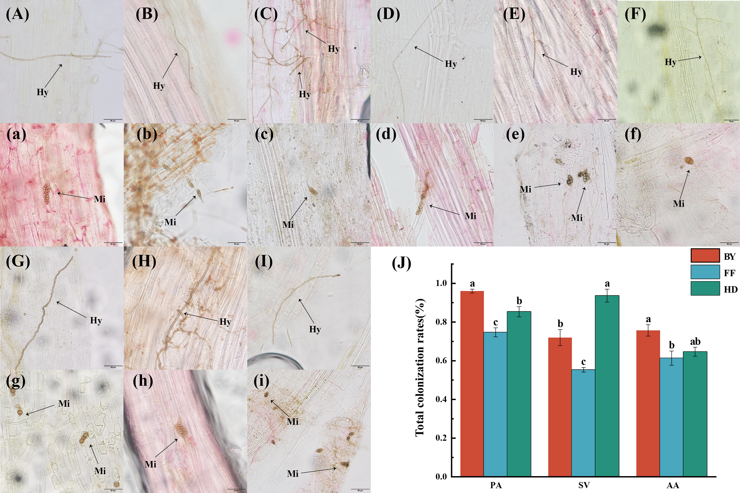
FIGURE S1. Colonization status and total colonization rate of dark septate endophytes (DSE) in the roots of three plant species across different sampling sites. The arrows indicate the following: Hy, DSE hyphae. Mi, DSE microsclerotia. (A, D, G. a, d, g), Phragmites australis; (B, E, H. b, e, h), Setaria viridis; (C, F, I. c, f, i), Artemisia annua; (A, B, C. a, b, c), Baiyang Lake (D, E, F. d, e, f), Fengfeng mining site (G, H, I. g, h, i), Huangdao; (J), total colonization rate of DSE. Note: PA, Phragmites australis; SV, Setaria viridis; AA, Artemisia annua; BY, Baiyang Lake; FF, Fengfeng mining site; HD, Haungdao.

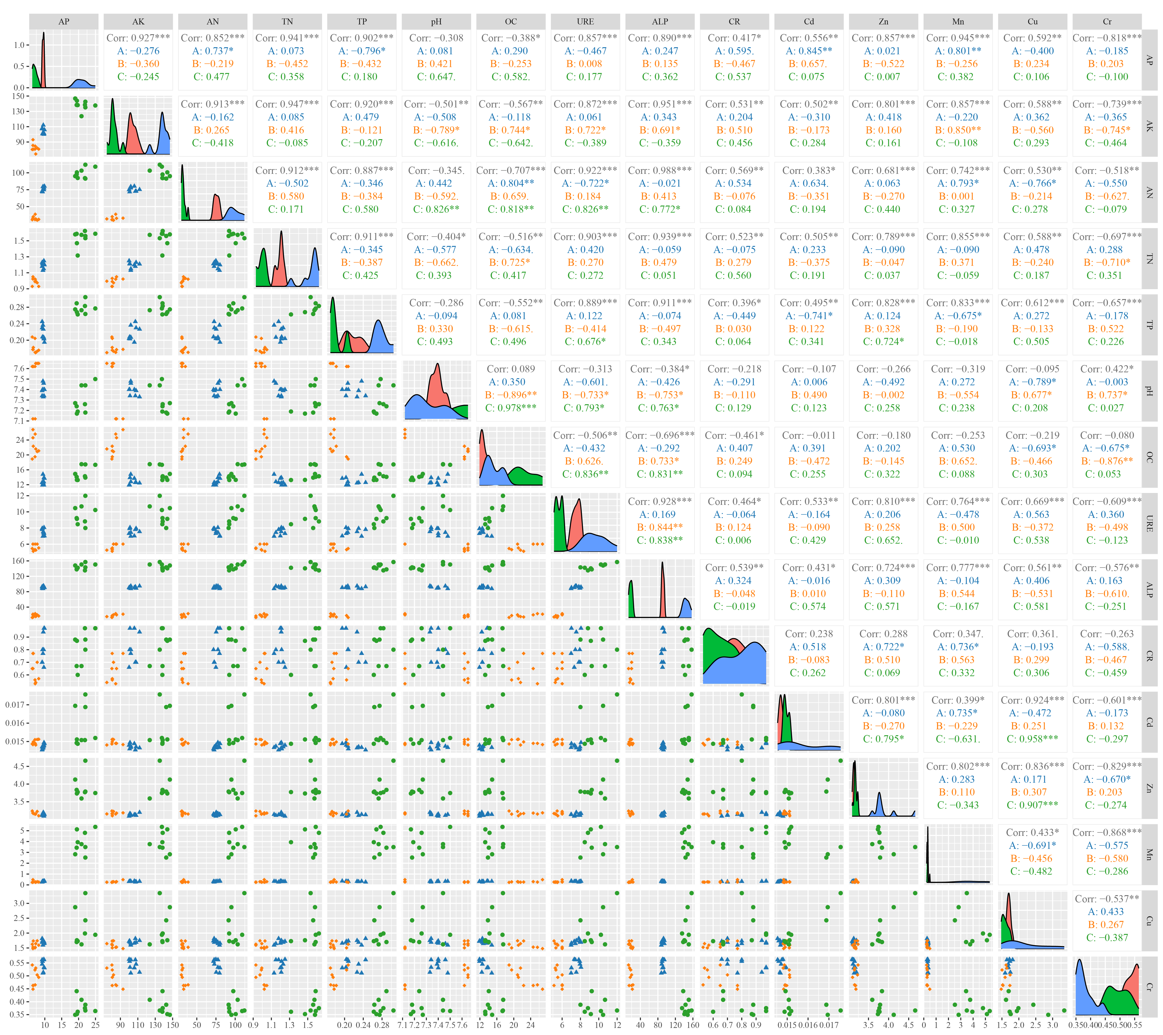
FIGURE S2. Pair plots of DSE isolation frequencies and soil factor contents with soil exchangeable heavy metal concentrations. Asterisks indicate statistical significance in ggpairs at * < 0.05; ** < 0.01; and *** < 0.001. A, DSE from Baiyang Lake; B, DSE from the Fengfeng mining site; C, DSE from Huangdao.

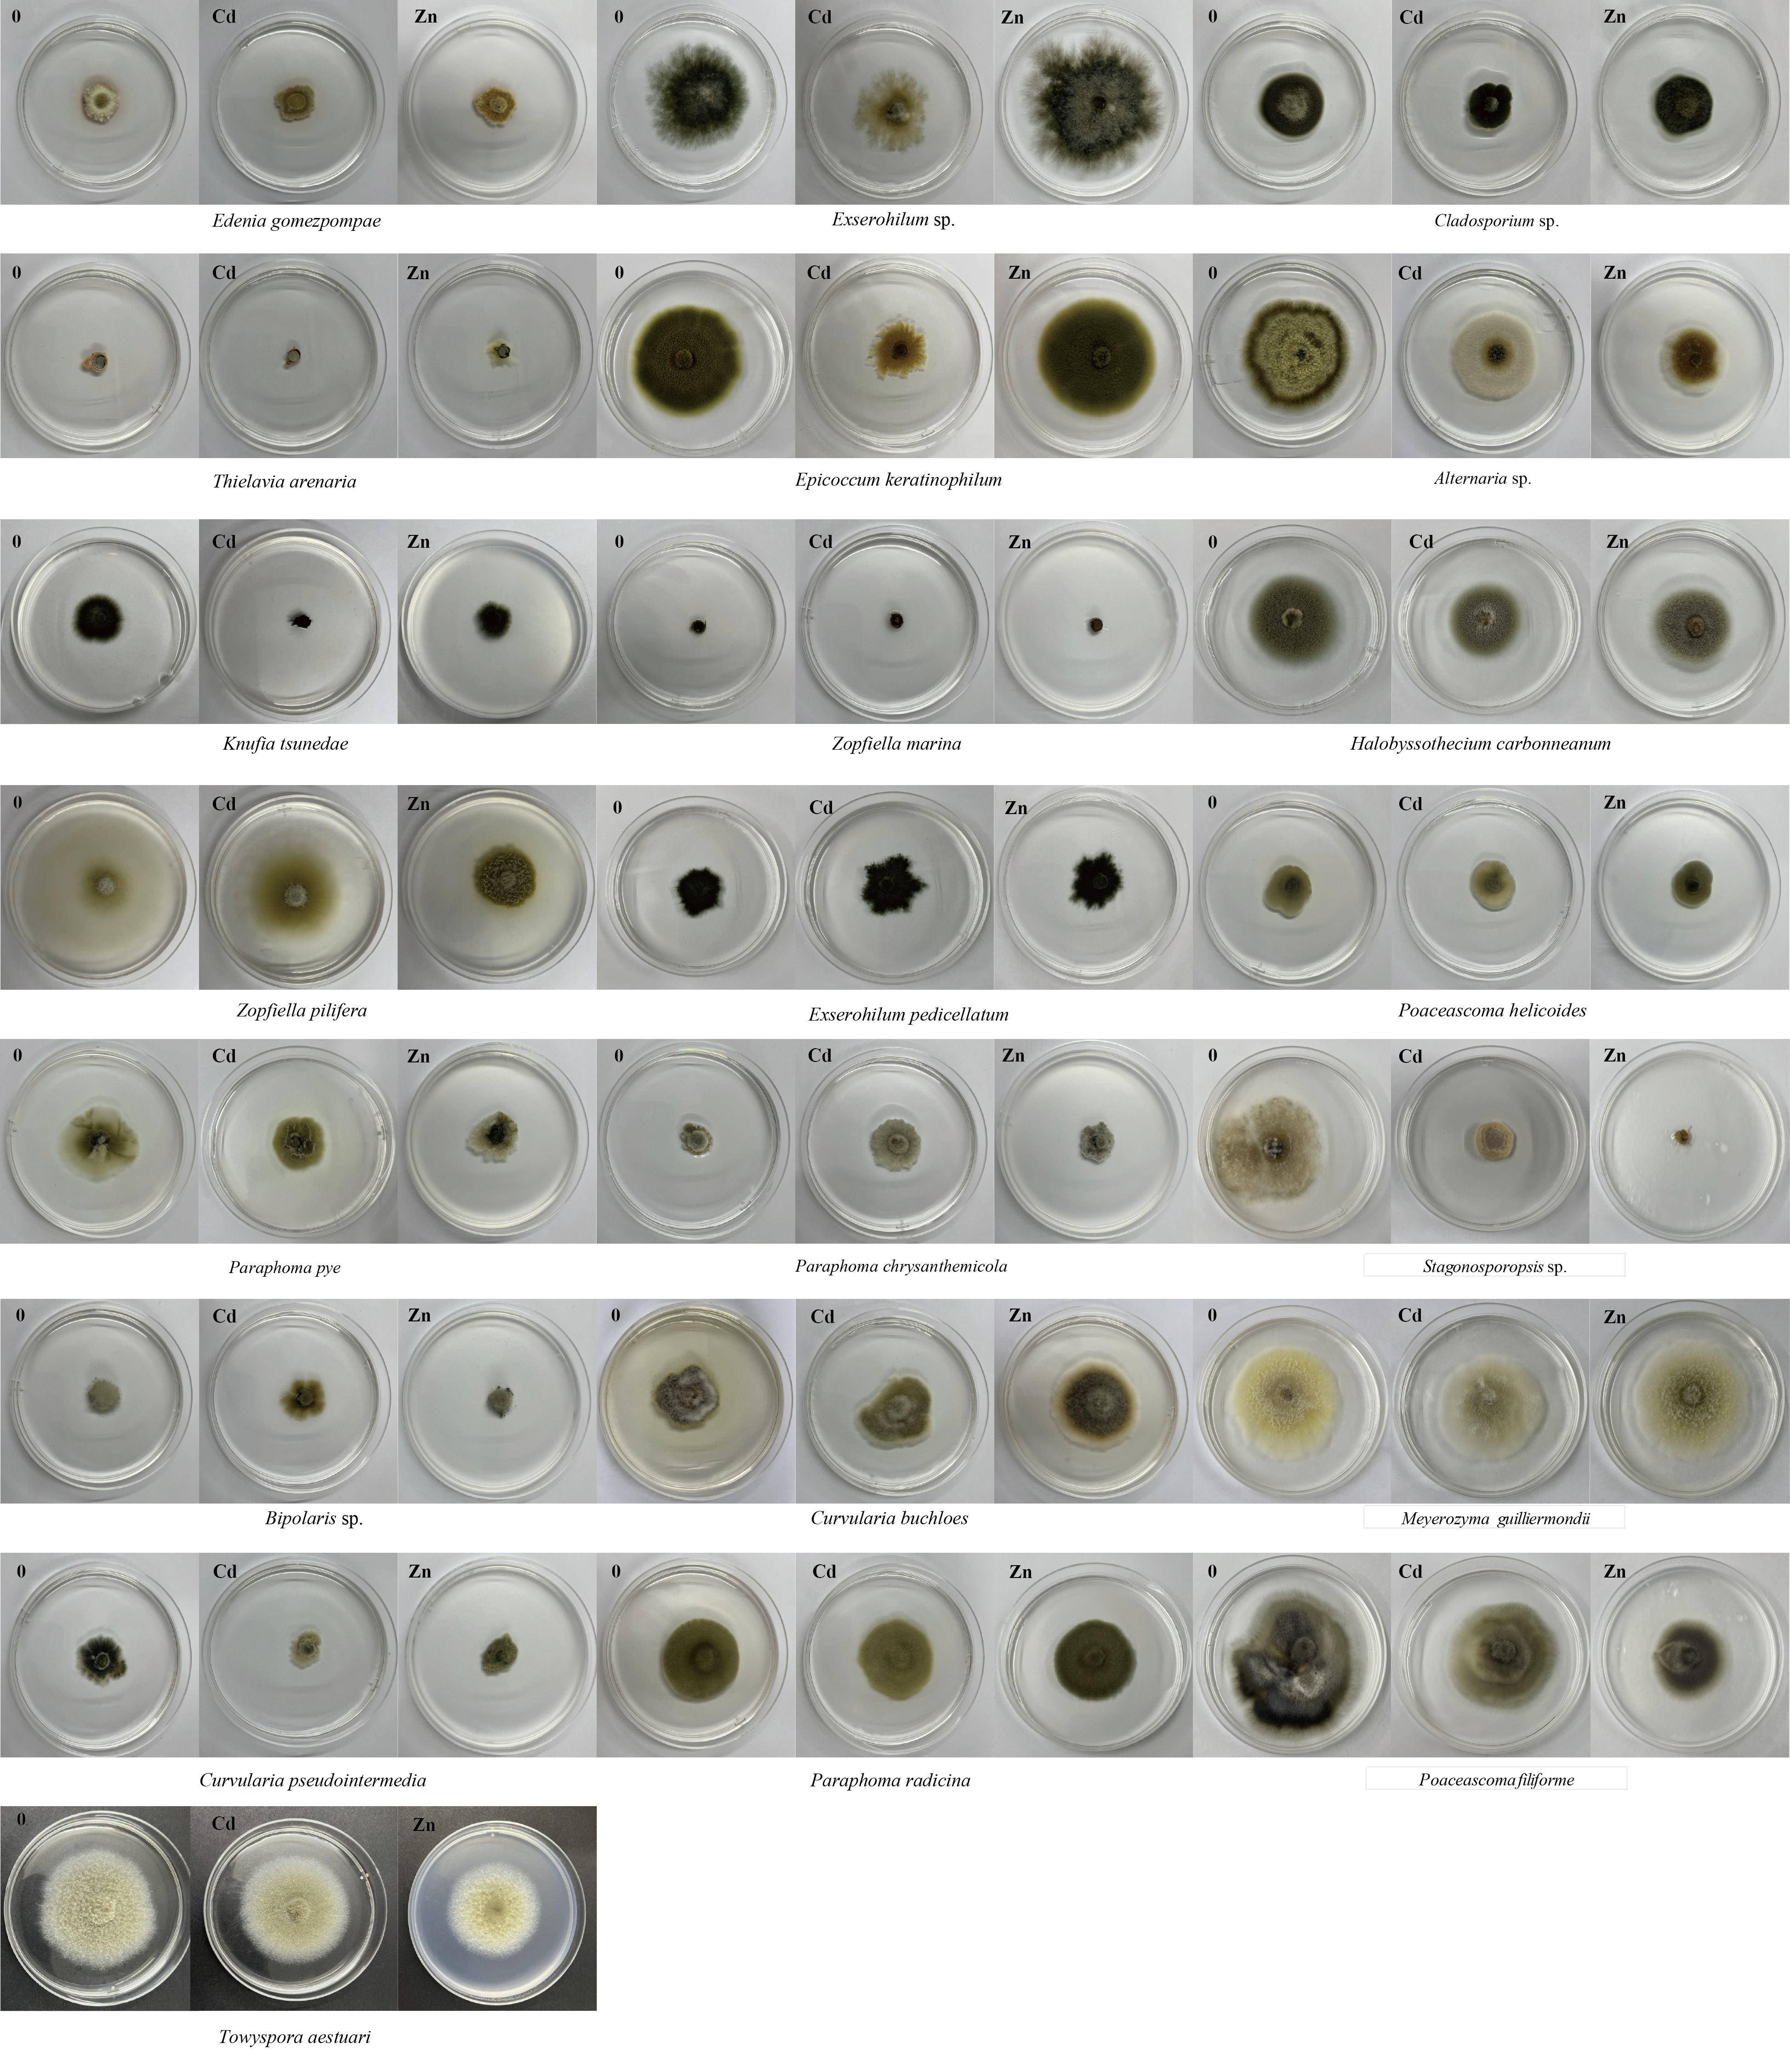
FIGURE S3. The colony diameters of DSE grown on MMN solid media at 27 °C were measured. (0), Strains cultured under conventional conditions; (Cd), strains cultured under a Cd concentration of 40 mg/kg; (Zn), strains cultured under a Zn concentration of 1450 mg/kg.

FIGURE S4. Pair plots of heavy metal-tolerant DSE isolation frequencies with fungal richness. Asterisks indicate statistical significance in ggpairs at * < 0.05; ** < 0.01; and *** < 0.001. A, DSE from Baiyang Lake; B, DSE from the Fengfeng mining site; C, DSE from Huangdao.

GitHub link: https://github.com/dddsx45/ddddsxwzzr.git

