Supplementary Material

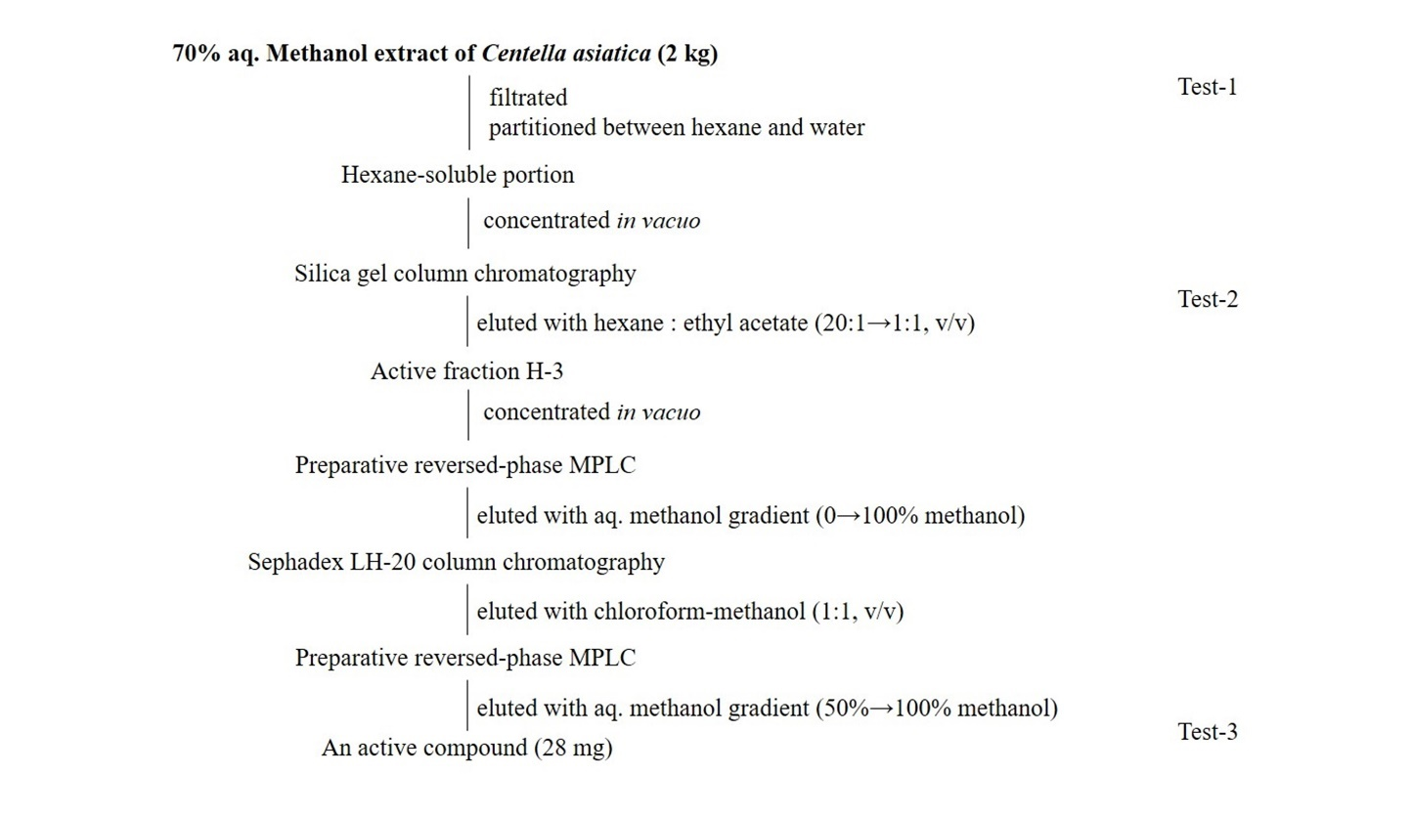

Figure S1. Isolation procedure of an active compound from C. asiatica extract.

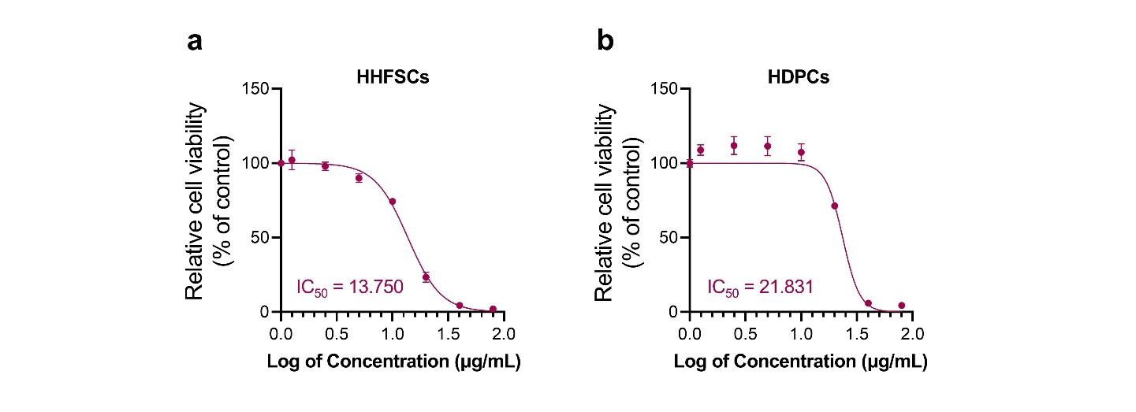

Figure S2. Dose-response curve and IC₅₀ calculation of araliadiol on cell viability in human hair follicle cells.

(a-b) Human hair follicle cells were treated with varying concentrations of araliadiol (0-80 μg/mL) for 24 h. Cell viability in HHFSCs (a) and HDPCs (b) was assessed using a WST-1 assay. Results are presented as the mean ± SD of three independent experiments.

