Online Supplementary Materials

Figure S1. Patient flow and prevalence of post-traumatic stress disorder (PTSD).
Table S1. Patient data at baseline by completion of the heart rate variability (HRV) evaluation in 1,142 patients with physical injuries.
Table S2. Baseline characteristics by post-traumatic stress disorder (PTSD) diagnosis over 2 years in 538 patients with physical injuries.
Table S3. Baseline characteristics by lower (≤ 38 ms²) vs. higher (> 38 ms²) high frequency (HF) component of heart rate variability in 538 patients with physical injuries.

Figure S1. Patient flow and prevalence of post-traumatic stress disorder (PTSD).

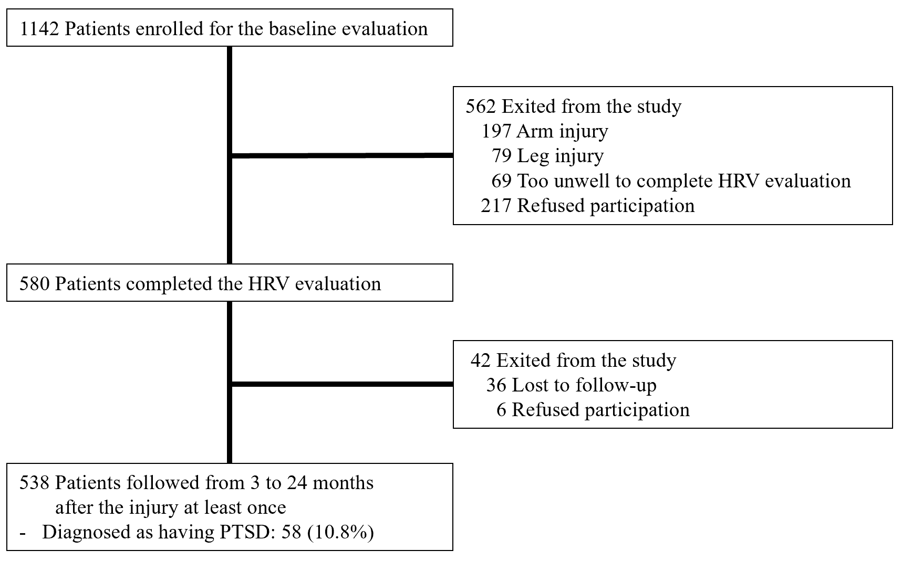

Table S1. Patient data at baseline by completion of the heart rate variability (HRV) evaluation in 1,142 patients with physical injuries.
 | Completed HRV  (N=580) | Uncompleted HRV  (N=562) | Statistical coefficients | P-valueª
Socio-demographic characteristics
Age, mean (SD) years | 57.2 (16.8) | 56.4 (17.6) | t=+0.750 | 0.454
Sex, N (%) female | 182 (31.4) | 177 (31.5) | χ²=0.002 | 0.967
Education, mean (SD) years | 10.6 (4.3) | 10.8 (3.9) | t=-0.516 | 0.606
Marital status, N (%) unmarried | 191 (32.9) | 191 (34.0) | χ²=0.143 | 0.706
Living alone, N (%) | 89 (15.3) | 88 (15.7) | χ²=0.021 | 0.884
Unemployed status, N (%) | 100 (17.2) | 120 (21.4) | χ²=3.101 | 0.078
Pre-trauma characteristics
Previous psychiatric disorders, N (%) | 49 (8.4) | 37 (6.6) | χ²=1.425 | 0.233
Previous traumatic events, N (%) | 29 (5.0) | 18 (3.2) | χ²=2.336 | 0.126
Any childhood abuse, N (%) | 40 (6.9) | 30 (5.3) | χ²=1.205 | 0.272
Physical disorders, mean (SD) numbers | 2.0 (2.1) | 1.9 (2.0) | t=+1.063 | 0.288
Current smoker, N (%) | 156 (26.9) | 162 (28.8) | χ²=0.529 | 0.467
AUDIT, mean (SD) scores | 10.3 (10.1) | 10.0 (10.0) | t=+0.382 | 0.702
Body mass index, mean (SD) | 23.6 (3.4) | 23.5 (3.4) | t=+0.144 | 0.886
Trauma related characteristics
Injury type, N (%) intentional | 53 (9.1) | 45 (8.0) | χ²=0.465 | 0.495
Injury Severity Score, mean (SD) scores | 14.1 (5.3) | 15.0 (6.3) | t=-2.747 | 0.006
Glasgow Coma Scale, mean (SD) scores | 14.9 (0.6) | 14.8 (0.8) | t=+1.415 | 0.157
Got surgery for the injury, N (%) | 291 (50.2) | 312 (55.5) | χ²=2.270 | 0.071
Peri-trauma assessment scales and measurements, mean (SD)
CAPS-5 | 11.0 (11.5) | 11.3 (12.6) | t=-0.451 | 0.652
HAM-A | 4.7 (4.6) | 4.7 (5.1) | t=-0.070 | 0.944
HAM-D | 6.3 (5.4) | 6.2 (5.8) | t=+0.327 | 0.744
Systolic blood pressure, mmHg | 119.1 (14.1) | 120.0 (13.3) | t=-1.070 | 0.285
Diastolic blood pressure, mmHg | 72.0 (9.2) | 72.5 (9.1) | t=-0.920 | 0.358
Heart rate per minute | 78.7 (11.1) | 78.0 (11.0) | t=+1.129 | 0.259
ª t-tests or χ² tests, as appropriate between patients with and without 24-months follow-up evaluation.
AUDIT: Alcohol Use Disorders Identification Test; CAPS-5: Clinician Administered PTSD Scale for Diagnostic and Statistical Manual of mental disorders, 5th edition; HAMA: Hamilton Anxiety Rating Scale; HAMD: Hamilton Depression Rating Scale.

Table S2. Baseline characteristics by post-traumatic stress disorder (PTSD) diagnosis over 2 years in 538 patients with physical injuries.
 | Present  PTSD (N=58) | Absent  PTSD  (N=480) | Statistical coefficients | P-valueª
Socio-demographic characteristics
Age, mean (SD) years | 54.1 (15.8) | 57.4 (17.1) | t=-1.408 | 0.160
Sex, N (%) female | 25 (43.1) | 144 (30.0) | χ²=4.124 | 0.042
Education, mean (SD) years | 11.9 (3.5) | 10.5 (4.3) | t=+2.819 | 0.006
Marital status, N (%) unmarried | 17 (29.3) | 161 (33.5) | χ²=0.418 | 0.518
Living alone, N (%) | 5 (8.6) | 74 (15.4) | χ²=1.908 | 0.167
Unemployed status, N (%) | 9 (15.5) | 79 (16.5) | χ²=0.033 | 0.855
Pre-trauma characteristics
Previous psychiatric disorders, N (%) | 11 (19.0) | 30 (6.3) | χ²=11.884 | 0.001
Previous traumatic events, N (%) | 8 (13.8) | 21 (4.4) | χ²=9.000 | 0.003
Physical disorders, mean (SD) numbers | 1.6 (1.9) | 2.1 (2.1) | t=-1.178 | 0.239
Current smoker, N (%) | 15 (25.9) | 125 (26.0) | χ²=0.001 | 0.977
AUDIT, mean (SD) scores | 8.7 (10.0) | 10.4 (10.0) | t=-1.207 | 0.228
Body mass index, mean (SD) | 23.8 (3.7) | 23.6 (3.4) | t=+0.341 | 0.733
Trauma related characteristics
Injury type, N (%) intentional | 4 (6.9) | 47 (9.8) | χ²=0.505 | 0.477
Injury Severity Score, mean (SD) scores | 13.9 (4.9) | 14.0 (5.3) | t=-0.217 | 0.829
Glasgow Coma Scale, mean (SD) scores | 14.8 (0.7) | 14.9 (0.6) | t=-0.628 | 0.530
Got surgery for the injury, N (%) | 32 (55.2) | 236 (49.2) | χ²=0.747 | 0.388
Peri-trauma assessment scales and measurements, mean (SD)
HAMA | 9.5 (6.0) | 4.1 (4.1) | t=+6.697 | <0.001
HAMD | 11.4 (6.4) | 5.7 (5.0) | t=+6.557 | <0.001
Systolic blood pressure, mmHg | 117.8 (11.9) | 119.3 (14.4) | t=-0.780 | 0.435
Diastolic blood pressure, mmHg | 70.7 (9.9) | 72.1 (9.1) | t=-1.123 | 0.262
Heart rate per minute | 80.3 (10.6) | 78.5 (11.1) | t=+1.210 | 0.227
ª t-tests or χ² tests, as appropriate between patients with and without 24-months follow-up evaluation.
AUDIT: Alcohol Use Disorders Identification Test; HAMA: Hamilton Anxiety Rating Scale; HAMD: Hamilton Depression Rating Scale.

Table S3. Baseline characteristics by lower (≤ 38 ms²) vs. higher (> 38 ms²) high frequency (HF) component of heart rate variability in 538 patients with physical injuries.
 | Lower HF (N=269) | Higher HF  (N=269) | Statistical coefficients | P-valueª
Socio-demographic characteristics
Age, mean (SD) years | 58.6 (15.8) | 55.4 (17.9) | t=+2.183 | 0.019
Sex, N (%) female | 87 (32.3) | 82 (30.5) | χ²=0.216 | 0.642
Education, mean (SD) years | 10.3 (4.2) | 11.0 (4.2) | t=-1.866 | 0.063
Marital status, N (%) unmarried | 82 (30.5) | 96 (35.7) | χ²=1.646 | 0.200
Living alone, N (%) | 34 (12.6) | 45 (16.7) | χ²=1.795 | 0.180
Unemployed status, N (%) | 36 (13.4) | 52 (19.3) | χ²=3.478 | 0.062
Pre-trauma characteristics
Previous psychiatric disorders, N (%) | 21 (7.8) | 20 (7.4) | χ²=0.026 | 0.871
Previous traumatic events, N (%) | 17 (6.3) | 12 (4.5) | χ²=0.911 | 0.340
Physical disorders, mean (SD) numbers | 2.1 (2.1) | 1.9 (2.1) | t=+0.972 | 0.332
Current smoker, N (%) | 64 (23.8) | 76 (28.3) | χ²=1.390 | 0.238
AUDIT, mean (SD) scores | 10.2 (10.0) | 10.3 (10.0) | t=-0.112 | 0.911
Body mass index, mean (SD) | 23.6 (3.3) | 23.6 (3.7) | t=+0.088 | 0.930
Trauma related characteristics
Injury type, N (%) intentional | 29 (10.8) | 22 (8.2) | χ²=1.061 | 0.303
Injury Severity Score, mean (SD) scores | 14.1 (5.3) | 13.9 (5.2) | t=+0.533 | 0.594
Glasgow Coma Scale, mean (SD) scores | 14.9 (0.6) | 14.9 (0.6) | t=-0.538 | 0.560
Got surgery for the injury, N (%) | 132 (49.1) | 136 (50.6) | χ²=0.119 | 0.730
Peri-trauma assessment scales and measurements, mean (SD)
HAMA | 5.2 (5.1) | 4.2 (4.2) | t=+2.715 | 0.007
HAMD | 6.9 (5.7) | 5.7 (5.0) | t=+2.732 | 0.007
Systolic blood pressure, mmHg | 119.5 (13.6) | 118.8 (14.6) | t=+0.426 | 0.592
Diastolic blood pressure, mmHg | 72.0 (9.3) | 71.9 (9.1) | t=+0.122 | 0.903
Heart rate per minute | 81.5 (10.7) | 75.8 (10.7) | t=+6.227 | <0.001
ª t-tests or χ² tests, as appropriate between patients with and without 24-months follow-up evaluation.
AUDIT: Alcohol Use Disorders Identification Test; HAMA: Hamilton Anxiety Rating Scale; HAMD: Hamilton Depression Rating Scale.

