Supplementary Table 1: ANOVA-Results of the linear mixed model. ns = not significant, * = p-value <0.05, ** = p-value<0.005, *** = p-value <0.0005. B = biostimulants, F = fertilizer, S = soil, T = time after fertilization. X means that the term was not included in the model of this response variable.
 | CAL-P | Microbial Biomass P | Acid Phosphatase Activity | Alkaline Phosphatase Activity
B | ** | ns | ns | ns
F | *** | ns | * | *
S | *** | X | *** | ***
T | *** | ns | X | X
BxF | ns | ns | ns | ns
BxS | ns | X | ns | ns
BxT | ns | ns | X | X
FxS | *** | X | ns | ns
FxT | *** | ns | X | X
BxFxS | * | X | ns | ns
BxFxT | ns | ns | X | X
BxSxT | ns | X | X | X
FxSxT | *** | X | X | X
BxFxSxT | ns | X | X | X

Supplementary Table 2: ANOVA-Results of the linear mixed model. ns = not significant, * = p-value <0.05, ** = p-value<0.005, *** = p-value <0.0005. B = biostimulants, F = fertilizer, T = time after fertilization. X means that the term was not included in the model of this response variable.
 | Plant traits measured several times during the growing period | Plant traits measured once at harvest | CAL-P | Microbial Biomass P | Acid Phosphatase Activity | Alkaline Phosphatase Activity | pH
B | ns | ns | ns | ** | ns | ns | *
F | *** | *** | *** | *** | ns | ns | ***
T | *** | X | *** | X | X | X | X
BxF | ns | ns | ns | ** | ns | ns | ns
BxT | ns | X | ns | X | X | X | X
FxT | *** | X | *** | X | X | X | X
BxFxT | ns | X | ns | X | X | X | X

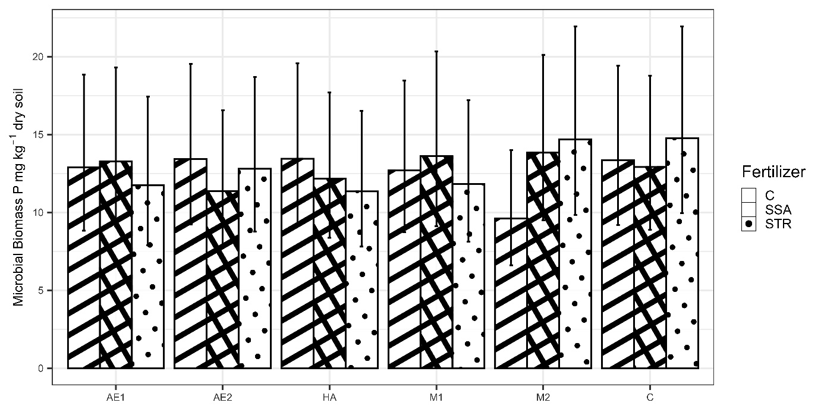
Supplementary Fig 1: Microbial Biomass P in dry soil in dependence on biostimulants and fertilization (n=180). Medians are displayed by bars with their confidence limits (α=0.05). C = Control, SSA = treated sewage sludge ash, STR = struvite containing P fertilizer, AE1+2 = plant extract, HA = humic acid, M1+2 = microbial consortia, C=control.

Supplementary Table 3: pH value in dependence on biostimulants, soil and fertilizer. AE1+2 = plant extract, HA = humic acid, M1+2 = microbial consortia. C = Control, SSA = treated sewage sludge ash, STR = struvite containing P fertilizer.
Biostimulant | Soil | Fertilizer | pH
AE1 |  |  | 5.3
AE2 |  |  | 5.3
HA |  |  | 5.3
M1 |  |  | 5.3
M2 |  |  | 5.3
C |  |  | 5.3
 | Class B | C | 5.6
 | Class B | SSA | 5.7
 | Class B | STR | 5.7
 | Class A | C | 4.8
 | Class A | SSA | 4.9
 | Class A | STR | 4.9

Supplementary Table 4: pH value in dependence on biostimulants, soil and fertilizer. AE1 = plant extract, HA = humic acid, M2 = microbial consortia. C = Control, SSA = treated sewage sludge ash, STR = struvite containing P fertilizer.
Biostimulant | Fertilizer | pH
AE1 |  | 5.0
HA |  | 5.0
M2 |  | 5.0
C |  | 5.0
 | C | 4.9
 | SSA | 5.1
 | STR | 5.0

