Supplementary Material

**Cu-alginate hydrogels in microfluidic systems: a sustainable catalytic approach for click chemistry**

**Arijana Ramšak1, Martin Gazvoda1, Igor Plazl 1, Rok Ambrožič1\***

1University of Ljubljana, Faculty of Chemistry and Chemical Technology, Večna pot 113, 1000 Ljubljana, Slovenia

**\*Correspondence:** [rok.ambrozic@fkkt.uni-lj.si](mailto:rok.ambrozic@fkkt.uni-lj.si)

# Development of CFD model

The first step in the development of the CFD model was the geometry of the microfluidic device with appropriate meshing (Fig. A1). The mesh quality was assessed on the basis of mesh statistics: The average skewness was below 0.33, the number of nodes was 31588 and the number of elements was 65400. We also tested more dense meshes to assess their impact on CFD prediction. However, as no further improvement in concentration distribution was observed at higher computation times, the original mesh was preserved.

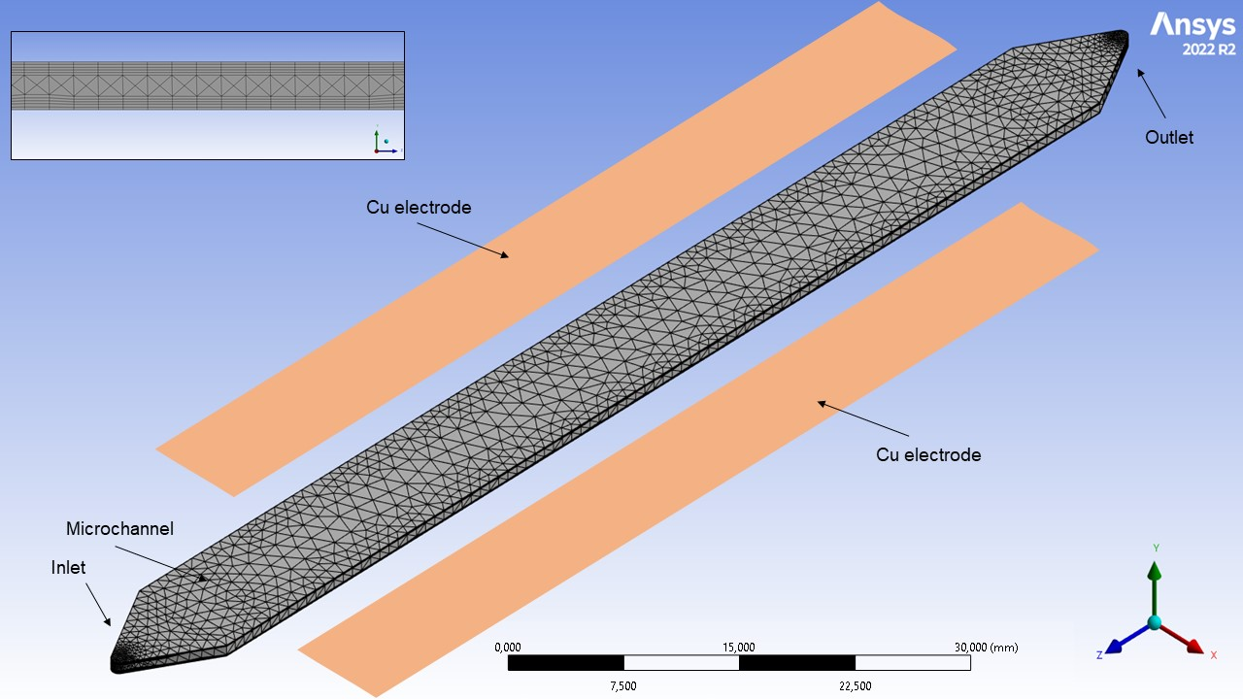

**Figure A1** The mesh of geometry used for CFD simulation. The geometry and meshing process was performed within Ansys software. The inset represents the mesh quality in y-direction.

The development of a CFD model for electrodeposition and dissolution of alginate hydrogel involves the equations governing fluid mechanics by conservation of mass and conservation of momentum. The conservation of mass for an incompressible fluid is:

|  |  |
| --- | --- |
| $$∇∙u=0$$ | (A1) |

while conservation of momentum can be expressed by the Navier-Stokes equations:

|  |  |
| --- | --- |
| $$\frac{∂u}{∂t}=∇∙\left(u⊗u\right)-∇\left(ν∇u\right)=\frac{1}{ρ}∇p+F$$ | (A2) |

where $u$ is the fluid velocity, $ν$ is the kinematic viscosity, $ρ$ is the fluid density, $p$ is the fluid pressure, and $F$ is any body force acting on the fluid. The solution of the Navier-Stokes equations was obtained using a built-in function of Ansys FLUENT.

The mass transport of charge carriers in aqueous systems can be described by the Nernst-Planck equations:

|  |  |
| --- | --- |
| $$\frac{∂C}{∂t}=-∇∙\left[-D∇C-\left(\frac{FnD}{RT}C\right)∇φ-Cu\right]$$ | (A3) |

where $C$ is the mass fraction of Fe ion concentration, $D$ is the diffusivity of Cu ions, $F$ is Faraday’s constant, $n$ is the valence for Cu ions, $R$ is the gas constant, $T$ is temperature, and $φ$ is the electric potential of the electrolyte. The first term on the right side of equation (A3) represents diffusion, the middle term is the migration of ion concentration (this is a coupling term between the electric potential and ion concentration), and the last term is convection due to fluid motion. Since a constant fluid velocity was used with a constant inlet concentration of alginate and we can assume uniform current density on the electrode surface resulting in constant rate of redox reaction, the system converges to steady state. As a result, all unknown variables can be estimated by fitting the simulation to experimentally determined concentration profiles.

The equations presented so far consider only the electrolyte and not the electrodynamics arising from the growth of the hydrogel layer. The conductivity of the anode and cathode is very high compared to that of the electrolyte, and it is assumed that the electric potential in the electrode is constant and equal to the source voltage. Under these assumptions, the electrodes are treated as boundaries in the simulations. The potential of the electrolyte floats and adapts to satisfy the equilibrium of the current, so that an equal amount of current leaving the cathode also enters the anode, and electroneutrality of electrolyte. Volume electroneutrality was assumed for the solution of the electrolyte potential ($φ_{e}$):

|  |  |
| --- | --- |
| $$i_{e}=σ∙φ_{e}$$ | (A4) |

where $i_{e}$ is the local current density and $σ$ is the electrolyte conductivity, which is assumed to be a constant. The local current density was calculated using the Butler–Volmer equation and electrode current density ($i)$, which is assumed to be constant.

|  |  |
| --- | --- |
| $$i=i_{e}\left(exp\left(\frac{a_{a}zFη}{RT}\right)-exp\left(\frac{a_{c}zFη}{RT}\right)\right)$$ | (A5) |

where $a_{a}, a_{c}$ are electrode charge transfer coefficients and $η$ is the potential difference. The main electrode reaction on both the anode and cathode surfaces is the oxidation/reduction reaction of Cu:

|  |  |
| --- | --- |
| ${Cu}^{0}-{2e}^{-}→{Cu}^{2+}$**–** Cu oxidation on anode surface | (A6) |
| ${Cu}^{2+}+2e^{-}→{Cu}^{0}$– Cu reduction on cathode surface | (A7) |

In addition, formed Cu2+ ions react with free alginate polymer chains (${ALG}_{\left(aq\right)}$) to form hydrogel (${Cu}^{2+}-{ALG}_{(s)}$) according to:

|  |  |
| --- | --- |
| ${Cu}^{2+}+{ALG}_{\left(aq\right)}{⇄Cu}^{2+}-{ALG}_{(s)}$– hydrogel formation on anode surface | (A8) |

The reaction rate constants (ko kr, kh, kh’) were correlated with the local current density, which was calculated according to Eq. (A5). The latter was then incorporated in CFD model as user defined function (UDF) via source term. The rates of redox reactions are significantly higher than is the rate of hydrogel formation, which become rate-defined step and can be express as follows:

|  |  |
| --- | --- |
| $$\frac{d[{Cu}^{2+}-{ALG}_{(s)}]}{dt}=k_{h}\left(i\right)∙[{Cu}^{2+}]∙{[ALG}_{\left(aq\right)}]-k_{h}^{'}(i)∙{[Cu}^{2+}-{ALG}_{(s)}]$$ | (A8) |

Considering all the above data, the deposition rate and/or hydrogel growth rate at the anode interfaces can be calculated.

# Supplementary Figures and Tables

## Supplementary Figures



**Figure S1** Calibration curve for the determination of the Cu concentration by the AAS method, prepared from a copper standard solution (Cu(NO3)2 in HNO3 0.5 mol/L) in various concentrations.

**Figure S2** 1H-NMR spectrum of the crude product mixture in the case of a 60-minute flow reaction in which 55% of the 1-benzyl-4-phenyl-1*H*-1,2,3-triazole product was formed. In addition to the integrated product resonances and the resonances of an internal standard 1,3,5-trimethoxybenzene, the spectrum also contains resonances of ethyl acetate, which was used for extraction, as well as of unreacted starting phenylacetylene and benzyl azide.

**Figure S3** 1H-NMR spectrum of the crude product mixture in the case of a 120-minute flow reaction in which 99% of the 1-benzyl-4-phenyl-1*H*-1,2,3-triazole product was formed. In addition to the integrated product resonances and the resonances of an internal standard 1,3,5-trimethoxybenzene, the spectrum also contains ethyl acetate, which was used for extraction.

**Figure S4** 1H-NMR spectrum of the crude product mixture in the case of a batch reaction in which 10% of the 1-benzyl-4-phenyl-1*H*-1,2,3-triazole product was formed. In addition to the integrated product resonances and the resonances of an internal standard 1,3,5-trimethoxybenzene, the spectrum also contains resonances of ethyl acetate, which was used for extraction, as well as of unreacted starting phenylacetylene and benzyl azide.