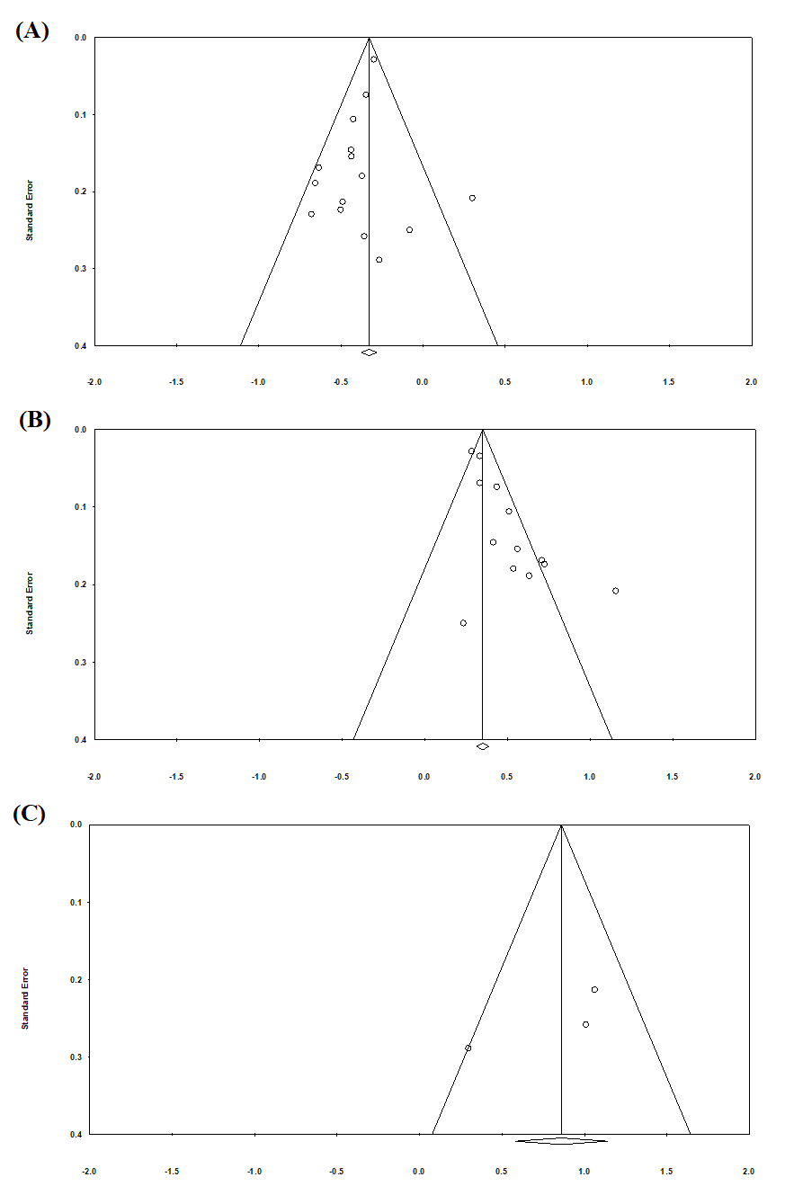

**Fig S1.** Maximal strength and (A) Echo intensity, (B) Muscle thickness, (C) Cross-sectional area: funnel plot of standard errors plotted against study effect sizes.

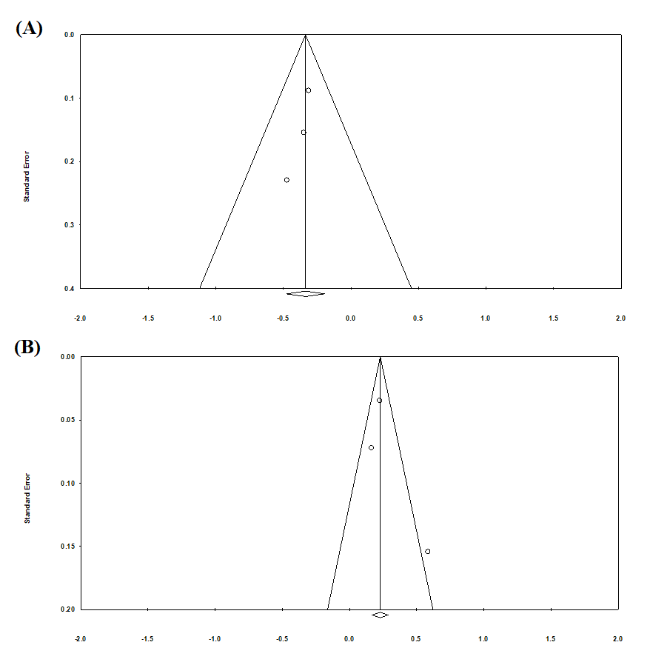

**Fig S2.** Handgrip strength and (A) Echo intensity, (B) Muscle thickness: funnel plot of standard errors plotted against study effect sizes.

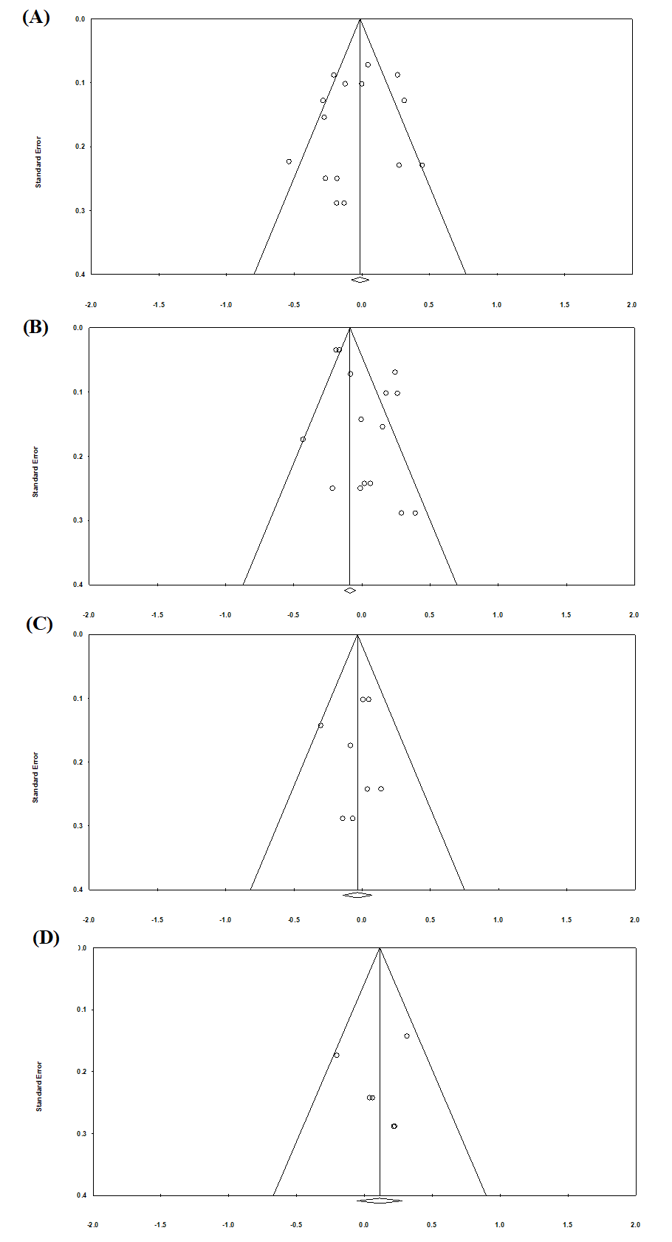

**Fig S3.** Gait speed and (A) Echo intensity, (B) Muscle thickness; (C) Cross-sectional area, (D) Pennation angle: Funnel plot of standard errors plotted against study effect sizes.

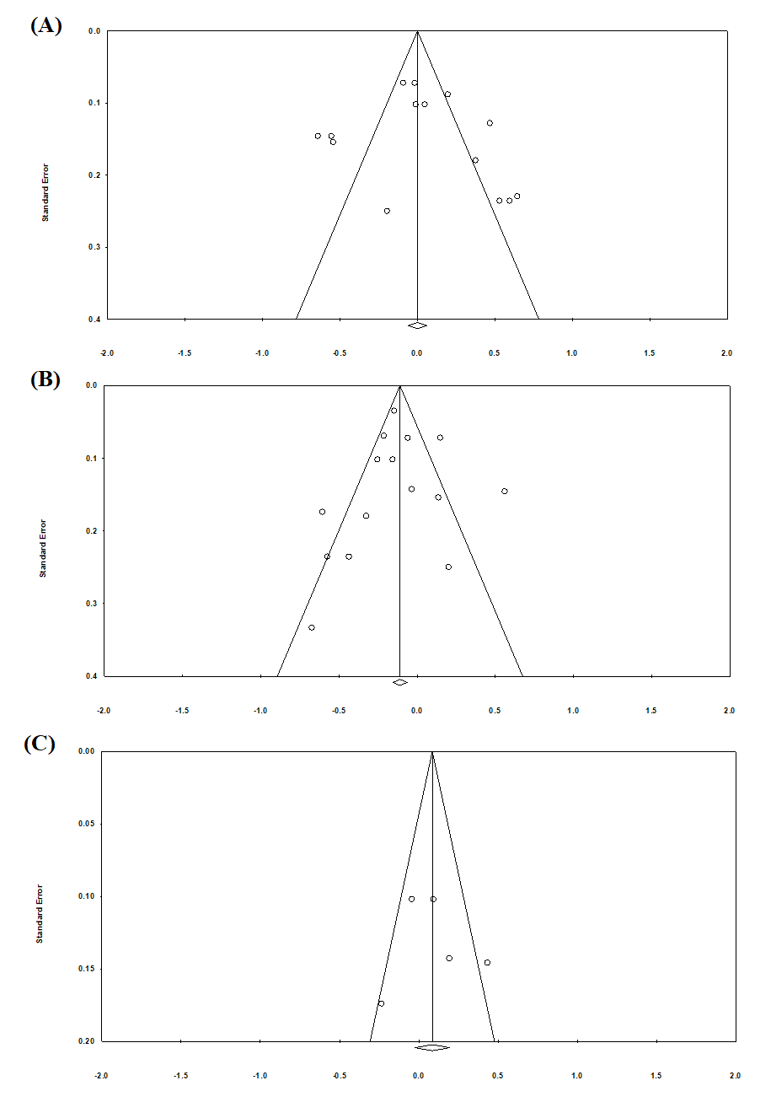

**Fig S4.** Chair stand test and (A) Echo intensity, (B) Muscle thickness (C) Fascicle length: Funnel plot of standard errors plotted against study effect sizes.