**Cost-effectiveness analysis of the tislelizumab versus docetaxel for advanced or metastatic non-small-cell lung cancer in China**

Xiaoyu Zhang1, *, Xiongxiong Fan1, *, Jin Zhang1,2, Fengli Jiang1,2, Yiping Wu1, Beibei Yang1, Xinghuan Li1, Dong Liu1,2

1From Clinical Pharmacy Office, Baoji Central Hospital, Baoji, Shaanxi, China

2Department of Pharmacy, Xi’an Jiaotong University Health Science Center, Xi’an, Shaanxi, China

*These authors contributed equally to this work.

Correspondence to: Dong Liu, Clinical Pharmacy Office, Baoji Central Hospital, Baoji, Shaanxi, China, 8 Jiangtan Road, Weibin District, Baoji City, Shaanxi Province. E-mail: [liudong691122@126.com](mailto:liudong691122@126.com) (D. L.)

**Table S1. Comparison of parameters of K-M curves after reconstruction.**

|  |  |  |
| --- | --- | --- |
| **Parameter** | **RATIONALE-303** | **Reconstructed curve** |
| HR | 0.63 | 0.6154 |
| L95% | 0.53 | 0.5194 |
| U95% | 0.75 | 0.7292 |

L95%: 95% lower limit; U95%: 95% upper limit.

**Table S2. AIC and BIC statistics for alternate parametric distributions.**

|  |  |  |  |  |
| --- | --- | --- | --- | --- |
| **Parameter** | **AIC** | | **BIC** | |
| **Tislelizumab** | **Docetaxel** | **Tislelizumab** | **Docetaxel** |
| OS |  |  |  |  |
| Weibull (AFT) | 3017.35 | 1536.78 | 3025.92 | 1543.97 |
| log−Normal | 3007.19 | 1522.88 | 3015.76 | 1530.07 |
| log−Logistic | 3001.65 | 1524.55 | 3010.21 | 1531.75 |
| Gompertz | 3025.62 | 1541.66 | 3034.18 | 1548.85 |
| Gen. Gamma | 3005.65 | 1524.73 | 3018.50 | 1535.53 |
| Gamma | 3013.75 | 1533.83 | 3022.32 | 1541.02 |
| Exponential | 3023.88 | 1539.70 | 3028.16 | 1543.30 |
| PFS |  |  |  |  |
| Weibull (AFT) | 2896.63 | 1067.67 | 2905.19 | 1074.86 |
| log−Normal | 2785.19 | 1008.19 | 2793.75 | 1015.38 |
| log−Logistic | 2794.00 | 999.89 | 2802.57 | 1007.09 |
| Gompertz | 2838.56 | 1074.13 | 2847.13 | 1081.33 |
| Gen. Gamma | 2759.20 | 1008.55 | 2772.05 | 1019.34 |
| Gamma | 2907.09 | 1052.76 | 2915.65 | 1059.95 |
| Exponential | 2907.25 | 1075.15 | 2911.53 | 1078.75 |

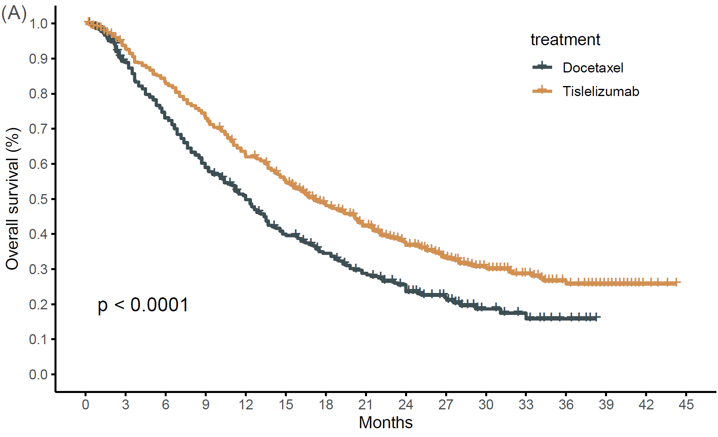

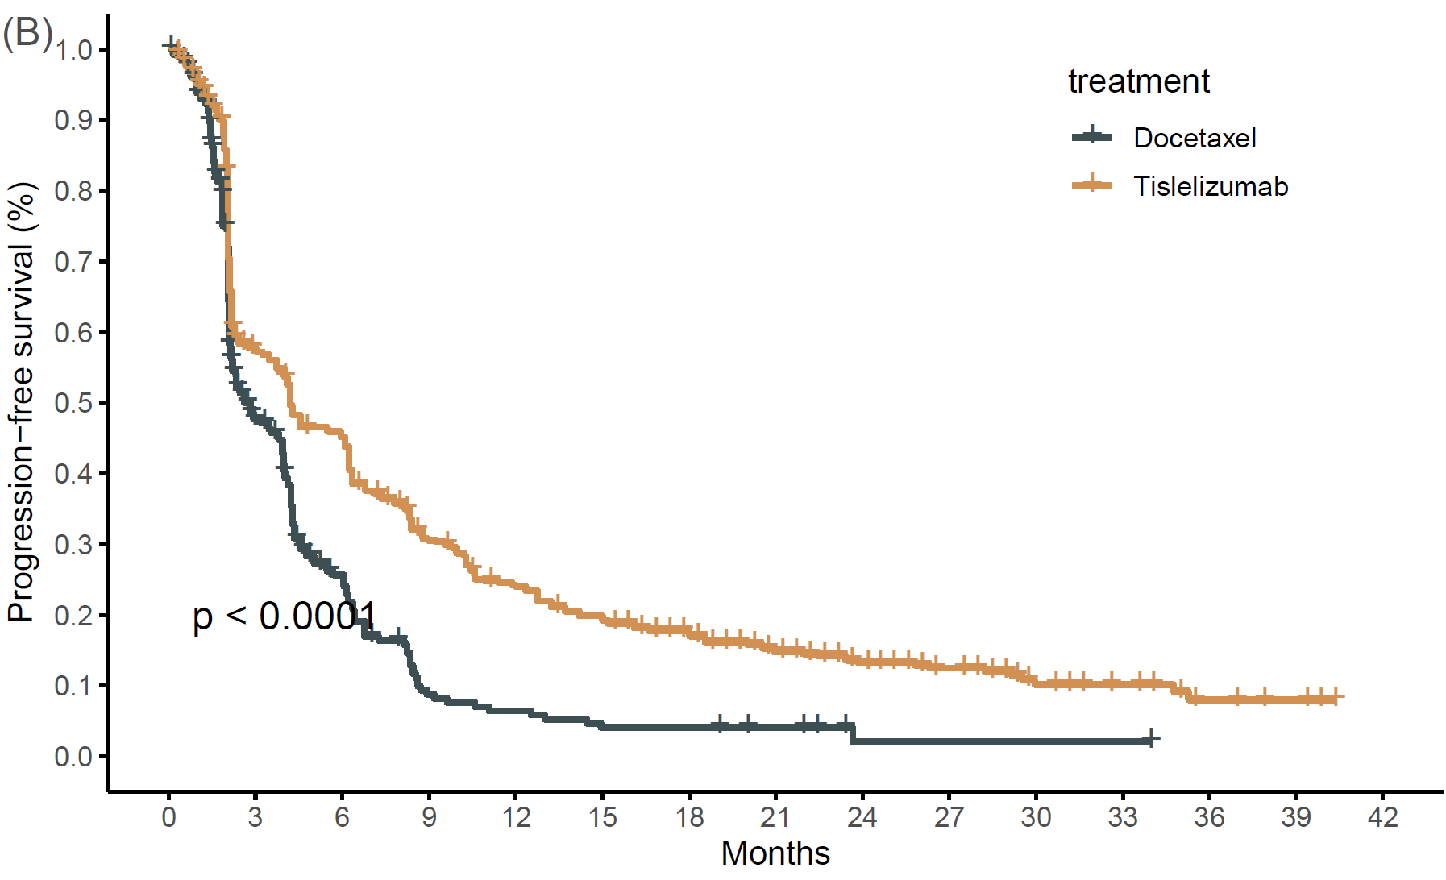

**Figure S1.** (A) Reconstructed OS curve; (B) Reconstructed PFS curve.

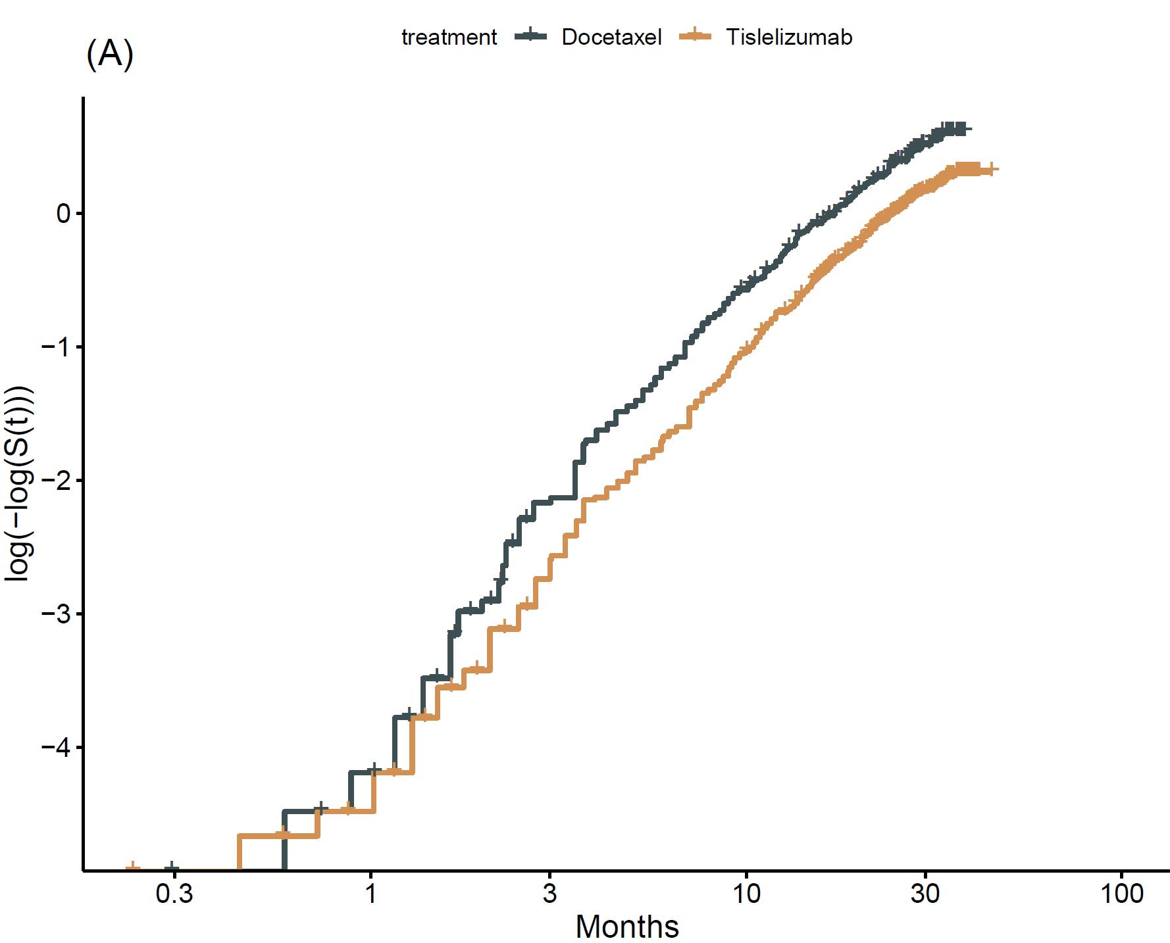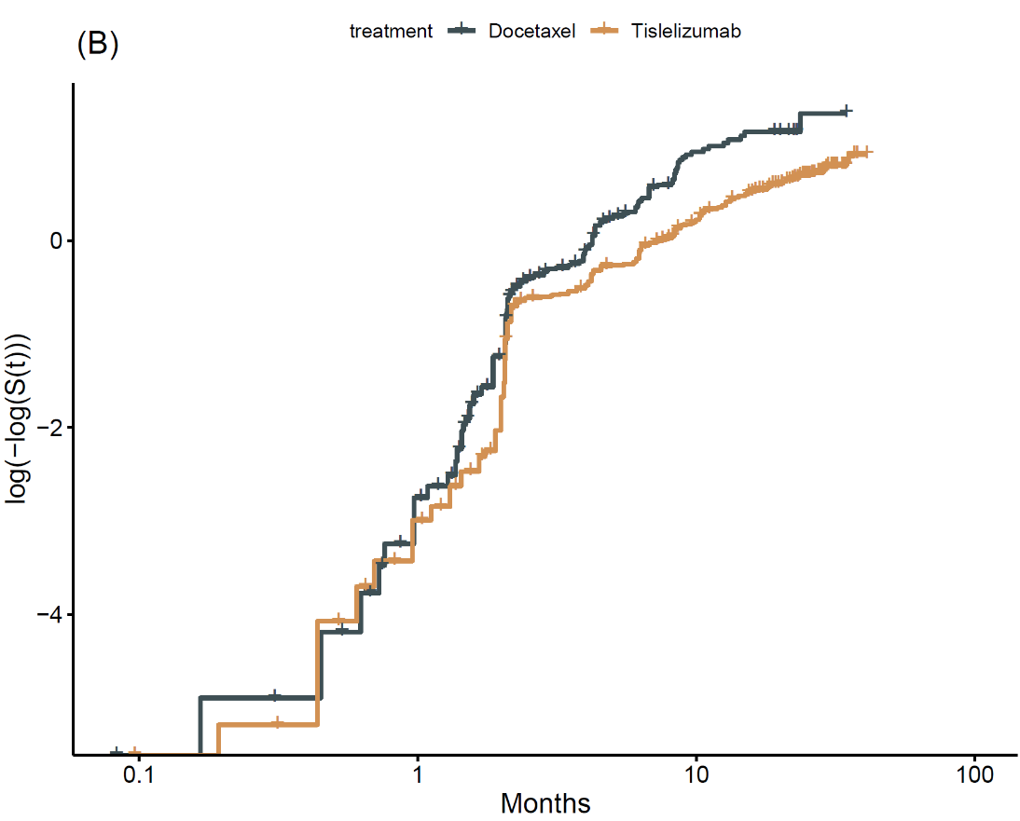

**Figure S2.** (A) Proportional Hazard Model of OS data; (B) Proportional Hazard Model of PFS data.