Supplementary Material

Article Title

Karla Gonçalves*, Szabolcs Varga, Dariusz Butrymowicz, Kamil Śmierciew

**\* Correspondence:** Corresponding Author: karlag@fe.up.pt

# Supplementary Figures and Tables

## Supplementary Figures

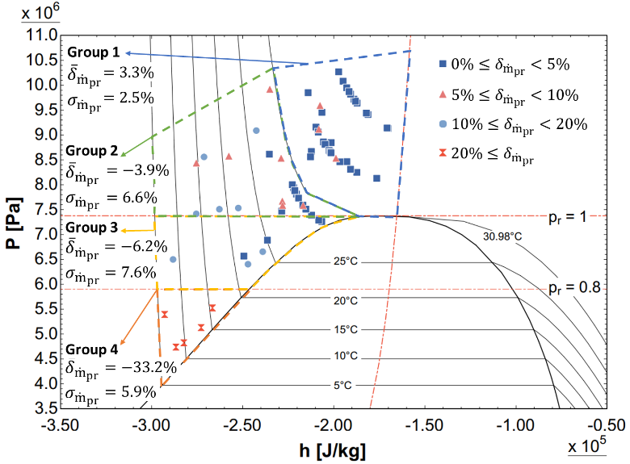

Figure 1 – Motive mass flow rate prediction errors as a function of the primary flow inlet properties based on the results in (1,18,20).

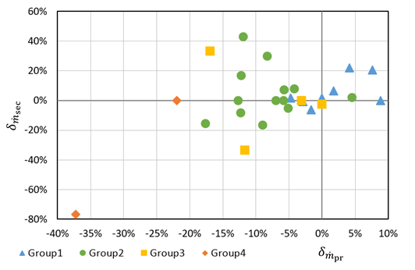

Figure 2 – Secondary vs primary mass flow rate prediction errors by (1,20), coloured by primary inlet conditions groups.

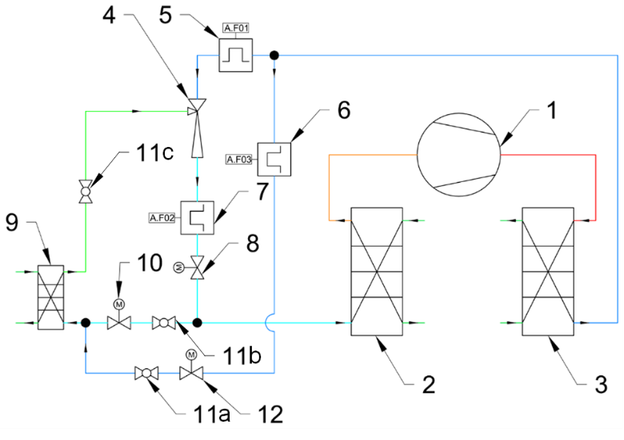

Figure 3 – Simplified diagram of the ejector test rig.

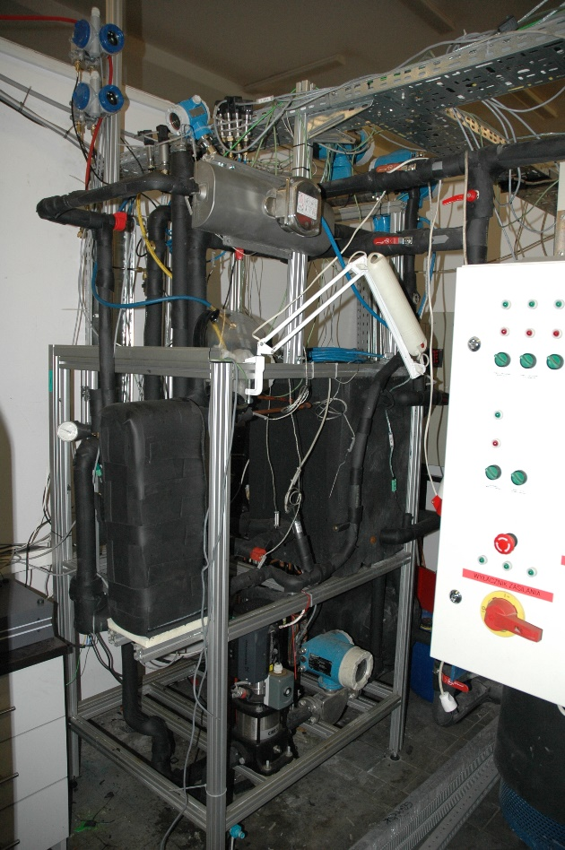

Figure 4 – Photo of the test rig.

**Figure 5 -** Simulation domain, with different boundary layers identified. Details about fluid properties for inlets and outlets can be found on table 3.

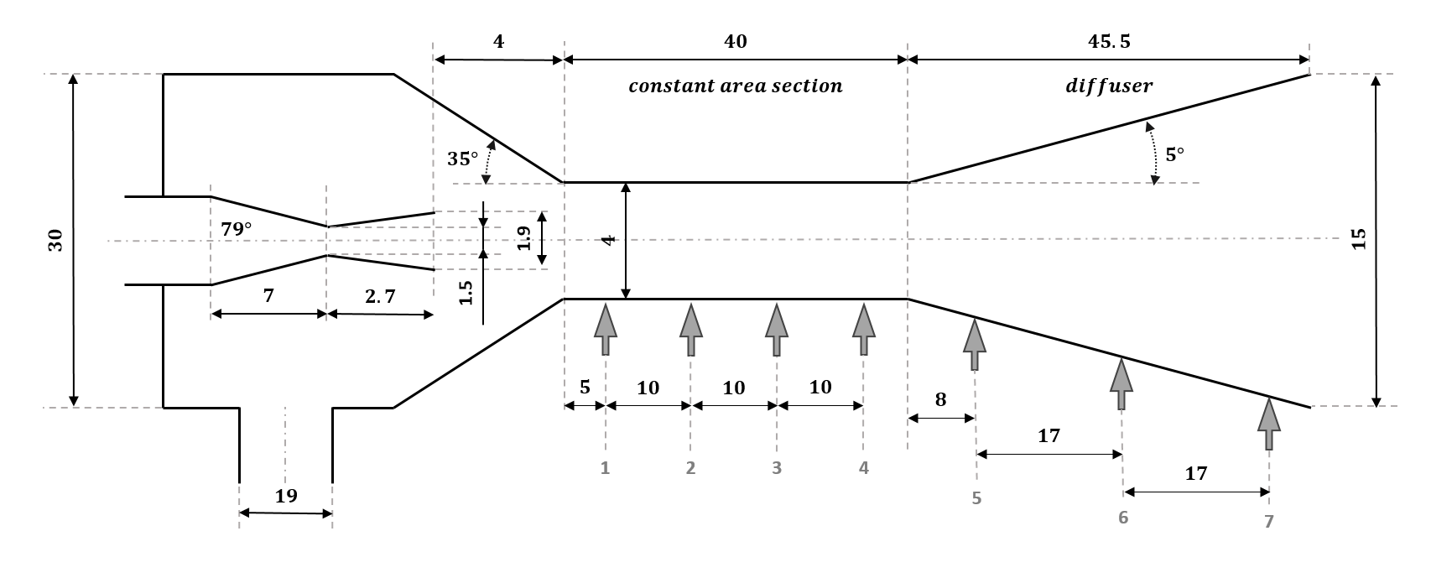

**Figure** **6 -** Ejector geometry detail in mm, with indication of the pressure and temperature sensors positions.

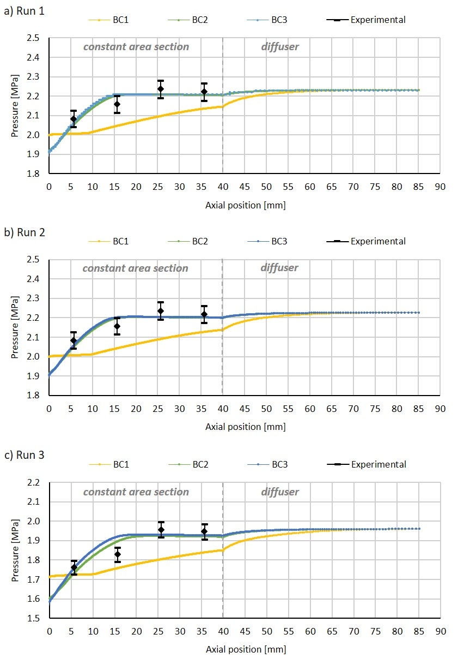

Figure 7 – Experimental wall pressure profile for the constant area section and CFD results for the constant area section and diffuser, for Run 1 (a), Run 2 (b) and Run 3 (c).

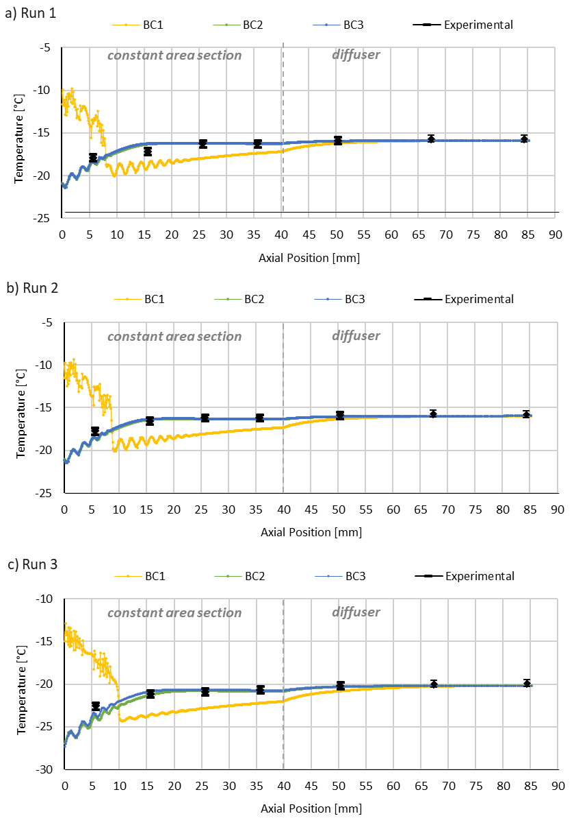

Figure 8 – Temperature distribution, after the nozzle outlet, simulated by the CFD model and obtained by experimental measurements (with the corresponding error bars): a) Run 1, b) Run 2 and c) Run 3.

## Supplementary Tables

Table 1 – Operating conditions and results obtained during the experimental test compared with the computed values.

|  |  |  |  |  |  |  |  |
| --- | --- | --- | --- | --- | --- | --- | --- |
|  | Experimental Data | | | | Computed Values | | |
|  | p | T | ρ | $$\dot{m}$$ | ρ*(p, T) | T*(p, ρ) | x*(p, ρ) |
|  | [kPa] | [ºC] | [kg/m3] | [g/s] | [kg/m3] | [ºC] | - |
| Motive nozzle inlet (pr) | 3483 | -1.4 | 992 | 71.1 | 937 | -10.7 | - |
| 3474 | -1.3 | 991 | 70.8 | 936 | -10.5 | - |
| 3451 | -2.1 | 995 | 74.0 | 941 | -11.3 | - |
| Suction chamber inlet (sec) | 2012 | -4.9 | - | 0.522 | - | - | - |
| 2013 | -4.3 | - | 0.409 | - | - | - |
| 1732 | -6.6 | - | 1.23 | - | - | - |
| Ejector outlet (out) | 2233 | -8.9 | 292 | - | 55.7 | -15.9# | 0.153 |
| 2227 | -8.4 | 288 | - | 55.3 | -16.0# | 0.155 |
| 1961 | -10.3 | 204 | - | 47.7 | -20.2# | 0.213 |
| * correspond to computed values using the property function of EES.  # saturated temperature | | | | | | | |

Table 2 – Energy balance calculation and entrainment ratio (ER), using the experimental results.

|  |  |  |  |  |  |  |  |  |  |  |
| --- | --- | --- | --- | --- | --- | --- | --- | --- | --- | --- |
|  | Measured | |  | EES output | | |  | ∆E [W] |  | ER |
| $${\dot{m}}_{pr}$$ [g/s] | $${\dot{m}}_{sec}$$ [g/s] | h*pr(p,ρ)  [kJ/kg] | h*sec(p,T)  [kJ/kg] | h*out(p,ρ)  [kJ/kg] |  |  |
| Run 1 | 71.1 | 0.522 |  | -332 | -52.5 | -302 |  | -2 050 |  | 0.73% |
| Run 2 | 70.8 | 0.409 |  | -332 | -51.8 | -301 |  | -2 080 |  | 0.58% |
| Run 3 | 74.0 | 1.23 |  | -337 | -49.8 | -292 |  | -2 760 |  | 1.7% |

NOTE: Despite the velocity is not included in the table, the kinetic energy was considered for the calculations.

Table 3 – Boundary conditions for the ejector flow, experimental and CFD predicted motive and entrained mass flow rate [g/s], secondary static pressure [kPa] and density at ejector outlet [kg/m3] and entrainment ratio. The CFD results are presented in bold.

|  |  |  |  |  |  |  |  |  |  |  |  |  |  |  |
| --- | --- | --- | --- | --- | --- | --- | --- | --- | --- | --- | --- | --- | --- | --- |
|  |  | Motive nozzle inlet (pr) | | | | Suction chamber inlet (sec) | | | | | | Ejector outlet (out) | | |
|  |  | p | h*(p,ρ) | $${\dot{m}}_{pr-CFD}$$ | $$δ_{{\dot{m}}_{pr}}$$ | h*(p,T) | psec |  |  |  | ER | p | ρout |  |
| BC | RUN | [kPa] | [kJ/kg] | [g/s] | [%] | [kJ/kg] | [kPa] | [%] | [g/s] | [%] | [-] | [kPa] | [kg/m3] | [%] |
| 1 | 1 | 3483 | -332 | **70.0** | -1.5% | -52.5 | 2012 | - | **11.2** | 2049% | 0.16 | 2233 | **258** | -12% |
| 2 | 3474 | -332 | **69.4** | -2.0% | -51.8 | 2013 | - | **11.6** | 2744% | 0.17 | 2227 | **249** | -14% |
| 3 | 3451 | -334 | **69.8** | -5.7% | -49.8 | 1732 | - | **12.1** | 882% | 0.17 | 1961 | **203** | -0.49% |
| 2 | 1 | 3483 | -332 | **70.0** | -1.5% | -52.5 | **1921** | -4.5% | 0.522 | - | 0.01 | 2233 | **575** | 97% |
| 2 | 3474 | -332 | **69.4** | -2.0% | -51.8 | **1915** | -4.9% | 0.409 | - | 0.01 | 2227 | **569** | 97% |
| 3 | 3451 | -334 | **69.8** | -5.7% | -49.8 | **1604** | -7.4% | 1.230 | - | 0.02 | 1961 | **397** | 95% |
| 3 | 1 | 3483 | -332 | **70.0** | -1.5% | - | **1912** | -4.9% | 0.0 | - | - | 2233 | **618** | 111% |
| 2 | 3474 | -332 | **69.4** | -2.0% | - | **1908** | -5.2% | 0.0 | - | - | 2227 | **602** | 109% |
| 3 | 3451 | -334 | **69.8** | -5.7% | - | **1583** | -8.6% | 0.0 | - | - | 1961 | **455** | 124% |

Table 4 – Temperature profile along the ejector length for the three test runs and outlet ejector temperature comparison between experimental (Tout), estimated by EES (T*out) and the mass-weighted average temperature at the ejector outlet predicted by CFD (Tout-CFD).

|  |  |  |  |  |  |  |  |  |  |  |  |  |  |
| --- | --- | --- | --- | --- | --- | --- | --- | --- | --- | --- | --- | --- | --- |
|  | Constant area section | | | |  | Diffuser | | |  | Ejector outlet | | | |
| 1 | 2 | 3 | 4 | 5 | 6 | 7 | Tout | T*out | Tout-CFD | Tout - T*out |
| Run 1 | -17.9 | -17.2 | -16.3 | -16.3 |  | -15.9 | -15.7 | -15.7 |  | -8.9 | -15.9 | -15.9 | 6.9 |
| Run 2 | -17.7 | -16.6 | -16.2 | -16.2 |  | -15.9 | -15.7 | -15.8 |  | -8.4 | -16.0 | -16.0 | 7.6 |
| Run 3 | -22.6 | -21.2 | -20.9 | -20.7 |  | -20.2 | -20.0 | -19.9 |  | -10.3 | -20.2 | -20.2 | 9.8 |

Table 5 – Energy imbalance properties and results.

|  |  |  |  |  |  |  |  |  |  |
| --- | --- | --- | --- | --- | --- | --- | --- | --- | --- |
|  |  | CFD | | | | | |  | Experimental |
| $${\dot{m}}_{pr}$$ [g/s] | $$h_{pr}^{*}$$ [kJ/kg] | $${\dot{m}}_{sec}$$ [g/s] | $$h_{sec}^{*}$$ [kJ/kg] | $$h_{out}$$ [kJ/kg] | ∆E  [W] |  | ∆E  [W] |
| Run 1 | BC1 | 70.0 | -332 | 11.2 | -52.5 | -294 | 3.46 |  | -2 050 |
| BC2 | 0.522 | -52.5 | -330 | 0.876 |  |
| BC3 | 0 | -333 | -332 | 1.04 |  |
|  |  |  |  |  |  |  |  |  |  |
| Run 2 | BC1 | 69.4 | -332 | 11.6 | -51.8 | -292 | 3.44 |  | -2 080 |
| BC2 | 0.409 | -51.8 | -330 | 0.945 |  |
| BC3 | 0 | -332 | -332 | 1.09 |  |
|  |  |  |  |  |  |  |  |  |  |
| Run 3 | BC1 | 69.8 | -334 | 12.1 | -49.8 | -292 | 4.90 |  | -2 760 |
| BC2 | 1.23 | -49.8 | -329 | 0.400 |  |
| BC3 | 0 | -34.1 | -334 | 0.47 |  |