Supplemental Table 1:

Different factors for RUSLE model

|  |  |  |  |
| --- | --- | --- | --- |
| Factor | Variables | Unit | Data Resource |
| R | precipitation | mm/year | http://www.worldclim.org/current |
| K | Sand fraction | % | https://www.isric.org/projects/soil-property-maps-africa-250-m-resolution |
| K | Silt fraction | % |
| K | Clay fraction | % |
| K | Organic Carbon | % |
| LS | Slope gradient | Degree | Shuttle Radar Topography Mission (SRTM) |
| C | The annual mean value of The normalized difference vegetation index (NDVI) | - | https://www.planet.com/basemaps |
| P | Slope gradient | Degree | Shuttle Radar Topography Mission (SRTM) |

Supplmental Table 2:

Equations for RUSLE model

|  |  |
| --- | --- |
| Target | Equation |
| KUSLE | = fcsand $×$ fci $-$ si $×$ forgc $×$ fhisand |
| KRUSLE | = K factor = KUSLE $×$ 0.137 |
| fcsand | $$\left[0.2+0.3 ×\exp\left(-0.256×ms× \left(1-\frac{msilt}{100}\right)\right)\right]$$ |
| fci-si | $${\left(\frac{msilt}{mc +msilt}\right)}^{0.3}$$ |
| forgc | $$\left(1-\frac{0.25×orgC}{orgC+exp\left[3.75-2.95×orgC\right]} \right)$$ |
| fhisand | $$\left(1-\frac{0.7×\left(1-\frac{ms}{100}\right)}{\left(1-\frac{ms}{100}\right)+exp\left[-5.51+22.9×\left(1-\frac{ms}{100}\right)\right]}\right)$$ |

where,

fcsand : a factor that equates low soil erodibility to soil with high coarse sand content and high values to soils with minute sand

fci – si : a factor that equates low erodibility to soils with high caly to silt ratios

forgc : a soil erodibility factor based on its organic carbon content

fhisa : a soil erodibility factor based on its sandiness

ms : sand fraction content (particles with a diameter of 0.5 to 2 mm diameter ) (%)

msilt : silt fraction content (particles with a diameter of 0.002 to 0.5 mm) (%)

mc : clay fraction content (particles <0.002 mm in diameter) (%)

orgC : organic carbon fraction content (%)

Supplmental Figure 1: Flow chart of L-S factor for RUSLE model

Supplemental Figure 2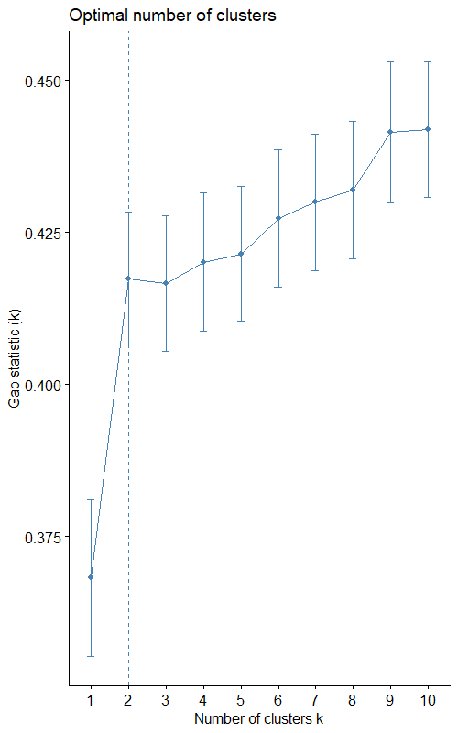

Supplemental Figure 3: Clustering analysis

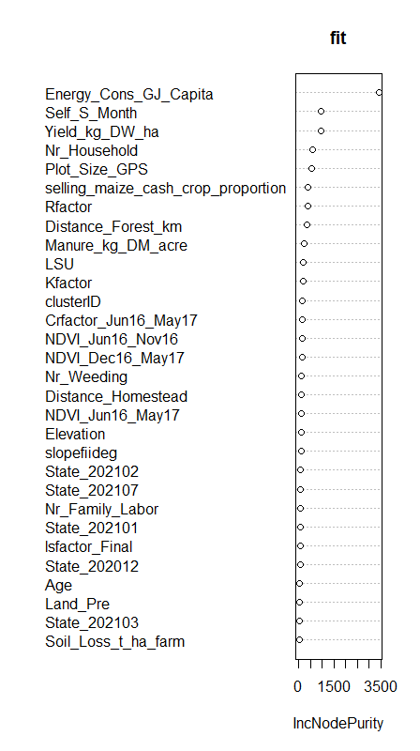

Supplemental Figure 4: List of major variables for decision tree machine learning method