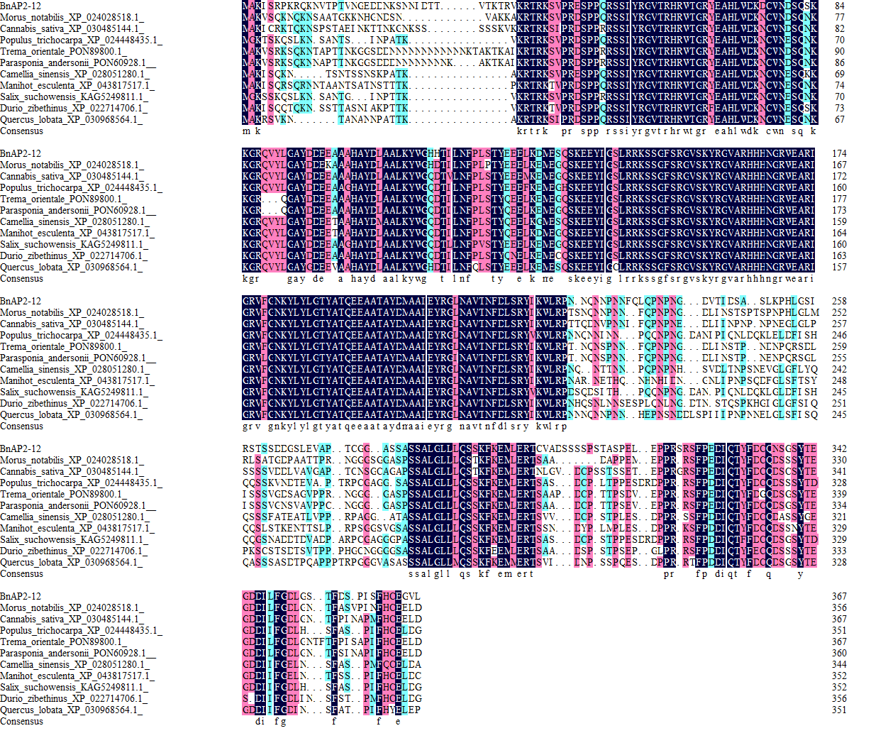

Figure S9 Sequence alignment of ramie BnAP2-12 with other species.