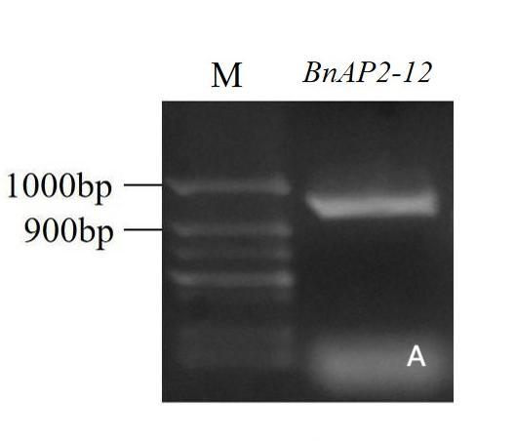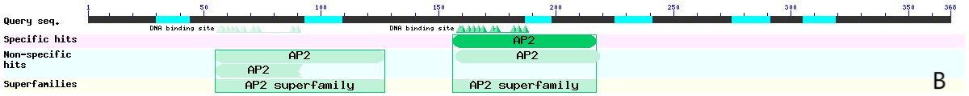

Figure S8 Electropherogram of BnAP2-12 CDS and conservative domain analysis.

(A)Horizontal gel electropherogram of PCR production.(B)Conservative domain analysis