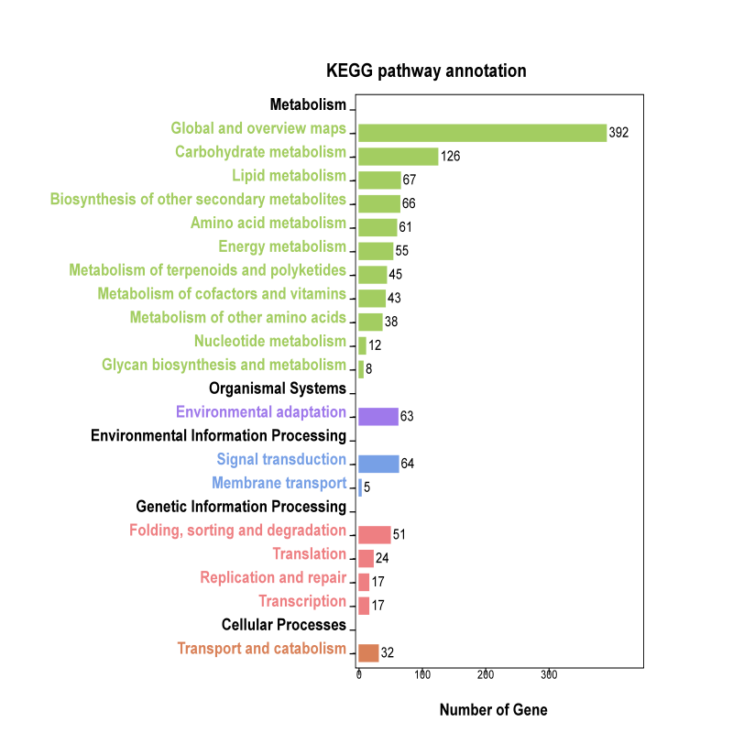

Figure S7. KEGG pathway annotation and classification of DEGs